UNITED STATES
SECURITIES AND EXCHANGE COMMISSION
WASHINGTON, D.C. 20549

Form 6-K

REPORT OF FOREIGN PRIVATE ISSUER
PURSUANT TO RULE 13a-16 OR 15d-16
OF THE SECURITIES EXCHANGE ACT OF 1934
For the month of November 2023
Commission File Number 1-14840

AMDOCS LIMITED

Hirzel House, Smith Street,
St. Peter Port, Island of Guernsey, GY1 2NG
Amdocs, Inc.
625 Maryville Centre Drive, Suite 200, Saint Louis, Missouri 63141
(Address of principal executive offices)

Indicate by check mark whether the registrant files or will file annual reports under cover of Form 20-F or Form 40-F:
FORM 20-F ☒ FORM 40-F ☐

On November 7, 2023 Amdocs Limited (Amdocs) issued a press release announcing financial results for the quarter ended September 30, 2023. A copy of the press release and the accompanying presentation are furnished as Exhibits 99.1 and 99.2 to this Report of Foreign Private Issuer on Form 6-K.
The information in this Form 6-K (including Exhibits 99.1 and 99.2) shall not be deemed filed for purposes of Section 18 of the Securities Exchange Act of 1934 (the Exchange Act) or otherwise subject to the liabilities of that section, nor shall it be deemed incorporated by reference in any filing under the Securities Act of 1933 or the Exchange Act.

EXHIBIT INDEX

EXHIBIT  NO. |  | DESCRIPTION
99.1 |  | Amdocs Limited Press Release Announcing Q4 Earnings, dated November 7, 2023.
99.2 |  | Fiscal Q4 2023 Earnings Presentation

SIGNATURES
Pursuant to the requirements of the Securities Exchange Act of 1934, the registrant has duly caused this report to be signed on its behalf by the undersigned, thereunto duly authorized.

AMDOCS LIMITED
By: |  | /s/ Matthew E. Smith
 |  | Matthew E. Smith
 |  | Secretary and Authorized Signatory
Date: November 7, 2023
Exhibit 99.1

 |  | 

Amdocs Limited Reports Fourth Quarter & Full Year Fiscal 2023 Results Initiates Fiscal 2024 Outlook
Record Fiscal 2023 Revenue of $4.89 Billion, up 6.8% YoY as Reported and 7.7% YoY in Constant Currency(1)
Record 12-Month Backlog of $4.15 Billion, up 4.5% YoY
Expects Fiscal 2024 Revenue Growth of 1%-5% YoY as Reported and in Constant Currency(1)
Expects Double-digit Diluted Earnings Per Share Growth in Fiscal 2024, Supported by Accelerated Profitability Improvement
Board Approves 10% Increase of Quarterly Cash Dividend
Full Year Fiscal 2023 Highlights
(All comparisons are against the prior year)

 |  |  | Record revenue of $4,888 million, up 6.8% as reported and up 7.7% in constant currency(1), including record revenue of $3,307 million in North America and record revenue of $703 million in Europe

 |  |  | Record managed services revenue of $2,857 million, equivalent to approximately 58% of total revenue

 |  |  | GAAP diluted EPS of $4.49, up 1.1%

 |  |  | Non-GAAP diluted EPS of $5.91, up 11.5%

 |  |  | Free cash flow of $698 million, comprised of cash flow from operations of $823 million, less $124 million in net capital expenditures and other(2), and including $20 million of restructuring payments not assumed in full year free cash flow guidance of $700 million

 |  |  | Repurchased $490 million of ordinary shares during the fiscal year

 |  |  | Record twelve-month backlog of $4.15 billion, up 4.5% as compared to last years fourth fiscal quarter, and up approximately $10 million sequentially

(1) | Revenue on a constant currency basis assumes exchange rates in the current period were unchanged from the prior period
(2) | Please refer to the Selected Financial Metrics tables below (figures may not sum because of rounding)

Fourth Quarter Fiscal 2023 Highlights
(All comparisons are against the prior year)

 |  |  | Record revenue of $1,243 million, up 6.5% as reported and up 6.3% in constant currency(1); revenue was above the midpoint of $1,220-$1,260 million guidance range

 |  |  | Record revenue of $834 million in North America, up 5.0%, and strong growth in Europe, up approximately 20%

 |  |  | GAAP diluted EPS of $0.86, above the guidance range of $0.67-$0.81

 |  |  | Non-GAAP diluted EPS of $1.42, above the midpoint guidance range of $1.38-$1.44; non-GAAP diluted EPS excludes restructuring charges of $46 million

 |  |  | GAAP operating income of $139 million; GAAP operating margin of 11.2%, down 350 basis points as compared to last years fourth fiscal quarter and down 360 basis points sequentially, primarily reflecting restructuring charges of $46 million

 |  |  | Non-GAAP operating income of $221 million; non-GAAP operating margin of 17.8%, up 20 basis points as compared to last years fourth fiscal quarter and unchanged sequentially, reflecting a continued focus on operational excellence

 |  |  | The Board of Directors (the Board) approved a 10% increase in the Companys quarterly cash dividend payment from $0.435 per share to $0.479 per share, anticipated to be first paid in April 2024, subject to shareholder approval at the February 2024 annual meeting

 |  |  | Our current Chairman of the Board, Mr. Rob Minicucci, has stepped down as Chairman effective as of November 7, 2023, and our current director, Mr. Eli Gelman, is stepping in as the new Chairman of the Board effective as of the same date. We want to thank Mr. Minicucci for his great contribution to the Company during his 12-year tenure as the Chairman of the Board and look forward to him continuing to contribute to the Board as director. We warmly wish Mr. Gelman much success in his new role
JERSEY CITY, NJ  November 7, 2023  Amdocs Limited (NASDAQ: DOX), a leading provider of software and services to communications and media companies, today reported operating results for the fourth fiscal quarter and full fiscal year ended September 30, 2023.

I am pleased to report solid fiscal 2023 results, including strong revenue growth, positive sales momentum, improved profitability, and robust free cash flow. Record revenue of $4.89 billion grew 7.7% in constant currency(1) as we supported our customers multi-year journey of digital modernization, network automation, cloud migration, and the deployment and monetization of 5G and fiber networks. North America and Europe had a record year as we accelerated modernization projects at AT&T, T-Mobile, Vodafone, Three Group and others. Revenue from cloud activities grew at a double-digit rate in fiscal 2023 and exceeded 20% of total revenue for the first time as a growing list of customers increasingly recognize our unique industry expertise, superior product offering, strong web-scale partnerships, and an ability to remove complexity by delivering end-to-end, fully accountable cloud migration paths. Additionally, we extended our Generative-AI leadership position, leveraging our Microsoft partnership and Amdocs amAIz framework to already embed telco-specific Generative AI use cases across our latest CES suite, said Shuky Sheffer, president and chief executive officer of Amdocs Management Limited.
Focused execution was a hallmark of fiscal 2023, as we achieved a record number of project milestones while delivering improved operating profitability resulting from the deployment of automation and other sophisticated tools. Similarly, I was pleased with our earnings to cash conversion of roughly 100%. Additionally, managed services had another record year, during which we expanded activities under extended multi-year engagements with customers such as AT&T Cricket, DISH, Three UK, Vodafone Ziggo in Netherlands, and Globe in the Philippines, said Tamar Rapaport-Dagim, chief financial officer & chief operating officer of Amdocs Management Limited.
Sheffer concluded, Amdocs continues to serve a large and expanding addressable market reflecting our customers critical multi-year modernization journey to cloud-based 5G and fiber networks, Generative AI, and improved consumer and B2B experience. As we enter fiscal 2024, we expect revenue growth of 1% to 5%, impacted by continued revenue headwinds, among which service providers are prioritizing modernization programs in lieu of reduced investments to enhance legacy systems. Having said that, our market and technology leadership positions Amdocs as the industrys partner of choice for continued modernization and supports an outlook for another year of double-digit cloud revenue

growth in fiscal 2024. I am pleased to report that our ongoing efforts to drive operational excellence through automation and other sophisticated tools, including Generative AI, is expected to yield accelerated profitability improvement this year. Additionally, we expect strong earnings to cash conversion and a fourth consecutive year of double-digit earnings per share growth in fiscal 2024, assuming the midpoint of our guidance range.
Revenue
(All comparisons are against the prior year period)

 |  | In millions
 |  | Three months ended |  |  |  |  |  |  |  |  |  |  |  | Twelve months ended
 |  | September 30, 2023 |  |  |  |  |  |  |  |  |  |  |  | September 30, 2023
 |  | Actual |  |  |  | Previous  Guidance |  |  |  | Actual |  |  |  | Previous  Guidance
Revenue |  | $ | 1,243 |  |  | $ | 1,220 - $1,260 |  |  | $ | 4,888 |  |  |  | 
Revenue Growth, as reported |  |  | 6.5 | % |  |  |  |  |  |  | 6.8 | % |  |  | 6.3%-7.1 | %
Revenue Growth, constant currency (1) |  |  | 6.3 | % |  |  |  |  |  |  | 7.7 | % |  |  | 7.2%-8.0 | %

 |  |  | Revenue for the fourth fiscal quarter of 2023 was above the midpoint of Amdocs guidance, and includes an immaterial foreign currency movement compared to our guidance assumptions

 |  |  | Revenue for the fourth fiscal quarter includes an unfavorable impact from foreign currency movements of approximately $2 million relative to the third quarter of fiscal 2023

 |  |  | Revenue for the full year fiscal 2023 includes an unfavorable impact from foreign currency movements of approximately 0.9% year-over-year

Net Income and Earnings Per Share

` |  | In thousands, expect per share data
 |  | Three months ended |  |  |  |  |  |  |  | Twelve months ended
 |  | September 30, |  |  |  |  |  |  |  | September 30,
 |  | 2023 |  |  |  | 2022 |  |  |  | 2023 |  |  |  | 2022
GAAP Measures
Net Income |  | $ | 102,666 |  |  | $ | 128,936 |  |  | $ | 542,962 |  |  | $ | 549,501
Net Income attributable to Amdocs Limited |  | $ | 102,011 |  |  | $ | 128,936 |  |  | $ | 540,709 |  |  | $ | 549,501
Diluted earnings per share |  | $ | 0.86 |  |  | $ | 1.05 |  |  | $ | 4.49 |  |  | $ | 4.44
Non-GAAP Measures
Non-GAAP Net Income |  | $ | 169,009 |  |  | $ | 157,548 |  |  | $ | 714,454 |  |  | $ | 655,147
Non-GAAP Net Income attributable to Amdocs Limited |  | $ | 168,354 |  |  | $ | 157,548 |  |  | $ | 712,201 |  |  | $ | 655,147
Non-GAAP Diluted earnings per share |  | $ | 1.42 |  |  | $ | 1.29 |  |  | $ | 5.91 |  |  | $ | 5.30

 |  |  | Non-GAAP net income excludes restructuring charges, amortization of purchased intangible assets and other acquisition-related costs, changes in certain acquisition related liabilities measured at fair value, equity-based compensation expenses, gain from divestiture of OpenMarket and other, net of related tax effects, in all the periods presented
For further details of the reconciliation of selected financial metrics from GAAP to Non-GAAP, please refer to the tables below.
Capital Allocation

 |  |  | M&A Activity: On August 22, 2023, Amdocs completed the acquisition of Procom Consulting for a net consideration of approximately $37 million, with additional consideration to be paid later based on the achievement of certain performance metrics; on November 2, 2023, Amdocs completed the acquisition of Astadia for a net consideration of approximately $75 million in cash, with additional consideration to be paid later based on the achievement of certain performance metrics

 |  |  | Quarterly Cash Dividend Program: On November 7, 2023, the Board approved the Companys next quarterly cash dividend payment of $0.435 per share and set December 29, 2023 as the record date for determining the shareholders entitled to receive the dividend, which will be payable on January 26, 2024

 |  |  | The Board also approved a 10% increase in the Companys quarterly cash dividend payment to $0.479 per share, which is anticipated to be first paid in April 2024, provided that the increase is approved by shareholders at the February 2024 annual general meeting of shareholders

 |  |  | Share Repurchase Activity: Repurchased $155 million of ordinary shares during the fourth quarter of fiscal 2023

Twelve-month Backlog
Twelve-month backlog was a record $4.15 billion at the end of the fourth quarter of fiscal 2023, up approximately 4.5% as compared to last years fourth fiscal quarter. Twelve-month backlog includes anticipated revenue related to contracts, estimated revenue from managed services contracts, letters of intent, maintenance and estimated on-going support activities.
First Quarter Fiscal 2024 Outlook

In millions, except per share data
Q1 2024
Revenue |  | $ | 1,225-$1,265
GAAP diluted EPS |  | $ | 1.18-$1.26
Non-GAAP diluted EPS |  | $ | 1.53-$1.59

 |  |  | First quarter revenue guidance assumes negative $5 million sequential impact from foreign currency fluctuations as compared to the fourth quarter of fiscal 2023

 |  |  | First quarter non-GAAP diluted EPS guidance excludes equity-based compensation expense of approximately $0.19-$0.21 per share, amortization of purchased intangible assets and other acquisition-related costs of approximately $0.11 per share, changes in certain acquisitions related liabilities measured at fair value, and other, net of related tax effects

 |  |  | The impact of recent acquisitions on GAAP diluted EPS will not be known until after Amdocs completes the purchase price allocation
Full Year Fiscal 2024 Outlook

FY 2024, year-over-year growth
Guidance
Revenue growth, as reported |  |  | 1.0%-5.0%
Revenue growth, constant currency(1) |  |  | 1.2%-5.2%
GAAP diluted EPS growth |  |  | 11.0%-18.0%
Non-GAAP diluted EPS growth |  |  | 8.0%-12.0%
 |  | FY 2024, in millions Guidance
Free cash flow(2) |  | ~$ | 750

 |  |  | Full year fiscal 2024 revenue guidance incorporates an expected immaterial impact from foreign currency fluctuations of approximately 0.2% year-over-year

 |  |  | Non-GAAP diluted earnings per share growth excludes equity-based compensation expense of approximately $0.77-$0.85 per share, amortization of purchased intangible assets and other acquisition-related costs of approximately $0.43 per share, changes in certain acquisitions related liabilities measured at fair value, and other, net of related tax effects

 |  |  | The impact of recent acquisitions on GAAP diluted EPS will not be known until after Amdocs completes the purchase price allocation

 |  |  | The impact of recent acquisitions on Amdocs non-GAAP diluted earnings per share is expected to be neutral in the full fiscal year 2024

 |  |  | Non-GAAP operating margin is anticipated to be within a range of 18.1% to 18.7% for the full year fiscal 2024

 |  |  | Non-GAAP effective tax rate is anticipated to be within a range of 13.0% to 17.0% for the full year fiscal 2024

 |  |  | Free cash flow(2) is comprised of cash flow from operations, less net capital expenditures and other, and excludes anticipated payments related to restructuring charges
The forward looking statements regarding our first fiscal quarter 2024 and full year fiscal 2024 guidance take into consideration the Companys current expectations regarding macro and industry specific risks and various uncertainties and certain assumptions that we will discuss on our earnings conference call. However, we note that market dynamics continue to shift rapidly and we cannot predict all possible outcomes, including those resulting from certain geopolitical events (including the recent attacks in Israel and evolving conflict), the current inflationary environment, global or regional events, such as the COVID-19 pandemic and the prevailing level of macro-economic, business and operational uncertainty, which have created, and continue to create, a significant amount of uncertainty, or from current and potential customer consolidation or their other strategic corporate activities.

Conference Call and Earnings Webcast Presentation Details
Amdocs will host a conference call and earnings webcast presentation on November 7, 2023 at 5:00 p.m. Eastern Time to discuss the Companys fourth quarter of fiscal 2023 results.
To participate in the call, please register here to receive the dial-in numbers and unique access PIN. The conference call and webcast will also be carried live on the Internet and may be accessed via the Amdocs website at https://investors.amdocs.com. Presentation slides will be available shortly before the webcast.
Non-GAAP Financial Measures
This release includes non-GAAP diluted earnings per share and other non-GAAP financial measures, including free cash flow and normalized free cash flow, revenue on a constant currency(1) basis, non-GAAP cost of revenue, non-GAAP research and development, non-GAAP selling, general and administrative, non-GAAP operating income, non-GAAP operating margin, non-GAAP interest and other expenses, net, non-GAAP income taxes, non-GAAP effective tax rate, non-GAAP net income, non-GAAP net income attributable to Amdocs Limited and non-GAAP diluted earnings per share growth. These other non-GAAP measures exclude the following items:

 |  |  | amortization of purchased intangible assets and other acquisition-related costs;

 |  |  | changes in certain acquisition-related liabilities measured at fair value;

 |  |  | restructuring and unusual charges or benefits (such as a gain from divestiture of OpenMarket);

 |  |  | equity-based compensation expense;

 |  |  | other; and

 |  |  | tax effects related to the above.

Free cash flow equals cash generated by operating activities less net capital expenditures and other. Normalized free cash flow, a measure of our operating performance, is further adjusted to exclude net capital expenditures related to the new campus development, payments for non-recurring and unusual charges (such as capital gains tax in relation to the divestiture of OpenMarket), and payments of acquisition related liabilities. Normalized free cash flow is not comparable to free cash flow. These non-GAAP financial measures are not in accordance with, or an alternative for, generally accepted accounting principles and may be different from non-GAAP financial measures used by other companies. In addition, these non-GAAP financial measures are not based on any comprehensive set of accounting rules or principles. Amdocs believes that non-GAAP financial measures have limitations in that they do not reflect all of the amounts associated with Amdocs results of operations as determined in accordance with GAAP and that these measures should only be used to evaluate Amdocs results of operations in conjunction with the corresponding GAAP measures.
Amdocs believes that the presentation of non-GAAP diluted earnings per share and other financial measures, including free cash flow and normalized free cash flow, revenue on a constant currency(1) basis, non-GAAP cost of revenue, non-GAAP research and development, non-GAAP selling, general and administrative, non-GAAP operating income, non-GAAP operating margin, non-GAAP interest and other expenses, net, non-GAAP income taxes, non-GAAP effective tax rate, non-GAAP net income, non-GAAP net income attributable to Amdocs Limited and non-GAAP diluted earnings per share growth when shown in conjunction with the corresponding GAAP measures, provides useful information to investors and management regarding financial and business trends relating to its financial condition and results of operations, as well as the net amount of cash generated by its business operations after taking into account capital spending required to maintain or expand the business.

For its internal budgeting process and in monitoring the results of the business, Amdocs management uses financial statements that do not include amortization of purchased intangible assets and other acquisition-related costs, changes in certain acquisition-related liabilities measured at fair value, restructuring and unusual charges or benefits, equity-based compensation expense, other and related tax effects. Amdocs management also uses the foregoing non-GAAP financial measures, in addition to the corresponding GAAP measures, in reviewing the financial results of Amdocs. In addition, Amdocs believes that significant groups of investors exclude these items in reviewing its results and those of its competitors, because the amounts of the items between companies can vary greatly depending on the assumptions used by an individual company in determining the amounts of the items.
Amdocs further believes that, where the adjustments used in calculating non-GAAP diluted earnings per share are based on specific, identified amounts that impact different line items in the Consolidated Statements of Income (including cost of revenue, research and development, selling, general and administrative, operating income, interest and other expenses, net, income taxes and net income), it is useful to investors to understand how these specific line items in the Consolidated Statements of Income are affected by these adjustments. Please refer to the Reconciliation of Selected Financial Metrics from GAAP to Non-GAAP tables below.
Supporting Resources

 |  |  | Keep up with Amdocs news by visiting the Companys website

 |  |  | Subscribe to Amdocs RSS Feed and follow us on Twitter, Facebook, LinkedIn and YouTube
About Amdocs
Amdocs helps those who build the future to make it amazing. With our market-leading portfolio of software products and services, we unlock our customers innovative potential, empowering them to provide next-generation communication and media experiences for both the individual end user and large enterprise customers. Our approximately 30,000 employees around the globe are here to accelerate service providers migration to the cloud, enable them to differentiate in the 5G era, and digitalize and automate their operations. Listed on the NASDAQ Global Select Market, Amdocs had revenue of $4.89 billion in fiscal 2023.

For more information, visit Amdocs at www.amdocs.com.
This press release includes information that constitutes forward-looking statements made pursuant to the safe harbor provision of the Private Securities Litigation Reform Act of 1995, including statements about Amdocs growth and business results in future quarters and years. Although we believe the expectations reflected in such forward-looking statements are based upon reasonable assumptions, we can give no assurance that our expectations will be obtained or that any deviations will not be material. Such statements involve risks and uncertainties that may cause future results to differ from those anticipated. These risks include, but are not limited to, the effects of general macroeconomic conditions, prevailing level of macroeconomic, business and operational uncertainty, including as a result of geopolitical events or other global or regional events such as the recent attacks in Israel and evolving conflict and the COVID-19 pandemic, as well as the current inflationary environment, and the effects of these conditions on the Companys customers businesses and levels of business activity, including the effect of the current economic uncertainty and industry pressure on the spending decisions of the Companys customers. Amdocs ability to grow in the business markets that it serves, Amdocs ability to successfully integrate acquired businesses, adverse effects of market competition, rapid technological shifts that may render the Companys products and services obsolete, potential loss of a major customer, our ability to develop long-term relationships with our customers, our ability to successfully and effectively implement artificial intelligence and Generative AI in the Companys offerings and operations, and risks associated with operating businesses in the international market. Amdocs may elect to update these forward-looking statements at some point in the future; however, Amdocs specifically disclaims any obligation to do so. These and other risks are discussed at greater length in Amdocs filings with the Securities and Exchange Commission, including in our Annual Report on Form 20-F for the fiscal year ended September 30, 2022 filed on December 13, 2022 and in our Form 6-K furnished for the first quarter of fiscal 2023 filed on February 13, 2023, the second quarter of fiscal 2023 filed on May 22, 2023 and for the third quarter of fiscal 2023 on August 14, 2023.

Contact:
Matthew Smith
Head of Investor Relations
Amdocs
314-212-8328
E-mail: dox_info@amdocs.com

AMDOCS LIMITED
Consolidated Statements of Income
(In thousands, except per share data)

 |  | Three months ended  September 30, |  |  |  |  |  |  |  | Fiscal year ended  September 30,
 |  | 2023 |  |  |  | 2022 |  |  |  | 2023 |  |  |  | 2022
Revenue |  | $ | 1,242,564 |  |  | $ | 1,166,504 |  |  | $ | 4,887,550 |  |  | $ | 4,576,697
Operating expenses:
Cost of revenue |  |  | 803,600 |  |  |  | 751,358 |  |  |  | 3,159,941 |  |  |  | 2,957,547
Research and development |  |  | 97,693 |  |  |  | 96,218 |  |  |  | 374,855 |  |  |  | 354,706
Selling, general and administrative |  |  | 140,380 |  |  |  | 129,404 |  |  |  | 570,707 |  |  |  | 528,572
Amortization of purchased intangible assets and other |  |  | 15,601 |  |  |  | 17,838 |  |  |  | 57,156 |  |  |  | 71,075
Restructuring charges |  |  | 46,365 |  |  |  |  |  |  |  | 70,901 |  |  |  | 
 |  |  | 1,103,639 |  |  |  | 994,818 |  |  |  | 4,233,560 |  |  |  | 3,911,900
Operating income |  |  | 138,925 |  |  |  | 171,686 |  |  |  | 653,990 |  |  |  | 664,797
Interest and other expense, net |  |  | (5,307 | ) |  |  | (7,399 | ) |  |  | (17,629 | ) |  |  | (26,391 | )
Gain from sale of a business |  |  |  |  |  |  |  |  |  |  |  |  |  |  | 10,000
Income before income taxes |  |  | 133,618 |  |  |  | 164,287 |  |  |  | 636,361 |  |  |  | 648,406
Income taxes |  |  | 30,952 |  |  |  | 35,351 |  |  |  | 93,399 |  |  |  | 98,905
Net income |  | $ | 102,666 |  |  | $ | 128,936 |  |  | $ | 542,962 |  |  | $ | 549,501
Net income attributable to noncontrolling interests |  |  | 655 |  |  |  |  |  |  |  | 2,253 |  |  |  | 
Net income attributable to Amdocs Limited |  | $ | 102,011 |  |  | $ | 128,936 |  |  | $ | 540,709 |  |  | $ | 549,501
Basic earnings per share attributable to Amdocs Limited |  | $ | 0.86 |  |  | $ | 1.06 |  |  | $ | 4.52 |  |  | $ | 4.47
Diluted earnings per share attributable to Amdocs Limited |  | $ | 0.86 |  |  | $ | 1.05 |  |  | $ | 4.49 |  |  | $ | 4.44
Basic weighted average number of shares outstanding |  |  | 118,076 |  |  |  | 121,449 |  |  |  | 119,687 |  |  |  | 122,812
Diluted weighted average number of shares outstanding |  |  | 118,884 |  |  |  | 122,320 |  |  |  | 120,519 |  |  |  | 123,650
Cash dividends declared per share |  | $ | 0.435 |  |  | $ | 0.395 |  |  | $ | 1.700 |  |  | $ | 1.545

AMDOCS LIMITED
Selected Financial Metrics
(In thousands, except per share data)

 |  | Three months ended  September 30, |  |  |  |  |  |  |  | Fiscal year ended  September 30,
 |  | 2023 |  |  |  | 2022 |  |  |  | 2023 |  |  |  | 2022
Revenue |  | $ | 1,242,564 |  |  | $ | 1,166,504 |  |  | $ | 4,887,550 |  |  | $ | 4,576,697
Non-GAAP operating income |  |  | 221,105 |  |  |  | 205,337 |  |  |  | 868,602 |  |  |  | 804,894
Non-GAAP net income |  |  | 169,009 |  |  |  | 157,548 |  |  |  | 714,454 |  |  |  | 655,147
Non-GAAP net income attributable to Amdocs Limited |  |  | 168,354 |  |  |  | 157,548 |  |  |  | 712,201 |  |  |  | 655,147
Non-GAAP diluted earnings per share |  | $ | 1.42 |  |  | $ | 1.29 |  |  | $ | 5.91 |  |  | $ | 5.30
Diluted weighted average number of shares outstanding |  |  | 118,884 |  |  |  | 122,320 |  |  |  | 120,519 |  |  |  | 123,650
Free Cash Flows
(In thousands)

 |  | Three months ended  September 30, |  |  |  |  |  |  |  | Fiscal year ended  September 30,
 |  | 2023 |  |  |  | 2022 |  |  |  | 2023 |  |  |  | 2022
Net Cash Provided by Operating Activities |  | $ | 272,371 |  |  | $ | 216,919 |  |  | $ | 822,630 |  |  | $ | 756,719
Purchases of property and equipment, net (a) |  |  | (26,557 | ) |  |  | (81,819 | ) |  |  | (124,362 | ) |  |  | (227,219 | )
Free Cash Flow |  | $ | 245,814 |  |  | $ | 135,100 |  |  | $ | 698,268 |  |  | $ | 529,500
Normalized Free Cash Flow (b) for the three and fiscal year ended September 30, 2022: $175,708 and $665,327, respectively, excluding net capital expenditures related to the new campus development of $38,683 and $116,359, respectively, payment for acquisition related liability of $1,925 and $16,275, respectively, and tax payment on sale of business of $3,193, for fiscal year ended September 30, 2022.

(a) | The amounts under Purchase of property and equipment, net include proceeds from sale of property and equipment of $442 and $521 for the fiscal years ended September 30, 2023 and 2022, respectively.
(b) | Since Q12023, the Normalized Free Cash Flow is no longer applicable.

AMDOCS LIMITED
Reconciliation of Selected Financial Metrics from GAAP to Non-GAAP
(In thousands)

 |  | Three Months Ended September 30, 2023
 |  | GAAP |  |  |  | Amortization  of purchased  intangible  assets and  other |  |  |  | Equity based  compensation  expense |  |  |  | Changes in  certain  acquisitions  related  liabilities  measured  at fair  value |  |  |  | Restructuring  charges |  |  |  | Other |  |  |  | Tax  effect |  |  |  | Non-GAAP
Operating expenses:
Cost of revenue |  | $ | 803,600 |  |  | $ |  |  |  | $ | (12,401 | ) |  | $ | 4,579 |  |  | $ |  |  |  | $ |  |  |  | $ |  |  |  | $ | 795,778
Research and development |  |  | 97,693 |  |  |  |  |  |  |  | (2,285 | ) |  |  |  |  |  |  |  |  |  |  |  |  |  |  |  |  |  |  | 95,408
Selling, general and administrative |  |  | 140,380 |  |  |  |  |  |  |  | (10,107 | ) |  |  |  |  |  |  |  |  |  |  |  |  |  |  |  |  |  |  | 130,273
Amortization of purchased intangible assets and other |  |  | 15,601 |  |  |  | (15,601 | ) |  |  |  |  |  |  |  |  |  |  |  |  |  |  |  |  |  |  |  |  |  |  | 
Restructuring charges |  |  | 46,365 |  |  |  |  |  |  |  |  |  |  |  |  |  |  |  | (46,365 | ) |  |  |  |  |  |  |  |  |  |  | 
Total operating expenses |  |  | 1,103,639 |  |  |  | (15,601 | ) |  |  | (24,793 | ) |  |  | 4,579 |  |  |  | (46,365 | ) |  |  |  |  |  |  |  |  |  |  | 1,021,459
Operating income |  |  | 138,925 |  |  |  | 15,601 |  |  |  | 24,793 |  |  |  | (4,579 | ) |  |  | 46,365 |  |  |  |  |  |  |  |  |  |  |  | 221,105
Interest and other expense, net |  |  | (5,307 | ) |  |  |  |  |  |  |  |  |  |  |  |  |  |  |  |  |  |  | 398 |  |  |  |  |  |  |  | (4,909 | )
Income taxes |  |  | 30,952 |  |  |  |  |  |  |  |  |  |  |  |  |  |  |  |  |  |  |  |  |  |  |  | 16,235 |  |  |  | 47,187
Net income |  |  | 102,666 |  |  |  | 15,601 |  |  |  | 24,793 |  |  |  | (4,579 | ) |  |  | 46,365 |  |  |  | 398 |  |  |  | (16,235 | ) |  |  | 169,009
Net income attributable to noncontrolling interests |  |  | 655 |  |  |  |  |  |  |  |  |  |  |  |  |  |  |  |  |  |  |  |  |  |  |  |  |  |  |  | 655
Net income attributable to Amdocs Limited |  | $ | 102,011 |  |  | $ | 15,601 |  |  | $ | 24,793 |  |  | $ | (4,579 | ) |  | $ | 46,365 |  |  | $ | 398 |  |  | $ | (16,235 | ) |  | $ | 168,354

 |  | Three Months Ended September 30, 2022
 |  | GAAP |  |  |  | Amortization  of purchased  intangible  assets and  other |  |  |  | Equity based  compensation  expense |  |  |  | Changes in  certain  acquisitions  related  liabilities  measured  at fair  value |  |  |  | Other |  |  |  | Tax  effect |  |  |  | Non-GAAP
Operating expenses:
Cost of revenue |  | $ | 751,358 |  |  | $ |  |  |  | $ | (8,356 | ) |  | $ | 3,294 |  |  | $ |  |  |  | $ |  |  |  | $ | 746,296
Research and development |  |  | 96,218 |  |  |  |  |  |  |  | (1,538 | ) |  |  |  |  |  |  |  |  |  |  |  |  |  |  | 94,680
Selling, general and administrative |  |  | 129,404 |  |  |  |  |  |  |  | (9,213 | ) |  |  |  |  |  |  |  |  |  |  |  |  |  |  | 120,191
Amortization of purchased intangible assets and other |  |  | 17,838 |  |  |  | (17,838 | ) |  |  |  |  |  |  |  |  |  |  |  |  |  |  |  |  |  |  | 
Total operating expenses |  |  | 994,818 |  |  |  | (17,838 | ) |  |  | (19,107 | ) |  |  | 3,294 |  |  |  |  |  |  |  |  |  |  |  | 961,167
Operating income |  |  | 171,686 |  |  |  | 17,838 |  |  |  | 19,107 |  |  |  | (3,294 | ) |  |  |  |  |  |  |  |  |  |  | 205,337
Interest and other expense, net |  |  | (7,399 | ) |  |  |  |  |  |  |  |  |  |  |  |  |  |  | 400 |  |  |  |  |  |  |  | (6,999 | )
Income taxes |  |  | 35,351 |  |  |  |  |  |  |  |  |  |  |  |  |  |  |  |  |  |  |  | 5,439 |  |  |  | 40,790
Net income |  | $ | 128,936 |  |  | $ | 17,838 |  |  | $ | 19,107 |  |  | $ | (3,294 | ) |  | $ | 400 |  |  | $ | (5,439 | ) |  | $ | 157,548

AMDOCS LIMITED
Reconciliation of Selected Financial Metrics from GAAP to Non-GAAP
(In thousands)

 |  | Fiscal year ended September 30, 2023
 |  | GAAP |  |  |  | Amortization  of purchased  intangible  assets and  other |  |  |  | Equity based  compensation  expense |  |  |  | Changes in  certain  acquisitions  related  liabilities  measured  at fair  value |  |  |  | Restructuring  charges |  |  |  | Other |  |  |  | Tax  effect |  |  |  | Non-GAAP
Operating expenses:
Cost of revenue |  | $ | 3,159,941 |  |  | $ |  |  |  | $ | (42,969 | ) |  | $ | 3,143 |  |  | $ |  |  |  | $ |  |  |  | $ |  |  |  | $ | 3,120,115
Research and development |  |  | 374,855 |  |  |  |  |  |  |  | (7,509 | ) |  |  |  |  |  |  |  |  |  |  |  |  |  |  |  |  |  |  | 367,346
Selling, general and administrative |  |  | 570,707 |  |  |  |  |  |  |  | (39,220 | ) |  |  |  |  |  |  |  |  |  |  |  |  |  |  |  |  |  |  | 531,487
Amortization of purchased intangible assets and other |  |  | 57,156 |  |  |  | (57,156 | ) |  |  |  |  |  |  |  |  |  |  |  |  |  |  |  |  |  |  |  |  |  |  | 
Restructuring charges |  |  | 70,901 |  |  |  |  |  |  |  |  |  |  |  |  |  |  |  | (70,901 | ) |  |  |  |  |  |  |  |  |  |  | 
Total operating expenses |  |  | 4,233,560 |  |  |  | (57,156 | ) |  |  | (89,698 | ) |  |  | 3,143 |  |  |  | (70,901 | ) |  |  |  |  |  |  |  |  |  |  | 4,018,948
Operating income |  |  | 653,990 |  |  |  | 57,156 |  |  |  | 89,698 |  |  |  | (3,143 | ) |  |  | 70,901 |  |  |  |  |  |  |  |  |  |  |  | 868,602
Interest and other expense, net |  |  | (17,629 | ) |  |  |  |  |  |  |  |  |  |  |  |  |  |  |  |  |  |  | 906 |  |  |  |  |  |  |  | (16,723 | )
Income taxes |  |  | 93,399 |  |  |  |  |  |  |  |  |  |  |  |  |  |  |  |  |  |  |  |  |  |  |  | 44,026 |  |  |  | 137,425
Net income |  |  | 542,962 |  |  |  | 57,156 |  |  |  | 89,698 |  |  |  | (3,143 | ) |  |  | 70,901 |  |  |  | 906 |  |  |  | (44,026 | ) |  |  | 714,454
Net income attributable to noncontrolling interests |  |  | 2,253 |  |  |  |  |  |  |  |  |  |  |  |  |  |  |  |  |  |  |  |  |  |  |  |  |  |  |  | 2,253
Net income attributable to Amdocs Limited |  | $ | 540,709 |  |  | $ | 57,156 |  |  | $ | 89,698 |  |  | $ | (3,143 | ) |  | $ | 70,901 |  |  | $ | 906 |  |  | $ | (44,026 | ) |  | $ | 712,201

 |  | Fiscal year ended September 30, 2022
 |  | GAAP |  |  |  | Amortization  of purchased  intangible  assets and  other |  |  |  | Equity based  compensation  expense |  |  |  | Changes in  certain  acquisitions  related  liabilities  measured  at fair  value |  |  |  | Gain from  sale of a  business |  |  |  | Other |  |  |  | Tax  effect |  |  |  | Non-GAAP
Operating expenses:
Cost of revenue |  | $ | 2,957,547 |  |  | $ |  |  |  | $ | (32,096 | ) |  | $ | 2,785 |  |  | $ |  |  |  | $ |  |  |  | $ |  |  |  | $ | 2,928,236
Research and development |  |  | 354,706 |  |  |  |  |  |  |  | (5,631 | ) |  |  |  |  |  |  |  |  |  |  |  |  |  |  |  |  |  |  | 349,075
Selling, general and administrative |  |  | 528,572 |  |  |  |  |  |  |  | (34,080 | ) |  |  |  |  |  |  |  |  |  |  |  |  |  |  |  |  |  |  | 494,492
Amortization of purchased intangible assets and other |  |  | 71,075 |  |  |  | (71,075 | ) |  |  |  |  |  |  |  |  |  |  |  |  |  |  |  |  |  |  |  |  |  |  | 
Total operating expenses |  |  | 3,911,900 |  |  |  | (71,075 | ) |  |  | (71,807 | ) |  |  | 2,785 |  |  |  |  |  |  |  |  |  |  |  |  |  |  |  | 3,771,803
Operating income |  |  | 664,797 |  |  |  | 71,075 |  |  |  | 71,807 |  |  |  | (2,785 | ) |  |  |  |  |  |  |  |  |  |  |  |  |  |  | 804,894
Interest and other expense, net |  |  | (26,391 | ) |  |  |  |  |  |  |  |  |  |  |  |  |  |  |  |  |  |  | (1,605 | ) |  |  |  |  |  |  | (27,996 | )
Gain from sale of a business |  |  | 10,000 |  |  |  |  |  |  |  |  |  |  |  |  |  |  |  | (10,000 | ) |  |  |  |  |  |  |  |  |  |  | 
Income taxes |  |  | 98,905 |  |  |  |  |  |  |  |  |  |  |  |  |  |  |  |  |  |  |  |  |  |  |  | 22,846 |  |  |  | 121,751
Net income |  | $ | 549,501 |  |  | $ | 71,075 |  |  | $ | 71,807 |  |  | $ | (2,785 | ) |  | $ | (10,000 | ) |  | $ | (1,605 | ) |  | $ | (22,846 | ) |  |  | 655,147

AMDOCS LIMITED
Condensed Consolidated Balance Sheets
(In thousands)

 |  | As of
 |  | September 30,  2023 |  |  |  | September 30,  2022
ASSETS
Current assets:
Cash and cash equivalents |  | $ | 520,080 |  |  | $ | 573,377
Short-term interest-bearing investments |  |  | 222,451 |  |  |  | 244,603
Accounts receivable, net, including unbilled of $211,498 and $157,165, respectively |  |  | 944,477 |  |  |  | 946,777
Prepaid expenses and other current assets |  |  | 224,622 |  |  |  | 238,390
Total current assets |  |  | 1,911,630 |  |  |  | 2,003,147
Property and equipment, net |  |  | 790,923 |  |  |  | 794,287
Lease assets |  |  | 160,938 |  |  |  | 176,884
Goodwill and other intangible assets, net |  |  | 2,930,580 |  |  |  | 2,841,137
Other noncurrent assets |  |  | 631,582 |  |  |  | 574,938
Total assets |  | $ | 6,425,653 |  |  | $ | 6,390,393
LIABILITIES AND SHAREHOLDERS EQUITY
Current liabilities
Accounts payable, accruals and other |  | $ | 1,142,781 |  |  | $ | 955,658
Lease liabilities |  |  | 39,960 |  |  |  | 43,336
Deferred revenue |  |  | 170,634 |  |  |  | 253,686
Total current liabilities |  |  | 1,353,375 |  |  |  | 1,252,680
Lease liabilities |  |  | 121,654 |  |  |  | 138,378
Long-term debt, net of unamortized debt issuance costs |  |  | 645,696 |  |  |  | 645,117
Other noncurrent liabilities |  |  | 737,996 |  |  |  | 793,940
Total Amdocs Limited Shareholders equity |  |  | 3,523,759 |  |  |  | 3,517,769
Noncontrolling interests |  |  | 43,173 |  |  |  | 42,509
Total equity |  |  | 3,566,932 |  |  |  | 3,560,278
Total liabilities and equity |  | $ | 6,425,653 |  |  | $ | 6,390,393

AMDOCS LIMITED
Consolidated Statements of Cash Flows
(In thousands)

Fiscal year ended
September 30,
 |  | 2023 |  |  |  | 2022
Cash Flow from Operating Activities:
Net income |  | $ | 542,962 |  |  | $ | 549,501
Reconciliation of net income to net cash provided by operating activities:
Depreciation, amortization and impairment |  |  | 195,701 |  |  |  | 224,535
Amortization of debt issuance cost |  |  | 579 |  |  |  | 564
Equity-based compensation expense |  |  | 89,698 |  |  |  | 71,807
Gain from sale of a business |  |  |  |  |  |  | (10,000 | )
Deferred income taxes |  |  | (60,212 | ) |  |  | (3,292 | )
Loss from short-term interest-bearing investments |  |  | 2,762 |  |  |  | 2,728
Net changes in operating assets and liabilities, net of amounts acquired:
Accounts receivable, net |  |  | 3,457 |  |  |  | (64,978 | )
Prepaid expenses and other current assets |  |  | 7,891 |  |  |  | (3,527 | )
Other noncurrent assets |  |  | (1,532 | ) |  |  | 19,760
Lease assets and liabilities, net |  |  | (4,144 | ) |  |  | 1,394
Accounts payable, accrued expenses and accrued personnel |  |  | 158,876 |  |  |  | (83,932 | )
Deferred revenue |  |  | (157,829 | ) |  |  | (22,456 | )
Income taxes payable, net |  |  | (11,596 | ) |  |  | 15,648
Other noncurrent liabilities |  |  | 56,017 |  |  |  | 58,967
Net cash provided by operating activities |  |  | 822,630 |  |  |  | 756,719
Cash Flow from Investing Activities:
Purchase of property and equipment, net(a) |  |  | (124,362 | ) |  |  | (227,219 | )
Proceeds from sale of short-term interest-bearing investments |  |  | 25,984 |  |  |  | 21,948
Purchase of short-term interest-bearing investments |  |  |  |  |  |  | (34,275 | )
Net cash paid for business and intangible assets acquisitions |  |  | (121,818 | ) |  |  | (24,430 | )
Net cash received from sale of a business |  |  |  |  |  |  | 10,000
Other |  |  | (4,301 | ) |  |  | (8,525 | )
Net cash used in investing activities |  |  | (224,497 | ) |  |  | (262,501 | )
Cash Flow from Financing Activities:
Repurchase of shares |  |  | (489,524 | ) |  |  | (508,472 | )
Proceeds from employee stock option exercises |  |  | 48,681 |  |  |  | 82,924
Payments of dividends |  |  | (199,460 | ) |  |  | (186,073 | )
Distribution to noncontrolling interests |  |  | (1,589 | ) |  |  | 
Payment of contingent consideration from a business acquisition |  |  | (9,538 | ) |  |  | (18,284 | )
Net cash used in financing activities |  |  | (651,430 | ) |  |  | (629,905 | )
Net decrease in cash and cash equivalents |  |  | (53,297 | ) |  |  | (135,687 | )
Cash and cash equivalents at beginning of year |  |  | 573,377 |  |  |  | 709,064
Cash and cash equivalents at end of year |  | $ | 520,080 |  |  | $ | 573,377

AMDOCS LIMITED
Supplementary Information
(In millions)

 |  | Three months ended
 |  | September 30,  2023 |  |  |  | June 30,  2023 |  |  |  | March 31,  2023 |  |  |  | December 31,  2022 |  |  |  | September 30,  2022
North America |  | $ | 834.4 |  |  | $ | 830.9 |  |  | $ | 829.0 |  |  | $ | 812.7 |  |  | $ | 794.4
Europe |  |  | 175.5 |  |  |  | 187.3 |  |  |  | 171.7 |  |  |  | 168.7 |  |  |  | 146.4
Rest of the World |  |  | 232.6 |  |  |  | 217.8 |  |  |  | 222.6 |  |  |  | 204.3 |  |  |  | 225.7
Total Revenue |  | $ | 1,242.6 |  |  | $ | 1,236.0 |  |  | $ | 1,223.3 |  |  | $ | 1,185.7 |  |  | $ | 1,166.5

 |  | Three months ended
 |  | September 30,  2023 |  |  |  | June 30,  2023 |  |  |  | March 31,  2023 |  |  |  | December 31,  2022 |  |  |  | September 30,  2022
Managed Services Revenue |  | $ | 718.1 |  |  | $ | 719.8 |  |  | $ | 718.9 |  |  | $ | 699.8 |  |  | $ | 714.6

 |  | As of
 |  | September 30,  2023 |  |  |  | June 30,  2023 |  |  |  | March 31,  2023 |  |  |  | December 31,  2022 |  |  |  | September 30,  2022
12-Month Backlog |  | $ | 4,150 |  |  | $ | 4,140 |  |  | $ | 4,110 |  |  | $ | 4,090 |  |  | $ | 3,970

# # #

Exhibit 99.2 Amdocs Limited NASDAQ: DOX Fiscal Q4 2023 Earnings Presentation November 7, 2023 Shuky Sheffer President & CEO Tamar Rapaport-Dagim CFO & COO

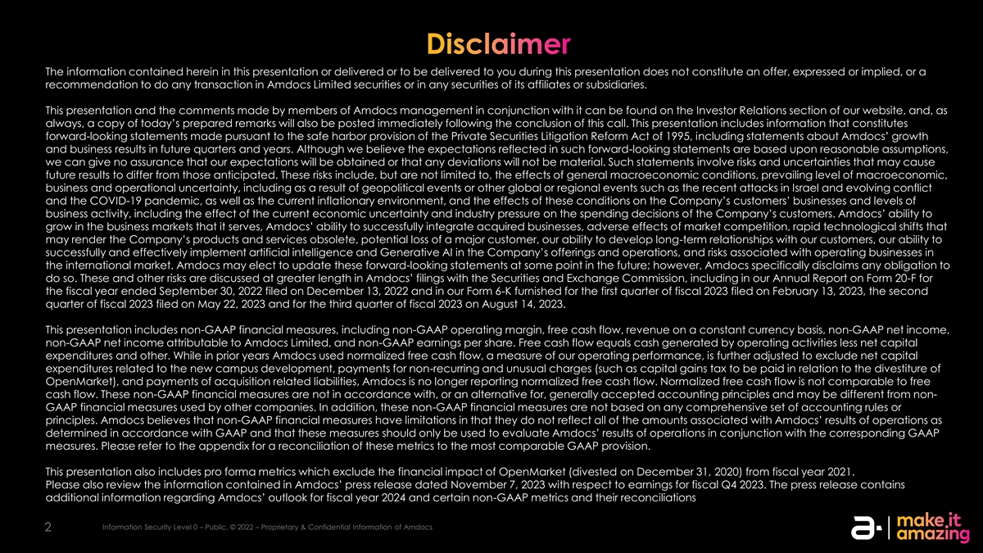
The information contained herein in this presentation or delivered or to be delivered to you during this presentation does not constitute an offer, expressed or implied, or a recommendation to do any transaction in Amdocs Limited securities or in any securities of its affiliates or subsidiaries. This presentation and the comments made by members of Amdocs management in conjunction with it can be found on the Investor Relations section of our website, and, as always, a copy of today’s prepared remarks will also be posted immediately following the conclusion of this call. This presentation includes information that constitutes forward-looking statements made pursuant to the safe harbor provision of the Private Securities Litigation Reform Act of 1995, including statements about Amdocs’ growth and business results in future quarters and years. Although we believe the expectations reflected in such forward-looking statements are based upon reasonable assumptions, we can give no assurance that our expectations will be obtained or that any deviations will not be material. Such statements involve risks and uncertainties that may cause future results to differ from those anticipated. These risks include, but are not limited to, the effects of general macroeconomic conditions, prevailing level of macroeconomic, business and operational uncertainty, including as a result of geopolitical events or other global or regional events such as the recent attacks in Israel and evolving conflict and the COVID-19 pandemic, as well as the current inflationary environment, and the effects of these conditions on the Company’s customers’ businesses and levels of business activity, including the effect of the current economic uncertainty and industry pressure on the spending decisions of the Company’s customers. Amdocs’ ability to grow in the business markets that it serves, Amdocs’ ability to successfully integrate acquired businesses, adverse effects of market competition, rapid technological shifts that may render the Company’s products and services obsolete, potential loss of a major customer, our ability to develop long-term relationships with our customers, our ability to successfully and effectively implement artificial intelligence and Generative AI in the Company’s offerings and operations, and risks associated with operating businesses in the international market. Amdocs may elect to update these forward-looking statements at some point in the future; however, Amdocs specifically disclaims any obligation to do so. These and other risks are discussed at greater length in Amdocs’ filings with the Securities and Exchange Commission, including in our Annual Report on Form 20-F for the fiscal year ended September 30, 2022 filed on December 13, 2022 and in our Form 6-K furnished for the first quarter of fiscal 2023 filed on February 13, 2023, the second quarter of fiscal 2023 filed on May 22, 2023 and for the third quarter of fiscal 2023 on August 14, 2023. This presentation includes non-GAAP financial measures, including non-GAAP operating margin, free cash flow, revenue on a constant currency basis, non-GAAP net income, non-GAAP net income attributable to Amdocs Limited, and non-GAAP earnings per share. Free cash flow equals cash generated by operating activities less net capital expenditures and other. While in prior years Amdocs used normalized free cash flow, a measure of our operating performance, is further adjusted to exclude net capital expenditures related to the new campus development, payments for non-recurring and unusual charges (such as capital gains tax to be paid in relation to the divestiture of OpenMarket), and payments of acquisition related liabilities, Amdocs is no longer reporting normalized free cash flow. Normalized free cash flow is not comparable to free cash flow. These non-GAAP financial measures are not in accordance with, or an alternative for, generally accepted accounting principles and may be different from non- GAAP financial measures used by other companies. In addition, these non-GAAP financial measures are not based on any comprehensive set of accounting rules or principles. Amdocs believes that non-GAAP financial measures have limitations in that they do not reflect all of the amounts associated with Amdocs’ results of operations as determined in accordance with GAAP and that these measures should only be used to evaluate Amdocs’ results of operations in conjunction with the corresponding GAAP measures. Please refer to the appendix for a reconciliation of these metrics to the most comparable GAAP provision. This presentation also includes pro forma metrics which exclude the financial impact of OpenMarket (divested on December 31, 2020) from fiscal year 2021. Please also review the information contained in Amdocs’ press release dated November 7, 2023 with respect to earnings for fiscal Q4 2023. The press release contains additional information regarding Amdocs’ outlook for fiscal year 2024 and certain non-GAAP metrics and their reconciliations Information Security Level 0 – Public. © 2022 – Proprietary & Confidential Information of Amdocs 2


Today’s Speakers Shuky Tamar Sheffer Rapaport-Dagim President & Chief Financial Officer & Chief Executive Officer Chief Operating Officer Information Security Level 0 – Public. © 2022 – Proprietary & Confidential Information of Amdocs 3

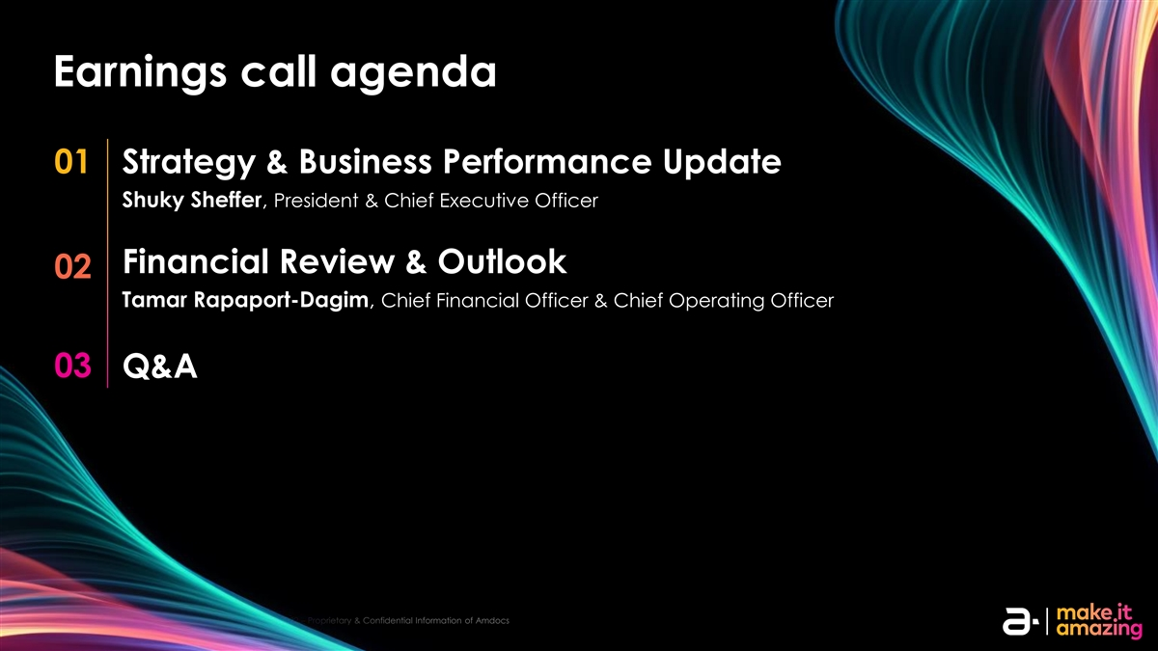
Earnings call agenda 01 Strategy & Business Performance Update Shuky Sheffer, President & Chief Executive Officer Financial Review & Outlook 02 Tamar Rapaport-Dagim, Chief Financial Officer & Chief Operating Officer 03 Q&A Information Security Level 0 – Public. © 2022 – Proprietary & Confidential Information of Amdocs 4


President & Chief Executive Officer Strategy and Business Performance Update Information Security Level 0 – Public. © 2022 – Proprietary & Confidential Information of Amdocs 5

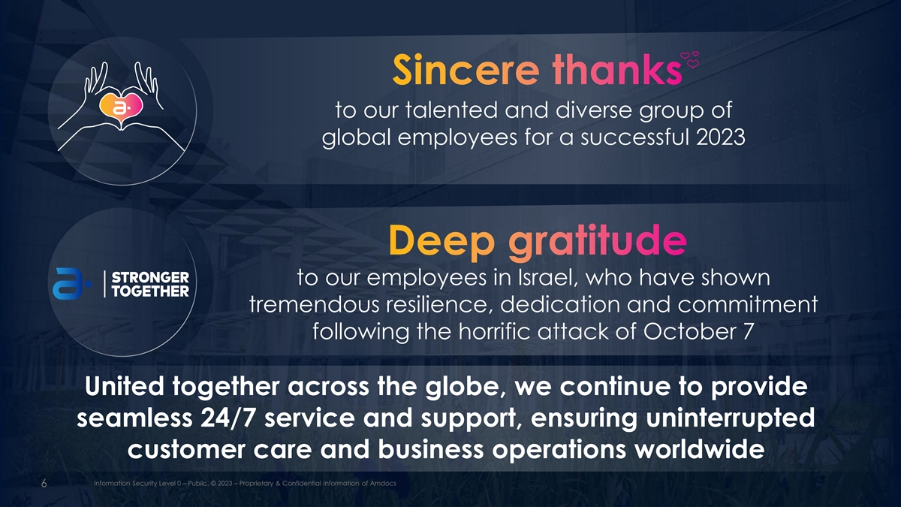
to our talented and diverse group of global employees for a successful 2023 to our employees in Israel, who have shown tremendous resilience, dedication and commitment following the horrific attack of October 7 United together across the globe, we continue to provide seamless 24/7 service and support, ensuring uninterrupted customer care and business operations worldwide IIn nf for orm ma at tiion on Se Sec cu ur riit ty y L Le evel vel 3 0 – – H Pu igh blilc y . Se © n 20 sit23 ive. – P ©r op 2022 rie t– aP ryr op & Con rietafriy d e & Con ntial Ifn id for en m tia atl ion Inf or of m A am tion doc of s Amdocs 6 6

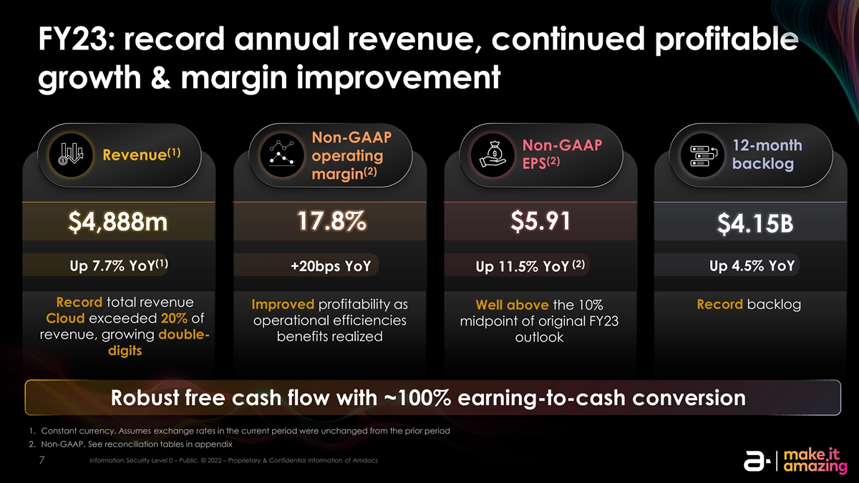
FY23: record annual revenue, continued profitable growth & margin improvement Non-GAAP Non-GAAP 12-month (1) Revenue operating (2) EPS backlog (2) margin 17.8% $5.91 $4,888m $4.15B (1) (2) Up 7.7% YoY +20bps YoY Up 4.5% YoY Up 11.5% YoY Record total revenue Improved profitability as Record backlog Well above the 10% Cloud exceeded 20% of operational efficiencies midpoint of original FY23 revenue, growing double- benefits realized outlook digits Robust free cash flow with ~100% earning-to-cash conversion 1. Constant currency. Assumes exchange rates in the current period were unchanged from the prior period 2. Non-GAAP. See reconciliation tables in appendix IIn nf for orm ma at tiion on Se Sec cu ur riit ty y L Le evel vel 0 0 – – P Pu ub blliic c. . © © 20 2022 22 – – P Pr rop opr riie et ta ar ry y & & Con Conf fiid de en nt tiia all IIn nf for orm ma at tiion on of of A Am md doc ocs s 7 7

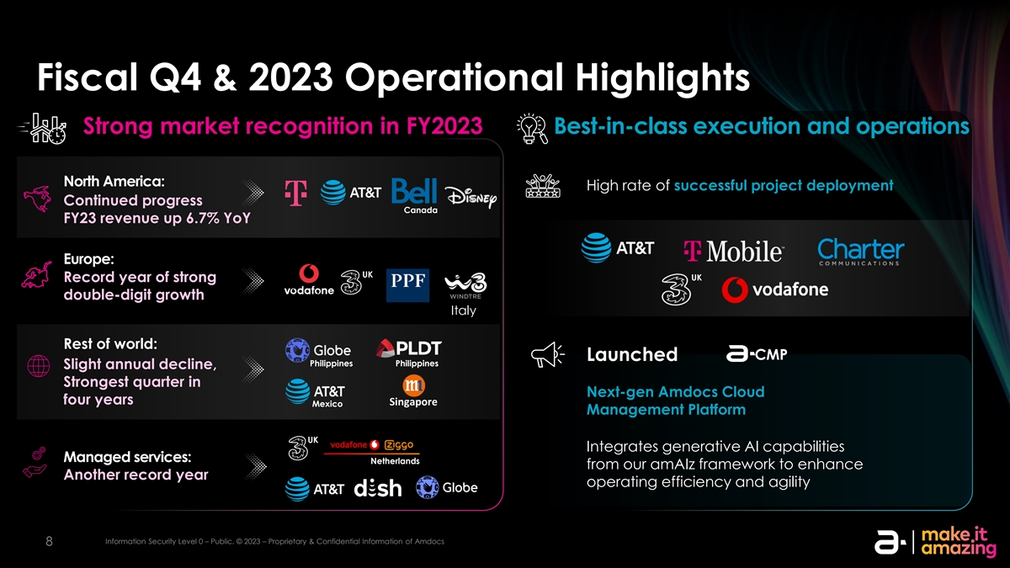
Fiscal Q4 & 2023 Operational Highlights Strong market recognition in FY2023 Best-in-class execution and operations North America: High rate of successful project deployment Continued progress Canada FY23 revenue up 6.7% YoY Europe: UK UK Record year of strong double-digit growth Italy Rest of world: CMP Launched Philippines Philippines Slight annual decline, Strongest quarter in Next-gen Amdocs Cloud four years Singapore Mexico Management Platform UK Integrates generative AI capabilities Managed services: Netherlands from our amAIz framework to enhance Another record year operating efficiency and agility IIn nf for orm ma at tiion on Se Sec cu ur riit ty y L Le evel vel 0 0 – – P Pu ub blliic c. . © © 20 2023 23 – – P Pr rop opr riie et ta ar ry y & & Con Conf fiid de en nt tiia all IIn nf for orm ma at tiion on of of A Am md doc ocs s 8 8

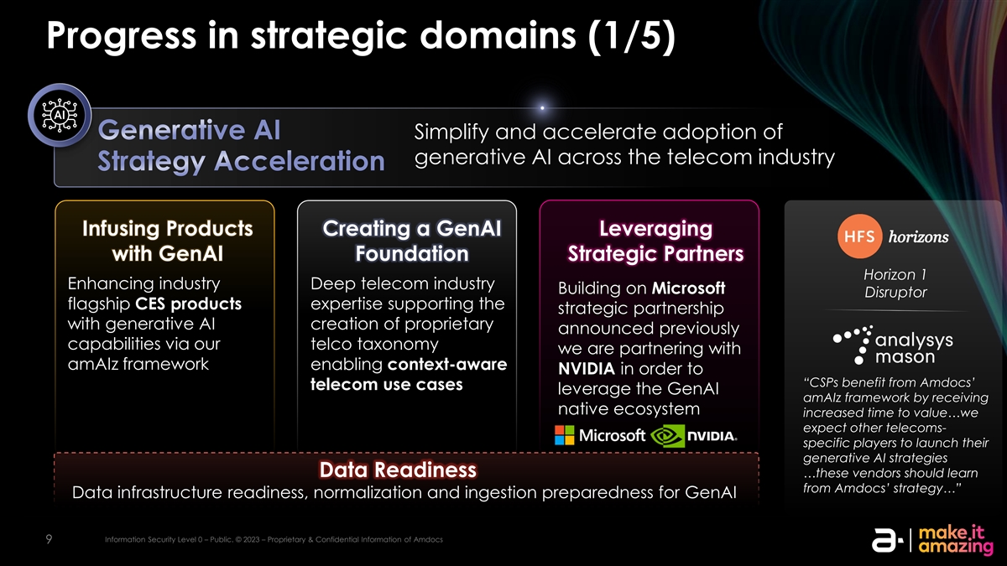
Progress in strategic domains (1/5) Simplify and accelerate adoption of generative AI across the telecom industry Infusing Products Creating a GenAI Leveraging with GenAI Foundation Strategic Partners Horizon 1 Enhancing industry Deep telecom industry Building on Microsoft Disruptor flagship CES products expertise supporting the strategic partnership with generative AI creation of proprietary announced previously capabilities via our telco taxonomy we are partnering with amAIz framework enabling context-aware NVIDIA in order to “CSPs benefit from Amdocs’ telecom use cases leverage the GenAI amAIz framework by receiving native ecosystem increased time to value…we expect other telecoms- specific players to launch their generative AI strategies Data Readiness …these vendors should learn from Amdocs’ strategy…” Data infrastructure readiness, normalization and ingestion preparedness for GenAI Information Security Level 0 – Public. © 2023 – Proprietary & Confidential Information of Amdocs 9

Progress in strategic domains (2/5) Accelerate the multi-year journey to the cloud Selected projects Business value Operation support services for Amdocs Flexible and cost-efficient infrastructure; Mexico applications to the public cloud unlock new business models Real-time rating and metering program expansion Facilitating seamless processes such as CI/CD pipeline, network integration and quality engineering testing Multi-year deal to modernize and consolidate Flexible and cost-efficient infrastructure monetization platforms on AWS Australia Amdocs to leverage the recently announced Microsoft-Oracle partnership, enabling the smooth transition of classic Amdocs applications to Azure Acquired Astadia, which specializes in highly sophisticated, mainframe-to-cloud migration and modernization, end-to-end projects from consulting to managed services Information Security Level 0 – Public. © 2023 – Proprietary & Confidential Information of Amdocs 10

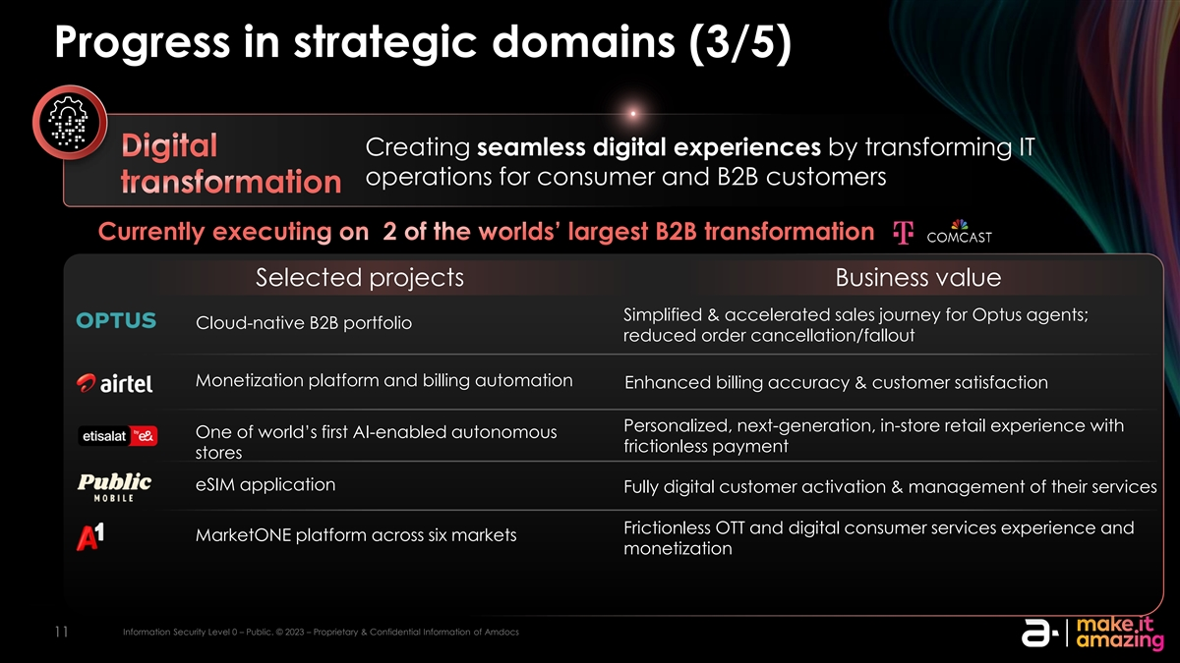
Progress in strategic domains (3/5) Creating seamless digital experiences by transforming IT operations for consumer and B2B customers Selected projects Business value Simplified & accelerated sales journey for Optus agents; Cloud-native B2B portfolio reduced order cancellation/fallout Monetization platform and billing automation Enhanced billing accuracy & customer satisfaction Personalized, next-generation, in-store retail experience with One of world’s first AI-enabled autonomous frictionless payment stores eSIM application Fully digital customer activation & management of their services Frictionless OTT and digital consumer services experience and MarketONE platform across six markets monetization Information Security Level 0 – Public. © 2023 – Proprietary & Confidential Information of Amdocs 11

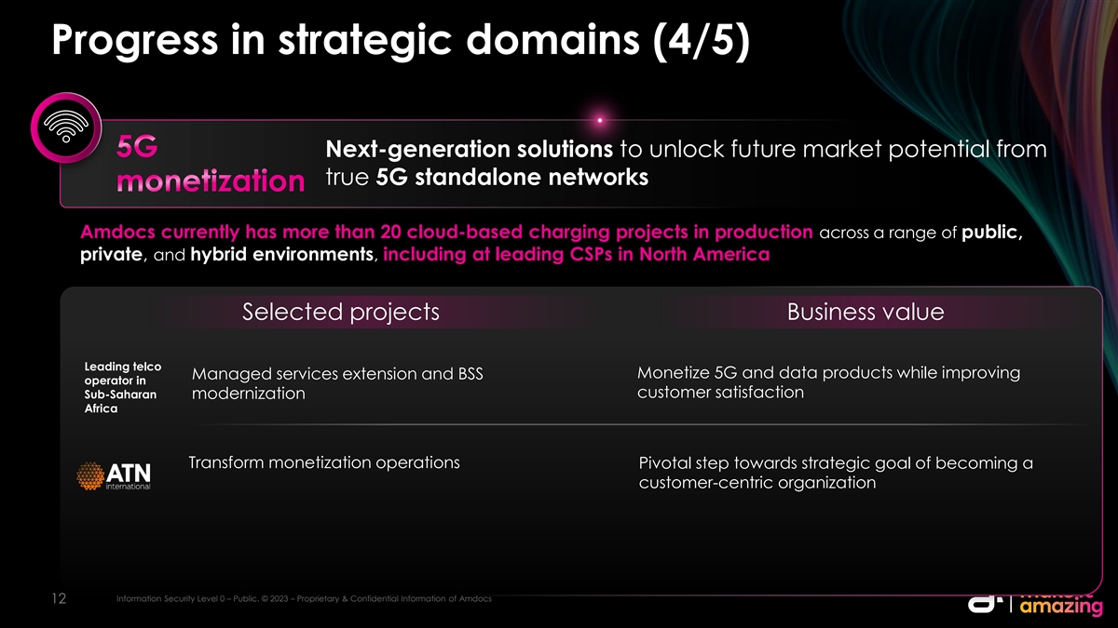
Progress in strategic domains (4/5) Next-generation solutions to unlock future market potential from true 5G standalone networks Amdocs currently has more than 20 cloud-based charging projects in production across a range of public, private, and hybrid environments, including at leading CSPs in North America Selected projects Business value Leading telco Monetize 5G and data products while improving Managed services extension and BSS operator in customer satisfaction Sub-Saharan modernization Africa Transform monetization operations Pivotal step towards strategic goal of becoming a customer-centric organization Information Security Level 0 – Public. © 2023 – Proprietary & Confidential Information of Amdocs 12

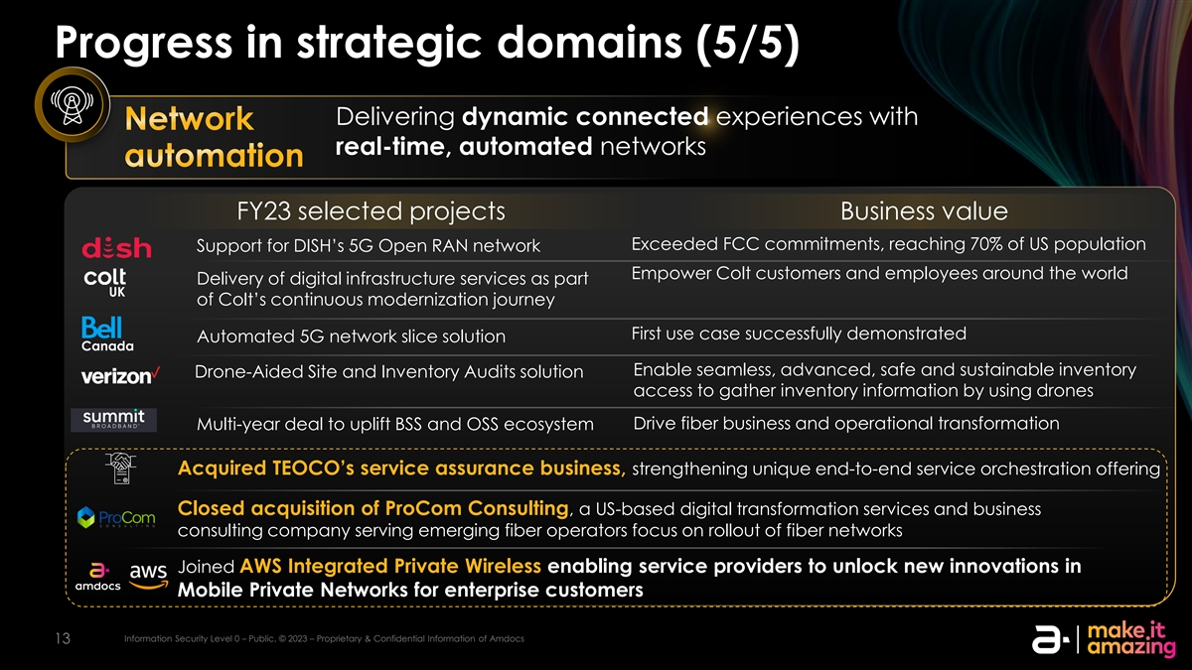
Progress in strategic domains (5/5) Delivering dynamic connected experiences with real-time, automated networks FY23 selected projects Business value Exceeded FCC commitments, reaching 70% of US population Support for DISH’s 5G Open RAN network Empower Colt customers and employees around the world Delivery of digital infrastructure services as part UK of Colt’s continuous modernization journey First use case successfully demonstrated Automated 5G network slice solution Canada Enable seamless, advanced, safe and sustainable inventory Drone-Aided Site and Inventory Audits solution access to gather inventory information by using drones Drive fiber business and operational transformation Multi-year deal to uplift BSS and OSS ecosystem Acquired TEOCO’s service assurance business, strengthening unique end-to-end service orchestration offering Closed acquisition of ProCom Consulting, a US-based digital transformation services and business consulting company serving emerging fiber operators focus on rollout of fiber networks Joined AWS Integrated Private Wireless enabling service providers to unlock new innovations in Mobile Private Networks for enterprise customers Information Security Level 0 – Public. © 2023 – Proprietary & Confidential Information of Amdocs 13

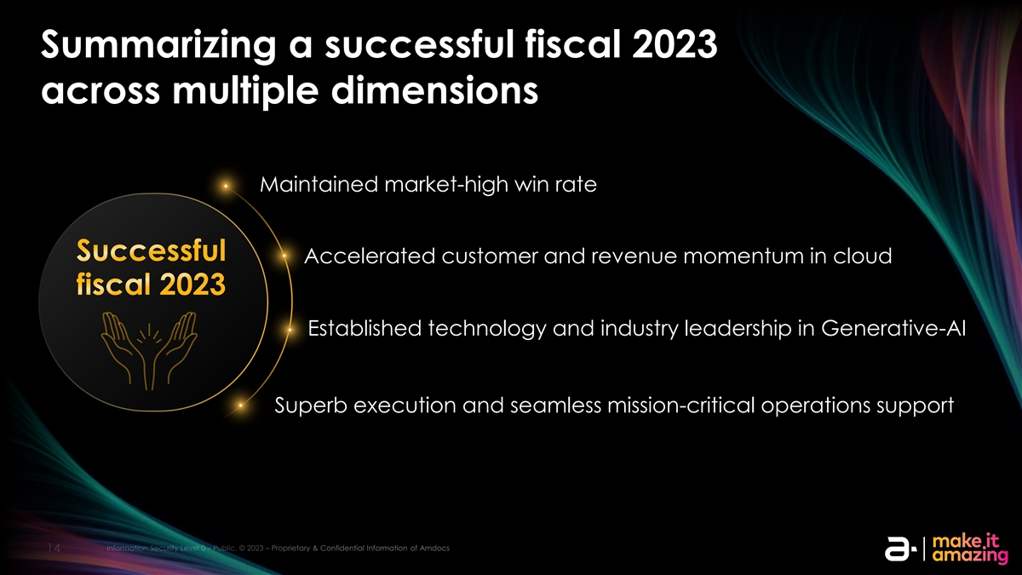
Summarizing a successful fiscal 2023 across multiple dimensions Maintained market-high win rate Accelerated customer and revenue momentum in cloud Established technology and industry leadership in Generative-AI Superb execution and seamless mission-critical operations support Information Security Level 0 – Public. © 2023 – Proprietary & Confidential Information of Amdocs 14

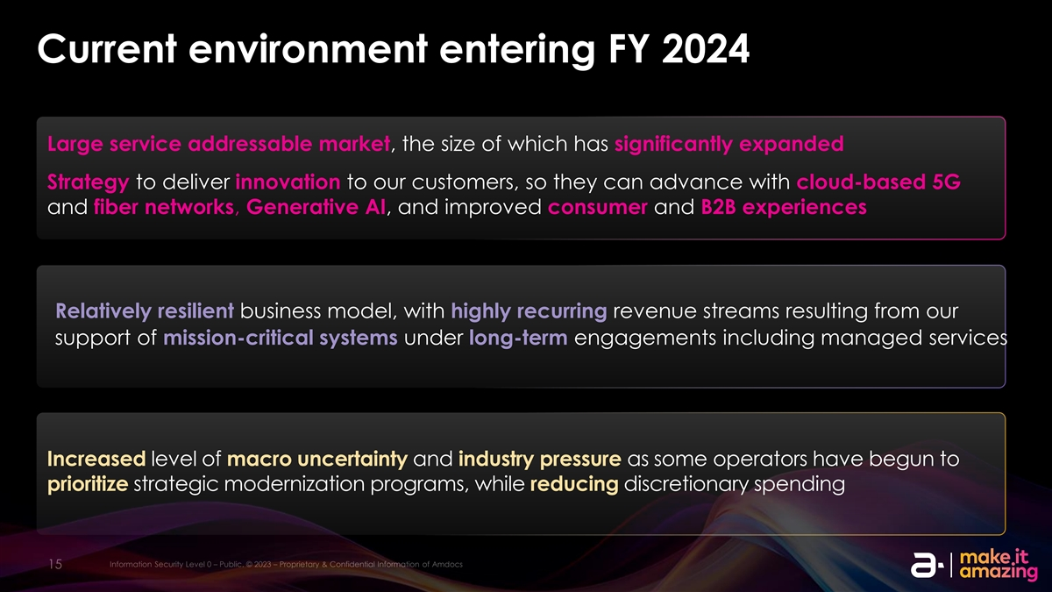
Current environment entering FY 2024 Large service addressable market, the size of which has significantly expanded Strategy to deliver innovation to our customers, so they can advance with cloud-based 5G and fiber networks, Generative AI, and improved consumer and B2B experiences Relatively resilient business model, with highly recurring revenue streams resulting from our support of mission-critical systems under long-term engagements including managed services Increased level of macro uncertainty and industry pressure as some operators have begun to prioritize strategic modernization programs, while reducing discretionary spending Information Security Level 0 – Public. © 2023 – Proprietary & Confidential Information of Amdocs 15

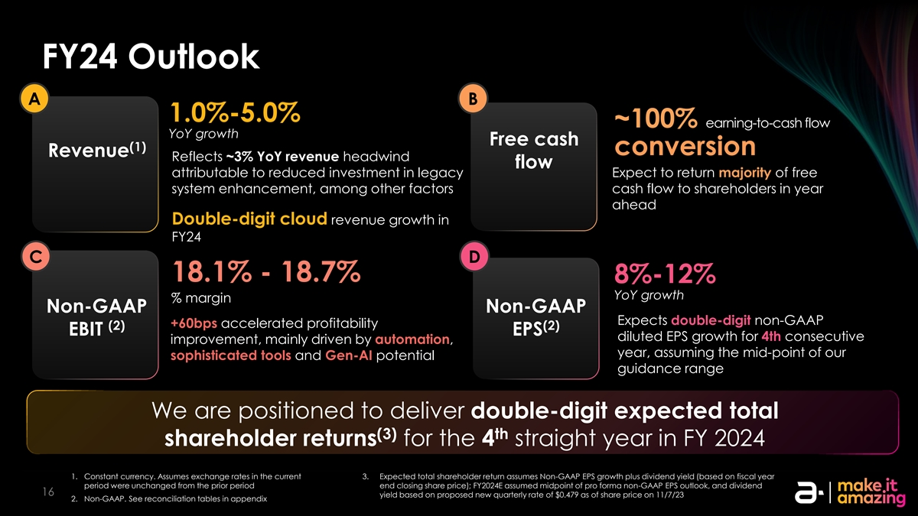
FY24 Outlook A B 1.0%-5.0% earning-to-cash flow YoY growth Free cash (1) conversion Revenue Reflects ~3% YoY revenue headwind flow attributable to reduced investment in legacy Expect to return majority of free system enhancement, among other factors cash flow to shareholders in year ahead Double-digit cloud revenue growth in FY24 C D 18.1% - 18.7% 8%-12% YoY growth % margin Non-GAAP Non-GAAP Expects double-digit non-GAAP +60bps accelerated profitability (2) (2) EBIT EPS diluted EPS growth for 4th consecutive improvement, mainly driven by automation, year, assuming the mid-point of our sophisticated tools and Gen-AI potential guidance range We are positioned to deliver double-digit expected total (3) th shareholder returns for the 4 straight year in FY 2024 1. Constant currency. Assumes exchange rates in the current 3. Expected total shareholder return assumes Non-GAAP EPS growth plus dividend yield (based on fiscal year period were unchanged from the prior period end closing share price); FY2024E assumed midpoint of pro forma non-GAAP EPS outlook, and dividend Information Security Level 0 – Public. © 2023 – Proprietary & Confidential Information of Amdocs 16 yield based on proposed new quarterly rate of $0.479 as of share price on 11/7/23 2. Non-GAAP. See reconciliation tables in appendix


Chief Financial Officer & Chief Operating Officer Financial Review & Outlook Information Security Level 0 – Public. © 2022 – Proprietary & Confidential Information of Amdocs 17

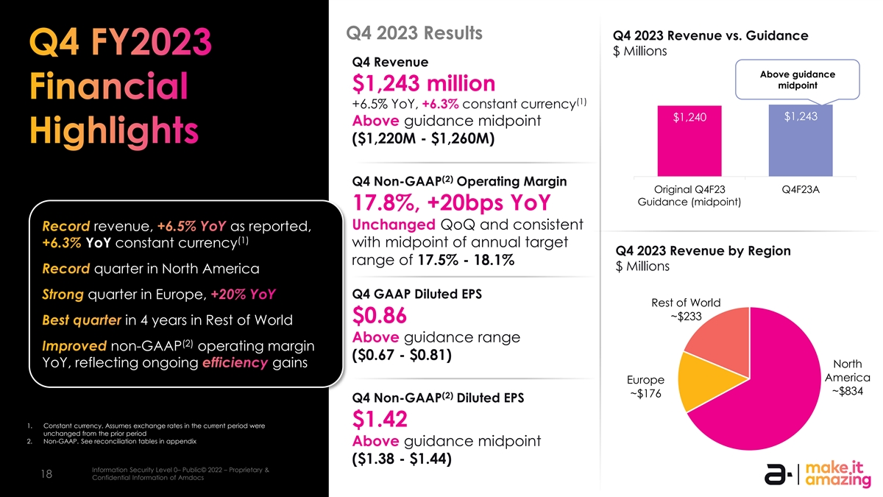
Q4 2023 Results Q4 2023 Revenue vs. Guidance $ Millions Q4 Revenue Above guidance midpoint $1,243 million (1) +6.5% YoY, +6.3% constant currency $1,243 $1,240 Above guidance midpoint ($1,220M - $1,260M) (2) Q4 Non-GAAP Operating Margin Original Q4F23 Q4F23A Guidance (midpoint) 17.8%, +20bps YoY Unchanged QoQ and consistent revenue, as reported, (1) YoY constant currency with midpoint of annual target Q4 2023 Revenue by Region range of 17.5% - 18.1% $ Millions quarter in North America Q4 GAAP Diluted EPS quarter in Europe, Rest of World ~$233 $0.86 in 4 years in Rest of World Above guidance range (2) non-GAAP operating margin ($0.67 - $0.81) YoY, reflecting ongoing gains North America Europe ~$834 ~$176 (2) Q4 Non-GAAP Diluted EPS $1.42 1. Constant currency. Assumes exchange rates in the current period were unchanged from the prior period 2. Non-GAAP. See reconciliation tables in appendix Above guidance midpoint ($1.38 - $1.44) Information Security Level 0– Public© 2022 – Proprietary & Information Security Level 0 – Public. © 2023 – Proprietary & Confidential Information of Amdocs 18 18 Confidential Information of Amdocs

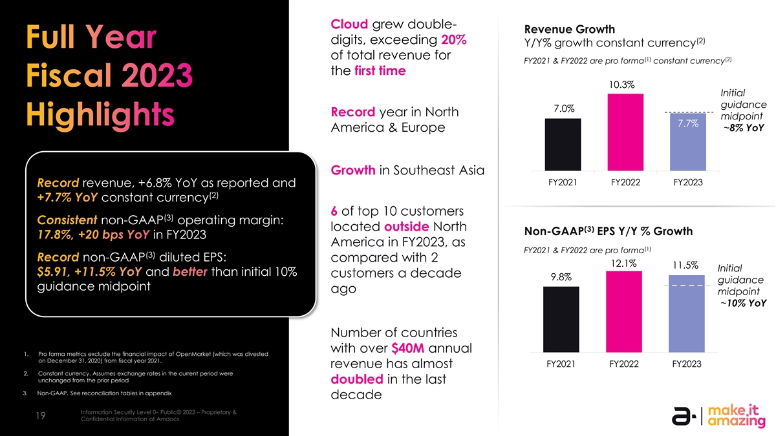
Cloud grew double- Revenue Growth (2) digits, exceeding 20% Y/Y% growth constant currency of total revenue for (1) (2) FY2021 & FY2022 are pro forma constant currency the first time 10.3% Initial guidance 7.0% Record year in North midpoint 7.7% America & Europe ~8% YoY Growth in Southeast Asia FY2021 FY2022 FY2023 revenue, +6.8% YoY as reported and (2) constant currency 6 of top 10 customers (3) non-GAAP operating margin: located outside North (3) Non-GAAP EPS Y/Y % Growth in FY2023 America in FY2023, as (1) FY2021 & FY2022 are pro forma (3) non-GAAP diluted EPS: compared with 2 12.1% 11.5% Initial and than initial 10% customers a decade 9.8% guidance guidance midpoint ago midpoint ~10% YoY Number of countries with over $40M annual 1. Pro forma metrics exclude the financial impact of OpenMarket (which was divested on December 31, 2020) from fiscal year 2021. FY2021 FY2022 FY2023 revenue has almost 2. Constant currency. Assumes exchange rates in the current period were unchanged from the prior period doubled in the last 3. Non-GAAP. See reconciliation tables in appendix decade Information Security Level 0– Public© 2022 – Proprietary & Information Security Level 0 – Public. © 2022 – Proprietary & Confidential Information of Amdocs 19 19 Confidential Information of Amdocs

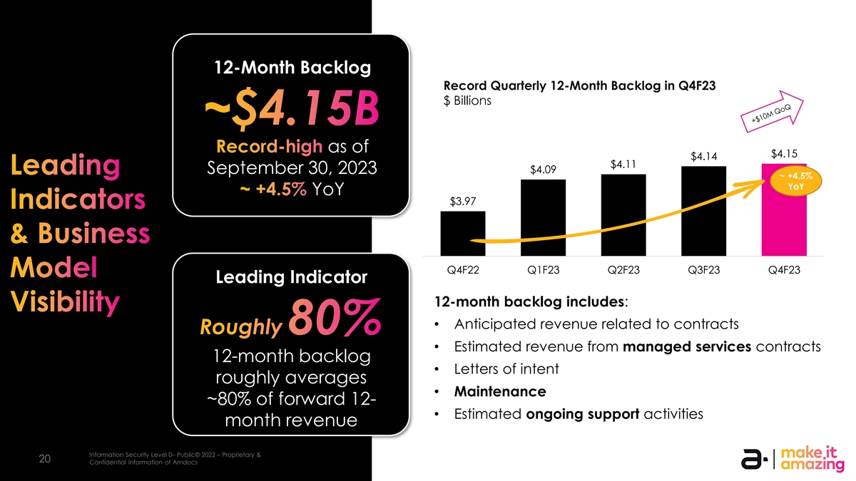
12-Month Backlog Record Quarterly 12-Month Backlog in Q4F23 12-month backlog growth has accelerated $ Billions year-over-year over the past several quarters as of $4.15 $4.14 $4.11 (1) (1) September 30, 2023 $4.09 ~ +4.5% YoY (1) YoY $3.97 (1) Q4F22 Q1F23 Q2F23 Q3F23 Q4F23 Leading Indicator 12-month backlog includes: • Anticipated revenue related to contracts • Estimated revenue from managed services contracts 12-month backlog • Letters of intent roughly averages • Maintenance ~80% of forward 12- • Estimated ongoing support activities month revenue Information Security Level 0– Public© 2022 – Proprietary & Information Security Level 0 – Public. © 2023 – Proprietary & Confidential Information of Amdocs 20 20 Confidential Information of Amdocs

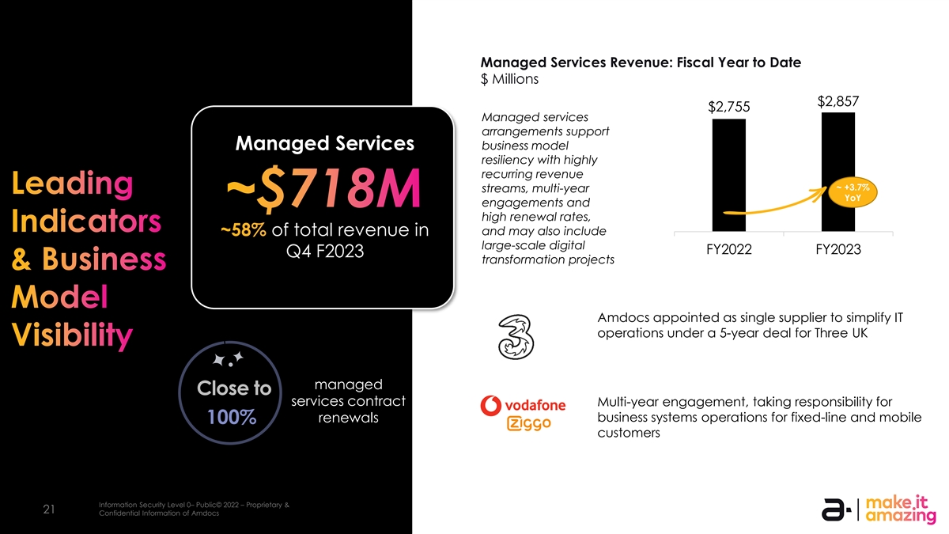
Managed Services Revenue: Fiscal Year to Date $ Millions $2,857 $2,755 Managed services arrangements support Managed Services business model resiliency with highly recurring revenue ~ +3.7% streams, multi-year YoY engagements and high renewal rates, and may also include of total revenue in large-scale digital FY2022 FY2023 Q4 F2023 transformation projects Amdocs appointed as single supplier to simplify IT operations under a 5-year deal for Three UK managed Close to services contract Multi-year engagement, taking responsibility for renewals business systems operations for fixed-line and mobile 100% customers Information Security Level 0– Public© 2022 – Proprietary & Information Security Level 0 – Public. © 2023 – Proprietary & Confidential Information of Amdocs 21 21 Confidential Information of Amdocs

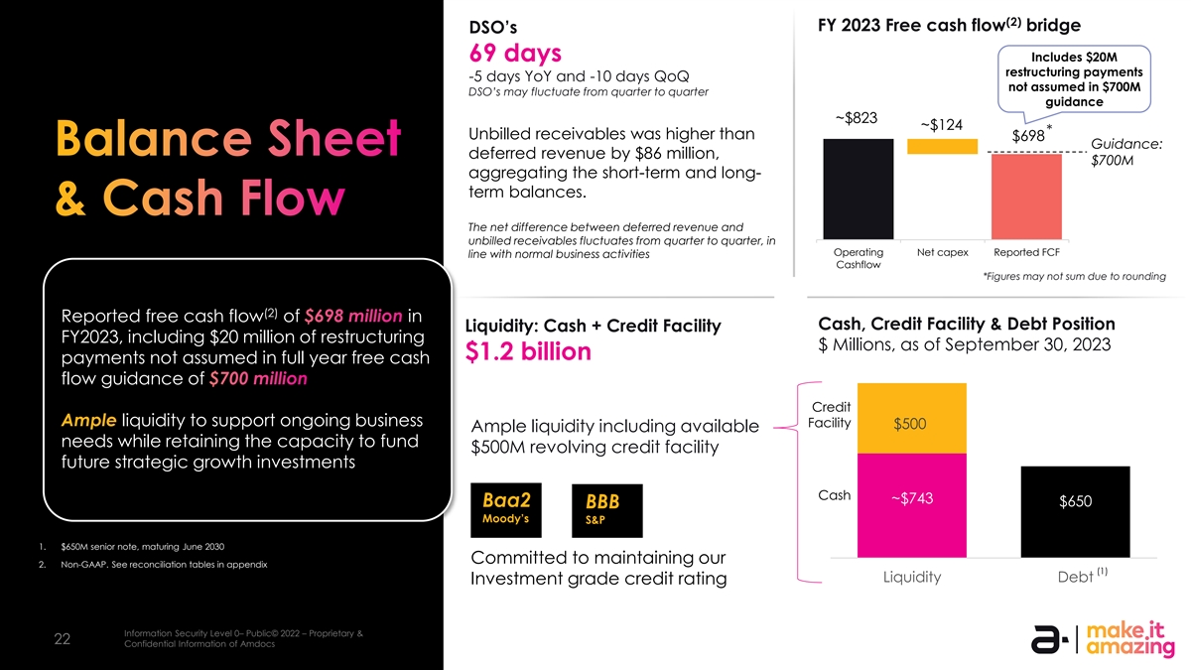
(2) FY 2023 Free cash flow bridge DSO’s 69 days Includes $20M restructuring payments -5 days YoY and -10 days QoQ not assumed in $700M DSO’s may fluctuate from quarter to quarter guidance ~$823 ~$124 * Unbilled receivables was higher than $698 Guidance: deferred revenue by $86 million, $700M aggregating the short-term and long- term balances. The net difference between deferred revenue and unbilled receivables fluctuates from quarter to quarter, in Operating Net capex Reported FCF line with normal business activities Cashflow *Figures may not sum due to rounding (2) Reported free cash flow of in Cash, Credit Facility & Debt Position Liquidity: Cash + Credit Facility FY2023, including $20 million of restructuring $ Millions, as of September 30, 2023 $1.2 billion payments not assumed in full year free cash flow guidance of Credit liquidity to support ongoing business Facility $500 Ample liquidity including available needs while retaining the capacity to fund $500M revolving credit facility future strategic growth investments Cash ~$743 $650 Baa2 BBB Moody’s S&P 1. $650M senior note, maturing June 2030 Committed to maintaining our 2. Non-GAAP. See reconciliation tables in appendix (1) $0 Liquidity Debt Investment grade credit rating Information Security Level 0– Public© 2022 – Proprietary & Information Security Level 0 – Public. © 2023 – Proprietary & Confidential Information of Amdocs 22 22 Confidential Information of Amdocs

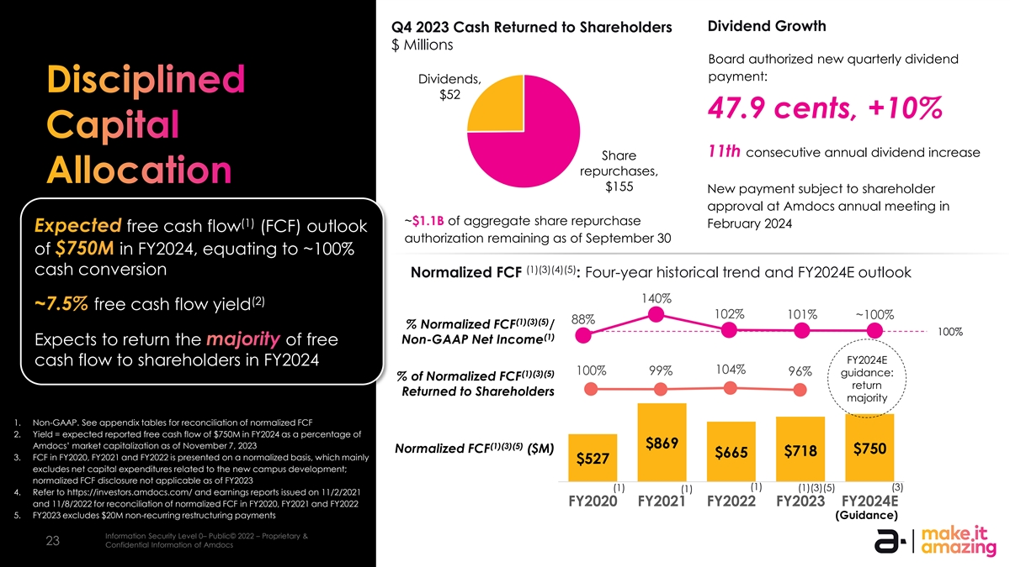
Dividend Growth Q4 2023 Cash Returned to Shareholders $ Millions Board authorized new quarterly dividend payment: Dividends, $52 47.9 cents, +10% 11th consecutive annual dividend increase Share repurchases, $155 New payment subject to shareholder approval at Amdocs annual meeting in ~$1.1B of aggregate share repurchase (1) February 2024 free cash flow (FCF) outlook authorization remaining as of September 30 of in FY2024, equating to ~100% (1)(3)(4)(5) cash conversion Normalized FCF : Four-year historical trend and FY2024E outlook 140% (2) free cash flow yield 102% 101% ~100% 88% (1)(3)(5) % Normalized FCF / 100% (1) Non-GAAP Net Income Expects to return the of free FY2024E cash flow to shareholders in FY2024 104% 100% 99% 96% (1)(3)(5) guidance: % of Normalized FCF return Returned to Shareholders majority 1. Non-GAAP. See appendix tables for reconciliation of normalized FCF 2. Yield = expected reported free cash flow of $750M in FY2024 as a percentage of $869 Amdocs’ market capitalization as of November 7, 2023 (1)(3)(5) Normalized FCF ($M) $750 $718 $665 3. FCF in FY2020, FY2021 and FY2022 is presented on a normalized basis, which mainly $527 excludes net capital expenditures related to the new campus development; normalized FCF disclosure not applicable as of FY2023 (1) (3) (1) (1)(3)(5) (1) 4. Refer to https://investors.amdocs.com/ and earnings reports issued on 11/2/2021 FY2020 FY2021 FY2022 FY2023 FY2024E and 11/8/2022 for reconciliation of normalized FCF in FY2020, FY2021 and FY2022 5. FY2023 excludes $20M non-recurring restructuring payments (Guidance) Information Security Level 0– Public© 2022 – Proprietary & Information Security Level 0 – Public. © 2023 – Proprietary & Confidential Information of Amdocs 23 23 Confidential Information of Amdocs

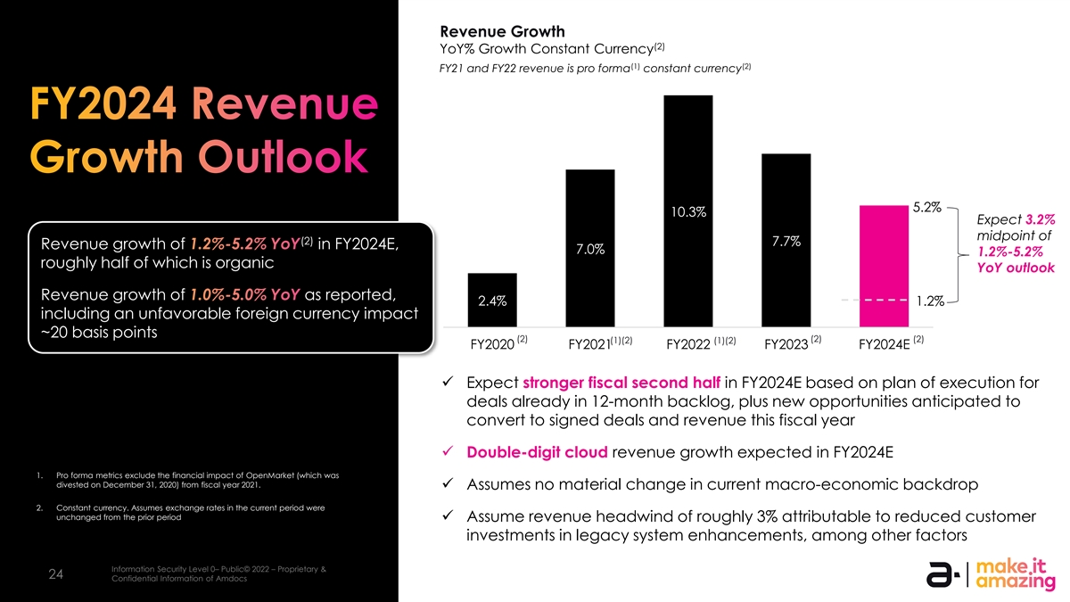
Revenue Growth (2) YoY% Growth Constant Currency (1) (2) FY21 and FY22 revenue is pro forma constant currency 5.2% 10.3% Expect 3.2% midpoint of (2) 7.7% Revenue growth of in FY2024E, 7.0% 1.2%-5.2% roughly half of which is organic YoY outlook Revenue growth of as reported, 2.4% 1.2% including an unfavorable foreign currency impact ~20 basis points (2) (2) (2) (1)(2) (1)(2) FY2020 FY2021 FY2022 FY2023 FY2024E ✓ Expect stronger fiscal second half in FY2024E based on plan of execution for deals already in 12-month backlog, plus new opportunities anticipated to convert to signed deals and revenue this fiscal year ✓ Double-digit cloud revenue growth expected in FY2024E 1. Pro forma metrics exclude the financial impact of OpenMarket (which was divested on December 31, 2020) from fiscal year 2021. ✓ Assumes no material change in current macro-economic backdrop 2. Constant currency. Assumes exchange rates in the current period were unchanged from the prior period ✓ Assume revenue headwind of roughly 3% attributable to reduced customer investments in legacy system enhancements, among other factors Information Security Level 0– Public© 2022 – Proprietary & Information Security Level 0 – Public. © 2023 – Proprietary & Confidential Information of Amdocs 24 24 Confidential Information of Amdocs

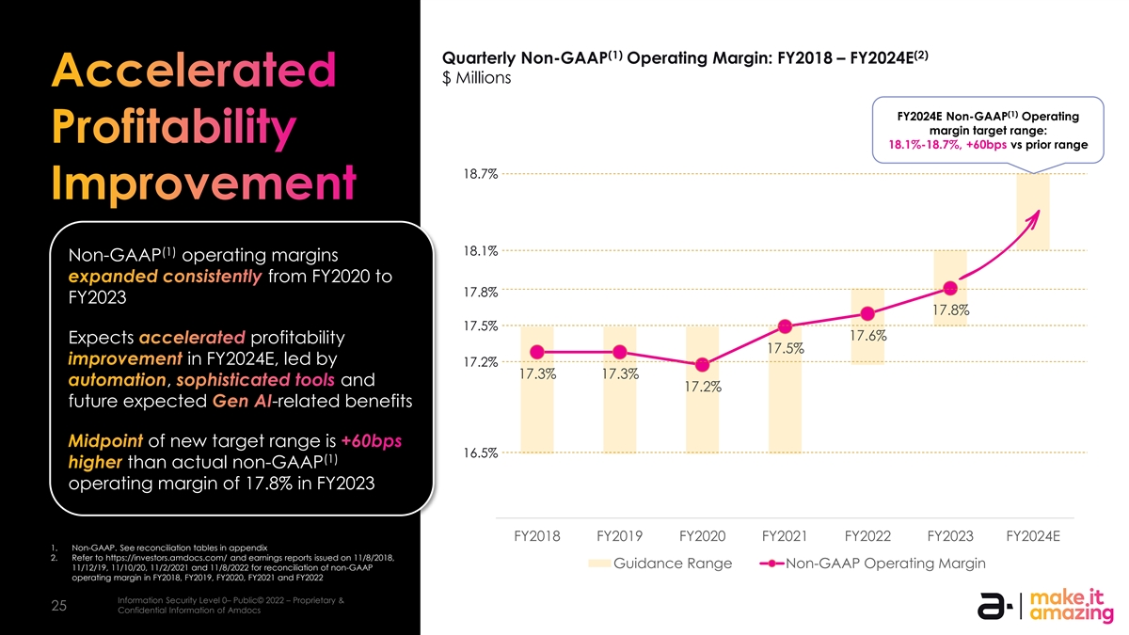
(1) (2) Quarterly Non-GAAP Operating Margin: FY2018 – FY2024E $ Millions (1) FY2024E Non-GAAP Operating margin target range: 18.1%-18.7%, +60bps vs prior range 18.7% 18.1% (1) Non-GAAP operating margins from FY2020 to 17.8% FY2023 17.8% 17.5% 17.6% Expects profitability 17.5% in FY2024E, led by 17.2% 17.3% 17.3% , and 17.2% future expected -related benefits of new target range is 16.5% (1) than actual non-GAAP operating margin of 17.8% in FY2023 FY2018 FY2019 FY2020 FY2021 FY2022 FY2023 FY2024E 1. Non-GAAP. See reconciliation tables in appendix 2. Refer to https://investors.amdocs.com/ and earnings reports issued on 11/8/2018, Guidance Range Non-GAAP Operating Margin 11/12/19, 11/10/20, 11/2/2021 and 11/8/2022 for reconciliation of non-GAAP operating margin in FY2018, FY2019, FY2020, FY2021 and FY2022 Information Security Level 0– Public© 2022 – Proprietary & Information Security Level 0 – Public. © 2023 – Proprietary & Confidential Information of Amdocs 25 25 Confidential Information of Amdocs

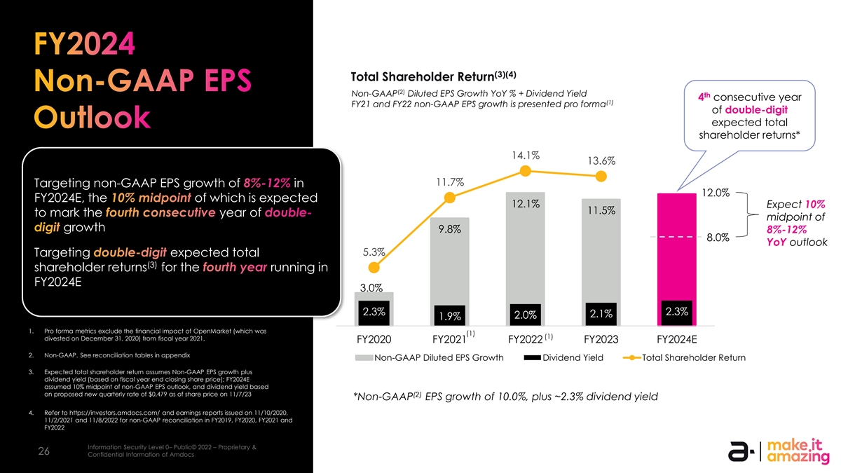
(3)(4) Total Shareholder Return (2) Non-GAAP Diluted EPS Growth YoY % + Dividend Yield th 4 consecutive year (1) FY21 and FY22 non-GAAP EPS growth is presented pro forma of double-digit expected total shareholder returns* 14.1% 13.6% 11.7% Targeting non-GAAP EPS growth of in 12.0% FY2024E, the of which is expected 12.1% Expect 10% 11.5% to mark the year of midpoint of growth 9.8% 8%-12% 8.0% YoY outlook 5.3% Targeting expected total (3) shareholder returns for the running in FY2024E 3.0% 2.3% 2.3% 2.1% 2.0% 1.9% 1. Pro forma metrics exclude the financial impact of OpenMarket (which was (1) (1) divested on December 31, 2020) from fiscal year 2021. FY2020 FY2021 FY2022 FY2023 FY2024E 2. Non-GAAP. See reconciliation tables in appendix Non-GAAP Diluted EPS Growth Dividend Yield Total Shareholder Return 3. Expected total shareholder return assumes Non-GAAP EPS growth plus dividend yield (based on fiscal year end closing share price); FY2024E assumed 10% midpoint of non-GAAP EPS outlook, and dividend yield based on proposed new quarterly rate of $0.479 as of share price on 11/7/23 (2) *Non-GAAP EPS growth of 10.0%, plus ~2.3% dividend yield 4. Refer to https://investors.amdocs.com/ and earnings reports issued on 11/10/2020, 11/2/2021 and 11/8/2022 for non-GAAP reconciliation in FY2019, FY2020, FY2021 and FY2022 Information Security Level 0– Public© 2022 – Proprietary & Information Security Level 0 – Public. © 2023 – Proprietary & Confidential Information of Amdocs 26 26 Confidential Information of Amdocs

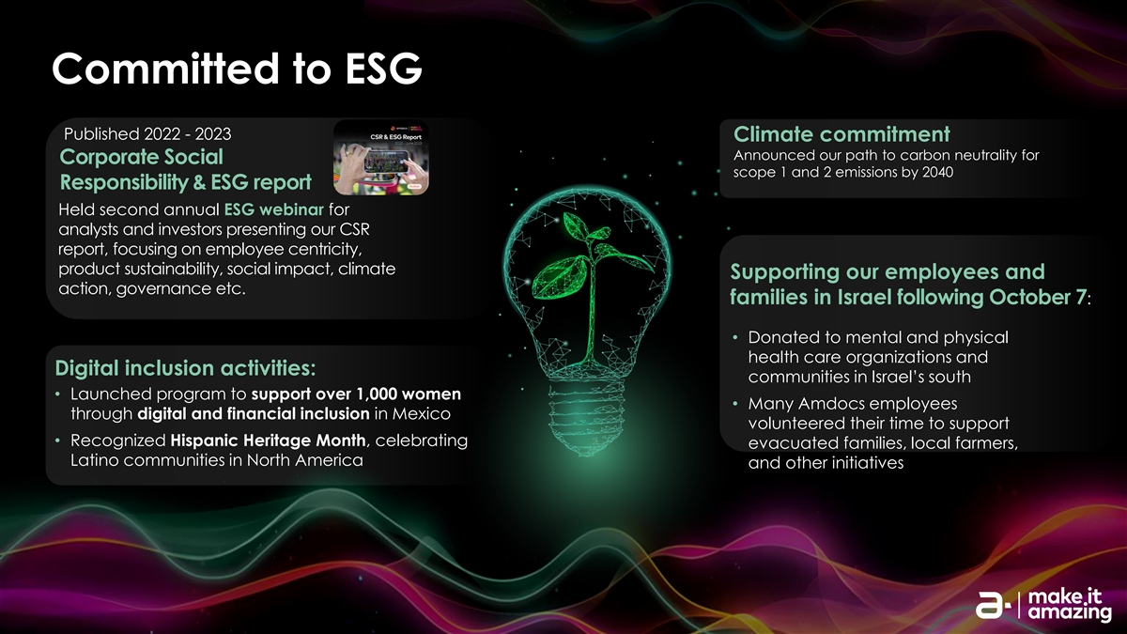
Committed to ESG Published 2022 - 2023 Climate commitment Announced our path to carbon neutrality for Corporate Social scope 1 and 2 emissions by 2040 Responsibility & ESG report Held second annual ESG webinar for analysts and investors presenting our CSR report, focusing on employee centricity, product sustainability, social impact, climate Supporting our employees and action, governance etc. families in Israel following October 7: • Donated to mental and physical health care organizations and Digital inclusion activities: communities in Israel’s south • Launched program to support over 1,000 women • Many Amdocs employees through digital and financial inclusion in Mexico volunteered their time to support • Recognized Hispanic Heritage Month, celebrating evacuated families, local farmers, Latino communities in North America and other initiatives


Q&A

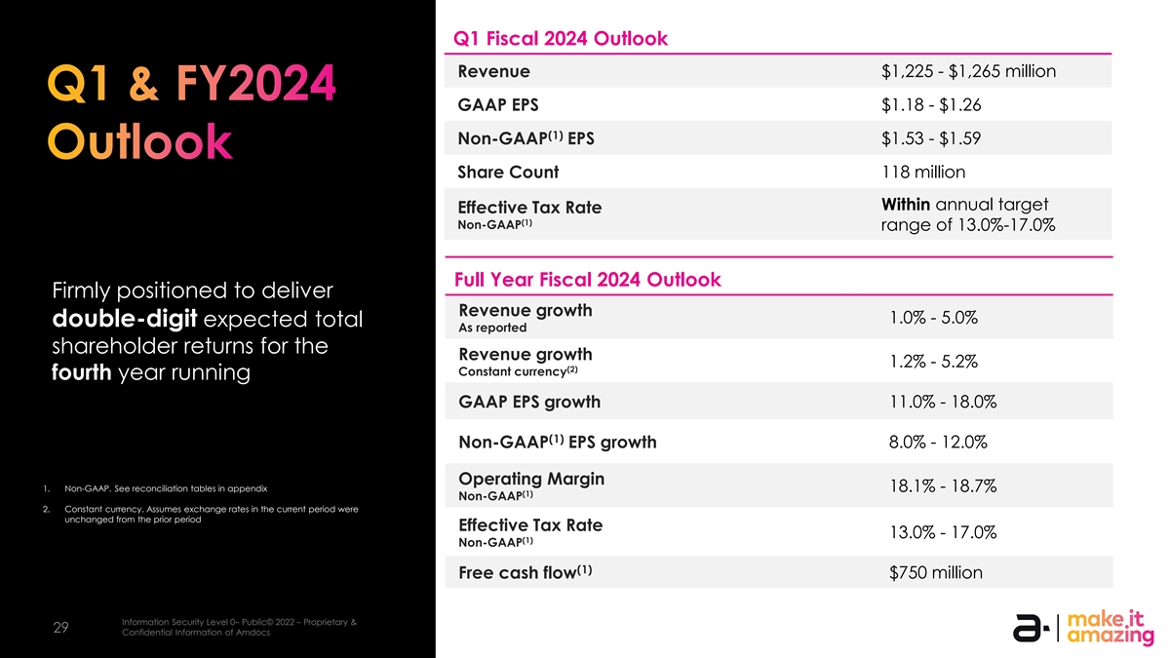
Q1 Fiscal 2024 Outlook $1,225 - $1,265 million Revenue GAAP EPS $1.18 - $1.26 (1) Non-GAAP EPS $1.53 - $1.59 Share Count 118 million Within annual target Effective Tax Rate (1) Non-GAAP range of 13.0%-17.0% Full Year Fiscal 2024 Outlook Firmly positioned to deliver Revenue growth 1.0% - 5.0% double-digit expected total As reported shareholder returns for the Revenue growth 1.2% - 5.2% (2) Constant currency fourth year running GAAP EPS growth 11.0% - 18.0% (1) Non-GAAP EPS growth 8.0% - 12.0% Operating Margin 1. Non-GAAP. See reconciliation tables in appendix 18.1% - 18.7% (1) Non-GAAP 2. Constant currency. Assumes exchange rates in the current period were unchanged from the prior period Effective Tax Rate 13.0% - 17.0% (1) Non-GAAP (1) Free cash flow $750 million Information Security Level 0– Public© 2022 – Proprietary & Information Security Level 0 – Public. © 2022 – Proprietary & Confidential Information of Amdocs 29 29 Confidential Information of Amdocs


Appendix Reconciliation Tables

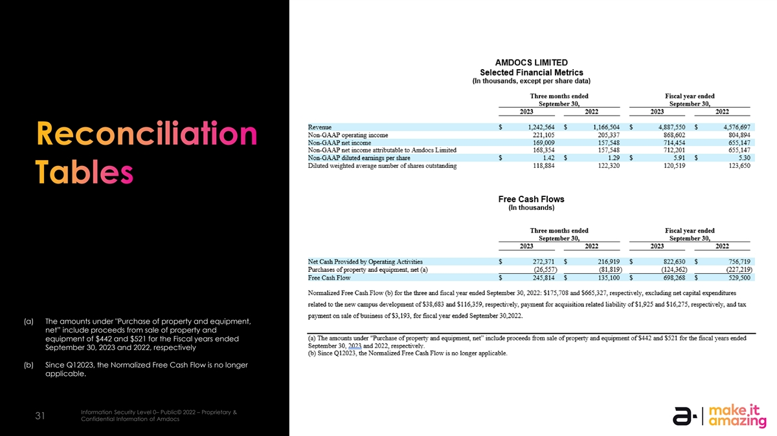
(a) The amounts under Purchase of property and equipment, net” include proceeds from sale of property and equipment of $442 and $521 for the Fiscal years ended September 30, 2023 and 2022, respectively (b) Since Q12023, the Normalized Free Cash Flow is no longer applicable. Information Security Level 0– Public© 2022 – Proprietary & Information Security Level 0 – Public. © 2023 – Proprietary & Confidential Information of Amdocs 31 31 Confidential Information of Amdocs

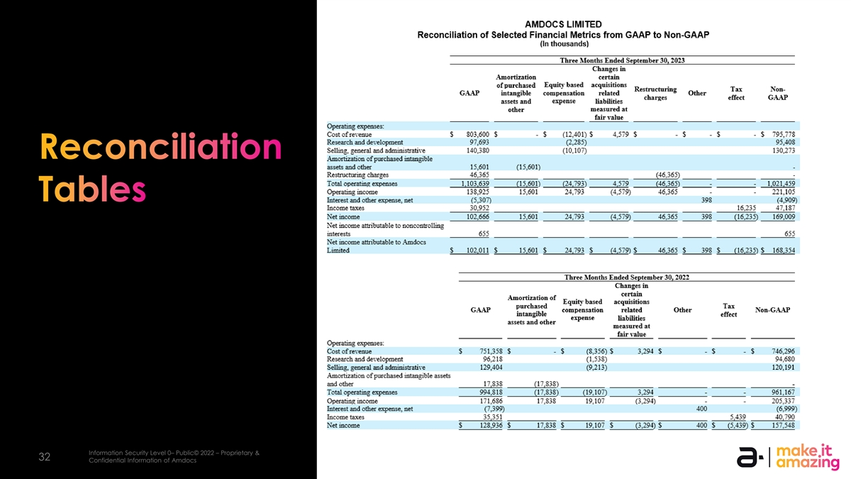
Information Security Level 0– Public© 2022 – Proprietary & Information Security Level 0 – Public. © 2023 – Proprietary & Confidential Information of Amdocs 32 32 Confidential Information of Amdocs

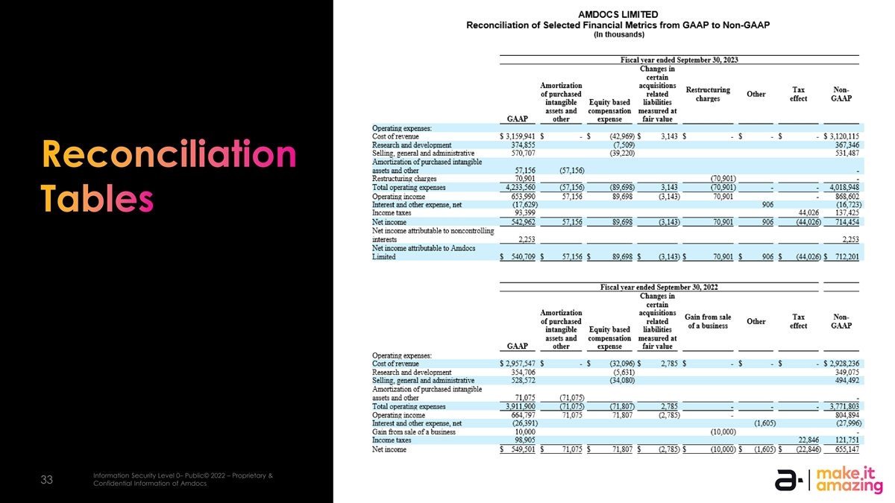
Information Security Level 0– Public© 2022 – Proprietary & Information Security Level 0 – Public. © 2023 – Proprietary & Confidential Information of Amdocs 33 33 Confidential Information of Amdocs


Thank you!

