UNITED STATES
SECURITIES AND EXCHANGE COMMISSION
WASHINGTON, D.C. 20549

Form 6-K

REPORT OF FOREIGN PRIVATE ISSUER
PURSUANT TO RULE 13a-16 OR 15d-16
OF THE SECURITIES EXCHANGE ACT OF 1934
For the month of August 2024
Commission File Number 1-14840

AMDOCS LIMITED

Hirzel House, Smith Street,
St. Peter Port, Island of Guernsey, GY1 2NG
Amdocs, Inc.
625 Maryville Centre Drive, Suite 200, Saint Louis, Missouri 63141
(Address of principal executive offices)

Indicate by check mark whether the registrant files or will file annual reports under cover of Form 20-F or Form 40-F:
FORM 20-F ☒ FORM 40-F ☐
On August 7, 2024 Amdocs Limited (Amdocs) issued a press release announcing financial results for the quarter ended June 30, 2024. A copy of the press release and the accompanying presentation are furnished as Exhibits 99.1 and 99.2 to this Report of Foreign Private Issuer on Form 6-K.
The information in this Form 6-K (including Exhibits 99.1 and 99.2) shall not be deemed filed for purposes of Section 18 of the Securities Exchange Act of 1934 (the Exchange Act) or otherwise subject to the liabilities of that section, nor shall it be deemed incorporated by reference in any filing under the Securities Act of 1933 or the Exchange Act.

EXHIBIT INDEX

EXHIBIT  NO. |  | DESCRIPTION
99.1 |  | Amdocs Limited Press Release Announcing Q3 Earnings, dated August 7, 2024
99.2 |  | Fiscal Q3 2024 Earnings Presentation

SIGNATURES
Pursuant to the requirements of the Securities Exchange Act of 1934, the registrant has duly caused this report to be signed on its behalf by the undersigned, thereunto duly authorized.

AMDOCS LIMITED
By: |  | /s/ Matthew E. Smith
 |  | Matthew E. Smith
 |  | Secretary and Authorized Signatory
Date: August 7, 2024
Exhibit 99.1



Amdocs Limited Reports Third Quarter Fiscal 2024 Results
Record Quarterly Revenue of $1.25 Billion, up 1.1% YoY as Reported and 1.8% YoY in
Constant Currency(1)
Record 12-Month Backlog of $4.25 Billion, up 2.7% YoY
Updates Fiscal 2024 Outlook:
Expects Revenue Growth of 1.9%-2.7% YoY as Reported
Reiterates Midpoint of Revenue Growth Outlook in Constant Currency(1) while Tightening
Expected Range to 2.3%-3.1% YoY
On-track to Achieve Accelerated Profitability Targets in Fiscal 2024
Expects GAAP Diluted EPS Growth of 7.4%9.2% YoY
Reiterates Midpoint of Non-GAAP Diluted EPS Growth Outlook while Tightening Expected
Range to 8.5%-9.5% YoY
Third Quarter Fiscal 2024 Highlights
(All comparisons are against the prior year)

 |  |  | Record revenue of $1,250 million, up 1.1% as reported and up 1.8% in constant currency(1); revenue was at the midpoint of the $1,235-$1,275 million guidance range, adjusting for a negative impact from foreign currency movements of approximately $5 million compared to our guidance assumptions

 |  |  | Record managed services revenue of $741 million, equivalent to approximately 59% of total revenue

 |  |  | GAAP diluted EPS of $1.21, including a restructuring charge of 11 cents per share, without which GAAP diluted EPS would have been at the high end of the guidance range of $1.24-$1.32

 |  |  | Non-GAAP diluted EPS of $1.62, at the higher end of the guidance range of $1.57-$1.63

(1) | Revenue on a constant currency basis assumes exchange rates in the current period were unchanged from the prior period
(2) | Please refer to the Selected Financial Metrics tables below (figures may not sum because of rounding)
(3) | Expected total shareholder return assumes Non-GAAP EPS growth plus dividend yield

 |  |  | GAAP operating income of $176 million; GAAP operating margin of 14.1%, up 160 basis points sequentially and down 70 basis points as compared to last years third fiscal quarter

 |  |  | Non-GAAP operating income of $232 million; non-GAAP operating margin of 18.6%, up 80 basis points as compared to last years third fiscal quarter and up 20 basis points sequentially, reflecting a continued focus on operational excellence

 |  |  | Free cash flow of $175 million, comprised of cash flow from operations of $191 million, less $16 million in net capital expenditures and other(2), including approximately $18 million of restructuring payments

 |  |  | Repurchased $169 million of ordinary shares during the third fiscal quarter

 |  |  | Record twelve-month backlog of $4.25 billion, up approximately 2.7% as compared to last years third fiscal quarter and up approximately $20 million sequentially
JERSEY CITY, NJ  August 7, 2024  Amdocs Limited (NASDAQ: DOX), a leading provider of software and services to communications and media companies, today reported operating results for the three months ended June 30, 2024.
We delivered solid Q3 results, highlighted by accelerated profitability gains and record revenue, in line with the midpoint of our guidance after currency adjustments. Sales momentum was healthy as we focused on delivering value in our strategic domains of cloud, digital modernization, 5G and fiber monetization, network automation and Generative AI. Notably, customer demand for Amdocs cloud solutions remains especially strong, highlighted by the significant 5-year cloud deal we previously announced with AT&T, as well as newly signed agreements to support the cloud migration journeys of TELUS in Canada and Vodafone Ziggo in Netherlands. I am also happy to announce that a leading global operator has chosen to integrate Amdocs Gen AI, telco-specific amAIz platform in its business operations. I believe this important award in partnership with NVIDIA demonstrates our commitment to innovation and the unique role Amdocs can play as one of the leading Gen AI technology enablers in the telecommunications industry today, said Shuky Sheffer, president and chief executive officer of Amdocs Management Limited.

The ongoing implementation of automation, AI and Gen AI, and other sophisticated tools continues to drive cost and efficiency benefits across our business, the cumulative effects of which translated to accelerated profitability gains in Q3. Our managed services offering is resonating in the market, highlighted by record quarterly revenue in Q3 and significant multi-year agreements to support the cloud migration journeys of AT&T, Telus and Vodafone Ziggo. Demonstrating our confidence in Amdocs unique business model, and the future success of the company, we also increased our pace of buyback activity in Q3, repurchasing approximately $169 million of Amdocs shares, said Tamar Rapaport-Dagim, chief financial officer & chief operating officer of Amdocs Management Limited.
Sheffer concluded, We continue to see a healthy pipeline of opportunities within our strategic growth domains, and our market win rate remains high as we leverage our pedigree for innovation and technology, market-leading portfolio, best-in-class execution and highly talented people. Nonetheless, we continue to operate in a challenging industry demand environment which is yet to improve. We are reiterating the midpoint of our constant currency(1) revenue growth expectations in fiscal 2024, which includes another year of double-digit growth in cloud. Moreover, our profitability gains are on-track with our targets, and we are positioned to deliver double-digit expected total shareholder returns(3) for the fourth year running.
In Remembrance
Amdocs announces with great sadness that Mr. Richard T.C. LeFave, a member of our Board of Directors, passed away on July 27, 2024. Mr. LeFave served as a director of Amdocs since 2011 and was the Chairman of the Technology and Innovation Committee and a member of several board committees. Mr. LeFave made invaluable contributions to the success of Amdocs through his mentorship and guidance throughout the years. The Board of Directors and our employees extend their deepest condolences to Mr. LeFaves family, friends, and colleagues.

Revenue
(All comparisons are against the prior year period)

 |  | In millions
 |  | Three months ended
 |  | June 30, 2024
 |  | Actual |  | Guidance
Revenue |  | $1,250 |  | $1,235 - $1,275
Revenue Growth, as reported |  | 1.1%
Revenue Growth, constant currency (1) |  | 1.8%

 |  |  | Revenue for the third fiscal quarter of 2024 was at the midpoint of Amdocs guidance, adjusting for an unfavorable impact from foreign currency movements of approximately $5 million relative to our guidance assumptions

 |  |  | Revenue for the third fiscal quarter includes an unfavorable impact from foreign currency movements of approximately $4 million relative to the second quarter of fiscal 2024
Net Income and Earnings Per Share

 |  | In thousands, except per share data
 |  | Three months ended
 |  | June 30,
 |  | 2024 |  |  |  | 2023
GAAP Measures
Net Income |  | $ | 140,998 |  |  | $ | 160,115
Net Income attributable to Amdocs Limited |  | $ | 140,289 |  |  | $ | 159,428
Diluted earnings per share |  | $ | 1.21 |  |  | $ | 1.32
Non-GAAP Measures
Non-GAAP Net Income |  | $ | 187,807 |  |  | $ | 189,605
Non-GAAP Net Income attributable to Amdocs Limited |  | $ | 187,098 |  |  | $ | 188,918
Non-GAAP Diluted earnings per share |  | $ | 1.62 |  |  | $ | 1.57

 |  |  | Non-GAAP net income excludes amortization of purchased intangible assets and other acquisition-related costs, changes in certain acquisition related liabilities measured at fair value, equity-based compensation expenses, and other, net of related tax effects, in all the periods presented, and in the three months ended June 30, 2024, also excludes restructuring charges net of related tax effects

For further details of the reconciliation of selected financial metrics from GAAP to Non-GAAP, please refer to the tables below.
Capital Allocation

 |  |  | Quarterly Cash Dividend Program: On August 7, 2024, the Board approved the Companys next quarterly cash dividend payment of $0.479 per share, and set September 30, 2024 as the record date for determining the shareholders entitled to receive the dividend, which will be payable on October 25, 2024

 |  |  | Share Repurchase Activity: Repurchased $169 million of ordinary shares during the third quarter of fiscal 2024
Twelve-month Backlog
Twelve-month backlog was a record $4.25 billion at the end of the third quarter of fiscal 2024, up approximately 2.7% as compared to last years third fiscal quarter. Twelve-month backlog includes anticipated revenue related to contracts, estimated revenue from managed services contracts, letters of intent, maintenance and estimated on-going support activities.
Fourth Quarter Fiscal 2024 Outlook

In millions, except per
share data
 |  | Q4 - 2024
Revenue |  | $1,240-$1,280
GAAP Diluted earnings per share |  | $1.34-$1.42
Non-GAAP Diluted earnings per share |  | $1.67-$1.73

 |  |  | Fourth quarter revenue guidance assumes immaterial sequential impact from foreign currency fluctuations as compared to the third quarter of fiscal 2024

 |  |  | Fourth quarter non-GAAP diluted EPS guidance excludes equity-based compensation expense of approximately $0.18-$0.20 per share, amortization of purchased intangible assets and other acquisition-related costs of approximately $0.11 per share, changes in certain acquisitions related liabilities measured at fair value, and other, net of related tax effects

 |  |  | GAAP diluted EPS guidance does not include the impact of future expected restructuring charges
Full Year Fiscal 2024 Outlook

 |  | FY 2024 - Year-over -Year growth
 |  | Current guidance |  | Previous guidance
Revenue Growth, as reported |  | 1.9%-2.7% |  | 1.6%-3.6%
Revenue Growth, constant currency (1) |  | 2.3%-3.1% |  | 1.7%-3.7%
GAAP Diluted earnings per share |  | 7.4%-9.2% |  | 7.0%-13.0%
Non-GAAP Diluted earnings per share |  | 8.5%-9.5% |  | 7.0%-11.0%

 |  | FY 2024, in millions
 |  | Current guidance |  |  |  | Previous guidance
Free Cash Flow (2) |  | $ | 700 |  |  | $ | 700

 |  |  | Full year fiscal 2024 revenue guidance incorporates an expected unfavorable impact from foreign currency fluctuations of approximately 0.4% year-over-year, as compared with an unfavorable impact of about 0.1% year-over-year previously

 |  |  | Non-GAAP diluted earnings per share growth excludes equity-based compensation expense of approximately $0.72-$0.74 per share, amortization of purchased intangible assets and other acquisition-related costs of approximately $0.46 per share, restructuring charges of $0.35, changes in certain acquisitions related liabilities measured at fair value, and other, net of related tax effects

 |  |  | GAAP diluted EPS guidance does not include the impact of future expected restructuring charges

 |  |  | Non-GAAP operating margin is anticipated to be within a range of 18.1% to 18.7% for the full year fiscal 2024

 |  |  | Non-GAAP operating margin is comprised of GAAP operating margin, excluding amortization on purchased intangible assets and other, equity-based compensation expense, restructuring charges, and changes in certain acquisitions related liabilities measured at fair value

 |  |  | Non-GAAP effective tax rate is anticipated to be within a range of 13% to 17% for the full year fiscal 2024

 |  |  | Free cash flow(2) is comprised of cash flow from operations, less net capital expenditures and other, and excludes payments related to restructuring charges
The forward looking statements regarding our fourth fiscal quarter 2024 and full year fiscal 2024 guidance take into consideration the Companys current expectations regarding macro and industry specific risks and various uncertainties and certain assumptions that we will discuss on our earnings conference call. However, we note that market dynamics continue to shift rapidly and we cannot predict all possible outcomes, including those resulting from certain geopolitical events, the current inflationary environment, global or regional events, such as the COVID-19 pandemic and the prevailing level of macro-economic, business and operational uncertainty, which have created, and continue to create, a significant amount of uncertainty, or from current and potential customer consolidation or their other strategic corporate activities.
Conference Call and Earnings Webcast Presentation Details
Amdocs will host a conference call and earnings webcast presentation on August 7, 2024 at 5:00 p.m. Eastern Time to discuss the Companys third quarter of fiscal 2024 results.
To participate in the call, please register here to receive the dial-in numbers and unique access PIN. The conference call and webcast will also be carried live on the Internet and may be accessed via the Amdocs website at https://investors.amdocs.com. Presentation slides will be available shortly before the webcast.
Non-GAAP Financial Measures
This release includes non-GAAP diluted earnings per share and other non-GAAP financial measures, including free cash flow, revenue on a constant currency(1) basis, non-GAAP cost of revenue, non-GAAP research and development, non-GAAP selling, general and administrative, non-GAAP operating income, non-GAAP operating margin, non-GAAP interest and other expenses, net, non-GAAP income taxes, non-GAAP effective tax rate, non-GAAP net income, non-GAAP net income attributable to Amdocs Limited and non-GAAP diluted earnings per share growth. These other non-GAAP measures exclude the following items:

 |  |  | amortization of purchased intangible assets and other acquisition-related costs;

 |  |  | changes in certain acquisition-related liabilities measured at fair value;

 |  |  | restructuring and unusual charges or benefits;

 |  |  | equity-based compensation expense;

 |  |  | other; and

 |  |  | tax effects related to the above.
Free cash flow equals cash generated by operating activities less net capital expenditures and other. These non-GAAP financial measures are not in accordance with, or an alternative for, generally accepted accounting principles and may be different from non-GAAP financial measures used by other companies. In addition, these non-GAAP financial measures are not based on any comprehensive set of accounting rules or principles. Amdocs believes that non-GAAP financial measures have limitations in that they do not reflect all of the amounts associated with Amdocs results of operations as determined in accordance with GAAP and that these measures should only be used to evaluate Amdocs results of operations in conjunction with the corresponding GAAP measures.
Amdocs believes that the presentation of non-GAAP diluted earnings per share and other financial measures, including free cash flow(2), revenue on a constant currency(1) basis, non-GAAP cost of revenue, non-GAAP research and development, non-GAAP selling, general and administrative, non-GAAP operating income, non-GAAP operating margin, non-GAAP interest and other expenses, net, non-GAAP income taxes, non-GAAP effective tax rate, non-GAAP net income, non-GAAP net income attributable to Amdocs Limited and non-GAAP diluted earnings per share growth when shown in conjunction with the corresponding GAAP measures, provides useful information to investors and management regarding financial and business trends relating to its financial condition and results of operations, as well as the net amount of cash generated by its business operations after taking into account capital spending required to maintain or expand the business.

For its internal budgeting process and in monitoring the results of the business, Amdocs management uses financial statements that do not include amortization of purchased intangible assets and other acquisition-related costs, changes in certain acquisition-related liabilities measured at fair value, restructuring and unusual charges or benefits, equity-based compensation expense, other and related tax effects. Amdocs management also uses the foregoing non-GAAP financial measures, in addition to the corresponding GAAP measures, in reviewing the financial results of Amdocs. In addition, Amdocs believes that significant groups of investors exclude these items in reviewing its results and those of its competitors, because the amounts of the items between companies can vary greatly depending on the assumptions used by an individual company in determining the amounts of the items.
Amdocs further believes that, where the adjustments used in calculating non-GAAP diluted earnings per share are based on specific, identified amounts that impact different line items in the Consolidated Statements of Income (including cost of revenue, research and development, selling, general and administrative, operating income, interest and other expenses, net, income taxes and net income), it is useful to investors to understand how these specific line items in the Consolidated Statements of Income are affected by these adjustments. Please refer to the Reconciliation of Selected Financial Metrics from GAAP to Non-GAAP tables below.
Supporting Resources
 |  |  | Keep up with Amdocs news by visiting the Companys website

 |  |  | Subscribe to Amdocs RSS Feed and follow us on Twitter, Facebook, LinkedIn and YouTube

About Amdocs
Amdocs helps those who build the future to make it amazing. With our market-leading portfolio of software products and services, we unlock our customers innovative potential, empowering them to provide next-generation communication and media experiences for both the individual end user and large enterprise customers. Our approximately 29,000 employees around the globe are here to accelerate service providers migration to the cloud, enable them to differentiate in the 5G era, and digitalize and automate their operations. Listed on the NASDAQ Global Select Market, Amdocs had revenue of $4.89 billion in fiscal 2023.
For more information, visit Amdocs at www.amdocs.com.
This press release includes information that constitutes forward-looking statements made pursuant to the safe harbor provision of the Private Securities Litigation Reform Act of 1995, including statements about Amdocs growth and business results in future quarters and years. Although we believe the expectations reflected in such forward-looking statements are based upon reasonable assumptions, we can give no assurance that our expectations will be obtained or that any deviations will not be material. Such statements involve risks and uncertainties that may cause future results to differ from those anticipated. These risks include, but are not limited to, the effects of general macroeconomic conditions, prevailing level of macroeconomic, business and operational uncertainty, including as a result of geopolitical events and the COVID-19 pandemic, as well as the current inflationary environment, and the effects of these conditions on the Companys customers businesses and levels of business activity, including the effect of the current economic uncertainty and industry pressure on the spending decisions of the Companys customers. Amdocs ability to grow in the business markets that it serves, Amdocs ability to successfully integrate acquired businesses, adverse effects of market competition, rapid technological shifts that may render the Companys products and services obsolete, potential loss of a major customer, our ability to develop long-term relationships with our customers, our ability to successfully and effectively implement artificial intelligence and Generative AI in the Companys offerings and operations, and risks associated with operating businesses in the international market. Amdocs may elect to update these forward-looking statements at

some point in the future; however, Amdocs specifically disclaims any obligation to do so. These and other risks are discussed at greater length in Amdocs filings with the Securities and Exchange Commission, including in our Annual Report on Form 20-F for the fiscal year ended September 30, 2023 filed on December 13, 2023 and our Form 6-K furnished for the first quarter of fiscal 2024 on February 20, 2024 and for the second quarter of fiscal 2024 filed on May 20, 2024.
Contact:
Matthew Smith
Head of Investor Relations
Amdocs
314-212-8328
E-mail: dox_info@amdocs.com

AMDOCS LIMITED
Consolidated Statements of Income
(In thousands, except per share data)

 |  | Three months ended  June 30, |  |  |  |  |  |  |  | Nine months ended  June 30,
 |  | 2024 |  |  |  | 2023 |  |  |  | 2024 |  |  |  | 2023
Revenue |  | $ | 1,250,059 |  |  | $ | 1,235,962 |  |  | $ | 3,741,107 |  |  | $ | 3,644,986
Operating expenses:
Cost of revenue |  |  | 809,970 |  |  |  | 804,007 |  |  |  | 2,424,710 |  |  |  | 2,356,341
Research and development |  |  | 90,368 |  |  |  | 92,162 |  |  |  | 270,729 |  |  |  | 277,162
Selling, general and administrative |  |  | 144,027 |  |  |  | 143,777 |  |  |  | 434,140 |  |  |  | 430,327
Amortization of purchased intangible assets and other |  |  | 15,111 |  |  |  | 13,302 |  |  |  | 47,719 |  |  |  | 41,555
Restructuring charges |  |  | 14,715 |  |  |  |  |  |  |  | 47,875 |  |  |  | 24,536
 |  |  | 1,074,191 |  |  |  | 1,053,248 |  |  |  | 3,225,173 |  |  |  | 3,129,921
Operating income |  |  | 175,868 |  |  |  | 182,714 |  |  |  | 515,934 |  |  |  | 515,065
Interest and other expense, net |  |  | (6,872 | ) |  |  | (4,421 | ) |  |  | (28,300 | ) |  |  | (12,322 | )
Income before income taxes |  |  | 168,996 |  |  |  | 178,293 |  |  |  | 487,634 |  |  |  | 502,743
Income tax expense |  |  | 27,998 |  |  |  | 18,178 |  |  |  | 78,489 |  |  |  | 62,447
Net income |  | $ | 140,998 |  |  | $ | 160,115 |  |  | $ | 409,145 |  |  | $ | 440,296
Net income attributable to noncontrolling interests |  |  | 709 |  |  |  | 687 |  |  |  | 2,389 |  |  |  | 1,598
Net income attributable to Amdocs Limited |  | $ | 140,289 |  |  | $ | 159,428 |  |  | $ | 406,756 |  |  | $ | 438,698
Basic earnings per share attributable to Amdocs Limited |  | $ | 1.22 |  |  | $ | 1.33 |  |  | $ | 3.50 |  |  | $ | 3.65
Diluted earnings per share attributable to Amdocs Limited |  | $ | 1.21 |  |  | $ | 1.32 |  |  | $ | 3.48 |  |  | $ | 3.62
Cash dividends declared per ordinary share |  | $ | 0.479 |  |  | $ | 0.435 |  |  | $ | 1.393 |  |  | $ | 1.265
Basic weighted average number of shares outstanding |  |  | 114,973 |  |  |  | 119,520 |  |  |  | 116,075 |  |  |  | 120,230
Diluted weighted average number of shares outstanding |  |  | 115,548 |  |  |  | 120,351 |  |  |  | 116,738 |  |  |  | 121,070

AMDOCS LIMITED
Selected Financial Metrics
(In thousands, except per share data)

 |  | Three months ended  June 30, |  |  |  |  |  |  |  | Nine months ended  June 30,
 |  | 2024 |  |  |  | 2023 |  |  |  | 2024 |  |  |  | 2023
Revenue |  | $ | 1,250,059 |  |  | $ | 1,235,962 |  |  | $ | 3,741,107 |  |  | $ | 3,644,986
Non-GAAP operating income |  |  | 232,390 |  |  |  | 220,222 |  |  |  | 687,065 |  |  |  | 647,497
Non-GAAP net income |  |  | 187,807 |  |  |  | 189,605 |  |  |  | 555,260 |  |  |  | 545,445
Non-GAAP net income attributable to Amdocs Limited |  |  | 187,098 |  |  |  | 188,918 |  |  |  | 552,871 |  |  |  | 543,847
Non-GAAP diluted earnings per share |  | $ | 1.62 |  |  | $ | 1.57 |  |  | $ | 4.74 |  |  | $ | 4.49
Diluted weighted average number of shares outstanding |  |  | 115,548 |  |  |  | 120,351 |  |  |  | 116,738 |  |  |  | 121,070
Free Cash Flows
(In thousands)

 |  | Three months ended  June 30, |  |  |  |  |  |  |  | Nine months ended  June 30,
 |  | 2024 |  |  |  | 2023 |  |  |  | 2024 |  |  |  | 2023
Net Cash Provided by Operating Activities |  | $ | 191,462 |  |  | $ | 172,557 |  |  | $ | 506,506 |  |  | $ | 550,259
Purchases of property and equipment, net (a) |  |  | (16,337 | ) |  |  | (28,983 | ) |  |  | (79,683 | ) |  |  | (97,805 | )
Free Cash Flow |  | $ | 175,125 |  |  | $ | 143,574 |  |  | $ | 426,823 |  |  | $ | 452,454

(a) | The amounts under Purchase of property and equipment, net, include immaterial proceeds from sale of property and equipment for the nine months ended June 30, 2024 and 2023, respectively.

AMDOCS LIMITED
Reconciliation of Selected Financial Metrics from GAAP to Non-GAAP
(In thousands)

 |  | Three Months Ended June 30, 2024
 |  | GAAP |  |  |  | Amortization  of purchased  intangible  assets and  other |  |  |  | Equity based  compensation  expense |  |  |  | Changes in  certain  acquisitions  related  liabilities  measured at  fair value |  |  |  | Restructuring  charges |  |  |  | Tax  effect |  |  |  | Non-  GAAP
Operating expenses:
Cost of revenue |  | $ | 809,970 |  |  | $ |  |  |  | $ | (13,351 | ) |  | $ | (584 | ) |  | $ |  |  |  | $ |  |  |  | $ | 796,035
Research and development |  |  | 90,368 |  |  |  |  |  |  |  | (2,166 | ) |  |  |  |  |  |  |  |  |  |  |  |  |  |  | 88,202
Selling, general and administrative |  |  | 144,027 |  |  |  |  |  |  |  | (10,595 | ) |  |  |  |  |  |  |  |  |  |  |  |  |  |  | 133,432
Amortization of purchased intangible assets and other |  |  | 15,111 |  |  |  | (15,111 | ) |  |  |  |  |  |  |  |  |  |  |  |  |  |  |  |  |  |  | 
Restructuring charges |  |  | 14,715 |  |  |  |  |  |  |  |  |  |  |  |  |  |  |  | (14,715 | ) |  |  |  |  |  |  | 
Total operating expenses |  |  | 1,074,191 |  |  |  | (15,111 | ) |  |  | (26,112 | ) |  |  | (584 | ) |  |  | (14,715 | ) |  |  |  |  |  |  | 1,017,669
Operating income |  |  | 175,868 |  |  |  | 15,111 |  |  |  | 26,112 |  |  |  | 584 |  |  |  | 14,715 |  |  |  |  |  |  |  | 232,390
Interest and other expense, net |  |  | (6,872 | ) |  |  |  |  |  |  |  |  |  |  |  |  |  |  |  |  |  |  |  |  |  |  | (6,872 | )
Income taxes |  |  | 27,998 |  |  |  |  |  |  |  |  |  |  |  |  |  |  |  |  |  |  |  | 9,713 |  |  |  | 37,711
Net income |  |  | 140,998 |  |  |  | 15,111 |  |  |  | 26,112 |  |  |  | 584 |  |  |  | 14,715 |  |  |  | (9,713 | ) |  |  | 187,807
Net income attributable to noncontrolling interests |  |  | 709 |  |  |  |  |  |  |  |  |  |  |  |  |  |  |  |  |  |  |  |  |  |  |  | 709
Net income attributable to Amdocs Limited |  | $ | 140,289 |  |  | $ | 15,111 |  |  | $ | 26,112 |  |  | $ | 584 |  |  | $ | 14,715 |  |  | $ | (9,713 | ) |  | $ | 187,098

 |  | Three Months Ended June 30, 2023
 |  | GAAP |  |  |  | Amortization  of purchased  intangible  assets and  other |  |  |  | Equity based  compensation  expense |  |  |  | Changes in  certain  acquisitions  related  liabilities  measured at  fair value |  |  |  | Other |  |  |  | Tax  effect |  |  |  | Non-  GAAP
Operating expenses:
Cost of revenue |  | $ | 804,007 |  |  | $ |  |  |  | $ | (11,852 | ) |  | $ | (152 | ) |  | $ |  |  |  | $ |  |  |  | $ | 792,003
Research and development |  |  | 92,162 |  |  |  |  |  |  |  | (2,037 | ) |  |  |  |  |  |  |  |  |  |  |  |  |  |  | 90,125
Selling, general and administrative |  |  | 143,777 |  |  |  |  |  |  |  | (10,165 | ) |  |  |  |  |  |  |  |  |  |  |  |  |  |  | 133,612
Amortization of purchased intangible assets and other |  |  | 13,302 |  |  |  | (13,302 | ) |  |  |  |  |  |  |  |  |  |  |  |  |  |  |  |  |  |  | 
Total operating expenses |  |  | 1,053,248 |  |  |  | (13,302 | ) |  |  | (24,054 | ) |  |  | (152 | ) |  |  |  |  |  |  |  |  |  |  | 1,015,740
Operating income |  |  | 182,714 |  |  |  | 13,302 |  |  |  | 24,054 |  |  |  | 152 |  |  |  |  |  |  |  |  |  |  |  | 220,222
Interest and other expense, net |  |  | (4,421 | ) |  |  |  |  |  |  |  |  |  |  |  |  |  |  | 508 |  |  |  |  |  |  |  | (3,913 | )
Income tax expense |  |  | 18,178 |  |  |  |  |  |  |  |  |  |  |  |  |  |  |  |  |  |  |  | 8,526 |  |  |  | 26,704
Net income |  |  | 160,115 |  |  |  | 13,302 |  |  |  | 24,054 |  |  |  | 152 |  |  |  | 508 |  |  |  | (8,526 | ) |  |  | 189,605
Net income attributable to noncontrolling interests |  |  | 687 |  |  |  |  |  |  |  |  |  |  |  |  |  |  |  |  |  |  |  |  |  |  |  | 687
Net income attributable to Amdocs Limited |  | $ | 159,428 |  |  | $ | 13,302 |  |  | $ | 24,054 |  |  | $ | 152 |  |  | $ | 508 |  |  | $ | (8,526 | ) |  | $ | 188,918

AMDOCS LIMITED
Reconciliation of Selected Financial Metrics from GAAP to Non-GAAP
(In thousands)

 |  | Nine Months Ended June 30, 2024
 |  | GAAP |  |  |  | Amortization  of purchased  intangible  assets and  other |  |  |  | Equity based  compensation  expense |  |  |  | Changes in  certain  acquisitions  related  liabilities  measured at  fair value |  |  |  | Restructuring  charges |  |  |  | Other |  |  |  | Tax  effect |  |  |  | Non-  GAAP
Operating expenses:
Cost of revenue |  | $ | 2,424,710 |  |  | $ |  |  |  | $ | (40,126 | ) |  | $ | 3,000 |  |  | $ |  |  |  | $ |  |  |  | $ |  |  |  | $ | 2,387,584
Research and development |  |  | 270,729 |  |  |  |  |  |  |  | (6,289 | ) |  |  |  |  |  |  |  |  |  |  |  |  |  |  |  |  |  |  | 264,440
Selling, general and administrative |  |  | 434,140 |  |  |  |  |  |  |  | (32,122 | ) |  |  |  |  |  |  |  |  |  |  |  |  |  |  |  |  |  |  | 402,018
Amortization of purchased intangible assets and other |  |  | 47,719 |  |  |  | (47,719 | ) |  |  |  |  |  |  |  |  |  |  |  |  |  |  |  |  |  |  |  |  |  |  | 
Restructuring charges |  |  | 47,875 |  |  |  |  |  |  |  |  |  |  |  |  |  |  |  | (47,875 | ) |  |  |  |  |  |  |  |  |  |  | 
Total operating expenses |  |  | 3,225,173 |  |  |  | (47,719 | ) |  |  | (78,537 | ) |  |  | 3,000 |  |  |  | (47,875 | ) |  |  |  |  |  |  |  |  |  |  | 3,054,042
Operating income |  |  | 515,934 |  |  |  | 47,719 |  |  |  | 78,537 |  |  |  | (3,000 | ) |  |  | 47,875 |  |  |  |  |  |  |  |  |  |  |  | 687,065
Interest and other expense, net |  |  | (28,300 | ) |  |  |  |  |  |  |  |  |  |  |  |  |  |  |  |  |  |  | 5,538 |  |  |  |  |  |  |  | (22,762 | )
Income tax expense |  |  | 78,489 |  |  |  |  |  |  |  |  |  |  |  |  |  |  |  |  |  |  |  |  |  |  |  | 30,554 |  |  |  | 109,043
Net income |  |  | 409,145 |  |  |  | 47,719 |  |  |  | 78,537 |  |  |  | (3,000 | ) |  |  | 47,875 |  |  |  | 5,538 |  |  |  | (30,554 | ) |  |  | 555,260
Net income attributable to noncontrolling interests |  |  | 2,389 |  |  |  |  |  |  |  |  |  |  |  |  |  |  |  |  |  |  |  |  |  |  |  |  |  |  |  | 2,389
Net income attributable to Amdocs Limited |  | $ | 406,756 |  |  | $ | 47,719 |  |  | $ | 78,537 |  |  | $ | (3,000 | ) |  | $ | 47,875 |  |  | $ | 5,538 |  |  | $ | (30,554 | ) |  | $ | 552,871

 |  | Nine Months Ended June 30, 2023
 |  | GAAP |  |  |  | Amortization  of purchased  intangible  assets and  other |  |  |  | Equity based  compensation  expense |  |  |  | Changes in  certain  acquisitions  related  liabilities  measured at  fair value |  |  |  | Restructuring  charges |  |  |  | Other |  |  |  | Tax  effect |  |  |  | Non-  GAAP
Operating expenses:
Cost of revenue |  | $ | 2,356,341 |  |  | $ |  |  |  | $ | (30,568 | ) |  | $ | (1,436 | ) |  | $ |  |  |  | $ |  |  |  | $ |  |  |  | $ | 2,324,337
Research and development |  |  | 277,162 |  |  |  |  |  |  |  | (5,224 | ) |  |  |  |  |  |  |  |  |  |  |  |  |  |  |  |  |  |  | 271,938
Selling, general and administrative |  |  | 430,327 |  |  |  |  |  |  |  | (29,113 | ) |  |  |  |  |  |  |  |  |  |  |  |  |  |  |  |  |  |  | 401,214
Amortization of purchased intangible assets and other |  |  | 41,555 |  |  |  | (41,555 | ) |  |  |  |  |  |  |  |  |  |  |  |  |  |  |  |  |  |  |  |  |  |  | 
Restructuring charges |  |  | 24,536 |  |  |  |  |  |  |  |  |  |  |  |  |  |  |  | (24,536 | ) |  |  |  |  |  |  |  |  |  |  | 
Total operating expenses |  |  | 3,129,921 |  |  |  | (41,555 | ) |  |  | (64,905 | ) |  |  | (1,436 | ) |  |  | (24,536 | ) |  |  |  |  |  |  |  |  |  |  | 2,997,489
Operating income |  |  | 515,065 |  |  |  | 41,555 |  |  |  | 64,905 |  |  |  | 1,436 |  |  |  | 24,536 |  |  |  |  |  |  |  |  |  |  |  | 647,497
Interest and other expense, net |  |  | (12,322 | ) |  |  |  |  |  |  |  |  |  |  |  |  |  |  |  |  |  |  | 508 |  |  |  |  |  |  |  | (11,814 | )
Income tax expense |  |  | 62,447 |  |  |  |  |  |  |  |  |  |  |  |  |  |  |  |  |  |  |  |  |  |  |  | 27,791 |  |  |  | 90,238
Net income |  |  | 440,296 |  |  |  | 41,555 |  |  |  | 64,905 |  |  |  | 1,436 |  |  |  | 24,536 |  |  |  | 508 |  |  |  | (27,791 | ) |  |  | 545,445
Net income attributable to noncontrolling interests |  |  | 1,598 |  |  |  |  |  |  |  |  |  |  |  |  |  |  |  |  |  |  |  |  |  |  |  |  |  |  |  | 1,598
Net income attributable to Amdocs Limited |  | $ | 438,698 |  |  | $ | 41,555 |  |  | $ | 64,905 |  |  | $ | 1,436 |  |  | $ | 24,536 |  |  | $ | 508 |  |  | $ | (27,791 | ) |  | $ | 543,847

AMDOCS LIMITED
Condensed Consolidated Balance Sheets
(In thousands)

 |  | As of
 |  | June 30,  2024 |  |  |  | September 30,  2023
ASSETS
Current assets:
Cash and cash equivalents |  | $ | 317,989 |  |  | $ | 520,080
Short-term interest-bearing investments |  |  | 184,182 |  |  |  | 222,451
Accounts receivable, net |  |  | 1,018,801 |  |  |  | 944,477
Prepaid expenses and other current assets |  |  | 242,797 |  |  |  | 224,622
Total current assets |  |  | 1,763,769 |  |  |  | 1,911,630
Property and equipment, net |  |  | 758,435 |  |  |  | 790,923
Lease assets |  |  | 162,573 |  |  |  | 160,938
Goodwill and other intangible assets, net |  |  | 3,019,770 |  |  |  | 2,930,580
Other noncurrent assets |  |  | 691,695 |  |  |  | 631,582
Total assets |  | $ | 6,396,242 |  |  | $ | 6,425,653
LIABILITIES AND SHAREHOLDERS EQUITY
Current liabilities
Accounts payable, accruals and other |  | $ | 1,248,961 |  |  | $ | 1,142,781
Lease liabilities |  |  | 40,077 |  |  |  | 39,960
Deferred revenue |  |  | 133,236 |  |  |  | 170,634
Total current liabilities |  |  | 1,422,274 |  |  |  | 1,353,375
Lease liabilities |  |  | 112,732 |  |  |  | 121,654
Long-term debt, net of unamortized debt issuance costs |  |  | 646,140 |  |  |  | 645,696
Other noncurrent liabilities |  |  | 668,276 |  |  |  | 737,996
Total Amdocs Limited Shareholders equity |  |  | 3,504,462 |  |  |  | 3,523,759
Noncontrolling interests |  |  | 42,358 |  |  |  | 43,173
Total equity |  |  | 3,546,820 |  |  |  | 3,566,932
Total liabilities and equity |  | $ | 6,396,242 |  |  | $ | 6,425,653

AMDOCS LIMITED
Consolidated Statements of Cash Flows
(In thousands)

Nine months ended
June 30,
 |  | 2024 |  |  |  | 2023
Cash Flow from Operating Activities:
Net income |  | $ | 409,145 |  |  | $ | 440,296
Reconciliation of net income to net cash provided by operating activities:
Depreciation, amortization and impairment |  |  | 143,738 |  |  |  | 148,412
Amortization of debt issuance cost |  |  | 445 |  |  |  | 432
Equity-based compensation expense |  |  | 78,537 |  |  |  | 64,905
Deferred income taxes |  |  | (12,347 | ) |  |  | (45,906 | )
Loss from short-term interest-bearing investments |  |  | 5,212 |  |  |  | 2,185
Net changes in operating assets and liabilities, net of amounts acquired:
Accounts receivable, net |  |  | (88,805 | ) |  |  | (128,371 | )
Prepaid expenses and other current assets |  |  | (9,276 | ) |  |  | (34,353 | )
Other noncurrent assets |  |  | (21,207 | ) |  |  | 3,410
Lease assets and liabilities, net |  |  | (10,440 | ) |  |  | (2,937 | )
Accounts payable, accrued expenses and accrued personnel |  |  | 125,063 |  |  |  | 108,922
Deferred revenue |  |  | (41,927 | ) |  |  | 1,207
Income taxes payable, net |  |  | (62,328 | ) |  |  | (42,744 | )
Other noncurrent liabilities |  |  | (9,304 | ) |  |  | 34,801
Net cash provided by operating activities |  | $ | 506,506 |  |  | $ | 550,259
Cash Flow from Investing Activities:
Purchase of property and equipment, net (a) |  |  | (79,683 | ) |  |  | (97,805 | )
Proceeds from sale of short-term interest-bearing investments |  |  | 49,516 |  |  |  | 15,553
Purchase of short-term interest-bearing investments |  |  | (9,061 | ) |  |  | 
Net cash paid for business acquisitions |  |  | (86,824 | ) |  |  | (84,425 | )
Other |  |  | 4,182 |  |  |  | (2,438 | )
Net cash used in investing activities |  | $ | (121,870 | ) |  | $ | (169,115 | )
Cash Flow from Financing Activities:
Repurchase of shares |  |  | (443,316 | ) |  |  | (334,499 | )
Proceeds from employee stock option exercises |  |  | 19,120 |  |  |  | 45,976
Payments of dividends |  |  | (157,264 | ) |  |  | (147,679 | )
Distribution to noncontrolling interests |  |  | (3,204 | ) |  |  | (209 | )
Payment of contingent consideration from a business acquisition |  |  | (2,063 | ) |  |  | (453 | )
Net cash used in financing activities |  | $ | (586,727 | ) |  | $ | (436,864 | )
Net decrease in cash and cash equivalents |  |  | (202,091 | ) |  |  | (55,720 | )
Cash and cash equivalents at beginning of period |  |  | 520,080 |  |  |  | 573,377
Cash and cash equivalents at end of period |  | $ | 317,989 |  |  | $ | 517,657

AMDOCS LIMITED
Supplementary Information
(In millions)

 |  | Three months ended
 |  | June 30, |  |  |  | March 31, |  |  |  | December 31, |  |  |  | September 30, |  |  |  | June 30,
 |  | 2024 |  |  |  | 2024 |  |  |  | 2023 |  |  |  | 2023 |  |  |  | 2023
North America |  | $ | 828.8 |  |  | $ | 823.2 |  |  | $ | 838.1 |  |  | $ | 834.4 |  |  | $ | 830.9
Europe |  |  | 175.9 |  |  |  | 184.8 |  |  |  | 181.4 |  |  |  | 175.5 |  |  |  | 187.3
Rest of the World |  |  | 245.3 |  |  |  | 237.8 |  |  |  | 225.7 |  |  |  | 232.6 |  |  |  | 217.8
Total Revenue |  | $ | 1,250.1 |  |  | $ | 1,245.8 |  |  | $ | 1,245.2 |  |  | $ | 1,242.6 |  |  | $ | 1,236.0

 |  | Three months ended
 |  | June 30, |  |  |  | March 31, |  |  |  | December 31, |  |  |  | September 30, |  |  |  | June 30,
 |  | 2024 |  |  |  | 2024 |  |  |  | 2023 |  |  |  | 2023 |  |  |  | 2023
Managed Services Revenue |  | $ | 740.8 |  |  | $ | 720.3 |  |  | $ | 722.5 |  |  | $ | 718.1 |  |  | $ | 719.8

 |  | as of
 |  | June 30, |  |  |  | March 31, |  |  |  | December 31, |  |  |  | September 30, |  |  |  | June 30,
 |  | 2024 |  |  |  | 2024 |  |  |  | 2023 |  |  |  | 2023 |  |  |  | 2023
12-Month Backlog |  | $ | 4,250 |  |  | $ | 4,230 |  |  | $ | 4,210 |  |  | $ | 4,150 |  |  | $ | 4,140

# # #

Exhibit 99.2 Amdocs Limited NASDAQ: DOX Fiscal Q3 2024 Earnings Presentation August 7, 2024 Shuky Sheffer President & CEO Tamar Rapaport-Dagim CFO & COO

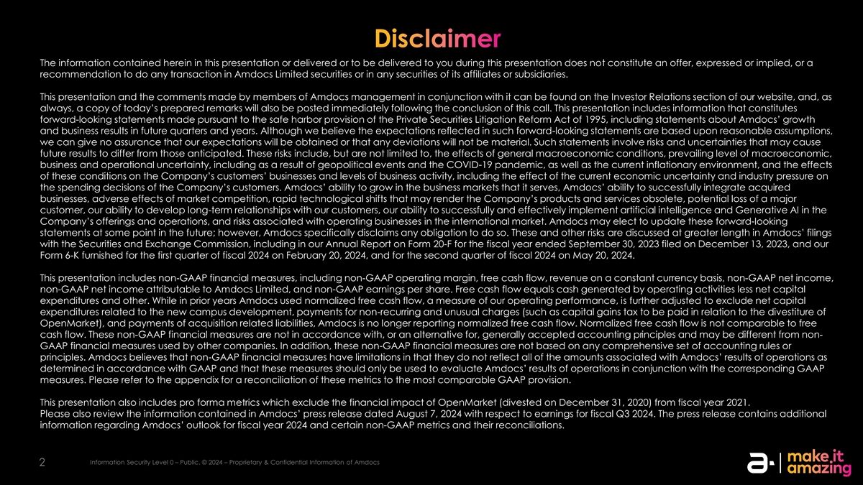
Disclaimer The information contained herein in this presentation or delivered or to be delivered to you during this presentation does not constitute an offer, expressed or implied, or a recommendation to do any transaction in Amdocs Limited securities or in any securities of its affiliates or subsidiaries. This presentation and the comments made by members of Amdocs management in conjunction with it can be found on the Investor Relations section of our website, and, as always, a copy of today’s prepared remarks will also be posted immediately following the conclusion of this call. This presentation includes information that constitutes forward-looking statements made pursuant to the safe harbor provision of the Private Securities Litigation Reform Act of 1995, including statements about Amdocs’ growth and business results in future quarters and years. Although we believe the expectations reflected in such forward-looking statements are based upon reasonable assumptions, we can give no assurance that our expectations will be obtained or that any deviations will not be material. Such statements involve risks and uncertainties that may cause future results to differ from those anticipated. These risks include, but are not limited to, the effects of general macroeconomic conditions, prevailing level of macroeconomic, business and operational uncertainty, including as a result of geopolitical events and the COVID-19 pandemic, as well as the current inflationary environment, and the effects of these conditions on the Company’s customers’ businesses and levels of business activity, including the effect of the current economic uncertainty and industry pressure on the spending decisions of the Company’s customers. Amdocs’ ability to grow in the business markets that it serves, Amdocs’ ability to successfully integrate acquired businesses, adverse effects of market competition, rapid technological shifts that may render the Company’s products and services obsolete, potential loss of a major customer, our ability to develop long-term relationships with our customers, our ability to successfully and effectively implement artificial intelligence and Generative AI in the Company’s offerings and operations, and risks associated with operating businesses in the international market. Amdocs may elect to update these forward-looking statements at some point in the future; however, Amdocs specifically disclaims any obligation to do so. These and other risks are discussed at greater length in Amdocs’ filings with the Securities and Exchange Commission, including in our Annual Report on Form 20-F for the fiscal year ended September 30, 2023 filed on December 13, 2023, and our Form 6-K furnished for the first quarter of fiscal 2024 on February 20, 2024, and for the second quarter of fiscal 2024 on May 20, 2024. This presentation includes non-GAAP financial measures, including non-GAAP operating margin, free cash flow, revenue on a constant currency basis, non-GAAP net income, non-GAAP net income attributable to Amdocs Limited, and non-GAAP earnings per share. Free cash flow equals cash generated by operating activities less net capital expenditures and other. While in prior years Amdocs used normalized free cash flow, a measure of our operating performance, is further adjusted to exclude net capital expenditures related to the new campus development, payments for non-recurring and unusual charges (such as capital gains tax to be paid in relation to the divestiture of OpenMarket), and payments of acquisition related liabilities, Amdocs is no longer reporting normalized free cash flow. Normalized free cash flow is not comparable to free cash flow. These non-GAAP financial measures are not in accordance with, or an alternative for, generally accepted accounting principles and may be different from non- GAAP financial measures used by other companies. In addition, these non-GAAP financial measures are not based on any comprehensive set of accounting rules or principles. Amdocs believes that non-GAAP financial measures have limitations in that they do not reflect all of the amounts associated with Amdocs’ results of operations as determined in accordance with GAAP and that these measures should only be used to evaluate Amdocs’ results of operations in conjunction with the corresponding GAAP measures. Please refer to the appendix for a reconciliation of these metrics to the most comparable GAAP provision. This presentation also includes pro forma metrics which exclude the financial impact of OpenMarket (divested on December 31, 2020) from fiscal year 2021. Please also review the information contained in Amdocs’ press release dated August 7, 2024 with respect to earnings for fiscal Q3 2024. The press release contains additional information regarding Amdocs’ outlook for fiscal year 2024 and certain non-GAAP metrics and their reconciliations. Information Security Level 0 – Public. © 2024 – Proprietary & Confidential Information of Amdocs 2


Today’s speakers Shuky Sheffer President & Chief Executive Officer Tamar Rapaport-Dagim Chief Financial Officer & Chief Operating Officer Information Security Level 0 – Public. © 2024 – Proprietary & Confidential Information of Amdocs 3


Earnings call agenda Strategy & business 1 performance update Shuky Sheffer, President & Chief Executive Officer 2 Financial review & outlook Tamar Rapaport-Dagim, Chief Financial Officer & Chief Operating Officer 3 Q&A Information Security Level 3 – Highly Sensitive. © 2024 – Proprietary & Confidential Information of Amdocs 4 4 4


Shuky Sheffer President & Chief Executive Officer Strategy and business performance update 5

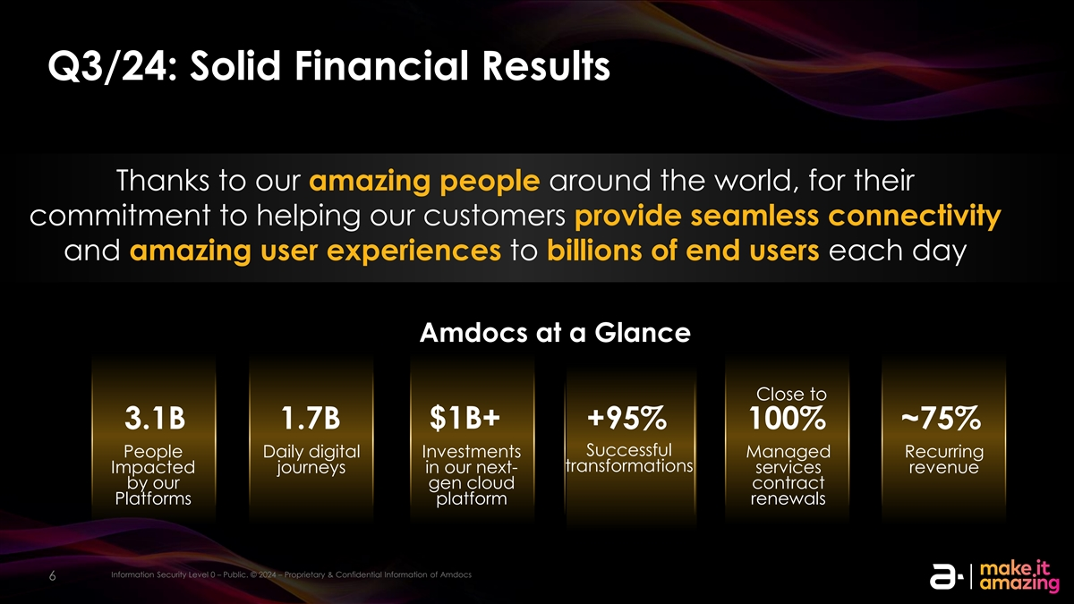
Q3/24: Solid Financial Results Thanks to our amazing people around the world, for their commitment to helping our customers provide seamless connectivity and amazing user experiences to billions of end users each day Amdocs at a Glance Close to $1B+ 3.1B 1.7B +95% 100% ~75% Successful People Daily digital Investments Managed Recurring transformations Impacted journeys in our next- services revenue by our gen cloud contract Platforms platform renewals Information Security Level 0 – Public. © 2024 – Proprietary & Confidential Information of Amdocs Information Security Level 3 – Highly Sensitive. © 2024 – Proprietary & Confidential Information of Amdocs 6 6

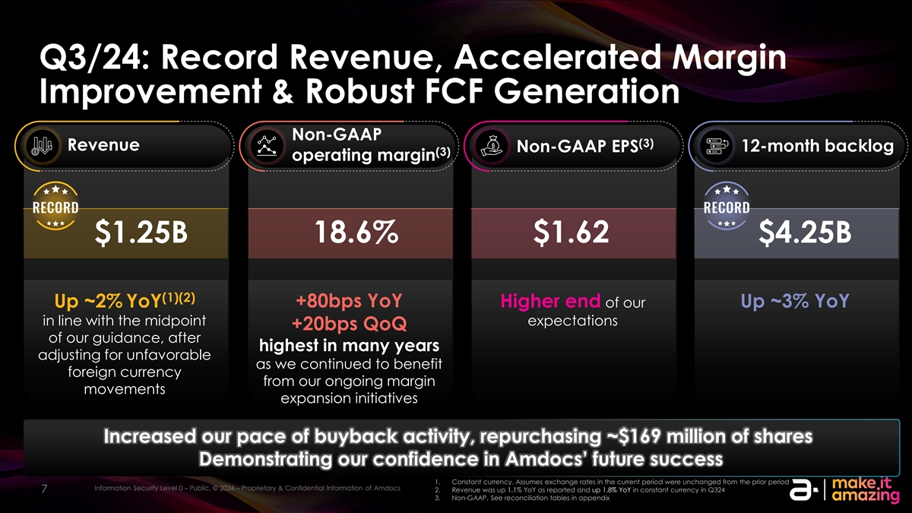
Q3/24: Record Revenue, Accelerated Margin Improvement & Robust FCF Generation Non-GAAP (3) Revenue Non-GAAP EPS 12-month backlog (3) operating margin 18.6% $1.62 $1.25B $4.25B (1)(2) Up ~2% YoY +80bps YoY Higher end of our Up ~3% YoY in line with the midpoint expectations +20bps QoQ of our guidance, after highest in many years adjusting for unfavorable as we continued to benefit foreign currency from our ongoing margin movements expansion initiatives Increased our pace of buyback activity, repurchasing ~$169 million of shares Demonstrating our confidence in Amdocs’ future success 1. Constant currency. Assumes exchange rates in the current period were unchanged from the prior period Information Security Level 0 – Public. © 2024 – Proprietary & Confidential Information of Amdocs Information Security Level 3 – Highly Sensitive. © 2024 – Proprietary & Confidential Information of Amdocs 2. Revenue was up 1.1% YoY as reported and up 1.8% YoY in constant currency in Q324 7 7 3. Non-GAAP. See reconciliation tables in appendix

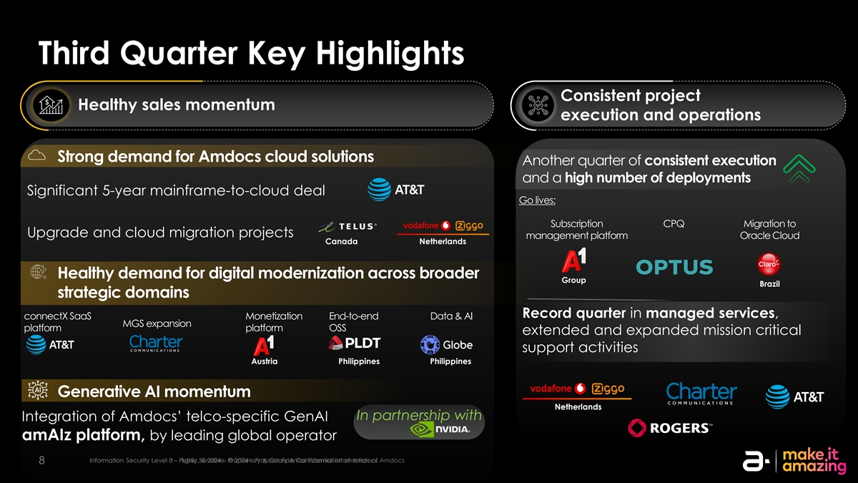
Third Quarter Key Highlights Consistent project Healthy sales momentum execution and operations Strong demand for Amdocs cloud solutions Another quarter of consistent execution and a high number of deployments Significant 5-year mainframe-to-cloud deal Go lives: Subscription CPQ Migration to Upgrade and cloud migration projects management platform Oracle Cloud Canada Netherlands Healthy demand for digital modernization across broader Group Brazil strategic domains Record quarter in managed services, connectX SaaS Monetization End-to-end Data & AI MGS expansion platform platform OSS extended and expanded mission critical support activities Austria Philippines Philippines Generative AI momentum Netherlands In partnership with Integration of Amdocs’ telco-specific GenAI amAIz platform, by leading global operator IIn nf for orm ma at tiion on Se Sec cu ur riit ty y L Le evel vel 3 0 – – H Pu igh blilc y . Se © n 202 sitive4 – . P ©r op 2024 riet– a P ryr op & Con rietafriy d e & Con ntial Ifn id for en m tia atl ion Inf or of m A am tion doc of s Amdocs 8 8

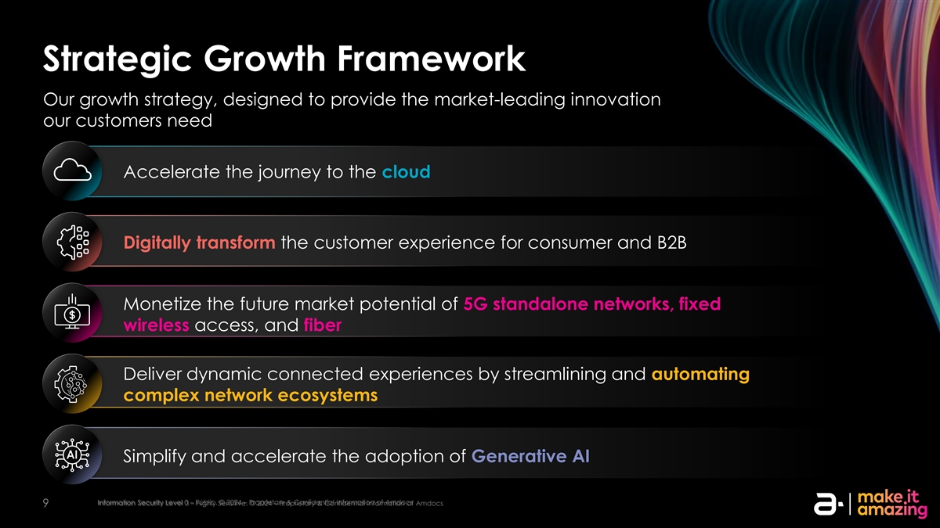
Strategic Growth Framework Our growth strategy, designed to provide the market-leading innovation our customers need Accelerate the journey to the cloud Digitally transform the customer experience for consumer and B2B Monetize the future market potential of 5G standalone networks, fixed wireless access, and fiber Deliver dynamic connected experiences by streamlining and automating complex network ecosystems Simplify and accelerate the adoption of Generative AI Information Security Level 0 – Public. © 2024 – Proprietary & Confidential Information of Amdocs Information Security Level 3 – Highly Sensitive. © 2024 – Proprietary & Confidential Information of Amdocs 9

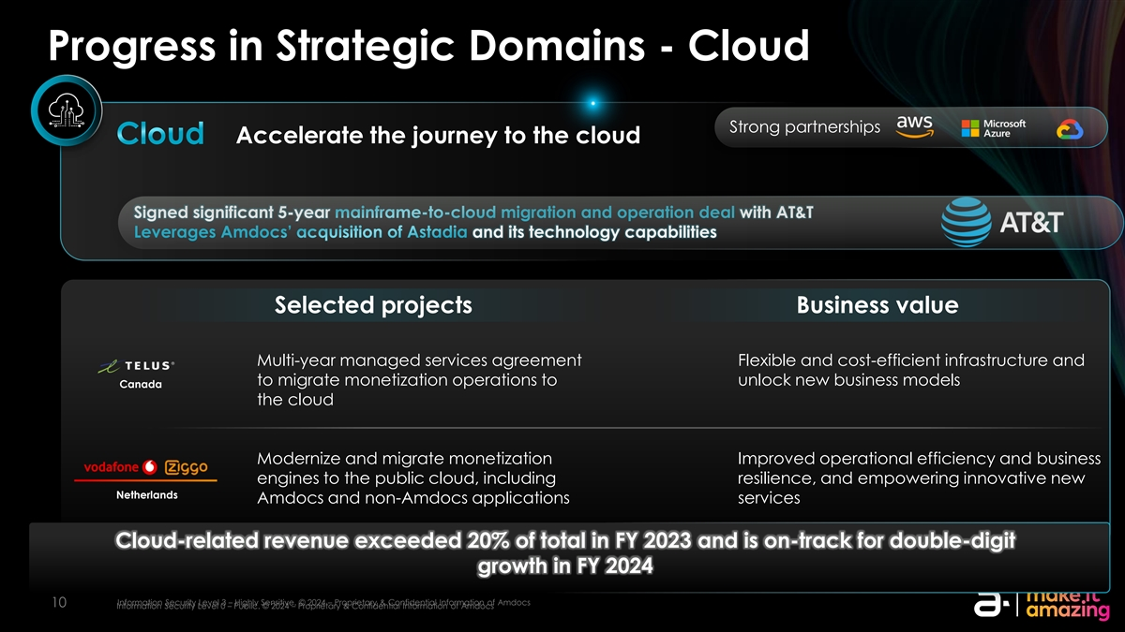
Progress in Strategic Domains - Cloud Strong partnerships Cloud Accelerate the journey to the cloud Signed significant 5-year mainframe-to-cloud migration and operation deal with AT&T Leverages Amdocs’ acquisition of Astadia and its technology capabilities Selected projects Business value Multi-year managed services agreement Flexible and cost-efficient infrastructure and to migrate monetization operations to unlock new business models Canada the cloud Modernize and migrate monetization Improved operational efficiency and business engines to the public cloud, including resilience, and empowering innovative new Netherlands Amdocs and non-Amdocs applications services Cloud-related revenue exceeded 20% of total in FY 2023 and is on-track for double-digit growth in FY 2024 Information Security Level 3 – Highly Sensitive. © 2024 – Proprietary & Confidential Information of Amdocs 10 Information Security Level 0 – Public. © 2024 – Proprietary & Confidential Information of Amdocs

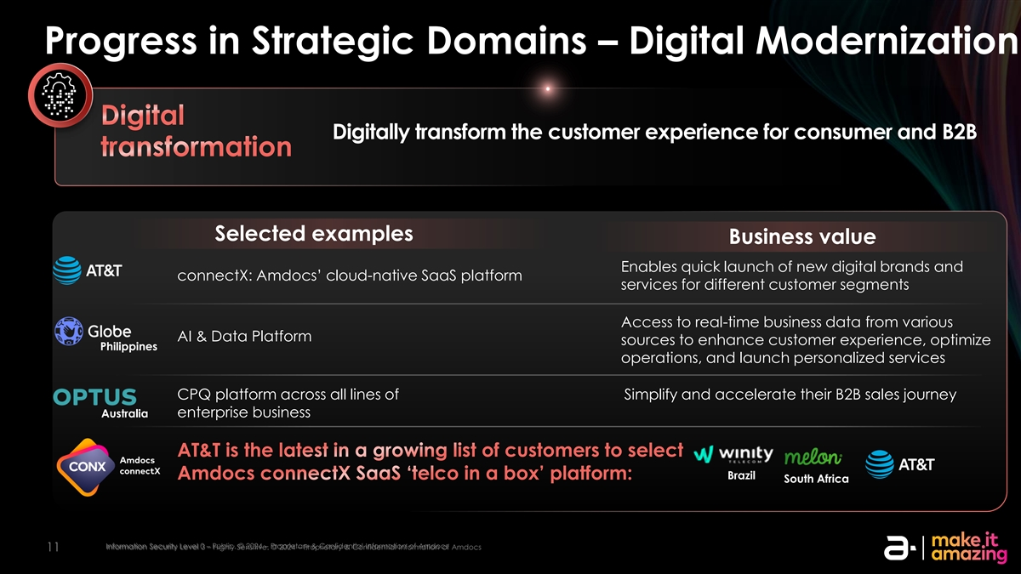
Progress in Strategic Domains – Digital Modernization Digital Digitally transform the customer experience for consumer and B2B transformation Selected examples Business value Enables quick launch of new digital brands and connectX: Amdocs’ cloud-native SaaS platform services for different customer segments Access to real-time business data from various AI & Data Platform sources to enhance customer experience, optimize Philippines operations, and launch personalized services CPQ platform across all lines of Simplify and accelerate their B2B sales journey Australia enterprise business AT&T is the latest in a growing list of customers to select Amdocs connectX SaaS ‘telco in a box’ platform: Brazil South Africa Information Security Level 0 – Public. © 2024 – Proprietary & Confidential Information of Amdocs Information Security Level 3 – Highly Sensitive. © 2024 – Proprietary & Confidential Information of Amdocs 11

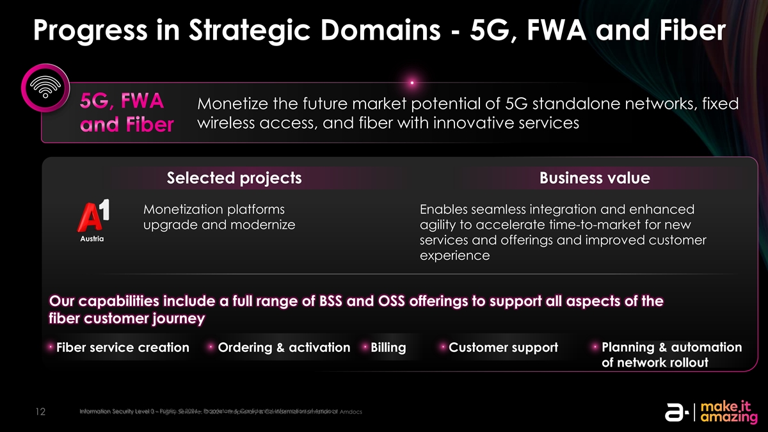
Progress in Strategic Domains - 5G, FWA and Fiber 5G, FWA Monetize the future market potential of 5G standalone networks, fixed wireless access, and fiber with innovative services and Fiber Selected projects Business value Monetization platforms Enables seamless integration and enhanced upgrade and modernize agility to accelerate time-to-market for new Austria services and offerings and improved customer experience Our capabilities include a full range of BSS and OSS offerings to support all aspects of the fiber customer journey Fiber service creation Ordering & activation Billing Customer support Planning & automation of network rollout Information Security Level 0 – Public. © 2024 – Proprietary & Confidential Information of Amdocs Information Security Level 3 – Highly Sensitive. © 2024 – Proprietary & Confidential Information of Amdocs 12

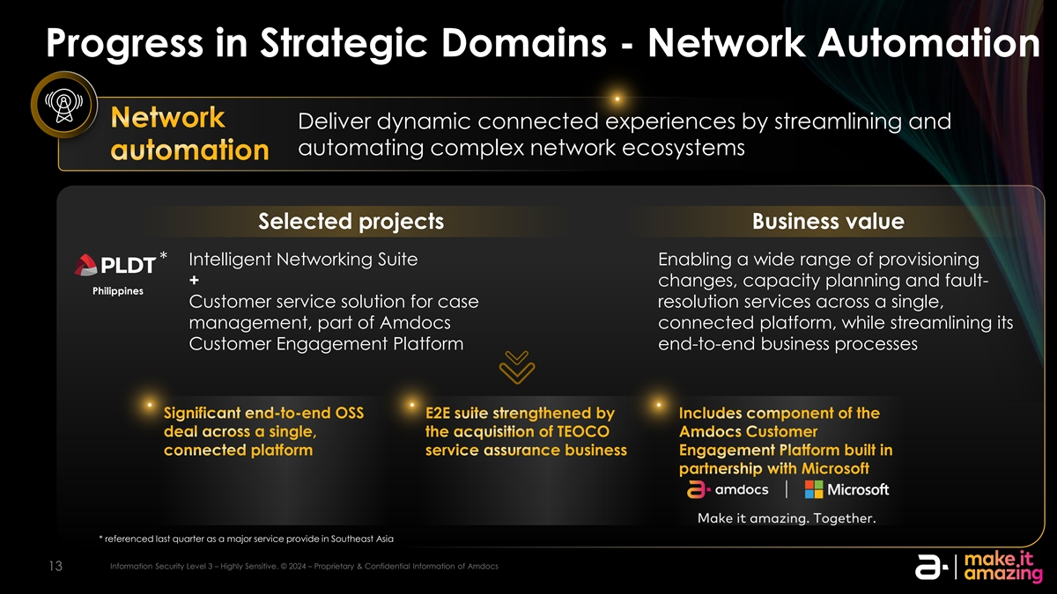
Progress in Strategic Domains - Network Automation Network Deliver dynamic connected experiences by streamlining and automating complex network ecosystems automation Selected projects Business value Intelligent Networking Suite Enabling a wide range of provisioning * + changes, capacity planning and fault- Philippines Customer service solution for case resolution services across a single, management, part of Amdocs connected platform, while streamlining its Customer Engagement Platform end-to-end business processes Significant end-to-end OSS E2E suite strengthened by Includes component of the deal across a single, the acquisition of TEOCO Amdocs Customer connected platform service assurance business Engagement Platform built in partnership with Microsoft * referenced last quarter as a major service provide in Southeast Asia Information Security Level 3 – Highly Sensitive. © 2024 – Proprietary & Confidential Information of Amdocs 13

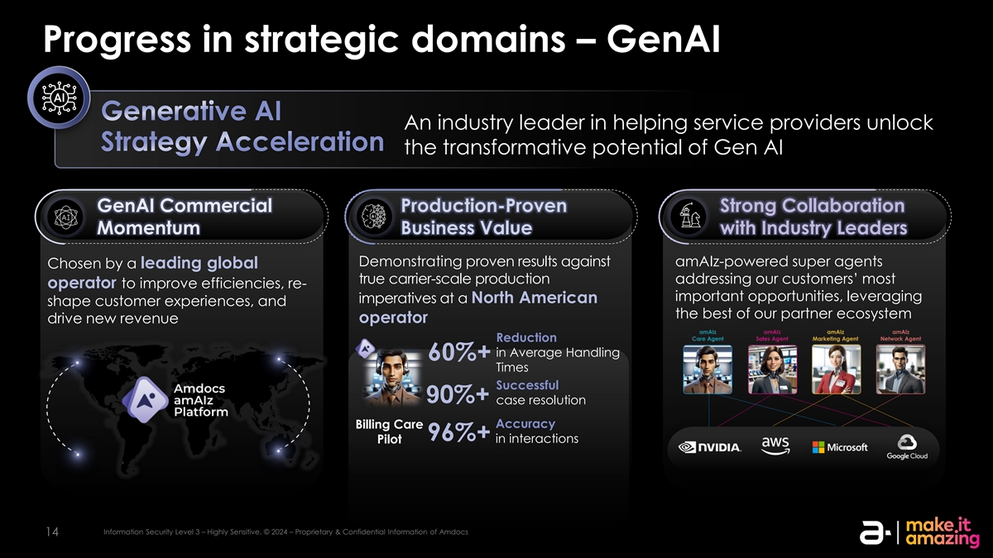
Progress in strategic domains – GenAI Generative AI An industry leader in helping service providers unlock Strategy Acceleration the transformative potential of Gen AI GenAI Commercial Production-Proven Strong Collaboration Momentum Business Value with Industry Leaders Demonstrating proven results against amAIz-powered super agents Chosen by a leading global true carrier-scale production addressing our customers’ most operator to improve efficiencies, re- important opportunities, leveraging imperatives at a North American shape customer experiences, and the best of our partner ecosystem drive new revenue operator Reduction in Average Handling 60%+ Times Successful 90%+ case resolution Accuracy Billing Care 96%+ Pilot in interactions Information Security Level 3 – Highly Sensitive. © 2024 – Proprietary & Confidential Information of Amdocs 14

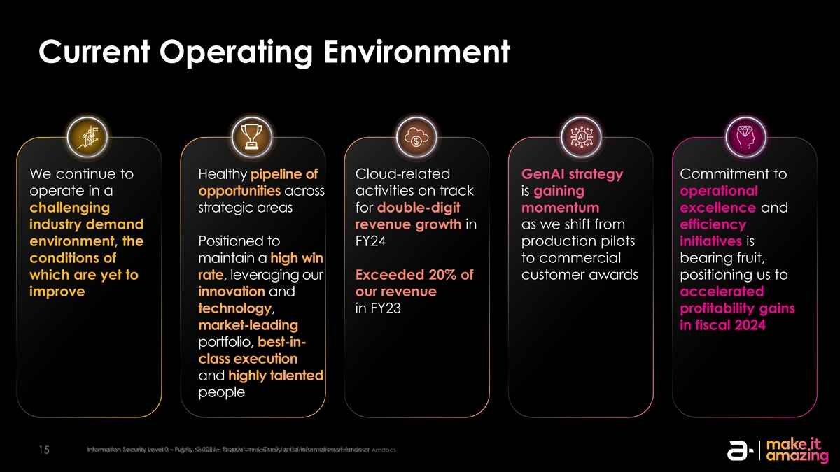
Current Operating Environment We continue to Healthy pipeline of Cloud-related GenAI strategy Commitment to operate in a opportunities across activities on track is gaining operational challenging strategic areas for double-digit momentum excellence and industry demand revenue growth in as we shift from efficiency environment, the Positioned to FY24 production pilots initiatives is conditions of maintain a high win to commercial bearing fruit, which are yet to rate, leveraging our Exceeded 20% of customer awards positioning us to improve innovation and our revenue accelerated technology, in FY23 profitability gains market-leading in fiscal 2024 portfolio, best-in- class execution and highly talented people Information Security Level 0 – Public. © 2024 – Proprietary & Confidential Information of Amdocs Information Security Level 3 – Highly Sensitive. © 2024 – Proprietary & Confidential Information of Amdocs 15

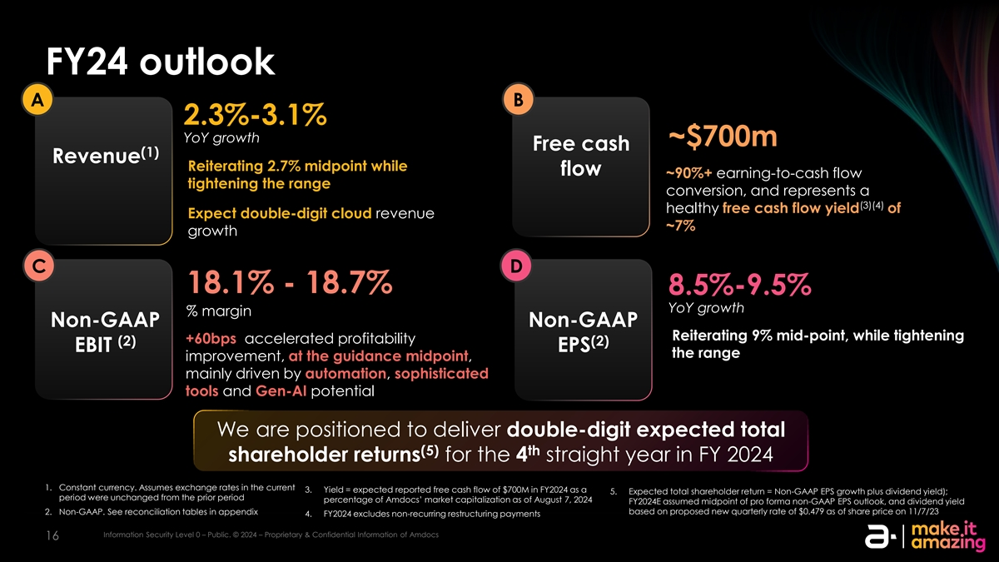
FY24 outlook A B 2.3%-3.1% YoY growth ~$700m Free cash (1) Revenue Reiterating 2.7% midpoint while flow ~90%+ earning-to-cash flow tightening the range conversion, and represents a (3)(4) healthy free cash flow yield of Expect double-digit cloud revenue ~7% growth C D 18.1% - 18.7% 8.5%-9.5% YoY growth % margin Non-GAAP Non-GAAP Reiterating 9% mid-point, while tightening +60bps accelerated profitability (2) (2) EBIT EPS the range improvement, at the guidance midpoint, mainly driven by automation, sophisticated tools and Gen-AI potential We are positioned to deliver double-digit expected total (5) th shareholder returns for the 4 straight year in FY 2024 1. Constant currency. Assumes exchange rates in the current 3. Yield = expected reported free cash flow of $700M in FY2024 as a 5. Expected total shareholder return = Non-GAAP EPS growth plus dividend yield); period were unchanged from the prior period percentage of Amdocs’ market capitalization as of August 7, 2024 FY2024E assumed midpoint of pro forma non-GAAP EPS outlook, and dividend yield based on proposed new quarterly rate of $0.479 as of share price on 11/7/23 2. Non-GAAP. See reconciliation tables in appendix 4. FY2024 excludes non-recurring restructuring payments Information Security Level 0 – Public. © 2024 – Proprietary & Confidential Information of Amdocs Information Security Level 0 – Public. © 2024 – Proprietary & Confidential Information of Amdocs 16


Tamar Rapaport-Dagim Chief Financial Officer & Chief Operating Officer Financial review & outlook 17

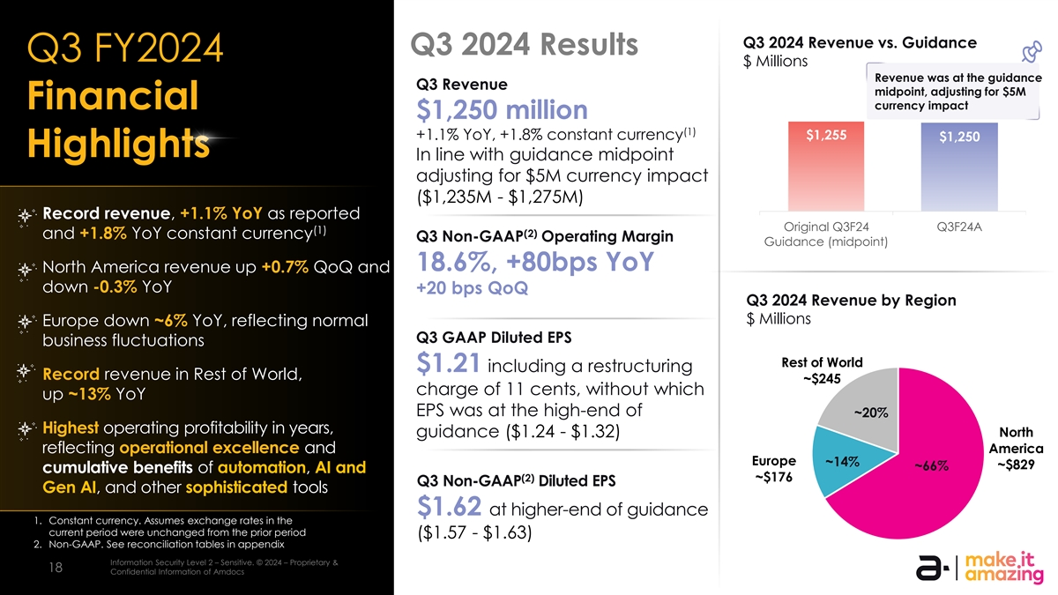
Q3 2024 Revenue vs. Guidance Q3 2024 Results Q3 FY2024 $ Millions Revenue was at the guidance Q3 Revenue midpoint, adjusting for $5M Financial currency impact $1,250 million (1) +1.1% YoY, +1.8% constant currency $1,255 $1,250 Highlights In line with guidance midpoint adjusting for $5M currency impact ($1,235M - $1,275M) Record revenue, +1.1% YoY as reported Original Q3F24 Q3F24A (1) (2) and +1.8% YoY constant currency Q3 Non-GAAP Operating Margin Guidance (midpoint) 18.6%, +80bps YoY North America revenue up +0.7% QoQ and down -0.3% YoY +20 bps QoQ Q3 2024 Revenue by Region $ Millions Europe down ~6% YoY, reflecting normal Q3 GAAP Diluted EPS business fluctuations Rest of World $1.21 including a restructuring Record revenue in Rest of World, ~$245 charge of 11 cents, without which up ~13% YoY EPS was at the high-end of ~20% Highest operating profitability in years, guidance ($1.24 - $1.32) North reflecting operational excellence and America Europe ~14% ~$829 ~66% cumulative benefits of automation, AI and (2) ~$176 Q3 Non-GAAP Diluted EPS Gen AI, and other sophisticated tools $1.62 at higher-end of guidance 1. Constant currency. Assumes exchange rates in the current period were unchanged from the prior period ($1.57 - $1.63) 2. Non-GAAP. See reconciliation tables in appendix Information Security Level 2 – Sensitive. © 2024 – Proprietary & Information Security Level 3 – Highly Sensitive. © 2024 – Proprietary & Confidential Information of Amdocs 18 18 Confidential Information of Amdocs

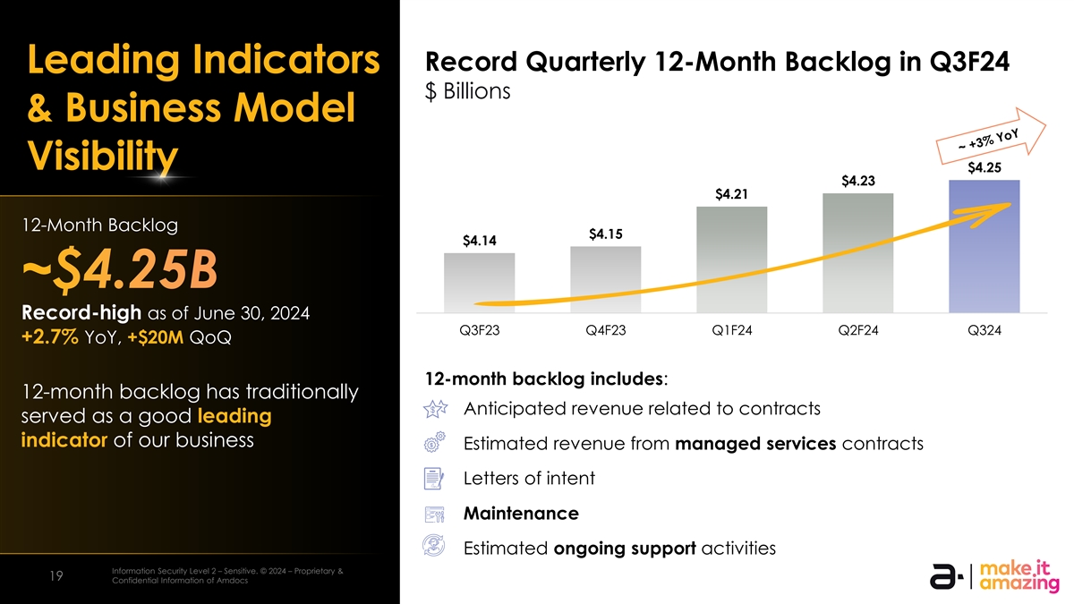
Record Quarterly 12-Month Backlog in Q3F24 Leading Indicators $ Billions 12-month backlog growth has accelerated & Business Model year-over-year over the past several quarters Visibility $4.25 $4.23 $4.21 (1) (1) 12-Month Backlog (1) $4.15 $4.14 ~$4.25B (1) Record-high as of June 30, 2024 Q3F23 Q4F23 Q1F24 Q2F24 Q324 +2.7% YoY, +$20M QoQ 12-month backlog includes: 12-month backlog has traditionally Anticipated revenue related to contracts served as a good leading indicator of our business Estimated revenue from managed services contracts Letters of intent Maintenance Estimated ongoing support activities Information Security Level 2 – Sensitive. © 2024 – Proprietary & Information Security Level 3 – Highly Sensitive. © 2024 – Proprietary & Confidential Information of Amdocs 19 19 Confidential Information of Amdocs

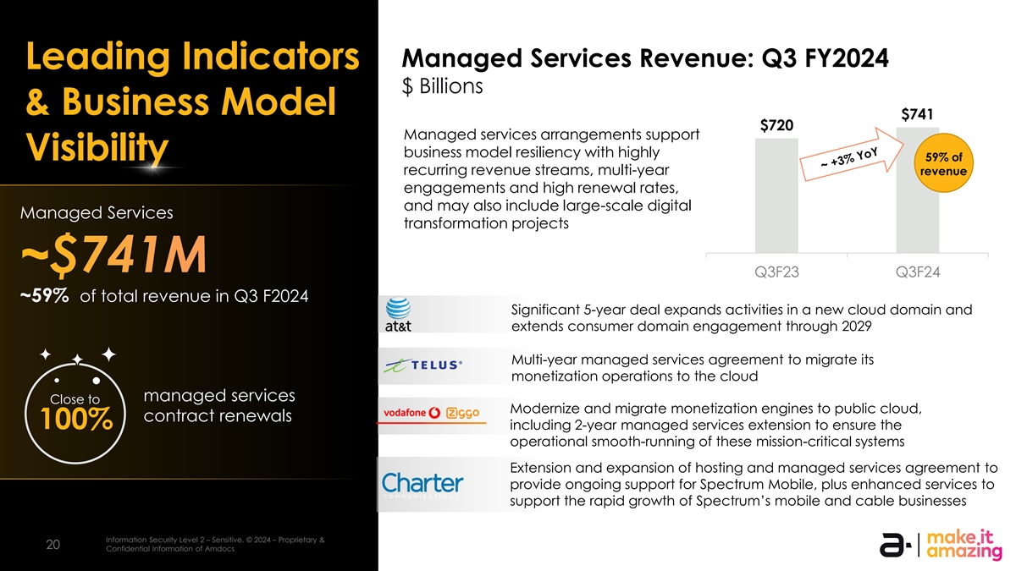
Managed Services Revenue: Q3 FY2024 Leading Indicators $ Billions & Business Model $741 $720 Managed services arrangements support business model resiliency with highly Visibility 59% of recurring revenue streams, multi-year revenue engagements and high renewal rates, and may also include large-scale digital Managed Services transformation projects ~$741M Q3F23 Q3F24 ~59% of total revenue in Q3 F2024 Significant 5-year deal expands activities in a new cloud domain and extends consumer domain engagement through 2029 Multi-year managed services agreement to migrate its monetization operations to the cloud managed services Close to Modernize and migrate monetization engines to public cloud, contract renewals 100% including 2-year managed services extension to ensure the operational smooth-running of these mission-critical systems Extension and expansion of hosting and managed services agreement to provide ongoing support for Spectrum Mobile, plus enhanced services to support the rapid growth of Spectrum’s mobile and cable businesses Information Security Level 2 – Sensitive. © 2024 – Proprietary & Information Security Level 3 – Highly Sensitive. © 2024 – Proprietary & Confidential Information of Amdocs 20 20 Confidential Information of Amdocs

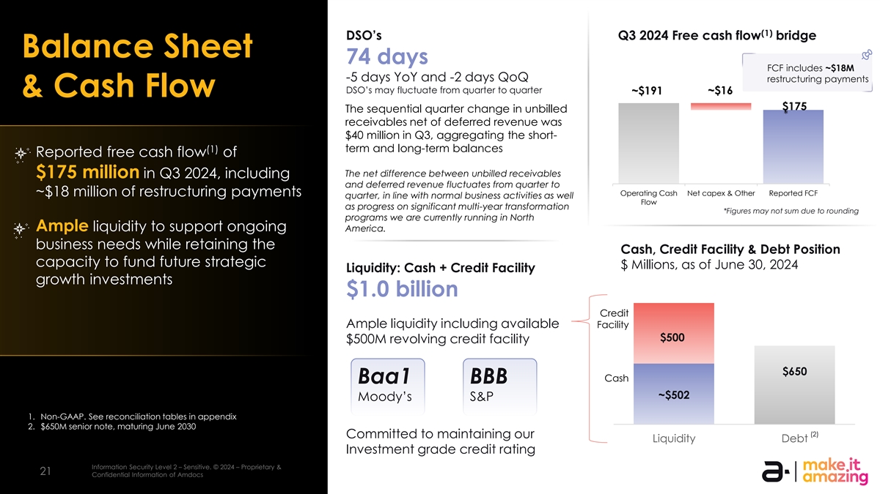
(1) DSO’s Q3 2024 Free cash flow bridge Balance Sheet 74 days FCF includes ~$18M -5 days YoY and -2 days QoQ restructuring payments DSO’s may fluctuate from quarter to quarter ~$16 ~$191 & Cash Flow $175 The sequential quarter change in unbilled * receivables net of deferred revenue was $40 million in Q3, aggregating the short- term and long-term balances (1) Reported free cash flow of The net difference between unbilled receivables $175 million in Q3 2024, including and deferred revenue fluctuates from quarter to Operating Cash Net capex & Other Reported FCF ~$18 million of restructuring payments quarter, in line with normal business activities as well Flow as progress on significant multi-year transformation *Figures may not sum due to rounding programs we are currently running in North Ample liquidity to support ongoing America. business needs while retaining the Cash, Credit Facility & Debt Position capacity to fund future strategic $ Millions, as of June 30, 2024 Liquidity: Cash + Credit Facility growth investments $1.0 billion Credit Ample liquidity including available Facility $500 $500M revolving credit facility $650 Cash Baa1 BBB ~$502 Moody’s S&P 1. Non-GAAP. See reconciliation tables in appendix 2. $650M senior note, maturing June 2030 (2) Committed to maintaining our $0 Liquidity Debt Investment grade credit rating Information Security Level 2 – Sensitive. © 2024 – Proprietary & Information Security Level 3 – Highly Sensitive. © 2024 – Proprietary & Confidential Information of Amdocs 21 21 Confidential Information of Amdocs

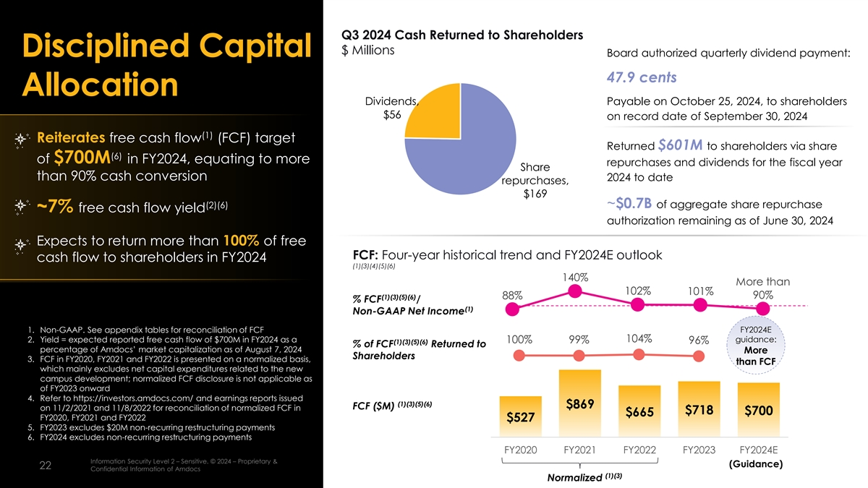
Q3 2024 Cash Returned to Shareholders $ Millions Disciplined Capital Board authorized quarterly dividend payment: 47.9 cents Allocation Dividends, Payable on October 25, 2024, to shareholders $56 on record date of September 30, 2024 (1) Reiterates free cash flow (FCF) target Returned $601M to shareholders via share (6) of $700M in FY2024, equating to more repurchases and dividends for the fiscal year Share than 90% cash conversion 2024 to date repurchases, $169 ~$0.7B of aggregate share repurchase (2)(6) ~7% free cash flow yield authorization remaining as of June 30, 2024 Expects to return more than 100% of free FCF: Four-year historical trend and FY2024E outlook cash flow to shareholders in FY2024 (1)(3)(4)(5)(6) 140% More than 102% 101% 88% 90% (1)(3)(5)(6) % FCF / (1) Non-GAAP Net Income 1. Non-GAAP. See appendix tables for reconciliation of FCF FY2024E 2. Yield = expected reported free cash flow of $700M in FY2024 as a 104% guidance: 100% 99% (1)(3)(5)(6) 96% % of FCF Returned to percentage of Amdocs’ market capitalization as of August 7, 2024 More Shareholders 3. FCF in FY2020, FY2021 and FY2022 is presented on a normalized basis, than FCF which mainly excludes net capital expenditures related to the new campus development; normalized FCF disclosure is not applicable as of FY2023 onward 4. Refer to https://investors.amdocs.com/ and earnings reports issued (1)(3)(5)(6) $869 FCF ($M) on 11/2/2021 and 11/8/2022 for reconciliation of normalized FCF in $718 $700 $665 FY2020, FY2021 and FY2022 $527 5. FY2023 excludes $20M non-recurring restructuring payments 6. FY2024 excludes non-recurring restructuring payments FY2020 FY2021 FY2022 FY2023 FY2024E Information Security Level 2 – Sensitive. © 2024 – Proprietary & Information Security Level 3 – Highly Sensitive. © 2024 – Proprietary & Confidential Information of Amdocs (Guidance) 22 22 Confidential Information of Amdocs (1)(3) Normalized

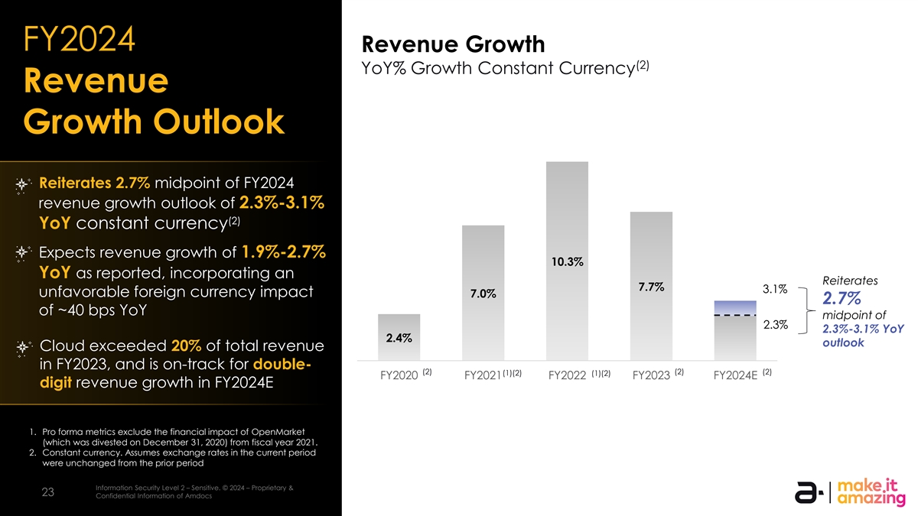
FY2024 Revenue Growth (2) YoY% Growth Constant Currency Revenue Growth Outlook Reiterates 2.7% midpoint of FY2024 revenue growth outlook of 2.3%-3.1% (2) YoY constant currency Expects revenue growth of 1.9%-2.7% 10.3% YoY as reported, incorporating an Reiterates 7.7% 3.1% unfavorable foreign currency impact 7.0% 2.7% of ~40 bps YoY midpoint of 2.3% 2.3%-3.1% YoY 2.4% outlook Cloud exceeded 20% of total revenue in FY2023, and is on-track for double- (2) (2) (2) (1)(2) (1)(2) FY2020 FY2021 FY2022 FY2023 FY2024E digit revenue growth in FY2024E 1. Pro forma metrics exclude the financial impact of OpenMarket (which was divested on December 31, 2020) from fiscal year 2021. 2. Constant currency. Assumes exchange rates in the current period were unchanged from the prior period Information Security Level 2 – Sensitive. © 2024 – Proprietary & Information Security Level 3 – Highly Sensitive. © 2024 – Proprietary & Confidential Information of Amdocs 23 23 Confidential Information of Amdocs

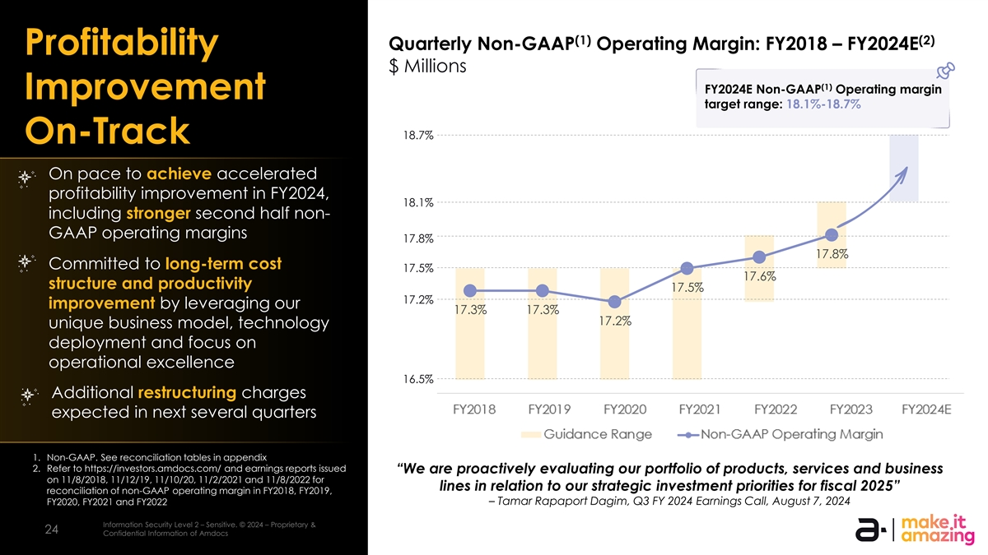
(1) (2) Quarterly Non-GAAP Operating Margin: FY2018 – FY2024E Profitability $ Millions (1) FY2024E Non-GAAP Operating margin Improvement target range: 18.1%-18.7% 18.7% On-Track On pace to achieve accelerated profitability improvement in FY2024, 18.1% including stronger second half non- GAAP operating margins 17.8% 17.8% Committed to long-term cost 17.5% 17.6% structure and productivity 17.5% 17.2% improvement by leveraging our 17.3% 17.3% 17.2% unique business model, technology deployment and focus on operational excellence 16.5% Additional restructuring charges expected in next several quarters FY2018 FY2019 FY2020 FY2021 FY2022 FY2023 FY2024E 1. Non-GAAP. See reconciliation tables in appendix 2. Refer to https://investors.amdocs.com/ and earnings reports issued “We are proactively evaluating our portfolio of products, services and business Guidance Range Non-GAAP Operating Margin on 11/8/2018, 11/12/19, 11/10/20, 11/2/2021 and 11/8/2022 for lines in relation to our strategic investment priorities for fiscal 2025” reconciliation of non-GAAP operating margin in FY2018, FY2019, – Tamar Rapaport Dagim, Q3 FY 2024 Earnings Call, August 7, 2024 FY2020, FY2021 and FY2022 Information Security Level 2 – Sensitive. © 2024 – Proprietary & Information Security Level 3 – Highly Sensitive. © 2024 – Proprietary & Confidential Information of Amdocs 24 24 Confidential Information of Amdocs

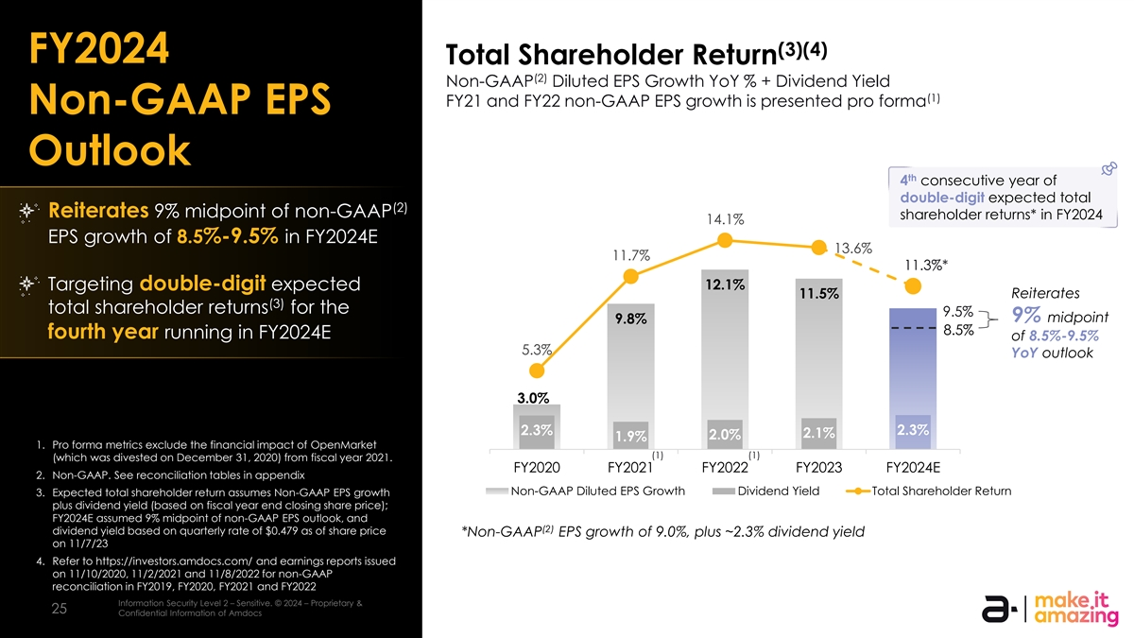
(3)(4) FY2024 Total Shareholder Return (2) Non-GAAP Diluted EPS Growth YoY % + Dividend Yield (1) FY21 and FY22 non-GAAP EPS growth is presented pro forma Non-GAAP EPS Outlook th 4 consecutive year of double-digit expected total (2) Reiterates 9% midpoint of non-GAAP shareholder returns* in FY2024 14.1% EPS growth of 8.5%-9.5% in FY2024E 13.6% 11.7% 11.3%* 12.1% Targeting double-digit expected Reiterates 11.5% (3) total shareholder returns for the 9.5% 9% midpoint 9.8% 8.5% fourth year running in FY2024E of 8.5%-9.5% 5.3% YoY outlook 3.0% 2.3% 2.3% 2.1% 2.0% 1.9% 1. Pro forma metrics exclude the financial impact of OpenMarket (1) (1) (which was divested on December 31, 2020) from fiscal year 2021. FY2020 FY2021 FY2022 FY2023 FY2024E 2. Non-GAAP. See reconciliation tables in appendix Non-GAAP Diluted EPS Growth Dividend Yield Total Shareholder Return 3. Expected total shareholder return assumes Non-GAAP EPS growth plus dividend yield (based on fiscal year end closing share price); FY2024E assumed 9% midpoint of non-GAAP EPS outlook, and (2) dividend yield based on quarterly rate of $0.479 as of share price *Non-GAAP EPS growth of 9.0%, plus ~2.3% dividend yield on 11/7/23 4. Refer to https://investors.amdocs.com/ and earnings reports issued on 11/10/2020, 11/2/2021 and 11/8/2022 for non-GAAP reconciliation in FY2019, FY2020, FY2021 and FY2022 Information Security Level 2 – Sensitive. © 2024 – Proprietary & Information Security Level 3 – Highly Sensitive. © 2024 – Proprietary & Confidential Information of Amdocs 25 25 Confidential Information of Amdocs


Committed to ESG Achieved a 55% reduction in Amdocs’ Scope 1&2 CO2 emissions since fiscal 2019, far exceeding our Science TIME Magazine Based Target commitments names Amdocs as one of World’s Most Sustainable Companies 2024 Amdocs’ global consumption of renewable energy reached nearly Amdocs’ ESG 59% in 2023, up significantly from just & CSR report for over 19% in 2021 2023/24 published IIn nf for orm ma at tiion on Se Sec cu ur riit ty y L Le evel vel 3 0 – – P Hu igh blilc y . Se © n 2024 sitive– . P ©r op 2024 riet– a P ryr op & Con rietafriy d e & Con ntial Ifn id for en m tia atl ion Inf or of m A am tion doc of s Amdocs 26 26 26 26


Q&A Information Security Level 3 – Highly Sensitive. © 2024 – Proprietary & Confidential Information of Amdocs 27 27 27


Appendix Outlook & Reconciliation Tables Information Security Level 3 – Highly Sensitive. © 2024 – Proprietary & Confidential Information of Amdocs 28 28 28

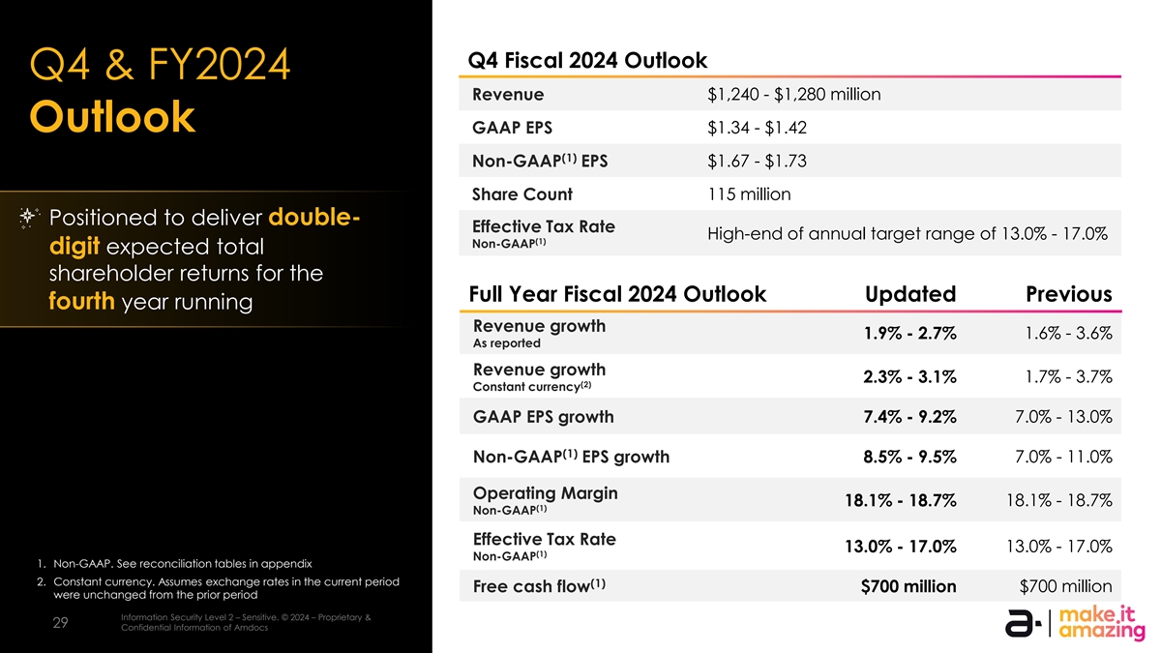
Q4 Fiscal 2024 Outlook Q4 & FY2024 Revenue $1,240 - $1,280 million Outlook $1.34 - $1.42 GAAP EPS (1) Non-GAAP EPS $1.67 - $1.73 Share Count 115 million Positioned to deliver double- Effective Tax Rate High-end of annual target range of 13.0% - 17.0% (1) Non-GAAP digit expected total shareholder returns for the Full Year Fiscal 2024 Outlook Updated Previous fourth year running Revenue growth 1.6% - 3.6% 1.9% - 2.7% As reported Revenue growth 1.7% - 3.7% 2.3% - 3.1% (2) Constant currency GAAP EPS growth 7.4% - 9.2% 7.0% - 13.0% (1) Non-GAAP EPS growth 8.5% - 9.5% 7.0% - 11.0% Operating Margin 18.1% - 18.7% 18.1% - 18.7% (1) Non-GAAP Effective Tax Rate 13.0% - 17.0% 13.0% - 17.0% (1) Non-GAAP 1. Non-GAAP. See reconciliation tables in appendix 2. Constant currency. Assumes exchange rates in the current period (1) Free cash flow $700 million $700 million were unchanged from the prior period Information Security Level 2 – Sensitive. © 2024 – Proprietary & Information Security Level 3 – Highly Sensitive. © 2024 – Proprietary & Confidential Information of Amdocs 29 29 Confidential Information of Amdocs

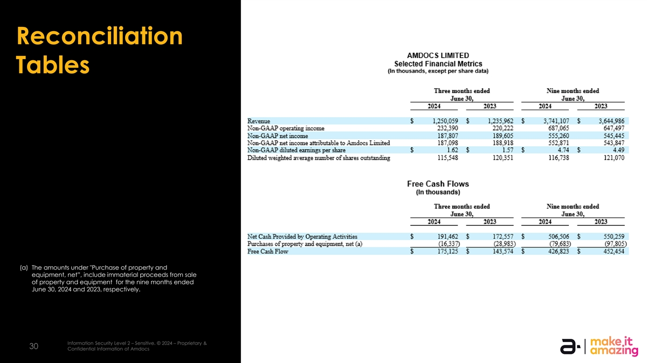
Reconciliation Tables (a) The amounts under Purchase of property and equipment, net”, include immaterial proceeds from sale of property and equipment for the nine months ended June 30, 2024 and 2023, respectively. Information Security Level 2 – Sensitive. © 2024 – Proprietary & Information Security Level 3 – Highly Sensitive. © 2024 – Proprietary & Confidential Information of Amdocs 30 30 Confidential Information of Amdocs

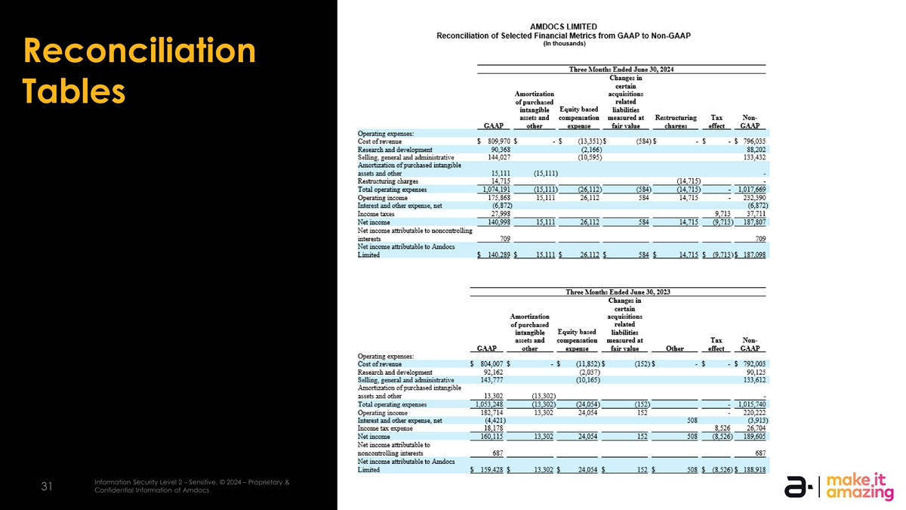
Reconciliation Tables Information Security Level 2 – Sensitive. © 2024 – Proprietary & Information Security Level 3 – Highly Sensitive. © 2024 – Proprietary & Confidential Information of Amdocs 31 31 Confidential Information of Amdocs

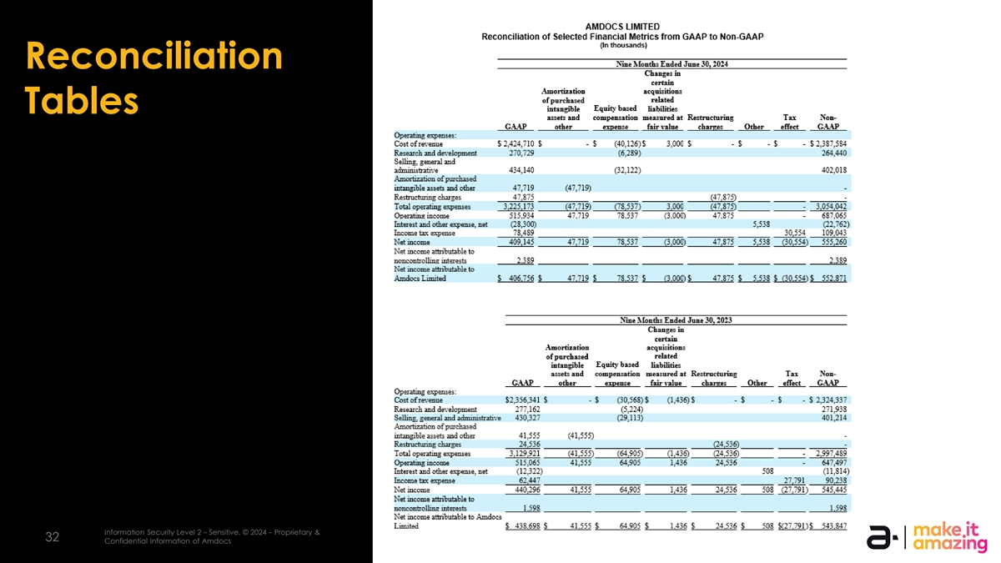
Reconciliation Tables Information Security Level 2 – Sensitive. © 2024 – Proprietary & Information Security Level 3 – Highly Sensitive. © 2024 – Proprietary & Confidential Information of Amdocs 32 32 Confidential Information of Amdocs


Thank you!

