UNITED STATES
SECURITIES AND EXCHANGE COMMISSION
WASHINGTON, D.C. 20549

Form 6-K

REPORT OF FOREIGN PRIVATE ISSUER
PURSUANT TO RULE 13a-16 OR 15d-16
OF THE SECURITIES EXCHANGE ACT OF 1934
For the month of August 2026
Commission File Number 1-14840

AMDOCS LIMITED

Hirzel House, Smith Street,
St. Peter Port, Island of Guernsey, GY1 2NG
Amdocs, Inc.
625 Maryville Centre Drive, Suite 200, Saint Louis, Missouri 63141
(Address of principal executive offices)

Indicate by check mark whether the registrant files or will file annual reports under cover of Form 20-F or Form 40-F:
FORM 20-F ☒ FORM 40-F ☐

On August 5, 2026 Amdocs Limited (“Amdocs”) issued a press release announcing financial results for the quarter ended June 30, 2026. A copy of the press release and the accompanying presentation are furnished as Exhibits 99.1 and 99.2 to this Report of Foreign Private Issuer on Form 6-K.
The information in this Form 6-K (including Exhibits 99.1 and 99.2) shall not be deemed “filed” for purposes of Section 18 of the Securities Exchange Act of 1934 (the “Exchange Act”) or otherwise subject to the liabilities of that section, nor shall it be deemed incorporated by reference in any filing under the Securities Act of 1933 or the Exchange Act.

EXHIBIT INDEX

EXHIBIT  NO. |  | DESCRIPTION
99.1 |  | Amdocs Limited Press Release Announcing Q3 Earnings, dated August 5, 2026
99.2 |  | Fiscal Q3 2026 Earnings Presentation

SIGNATURES
Pursuant to the requirements of the Securities Exchange Act of 1934, the registrant has duly caused this report to be signed on its behalf by the undersigned, thereunto duly authorized.

AMDOCS LIMITED
By: |  | /s/ Matthew E. Smith
 |  | Matthew E. Smith
 |  | Secretary and Authorized Signatory
Date: August 5, 2026
Exhibit 99.1

Amdocs Limited Reports Third Quarter Fiscal 2026 Results
Revenue of $1.17 Billion, up 2.7% YoY as Reported and up 2.2% YoY in Constant Currency(1)
Expects Fiscal 2026 Revenue Growth Outlook of 3.2%-4.0% YoY as Reported
Reiterates Midpoint of Fiscal 2026 Revenue Growth Outlook of 2.6% to 3.4% YoY in Constant Currency(1)
Announces Multi-Year Strategic Engagement with Liberty Latin America to Manage & Transform its Entire IT Domain Through Amdocs’ Agentic Operating System, aOS
Third Quarter Fiscal 2026 Highlights
(All comparisons are against same quarter of the prior year, unless otherwise stated)

 |  |  | Revenue of $1,175 million, up 2.7% as reported and up 2.2% in constant currency(1); revenue was at the midpoint of the $1,155-$1,195 million guidance range and includes a negligible impact from foreign currency movements relative to our guidance assumptions

 |  |  | Managed services record revenue of $791 million, equivalent to approximately 67% of total revenue and up 2.5%

 |  |  | GAAP diluted EPS of $0.59, including a restructuring charge of 91 cents per share, without which GAAP diluted EPS would have been above the guidance range of $1.39-$1.47

 |  |  | Non-GAAP diluted EPS of $1.84, at the midpoint of the guidance range of $1.81-$1.87

 |  |  | GAAP operating income of $105 million, including a restructuring charge of $106 million; GAAP operating margin of 8.9%, down 880 basis points compared to last year’s third quarter and 670 basis points sequentially

 |  |  | Non-GAAP operating income of $253 million; non-GAAP operating margin of 21.6%, up 20 basis points as compared to last year’s third fiscal quarter and up 10 basis points sequentially

(1) | Revenue on a constant currency basis assumes exchange rates in the current period were unchanged from the prior period
(2) | Please refer to the Selected Financial Metrics tables below (figures may not sum because of rounding)

 |  |  | Free cash flow of $172 million, comprised of cash flow from operations of $197 million, including $21 million of restructuring payments, less $25 million in net capital expenditures(2); excluding restructuring payments, free cash flow was $193 million; reiterates full year fiscal 2026 free cash(2) outlook of $710 million to $730 million, excluding restructuring payments

 |  |  | Repurchased $143 million of ordinary shares during the third fiscal quarter

 |  |  | Twelve-month backlog of $4.26 billion, up 2.7% as compared to last year’s third fiscal quarter and down $20 million sequentially
JERSEY CITY, NJ – August 5, 2026 – Amdocs Limited (NASDAQ: DOX), a leading provider of software and services to communications and media companies, today reported operating results for the three months ended June 30, 2026.
“I’m pleased to report solid Q3 results. Revenue of $1.175 billion was consistent with the midpoint of guidance, and profitability improved from a year ago as we continued to balance growth investments with accelerated internal transformation to become an agentic-first organization. Managed services had a record quarter, contributing 67% of total revenue, and twelve-month backlog grew by 2.7% from a year ago. With these results, we’re on track to achieve our fiscal 2026 financial guidance while closely monitoring macroeconomic developments and customer spending behavior in the current climate,” said Shimie Hortig, president and chief executive officer of Amdocs Management Limited.
Hortig continued, “As we’ve advanced our strategy over the last few months, I’d like to provide more details about our plans to lead Amdocs forward. Last quarter, I shared my excitement about the agentic era, and the long-term opportunity this presents to help our industry and customers fundamentally transform their IT and network domains. Our vision is to be the primary partner of choice to accelerate this agentic transformation and unlock its value for our customers. Today, we are introducing our new four-pillar growth strategy. Pillar 1, and the core of our strategy, is “aOS, Agentic Telco Operating System”, designed to fundamentally transform the way our customers operate their business. Pillar II is “New Vertical Expansion” where we plan to leverage our deep engineering pedigree, combined with our transformation expertise, to accelerate agentic modernization in another industry.

Pillar III is ”Emerging Growth Horizons” where we intend to capture and solve emerging needs driven by the GenAI revolution in our customer base and beyond. Pillar IV relates to the “Internal Transformation” of Amdocs to become an agentic-first organization as a key enabler to support our future growth.”
Hortig concluded, “As the first major proof point of our first growth pillar, I’m proud to share an important moment in our agentic journey. We signed a new, large-scale 10-year partnership with Liberty Latin America encompassing their entire end-to-end IT ecosystem. This is a true flagship engagement under which Liberty Latin America is trusting Amdocs to manage and transform its entire IT domain leveraging aOS, Amdocs’ agentic telco operating system. The engagement will transform Liberty Latin America’s traditional IT operations into an AI-driven operating model designed to accelerate time to market, increase product innovation, enhance customer and employee experience, and deliver significant cost savings. The deal is also a meaningful expansion of Amdocs’ footprint in the CALA region and is a major demonstration of our ability to handle highly complex mission critical operations across multiple markets.”
Revenue

(All comparisons are against same quarter of the prior year, unless otherwise stated)

 |  | In millions
 |  | Three months ended
 |  | June 30, 2026
 |  | Actual |  |  |  | Guidance
Revenue |  | $ | 1,175 |  |  | $ | 1,155 - $1,195
Revenue Growth, as reported |  |  | 2.7 | %
Revenue Growth, constant currency(1) |  |  | 2.2 | %

 |  |  | Revenue for the third fiscal quarter of 2026 was at the midpoint of Amdocs’ guidance and includes a negligible impact from foreign currency movements compared to our guidance assumptions

 |  |  | Revenue for the third fiscal quarter includes a positive impact from foreign currency movements of $5 million relative to the third quarter of fiscal 2025 and a negative impact from foreign currency movements of $1 million relative to the second quarter of fiscal 2026
Net Income and Earnings Per Share

 |  | In thousands, except per share data
 |  | Three months ended
 |  | June 30,
 |  | 2026 |  |  |  | 2025
GAAP Measures
Net Income |  | $ | 63,193 |  |  | $ | 154,802
Net Income attributable to Amdocs Limited |  | $ | 62,169 |  |  | $ | 154,001
Diluted earnings per share |  | $ | 0.59 |  |  | $ | 1.39
Non-GAAP Measures
Non-GAAP Net Income |  | $ | 195,940 |  |  | $ | 192,170
Non-GAAP Net Income attributable to Amdocs Limited |  | $ | 194,916 |  |  | $ | 191,369
Non-GAAP Diluted earnings per share |  | $ | 1.84 |  |  | $ | 1.72

 |  |  | Non-GAAP net income excludes amortization of purchased intangible assets and other acquisition-related costs, changes in certain acquisition related liabilities measured at fair value, equity-based compensation expenses, restructuring charges, and other, net of related tax effects. For further details of the reconciliation of selected financial metrics from GAAP to Non-GAAP, please refer to the tables below
Capital Allocation & Liquidity

 |  |  | Quarterly Cash Dividend Program: On August 5, 2026, the Board approved the Company’s next quarterly cash dividend payment at the rate of $0.569 per share, and set September 30, 2026 as the record date for determining the shareholders entitled to receive the dividend, which will be payable on October 30, 2026

 |  |  | Share Repurchase Activity: Repurchased $143 million of ordinary shares during the third quarter of fiscal 2026

Twelve-month Backlog
Twelve-month backlog was $4.26 billion at the end of the third quarter of fiscal 2026, up approximately 2.7% as compared to last year’s third fiscal quarter. Twelve-month backlog includes anticipated revenue related to contracts, estimated revenue from managed services contracts, letters of intent, maintenance and estimated on-going support activities.
Fourth Quarter Fiscal 2026 Outlook

In millions,
except per share
data
 |  | Q4 - 2026
Revenue |  | $1,175 - $1,215
GAAP Diluted earnings per share |  | $1.48 - $1.56
Non-GAAP Diluted earnings per share |  | $1.94 - $2.00

 |  |  | Fourth quarter revenue guidance assumes a negative $2.5 million sequential impact from foreign currency fluctuations as compared to the third quarter of fiscal 2026

 |  |  | GAAP diluted EPS guidance does not include the impact of future restructuring charges

 |  |  | Fourth quarter non-GAAP diluted EPS guidance excludes primarily equity-based compensation expense of approximately $0.22-$0.24 per share, amortization of purchased intangible assets and other acquisition-related costs of approximately $0.18 per share, changes in certain acquisitions related liabilities measured at fair value, and other, net of related tax effects
Full Year Fiscal 2026 Outlook

 |  | FY 2026 - Year-over - Year growth
 |  | Current guidance |  | Previous guidance
Revenue Growth, as reported |  | 3.2% - 4.0% |  | 2.6% - 4.6%
Revenue Growth, constant currency (1) |  | 2.6% - 3.4% |  | 2.0% - 4.0%
GAAP Diluted earnings per share |  | (5.0)% - (3.0)% |  | 12.0% - 15.0%
Non-GAAP Diluted earnings per share |  | 5.5% - 6.5% |  | 5.0% - 7.0%

 |  | FY 2026, in millions
 |  | Current guidance |  | Previous guidance
Free Cash Flow (2) |  | $710-$730 |  | $710-$730

 |  |  | Full year fiscal 2026 revenue guidance incorporates an expected positive impact from foreign currency fluctuations of approximately 0.6% year-over-year, unchanged as compared with our previous assumption, and includes some inorganic contribution

 |  |  | GAAP diluted EPS guidance does not include the impact of future restructuring charges

 |  |  | Non-GAAP diluted earnings per share growth excludes primarily equity-based compensation expense of approximately $0.95-$0.97 per share, amortization of purchased intangible assets and other acquisition-related costs of approximately $0.60 per share, changes in certain acquisitions related liabilities measured at fair value, and other, net of related tax effects

 |  |  | Non-GAAP operating margin is anticipated to be within a range of 21.3% to 21.9% for the full year fiscal 2026

 |  |  | Non-GAAP operating margin is comprised of GAAP operating margin, excluding amortization of purchased intangible assets and other, equity-based compensation expense, restructuring charges, and changes in certain acquisitions related liabilities measured at fair value

 |  |  | Non-GAAP effective tax rate is anticipated to be within a range of 16% to 19% for the full year fiscal 2026

 |  |  | Reiterates full year fiscal 2026 free cash flow(2) outlook of $710 million to $730 million, excluding payments related to restructuring charges; free cash flow(2) is comprised of cash flow from operations, less net capital expenditures

The forward-looking statements regarding our fourth fiscal quarter 2026 and full year fiscal 2026 guidance take into consideration the Company’s current expectations regarding macroeconomic, geopolitical and industry specific risks and various uncertainties and certain assumptions, some of which we will discuss on our earnings conference call. However, we note that market dynamics continue to shift rapidly and we cannot predict all possible outcomes, including those resulting from certain geopolitical events, the current inflationary environment, changes to trade policies including tariffs and trade restrictions and the resulting impact on economic activities (as our outlook assumes current economic conditions do not deteriorate significantly due to trade policy or other macro factors), global or regional events, and the prevailing level of macro-economic, business and operational uncertainty, including customer spending behavior which have created, and continue to create, a significant amount of uncertainty, or from current and potential customer consolidation or their other strategic corporate activities. See “Forward-Looking Statements” below.
Conference Call and Earnings Webcast Presentation Details
Amdocs will host a conference call and earnings webcast presentation on August 5, 2026 at 5:00 p.m. Eastern Time to discuss the Company’s third quarter of fiscal 2026 results. To participate in the call, please register here to receive the dial-in numbers and unique access PIN. The conference call and webcast will also be carried live on the Internet and may be accessed via the Amdocs website at https://investors.amdocs.com. Presentation slides will be available shortly before the webcast.
Non-GAAP Financial Measures
This release includes non-GAAP financial measures, including non-GAAP diluted earnings per share, free cash flow(2), revenue on a constant currency(1) basis, non-GAAP cost of revenue, non-GAAP research and development, non-GAAP selling, general and administrative, non-GAAP operating income, non-GAAP operating margin, non-GAAP interest and other expenses, net, non-GAAP income taxes, non-GAAP effective tax rate, non-GAAP net income, non-GAAP net income attributable to Amdocs Limited and non-GAAP diluted earnings per share growth. These other non-GAAP measures exclude the following items:

 |  |  | amortization of purchased intangible assets and other acquisition-related costs;

 |  |  | changes in certain acquisition-related liabilities measured at fair value;

 |  |  | restructuring and unusual charges or benefits;

 |  |  | equity-based compensation expense;

 |  |  | other; and

 |  |  | tax effects related to the above.
Free cash flow(2) equals cash generated by operating activities less net capital expenditures. These non-GAAP financial measures are not in accordance with, or an alternative for, generally accepted accounting principles and may be different from non-GAAP financial measures used by other companies. In addition, these non-GAAP financial measures are not based on any comprehensive set of accounting rules or principles. Amdocs believes that non-GAAP financial measures have limitations in that they do not reflect all of the amounts associated with Amdocs’ results of operations as determined in accordance with GAAP and that these measures should only be used to evaluate Amdocs’ results of operations in conjunction with the corresponding GAAP measures.
Amdocs believes that the presentation of non-GAAP financial measures, including non-GAAP diluted earnings per share, free cash flow(2), revenue on a constant currency(1) basis, non-GAAP cost of revenue, non-GAAP research and development, non-GAAP selling, general and administrative, non-GAAP operating income, non-GAAP operating margin, non-GAAP interest and other expenses, net, non-GAAP income taxes, non-GAAP effective tax rate, non-GAAP net income, non-GAAP net income attributable to Amdocs Limited and non-GAAP diluted earnings per share growth when shown in conjunction with the corresponding GAAP measures, provides useful information to investors and management regarding financial and business trends relating to its financial condition and results of operations, as well as the net amount of cash generated by its business operations after taking into account capital spending required to maintain or expand the business.

For its internal budgeting process and in monitoring the results of the business, Amdocs’ management uses financial statements that do not include amortization of purchased intangible assets and other acquisition-related costs, changes in certain acquisition-related liabilities measured at fair value, restructuring and unusual charges or benefits, equity-based compensation expense, other and related tax effects. Amdocs’ management also uses the foregoing non-GAAP financial measures, in addition to the corresponding GAAP measures, in reviewing the financial results of Amdocs. In addition, Amdocs believes that significant groups of investors exclude these items in reviewing its results and those of its competitors, because the amounts of the items between companies can vary greatly depending on the assumptions used by an individual company in determining the amounts of the items.
Amdocs further believes that, where the adjustments used in calculating non-GAAP diluted earnings per share are based on specific, identified amounts that impact different line items in the Consolidated Statements of Income (including cost of revenue, research and development, selling, general and administrative, operating income, interest and other expenses, net, income taxes and net income), it is useful to investors to understand how these specific line items in the Consolidated Statements of Income are affected by these adjustments. Please refer to the Reconciliation of Selected Financial Metrics from GAAP to Non-GAAP tables below.
Supporting Resources

 |  |  | Keep up with Amdocs news by visiting the Company’s website

 |  |  | Follow us on X, Facebook, LinkedIn and YouTube

About Amdocs
Amdocs helps the world’s leading communications and media companies deliver exceptional customer experiences through reliable, efficient, and secure operations at scale. We provide software products and services that embed intelligence into how work runs across business, IT, and network domains – delivering measurable outcomes in customer experience, network performance, cloud modernization, and revenue growth. With our talented people, and more than 40 years of experience running mission-critical systems around the globe, Amdocs runs billions of transactions daily. Our technology is relied on every day, connecting people worldwide and advancing a more inclusive, connected world. Together, we help those who shape the future to make it amazing. Amdocs is listed on the NASDAQ Global Select Market (NASDAQ: DOX) and reported revenue of $4.53 billion in fiscal 2025. For more information, visit www.amdocs.com.
Forward-Looking Statements
This press release includes information that constitutes forward-looking statements made pursuant to the safe harbor provision of the Private Securities Litigation Reform Act of 1995, including statements about Amdocs’ strategy, including with respect to artificial intelligence and agentic opportunities, growth, financial outlook, and business results in future quarters and years. Although we believe the expectations reflected in such forward-looking statements are based upon reasonable assumptions, we can give no assurance that our expectations will be obtained or that any deviations will not be material. Such statements involve risks, uncertainties, and other important factors that may cause future results to differ materially from those anticipated. These risks include, but are not limited to, the effects of general macroeconomic conditions, prevailing level of macroeconomic, business and operational uncertainty, including as a result of geopolitical events or other regional events or pandemics, changes to trade policies including tariffs and trade restrictions, as well as the current inflationary environment, and the effects of these conditions on the Company’s customers’ businesses and levels of business activity, including the effect of the current economic uncertainty and industry pressure on the spending decisions of the Company’s customers, Amdocs’ ability to grow in the business markets that it serves, Amdocs’ ability to successfully integrate acquired businesses, adverse effects of market competition, rapid technological shifts that may render the Company’s products and services obsolete, security incidents, including breaches and cyberattacks to our systems and networks and those of our partners or customers, potential loss of a major customer, our ability to develop long-term relationships with our customers, our ability to successfully and effectively implement artificial intelligence and Generative AI

in the Company’s offerings and operations, and risks associated with operating businesses in the international market. Amdocs may elect to update these forward-looking statements at some point in the future; however, Amdocs specifically disclaims any obligation to do so. These and other risks are discussed at greater length in Amdocs’ filings with the Securities and Exchange Commission, including in our Annual Report on Form 20-F for the fiscal year ended September 30, 2025, filed on December 15, 2025, and our Form 6-K furnished for the first quarter of fiscal 2026 on February 17, 2026 and for the second quarter of fiscal 2026 on May 26, 2026.
Contact:
Matthew Smith
Head of Investor Relations
Amdocs
314-212-8328
E-mail: dox_info@amdocs.com

AMDOCS LIMITED
Consolidated Statements of Income
(In thousands, except per share data)

 |  | Three months ended  June 30, |  |  |  |  |  |  |  | Nine months ended  June 30,
 |  | 2026 |  |  |  | 2025 |  |  |  | 2026 |  |  |  | 2025
Revenue |  | $ | 1,174,895 |  |  | $ | 1,144,437 |  |  | $ | 3,502,813 |  |  | $ | 3,382,695
Operating expenses:
Cost of revenue |  |  | 707,740 |  |  |  | 711,147 |  |  |  | 2,152,196 |  |  |  | 2,091,455
Research and development |  |  | 86,367 |  |  |  | 86,851 |  |  |  | 255,346 |  |  |  | 252,980
Selling, general and administrative |  |  | 149,252 |  |  |  | 127,589 |  |  |  | 416,650 |  |  |  | 384,301
Amortization of purchased intangible assets and other |  |  | 20,574 |  |  |  | 16,380 |  |  |  | 56,416 |  |  |  | 48,137
Restructuring charges |  |  | 106,424 |  |  |  | — |  |  |  | 128,130 |  |  |  | 6,783
 |  |  | 1,070,357 |  |  |  | 941,967 |  |  |  | 3,008,738 |  |  |  | 2,783,656
Operating income |  |  | 104,538 |  |  |  | 202,470 |  |  |  | 494,075 |  |  |  | 599,039
Interest and other expense, net |  |  | (14,082 | ) |  |  | (11,705 | ) |  |  | (31,310 | ) |  |  | (26,579 | )
Income before income taxes |  |  | 90,456 |  |  |  | 190,765 |  |  |  | 462,765 |  |  |  | 572,460
Income taxes |  |  | 27,263 |  |  |  | 35,963 |  |  |  | 102,346 |  |  |  | 101,805
Net income |  | $ | 63,193 |  |  | $ | 154,802 |  |  | $ | 360,419 |  |  | $ | 470,655
Net income attributable to noncontrolling interests |  |  | 1,024 |  |  |  | 801 |  |  |  | 2,869 |  |  |  | 2,278
Net income attributable to Amdocs Limited |  | $ | 62,169 |  |  | $ | 154,001 |  |  | $ | 357,550 |  |  | $ | 468,377
Basic earnings per share attributable to Amdocs Limited |  | $ | 0.59 |  |  | $ | 1.39 |  |  | $ | 3.35 |  |  | $ | 4.19
Diluted earnings per share attributable to Amdocs Limited |  | $ | 0.59 |  |  | $ | 1.39 |  |  | $ | 3.33 |  |  | $ | 4.17
Cash dividends declared per ordinary share |  | $ | 0.569 |  |  | $ | 0.527 |  |  | $ | 1.665 |  |  | $ | 1.533
Basic weighted average number of shares outstanding |  |  | 105,453 |  |  |  | 110,614 |  |  |  | 106,845 |  |  |  | 111,776
Diluted weighted average number of shares outstanding |  |  | 105,691 |  |  |  | 111,188 |  |  |  | 107,228 |  |  |  | 112,384

AMDOCS LIMITED
Selected Financial Metrics
(In thousands, except per share data)

 |  | Three months ended  June 30, |  |  |  |  |  |  |  | Nine months ended  June 30,
 |  | 2026 |  |  |  | 2025 |  |  |  | 2026 |  |  |  | 2025
Revenue |  | $ | 1,174,895 |  |  | $ | 1,144,437 |  |  | $ | 3,502,813 |  |  | $ | 3,382,695
Non-GAAP operating income |  |  | 253,409 |  |  |  | 244,708 |  |  |  | 755,184 |  |  |  | 720,212
Non-GAAP net income |  |  | 195,940 |  |  |  | 192,170 |  |  |  | 585,572 |  |  |  | 582,064
Non-GAAP net income attributable to Amdocs Limited |  |  | 194,916 |  |  |  | 191,369 |  |  |  | 582,703 |  |  |  | 579,786
Non-GAAP diluted earnings per share |  | $ | 1.84 |  |  | $ | 1.72 |  |  | $ | 5.43 |  |  | $ | 5.16
Diluted weighted average number of shares outstanding |  |  | 105,691 |  |  |  | 111,188 |  |  |  | 107,228 |  |  |  | 112,384
Free Cash Flows
(In thousands)

 |  | Three months ended  June 30, |  |  |  |  |  |  |  | Nine months ended  June 30,
 |  | 2026 |  |  |  | 2025 |  |  |  | 2026 |  |  |  | 2025
Net Cash Provided by Operating Activities |  | $ | 197,217 |  |  | $ | 241,243 |  |  | $ | 518,983 |  |  | $ | 519,256
Purchases of property and equipment, net (a) |  |  | (25,293 | ) |  |  | (29,421 | ) |  |  | (78,769 | ) |  |  | (72,740 | )
Free Cash Flow |  | $ | 171,924 |  |  | $ | 211,822 |  |  | $ | 440,214 |  |  | $ | 446,516

(a) | The amounts under “Purchase of property and equipment, net”, include immaterial proceeds from sale of property and equipment for the three and nine months ended June 30, 2026 and 2025, respectively.

AMDOCS LIMITED
Reconciliation of Selected Financial Metrics from GAAP to Non-GAAP
(In thousands)

 |  | Three Months Ended June 30, 2026
 |  | GAAP |  |  |  | Amortization  of purchased  intangible  assets and  other |  |  |  | Equity based  compensation  expense |  |  |  | Changes in  certain  acquisitions  related  liabilities  measured at  fair value |  |  |  | Restructuring  charges |  |  |  | Other |  |  |  | Tax  effect |  |  |  | Non-  GAAP
Operating expenses:
Cost of revenue |  | $ | 707,740 |  |  | $ | — |  |  | $ | (10,005 | ) |  | $ | (135 | ) |  | $ | — |  |  | $ | — |  |  | $ | — |  |  | $ | 697,600
Research and development |  |  | 86,367 |  |  |  |  |  |  |  | (1,796 | ) |  |  |  |  |  |  |  |  |  |  |  |  |  |  |  |  |  |  | 84,571
Selling, general and administrative |  |  | 149,252 |  |  |  |  |  |  |  | (9,802 | ) |  |  | (135 | ) |  |  |  |  |  |  |  |  |  |  |  |  |  |  | 139,315
Amortization of purchased intangible assets and other |  |  | 20,574 |  |  |  | (20,574 | ) |  |  |  |  |  |  |  |  |  |  |  |  |  |  |  |  |  |  |  |  |  |  | —
Restructuring charges |  |  | 106,424 |  |  |  |  |  |  |  |  |  |  |  |  |  |  | $ | (106,424 | ) |  |  |  |  |  |  |  |  |  |  | —
Total operating expenses |  |  | 1,070,357 |  |  |  | (20,574 | ) |  |  | (21,603 | ) |  |  | (270 | ) |  |  | (106,424 | ) |  |  | — |  |  |  | — |  |  |  | 921,486
Operating income |  |  | 104,538 |  |  |  | 20,574 |  |  |  | 21,603 |  |  |  | 270 |  |  |  | 106,424 |  |  |  |  |  |  |  |  |  |  |  | 253,409
Interest and other expense, net |  |  | (14,082 | ) |  |  |  |  |  |  |  |  |  |  |  |  |  |  |  |  |  | $ | (111 | ) |  |  |  |  |  |  | (14,193 | )
Income taxes |  |  | 27,263 |  |  |  |  |  |  |  |  |  |  |  |  |  |  |  |  |  |  |  |  |  |  |  | 16,013 |  |  |  | 43,276
Net income |  |  | 63,193 |  |  |  | 20,574 |  |  |  | 21,603 |  |  |  | 270 |  |  |  | 106,424 |  |  |  | (111 | ) |  |  | (16,013 | ) |  |  | 195,940
Net income attributable to noncontrolling interests |  |  | 1,024 |  |  |  |  |  |  |  |  |  |  |  |  |  |  |  |  |  |  |  |  |  |  |  |  |  |  |  | 1,024
Net income attributable to Amdocs Limited |  | $ | 62,169 |  |  | $ | 20,574 |  |  | $ | 21,603 |  |  | $ | 270 |  |  | $ | 106,424 |  |  | $ | (111 | ) |  | $ | (16,013 | ) |  | $ | 194,916

 |  | Three Months Ended June 30, 2025
 |  | GAAP |  |  |  | Amortization  of purchased  intangible  assets and  other |  |  |  | Equity based  compensation  expense |  |  |  | Changes in  certain  acquisitions  related  liabilities  measured at  fair value |  |  |  | Other |  |  |  | Tax  effect |  |  |  | Non-  GAAP
Operating expenses:
Cost of revenue |  | $ | 711,147 |  |  | $ | — |  |  | $ | (12,652 | ) |  | $ | (361 | ) |  | $ | — |  |  | $ | — |  |  | $ | 698,134
Research and development |  |  | 86,851 |  |  |  |  |  |  |  | (2,449 | ) |  |  |  |  |  |  |  |  |  |  |  |  |  |  | 84,402
Selling, general and administrative |  |  | 127,589 |  |  |  |  |  |  |  | (10,860 | ) |  |  | 464 |  |  |  |  |  |  |  |  |  |  |  | 117,193
Amortization of purchased intangible assets and other |  |  | 16,380 |  |  |  | (16,380 | ) |  |  |  |  |  |  |  |  |  |  |  |  |  |  |  |  |  |  | —
Restructuring charges |  |  | — |  |  |  |  |  |  |  |  |  |  |  |  |  |  |  | — |  |  |  |  |  |  |  | —
Total operating expenses |  |  | 941,967 |  |  |  | (16,380 | ) |  |  | (25,961 | ) |  |  | 103 |  |  |  |  |  |  |  |  |  |  |  | 899,729
Operating income |  |  | 202,470 |  |  |  | 16,380 |  |  |  | 25,961 |  |  |  | (103 | ) |  |  |  |  |  |  |  |  |  |  | 244,708
Interest and other expense, net |  |  | (11,705 | ) |  |  |  |  |  |  |  |  |  |  |  |  |  |  |  |  |  |  |  |  |  |  | (11,705 | )
Income taxes |  |  | 35,963 |  |  |  |  |  |  |  |  |  |  |  |  |  |  |  |  |  |  |  | 4,870 |  |  |  | 40,833
Net income |  |  | 154,802 |  |  |  | 16,380 |  |  |  | 25,961 |  |  |  | (103 | ) |  |  |  |  |  |  | (4,870 | ) |  |  | 192,170
Net income attributable to noncontrolling interests |  |  | 801 |  |  |  |  |  |  |  |  |  |  |  |  |  |  |  |  |  |  |  |  |  |  |  | 801
Net income attributable to Amdocs Limited |  | $ | 154,001 |  |  | $ | 16,380 |  |  | $ | 25,961 |  |  | $ | (103 | ) |  | $ | — |  |  | $ | (4,870 | ) |  | $ | 191,369

AMDOCS LIMITED
Reconciliation of Selected Financial Metrics from GAAP to Non-GAAP
(In thousands)

 |  | Nine Months Ended June 30, 2026
 |  | GAAP |  |  |  | Amortization  of purchased  intangible  assets and  other |  |  |  | Equity based  compensation  expense |  |  |  | Changes in  certain  acquisitions  related  liabilities  measured at  fair value |  |  |  | Restructuring  charges |  |  |  | Other |  |  |  | Tax  effect |  |  |  | Non-  GAAP
Operating expenses:
Cost of revenue |  | $ | 2,152,196 |  |  | $ | — |  |  | $ | (32,770 | ) |  | $ | (629 | ) |  | $ | — |  |  | $ | — |  |  | $ | — |  |  | $ | 2,118,797
Research and development |  |  | 255,346 |  |  |  |  |  |  |  | (5,723 | ) |  |  |  |  |  |  |  |  |  |  |  |  |  |  |  |  |  |  | 249,623
Selling, general and administrative |  |  | 416,650 |  |  |  |  |  |  |  | (45,199 | ) |  |  | 7,758 |  |  |  |  |  |  |  |  |  |  |  |  |  |  |  | 379,209
Amortization of purchased intangible assets and other |  |  | 56,416 |  |  |  | (56,416 | ) |  |  |  |  |  |  |  |  |  |  |  |  |  |  |  |  |  |  |  |  |  |  | —
Restructuring charges |  |  | 128,130 |  |  |  |  |  |  |  |  |  |  |  |  |  |  |  | (128,130 | ) |  |  |  |  |  |  |  |  |  |  | —
Total operating expenses |  |  | 3,008,738 |  |  |  | (56,416 | ) |  |  | (83,692 | ) |  |  | 7,129 |  |  |  | (128,130 | ) |  |  | — |  |  |  | — |  |  |  | 2,747,629
Operating income |  |  | 494,075 |  |  |  | 56,416 |  |  |  | 83,692 |  |  |  | (7,129 | ) |  |  | 128,130 |  |  |  |  |  |  |  |  |  |  |  | 755,184
Interest and other expense, net |  |  | (31,310 | ) |  |  |  |  |  |  |  |  |  |  |  |  |  |  |  |  |  |  | (6,175 | ) |  |  |  |  |  |  | (37,485 | )
Income taxes |  |  | 102,346 |  |  |  |  |  |  |  |  |  |  |  |  |  |  |  |  |  |  |  |  |  |  |  | 29,781 |  |  |  | 132,127
Net income |  |  | 360,419 |  |  |  | 56,416 |  |  |  | 83,692 |  |  |  | (7,129 | ) |  |  | 128,130 |  |  |  | (6,175 | ) |  |  | (29,781 | ) |  |  | 585,572
Net income attributable to noncontrolling interests |  |  | 2,869 |  |  |  |  |  |  |  |  |  |  |  |  |  |  |  |  |  |  |  |  |  |  |  |  |  |  |  | 2,869
Net income attributable to Amdocs Limited |  | $ | 357,550 |  |  | $ | 56,416 |  |  | $ | 83,692 |  |  | $ | (7,129 | ) |  | $ | 128,130 |  |  | $ | (6,175 | ) |  | $ | (29,781 | ) |  | $ | 582,703

 |  | Nine Months Ended June 30, 2025
 |  | GAAP |  |  |  | Amortization  of purchased  intangible  assets and  other |  |  |  | Equity based  compensation  expense |  |  |  | Changes in  certain  acquisitions  related  liabilities  measured at  fair value |  |  |  | Restructuring  charges |  |  |  | Other |  |  |  | Tax  effect |  |  |  | Non-  GAAP
Operating expenses:
Cost of revenue |  | $ | 2,091,455 |  |  | $ | — |  |  | $ | (38,258 | ) |  | $ | (721 | ) |  | $ | — |  |  | $ | — |  |  | $ | — |  |  | $ | 2,052,476
Research and development |  |  | 252,980 |  |  |  |  |  |  |  | (7,003 | ) |  |  |  |  |  |  |  |  |  |  |  |  |  |  |  |  |  |  | 245,977
Selling, general and administrative |  |  | 384,301 |  |  |  |  |  |  |  | (32,873 | ) |  |  | 12,602 |  |  |  |  |  |  |  |  |  |  |  |  |  |  |  | 364,030
Amortization of purchased intangible assets and other |  |  | 48,137 |  |  |  | (48,137 | ) |  |  |  |  |  |  |  |  |  |  |  |  |  |  |  |  |  |  |  |  |  |  | —
Restructuring charges |  |  | 6,783 |  |  |  |  |  |  |  |  |  |  |  |  |  |  |  | (6,783 | ) |  |  |  |  |  |  |  |  |  |  | —
Total operating expenses |  |  | 2,783,656 |  |  |  | (48,137 | ) |  |  | (78,134 | ) |  |  | 11,881 |  |  |  | (6,783 | ) |  |  |  |  |  |  |  |  |  |  | 2,662,483
Operating income |  |  | 599,039 |  |  |  | 48,137 |  |  |  | 78,134 |  |  |  | (11,881 | ) |  |  | 6,783 |  |  |  |  |  |  |  |  |  |  |  | 720,212
Interest and other expense, net |  |  | (26,579 | ) |  |  |  |  |  |  |  |  |  |  |  |  |  |  |  |  |  |  | 5,979 |  |  |  |  |  |  |  | (20,600 | )
Income taxes |  |  | 101,805 |  |  |  |  |  |  |  |  |  |  |  |  |  |  |  |  |  |  |  |  |  |  |  | 15,743 |  |  |  | 117,548
Net income |  |  | 470,655 |  |  |  | 48,137 |  |  |  | 78,134 |  |  |  | (11,881 | ) |  |  | 6,783 |  |  |  | 5,979 |  |  |  | (15,743 | ) |  |  | 582,064
Net income attributable to noncontrolling interests |  |  | 2,278 |  |  |  |  |  |  |  |  |  |  |  |  |  |  |  |  |  |  |  |  |  |  |  |  |  |  |  | 2,278
Net income attributable to Amdocs Limited |  | $ | 468,377 |  |  | $ | 48,137 |  |  | $ | 78,134 |  |  | $ | (11,881 | ) |  | $ | 6,783 |  |  | $ | 5,979 |  |  | $ | (15,743 | ) |  | $ | 579,786

AMDOCS LIMITED
Condensed Consolidated Balance Sheets
(In thousands)

 |  | As of
 |  | June 30,  2026 |  |  |  | September 30,  2025
ASSETS
Current assets:
Cash and cash equivalents |  | $ | 206,451 |  |  | $ | 324,999
Accounts receivable, net, including unbilled |  |  | 1,009,645 |  |  |  | 935,751
Prepaid expenses and other current assets |  |  | 376,669 |  |  |  | 331,387
Total current assets |  |  | 1,592,765 |  |  |  | 1,592,137
Property and equipment, net |  |  | 736,393 |  |  |  | 768,557
Lease assets |  |  | 165,282 |  |  |  | 182,088
Goodwill and other intangible assets, net |  |  | 3,223,852 |  |  |  | 3,046,962
Other noncurrent assets |  |  | 697,963 |  |  |  | 660,086
Total assets |  | $ | 6,416,255 |  |  | $ | 6,249,830
LIABILITIES AND SHAREHOLDERS’ EQUITY
Current liabilities
Accounts payable, accruals and other |  | $ | 1,243,491 |  |  | $ | 1,201,206
Short-term financing arrangements |  |  | 280,000 |  |  |  | —
Lease liabilities |  |  | 34,677 |  |  |  | 38,725
Deferred revenue |  |  | 144,328 |  |  |  | 118,861
Total current liabilities |  |  | 1,702,496 |  |  |  | 1,358,792
Lease liabilities |  |  | 124,968 |  |  |  | 140,776
Long-term debt, net of unamortized debt issuance costs |  |  | 647,368 |  |  |  | 646,901
Other noncurrent liabilities |  |  | 613,926 |  |  |  | 632,681
Total Amdocs Limited Shareholders’ equity |  |  | 3,286,514 |  |  |  | 3,429,453
Noncontrolling interests |  |  | 40,983 |  |  |  | 41,227
Total equity |  |  | 3,327,497 |  |  |  | 3,470,680
Total liabilities and equity |  | $ | 6,416,255 |  |  | $ | 6,249,830

AMDOCS LIMITED
Consolidated Statements of Cash Flows
(In thousands)

Nine months ended
June 30,
 |  | 2026 |  |  |  | 2025
Cash Flow from Operating Activities:
Net income |  | $ | 360,419 |  |  | $ | 470,655
Reconciliation of net income to net cash provided by operating activities:
Depreciation, amortization and impairment |  |  | 156,177 |  |  |  | 142,457
Amortization of debt issuance cost |  |  | 467 |  |  |  | 453
Equity-based compensation expense |  |  | 83,692 |  |  |  | 78,134
Deferred income taxes |  |  | 11,885 |  |  |  | 10,898
Loss from short-term interest-bearing investments |  |  | — |  |  |  | 1,869
Net changes in operating assets and liabilities, net of amounts acquired:
Accounts receivable, net |  |  | (101,765 | ) |  |  | 57,499
Prepaid expenses and other current assets |  |  | (12,622 | ) |  |  | (71,825 | )
Other noncurrent assets |  |  | 6,888 |  |  |  | (21,659 | )
Lease assets and liabilities, net |  |  | (3,049 | ) |  |  | 3,483
Accounts payable, accrued expenses and accrued personnel |  |  | 27,222 |  |  |  | (85,590 | )
Deferred revenue |  |  | 12,483 |  |  |  | 13,813
Income taxes payable, net |  |  | 8,216 |  |  |  | (17,781 | )
Other noncurrent liabilities |  |  | (31,030 | ) |  |  | (63,150 | )
Net cash provided by operating activities |  | $ | 518,983 |  |  | $ | 519,256
Cash Flow from Investing Activities:
Purchase of property and equipment, net (a) |  |  | (78,769 | ) |  |  | (72,740 | )
Proceeds from sale of short-term interest-bearing investments |  |  | — |  |  |  | 94,718
Net cash paid for business and intangible assets acquisitions |  |  | (217,644 | ) |  |  | (61,406 | )
Net cash from equity investments and other |  |  | 13,842 |  |  |  | 16,773
Net cash used in investing activities |  | $ | (282,571 | ) |  | $ | (22,655 | )
Cash Flow from Financing Activities:
Repurchase of shares |  |  | (427,077 | ) |  |  | (414,924 | )
Proceeds from employee stock option exercises |  |  | 6,768 |  |  |  | 18,097
Payments of dividends |  |  | (174,278 | ) |  |  | (166,425 | )
Distribution to noncontrolling interests |  |  | (3,113 | ) |  |  | (2,523 | )
Borrowings under financing arrangements |  |  | 280,000 |  |  |  | —
Payment of contingent consideration and deferred payment of business acquisitions |  |  | (37,260 | ) |  |  | (9,599 | )
Net cash used in financing activities |  | $ | (354,960 | ) |  | $ | (575,374 | )
Net decrease in cash and cash equivalents |  |  | (118,548 | ) |  |  | (78,773 | )
Cash and cash equivalents at beginning of period |  |  | 324,999 |  |  |  | 346,085
Cash and cash equivalents at end of period |  | $ | 206,451 |  |  | $ | 267,312

(a) | The amounts under “Purchase of property and equipment, net”, include immaterial proceeds from sale of property and equipment for the three and nine months ended June 30, 2026 and 2025, respectively.

AMDOCS LIMITED
Supplementary Information
(In millions)

 |  | Three months ended
 |  | June 30,  2026 |  |  |  | March 31,  2026 |  |  |  | December 31,  2025 |  |  |  | September 30,  2025 |  |  |  | June 30,  2025
North America |  | $ | 748.1 |  |  | $ | 754.3 |  |  | $ | 764.7 |  |  | $ | 762.4 |  |  | $ | 745.4
Europe |  |  | 193.5 |  |  |  | 191.8 |  |  |  | 181.7 |  |  |  | 179.8 |  |  |  | 189.4
Rest of the World |  |  | 233.3 |  |  |  | 225.8 |  |  |  | 209.5 |  |  |  | 208.0 |  |  |  | 209.6
Total Revenue |  | $ | 1,174.9 |  |  | $ | 1,172.0 |  |  | $ | 1,155.9 |  |  | $ | 1,150.2 |  |  | $ | 1,144.4
 |  | Three months ended
 |  | June 30,  2026 |  |  |  | March 31,  2026 |  |  |  | December 31,  2025 |  |  |  | September 30,  2025 |  |  |  | June 30,  2025
Managed Services Revenue |  | $ | 790.5 |  |  | $ | 758.7 |  |  | $ | 745.9 |  |  | $ | 748.3 |  |  | $ | 771.5
 |  | as of
 |  | June 30,  2026 |  |  |  | March 31,  2026 |  |  |  | December 31,  2025 |  |  |  | September 30,  2025 |  |  |  | June 30,  2025
12-Month Backlog |  | $ | 4,260 |  |  | $ | 4,280 |  |  | $ | 4,250 |  |  | $ | 4,190 |  |  | $ | 4,150

# # #

Exhibit 99.2 Amdocs Limited NASDAQ: DOX Fiscal Q3 2026 Earnings Presentation August 5, 2026 Shimie Hortig President & CEO Tal Rozenfeld Chief Financial Officer 1 Information Security Level 2 – Sensitive. © 2026 – Proprietary & Confidential Information of Amdocs

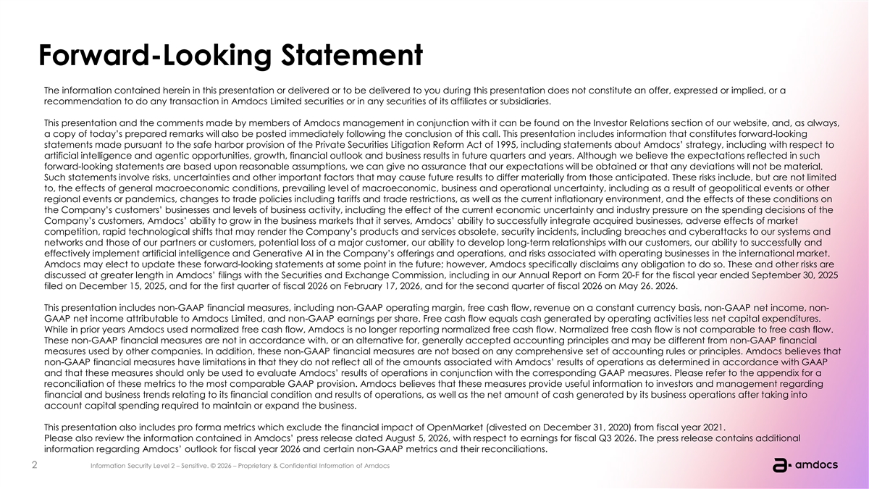
Forward-Looking Statement The information contained herein in this presentation or delivered or to be delivered to you during this presentation does not constitute an offer, expressed or implied, or a recommendation to do any transaction in Amdocs Limited securities or in any securities of its affiliates or subsidiaries. This presentation and the comments made by members of Amdocs management in conjunction with it can be found on the Investor Relations section of our website, and, as always, a copy of today’s prepared remarks will also be posted immediately following the conclusion of this call. This presentation includes information that constitutes forward-looking statements made pursuant to the safe harbor provision of the Private Securities Litigation Reform Act of 1995, including statements about Amdocs’ strategy, including with respect to artificial intelligence and agentic opportunities, growth, financial outlook and business results in future quarters and years. Although we believe the expectations reflected in such forward-looking statements are based upon reasonable assumptions, we can give no assurance that our expectations will be obtained or that any deviations will not be material. Such statements involve risks, uncertainties and other important factors that may cause future results to differ materially from those anticipated. These risks include, but are not limited to, the effects of general macroeconomic conditions, prevailing level of macroeconomic, business and operational uncertainty, including as a result of geopolitical events or other regional events or pandemics, changes to trade policies including tariffs and trade restrictions, as well as the current inflationary environment, and the effects of these conditions on the Company’s customers’ businesses and levels of business activity, including the effect of the current economic uncertainty and industry pressure on the spending decisions of the Company’s customers, Amdocs’ ability to grow in the business markets that it serves, Amdocs’ ability to successfully integrate acquired businesses, adverse effects of market competition, rapid technological shifts that may render the Company’s products and services obsolete, security incidents, including breaches and cyberattacks to our systems and networks and those of our partners or customers, potential loss of a major customer, our ability to develop long-term relationships with our customers, our ability to successfully and effectively implement artificial intelligence and Generative AI in the Company’s offerings and operations, and risks associated with operating businesses in the international market. Amdocs may elect to update these forward-looking statements at some point in the future; however, Amdocs specifically disclaims any obligation to do so. These and other risks are discussed at greater length in Amdocs’ filings with the Securities and Exchange Commission, including in our Annual Report on Form 20-F for the fiscal year ended September 30, 2025 filed on December 15, 2025, and for the first quarter of fiscal 2026 on February 17, 2026, and for the second quarter of fiscal 2026 on May 26. 2026. This presentation includes non-GAAP financial measures, including non-GAAP operating margin, free cash flow, revenue on a constant currency basis, non-GAAP net income, non- GAAP net income attributable to Amdocs Limited, and non-GAAP earnings per share. Free cash flow equals cash generated by operating activities less net capital expenditures. While in prior years Amdocs used normalized free cash flow, Amdocs is no longer reporting normalized free cash flow. Normalized free cash flow is not comparable to free cash flow. These non-GAAP financial measures are not in accordance with, or an alternative for, generally accepted accounting principles and may be different from non-GAAP financial measures used by other companies. In addition, these non-GAAP financial measures are not based on any comprehensive set of accounting rules or principles. Amdocs believes that non-GAAP financial measures have limitations in that they do not reflect all of the amounts associated with Amdocs’ results of operations as determined in accordance with GAAP and that these measures should only be used to evaluate Amdocs’ results of operations in conjunction with the corresponding GAAP measures. Please refer to the appendix for a reconciliation of these metrics to the most comparable GAAP provision. Amdocs believes that these measures provide useful information to investors and management regarding financial and business trends relating to its financial condition and results of operations, as well as the net amount of cash generated by its business operations after taking into account capital spending required to maintain or expand the business. This presentation also includes pro forma metrics which exclude the financial impact of OpenMarket (divested on December 31, 2020) from fiscal year 2021. Please also review the information contained in Amdocs’ press release dated August 5, 2026, with respect to earnings for fiscal Q3 2026. The press release contains additional information regarding Amdocs’ outlook for fiscal year 2026 and certain non-GAAP metrics and their reconciliations. 2 2 IIn nf fo or rm ma at tiio on n S Sec ecu ur riit ty y L Lev evel el 2 2 – – S Se en ns siit tiive ve.. © © 2026 2026 – – P Prrop oprriie et ta arry y & & C Con onffiid de en nt tiia all I In nffor orm ma at tiion on of of A Am md doc ocs s


Today’s speakers President & Chief Executive Officer Chief Financial Officer 3 Information Security Level 2 – Sensitive. © 2026 – Proprietary & Confidential Information of Amdocs

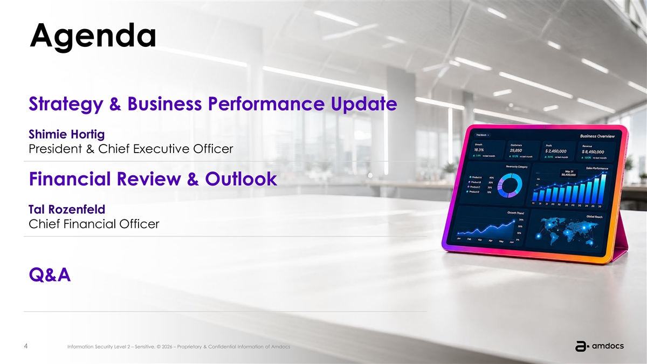
Agenda Strategy & Business Performance Update Shimie Hortig President & Chief Executive Officer Financial Review & Outlook Tal Rozenfeld Chief Financial Officer Q&A 4 4 IIn nf fo or rm ma at tiio on n S Sec ecu ur riit ty y L Lev evel el 2 2 – – S Se en ns siit tiive ve.. © © 2026 2026 – – P Prrop oprriie et ta arry y & & C Con onffiid de en nt tiia all I In nffor orm ma at tiion on of of A Am md doc ocs s


President & Chief Executive Officer Strategy and Business Performance Update 5 Information Security Level 2 – Sensitive. © 2026 – Proprietary & Confidential Information of Amdocs


1 Business Performance Update 6 6 IIn nf fo or rm ma at tiio on n S Sec ecu ur riit ty y L Lev evel el 2 2 – – S Se en ns siit tiive ve.. © © 2026 2026 – – P Prrop oprriie et ta arry y & & C Con onffiid de en nt tiia all I In nffor orm ma at tiion on of of A Am md doc ocs s

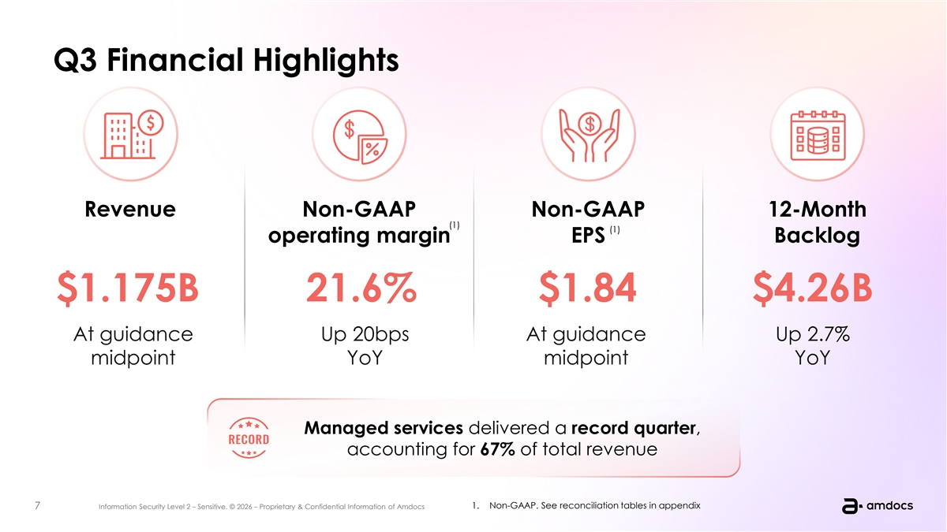
Q3 Financial Highlights Revenue Non-GAAP Non-GAAP 12-Month (1) (1) operating margin EPS Backlog $1.175B 21.6% $1.84 $4.26B At guidance Up 20bps At guidance Up 2.7% midpoint YoY midpoint YoY Managed services delivered a record quarter, accounting for 67% of total revenue 1. Non-GAAP. See reconciliation tables in appendix 7 7 IIn nf fo or rm ma at tiio on n S Sec ecu ur riit ty y L Lev evel el 2 2 – – S Se en ns siit tiive ve.. © © 2026 2026 – – P Prrop oprriie et ta arry y & & C Con onffiid de en nt tiia all I In nffor orm ma at tiion on of of A Am md doc ocs s

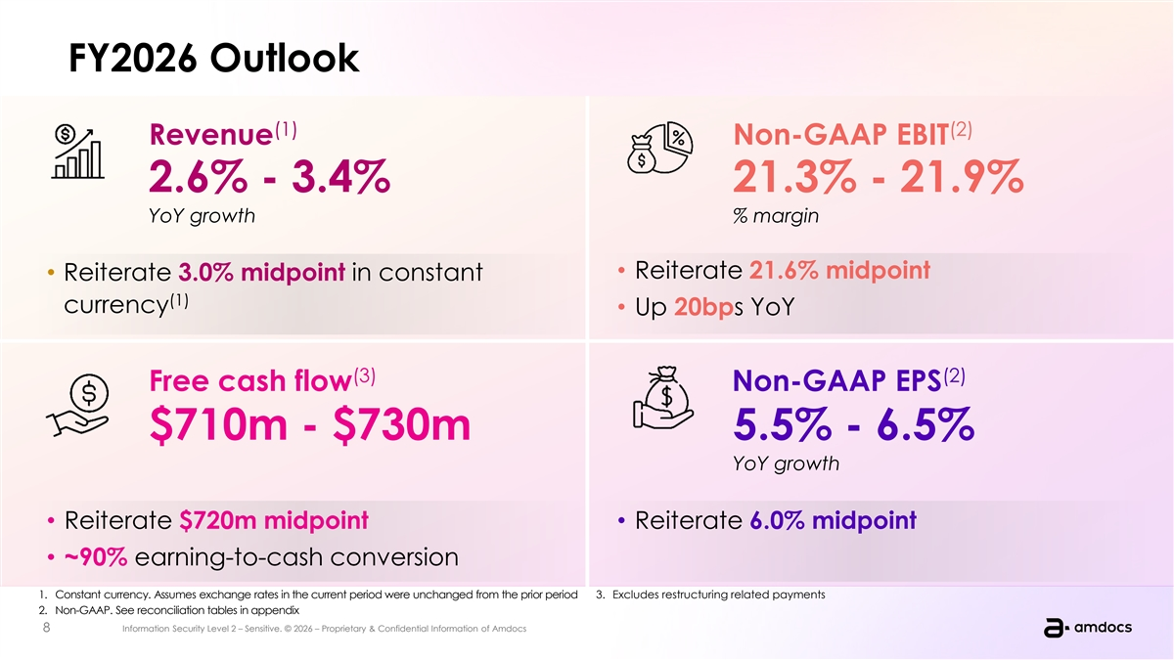
FY2026 Outlook (1) (2) Revenue Non-GAAP EBIT 2.6% - 3.4% 21.3% - 21.9% YoY growth % margin • Reiterate 21.6% midpoint • Reiterate 3.0% midpoint in constant (1) currency • Up 20bps YoY (3) (2) Free cash flow Non-GAAP EPS $710m - $730m 5.5% - 6.5% YoY growth • Reiterate $720m midpoint • Reiterate 6.0% midpoint • ~90% earning-to-cash conversion 1. Constant currency. Assumes exchange rates in the current period were unchanged from the prior period 3. Excludes restructuring related payments 2. Non-GAAP. See reconciliation tables in appendix 8 8 IIn nf fo or rm ma at tiio on n S Sec ecu ur riit ty y L Lev evel el 2 2 – – S Se en ns siit tiive ve.. © © 2026 2026 – – P Prrop oprriie et ta arry y & & C Con onffiid de en nt tiia all I In nffor orm ma at tiion on of of A Am md doc ocs s

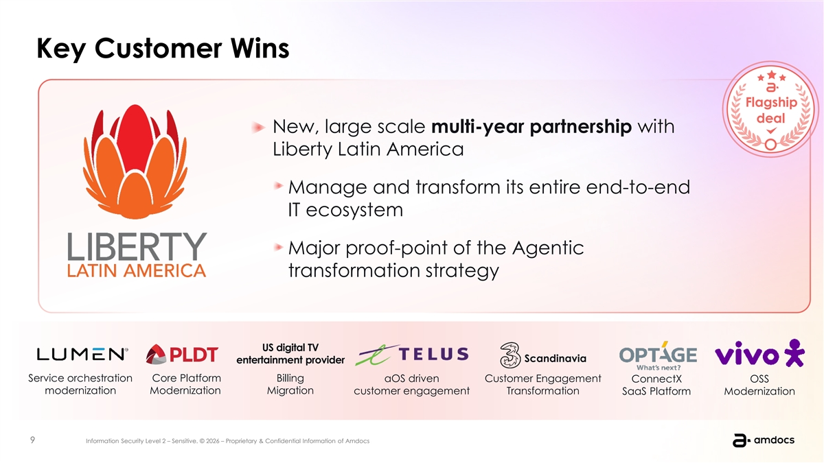
Key Customer Wins New, large scale multi-year partnership with Liberty Latin America Manage and transform its entire end-to-end IT ecosystem Major proof-point of the Agentic transformation strategy US digital TV Scandinavia entertainment provider Service orchestration Core Platform Billing aOS driven Customer Engagement ConnectX OSS modernization Modernization Migration customer engagement Transformation SaaS Platform Modernization 9 9 IIn nf fo or rm ma at tiio on n S Sec ecu ur riit ty y L Lev evel el 2 2 – – S Se en ns siit tiive ve.. © © 2026 2026 – – P Prrop oprriie et ta arry y & & C Con onffiid de en nt tiia all I In nffor orm ma at tiion on of of A Am md doc ocs s

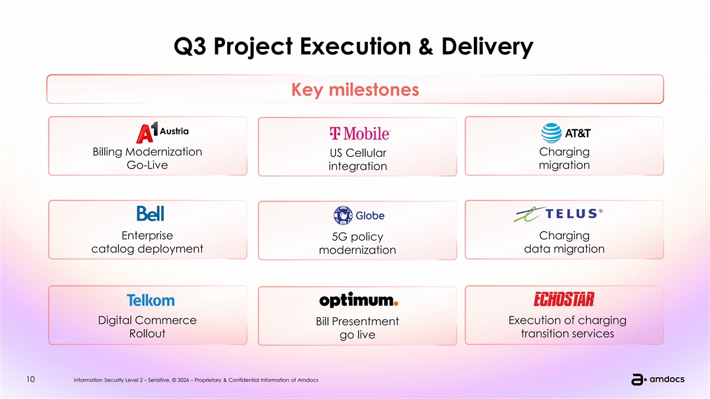
Q3 Project Execution & Delivery Key milestones Austria Billing Modernization Charging US Cellular Go-Live migration integration Enterprise Charging 5G policy catalog deployment data migration modernization Digital Commerce Execution of charging Bill Presentment Rollout transition services go live 10 10 IIn nf fo or rm ma at tiio on n S Sec ecu ur riit ty y L Lev evel el 2 2 – – S Se en ns siit tiive ve.. © © 2026 2026 – – P Prrop oprriie et ta arry y & & C Con onffiid de en nt tiia all I In nffor orm ma at tiion on of of A Am md doc ocs s


2 The Amdocs Strategy 11 11 IIn nf fo or rm ma at tiio on n S Sec ecu ur riit ty y L Lev evel el 2 2 – – S Se en ns siit tiive ve.. © © 2026 2026 – – P Prrop oprriie et ta arry y & & C Con onffiid de en nt tiia all I In nffor orm ma at tiion on of of A Am md doc ocs s

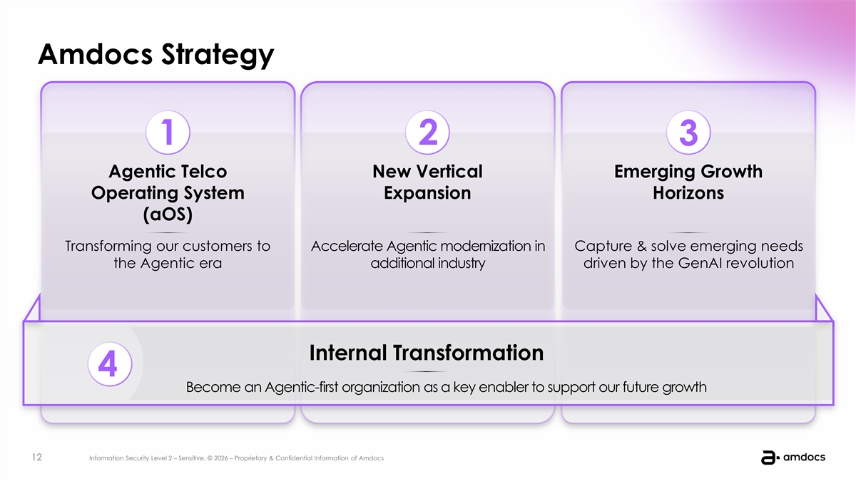
Amdocs Strategy 1 2 3 Agentic Telco New Vertical Emerging Growth Operating System Expansion Horizons (aOS) Transforming our customers to Accelerate Agentic modernization in Capture & solve emerging needs the Agentic era additional industry driven by the GenAI revolution Internal Transformation 4 Become an Agentic-first organization as a key enabler to support our future growth 12 12 IIn nf fo or rm ma at tiio on n S Sec ecu ur riit ty y L Lev evel el 2 2 – – S Se en ns siit tiive ve.. © © 2026 2026 – – P Prrop oprriie et ta arry y & & C Con onffiid de en nt tiia all I In nffor orm ma at tiion on of of A Am md doc ocs s

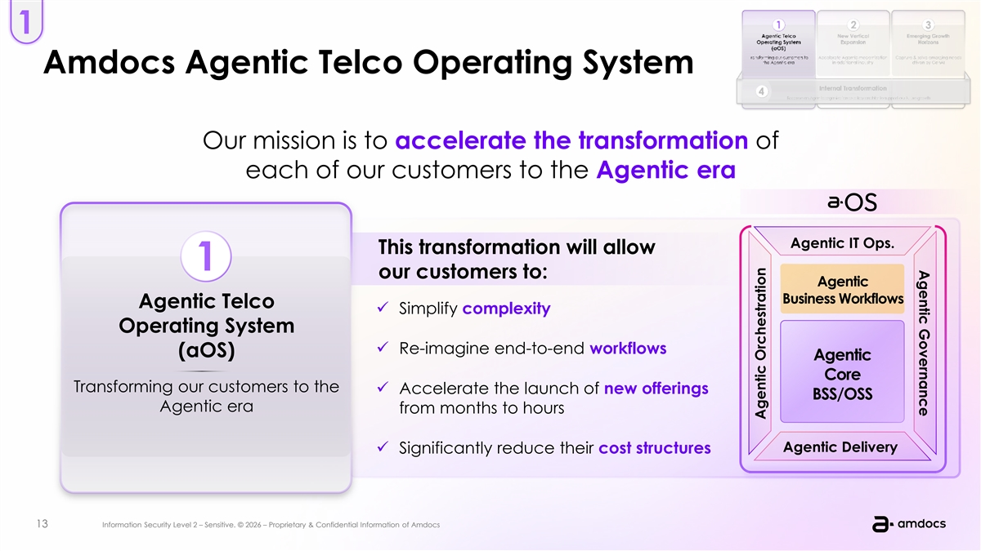
Agentic Governance 1 Amdocs Agentic Telco Operating System Our mission is to accelerate the transformation of each of our customers to the Agentic era Agentic IT Ops. This transformation will allow 1 our customers to: Agentic Business Workflows Agentic Telco ü Simplify complexity Operating System ü Re-imagine end-to-end workflows (aOS) Agentic Core Transforming our customers to the ü Accelerate the launch of new offerings BSS/OSS Agentic era from months to hours Agentic Delivery ü Significantly reduce their cost structures 13 13 IIn nf fo or rm ma at tiio on n S Sec ecu ur riit ty y L Lev evel el 2 2 – – S Se en ns siit tiive ve.. © © 2026 2026 – – P Prrop oprriie et ta arry y & & C Con onffiid de en nt tiia all I In nffor orm ma at tiion on of of A Am md doc ocs s Agentic Orchestration

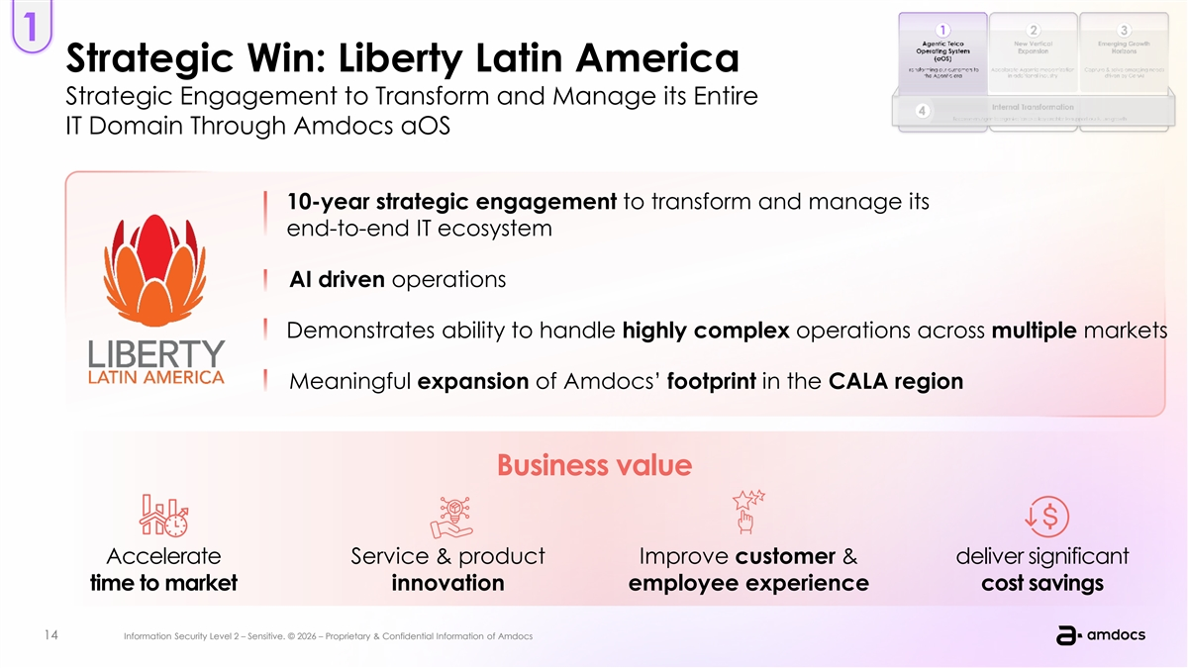
1 Strategic Win: Liberty Latin America Strategic Engagement to Transform and Manage its Entire IT Domain Through Amdocs aOS 10-year strategic engagement to transform and manage its end-to-end IT ecosystem AI driven operations Demonstrates ability to handle highly complex operations across multiple markets Meaningful expansion of Amdocs’ footprint in the CALA region Business value Accelerate Service & product Improve customer & deliver significant time to market innovation employee experience cost savings 14 14 IIn nf fo or rm ma at tiio on n S Sec ecu ur riit ty y L Lev evel el 2 2 – – S Se en ns siit tiive ve.. © © 2026 2026 – – P Prrop oprriie et ta arry y & & C Con onffiid de en nt tiia all I In nffor orm ma at tiion on of of A Am md doc ocs s

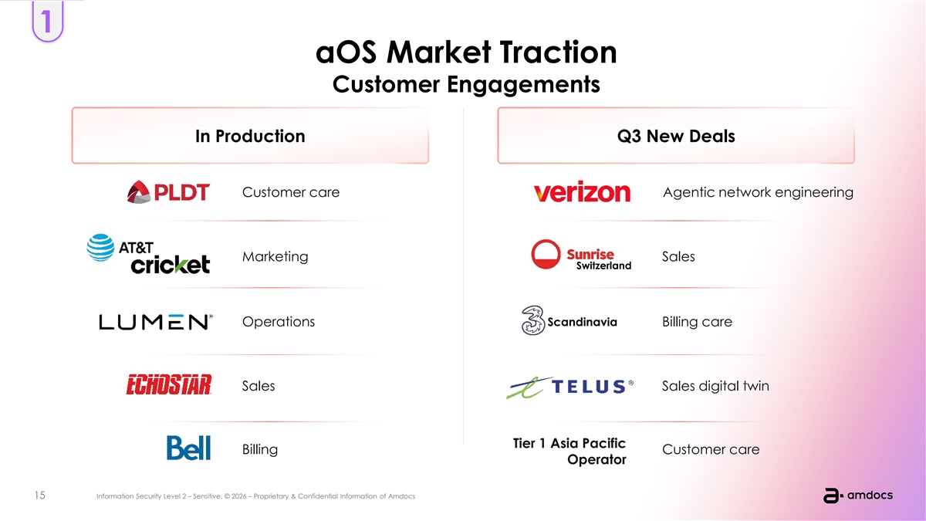
1 aOS Market Traction Customer Engagements In Production Q3 New Deals Customer care Agentic network engineering Marketing Sales Switzerland Operations Scandinavia Billing care Sales Sales digital twin Tier 1 Asia Pacific Billing Customer care Operator 15 15 IIn nf fo or rm ma at tiio on n S Sec ecu ur riit ty y L Lev evel el 2 2 – – S Se en ns siit tiive ve.. © © 2026 2026 – – P Prrop oprriie et ta arry y & & C Con onffiid de en nt tiia all I In nffor orm ma at tiion on of of A Am md doc ocs s

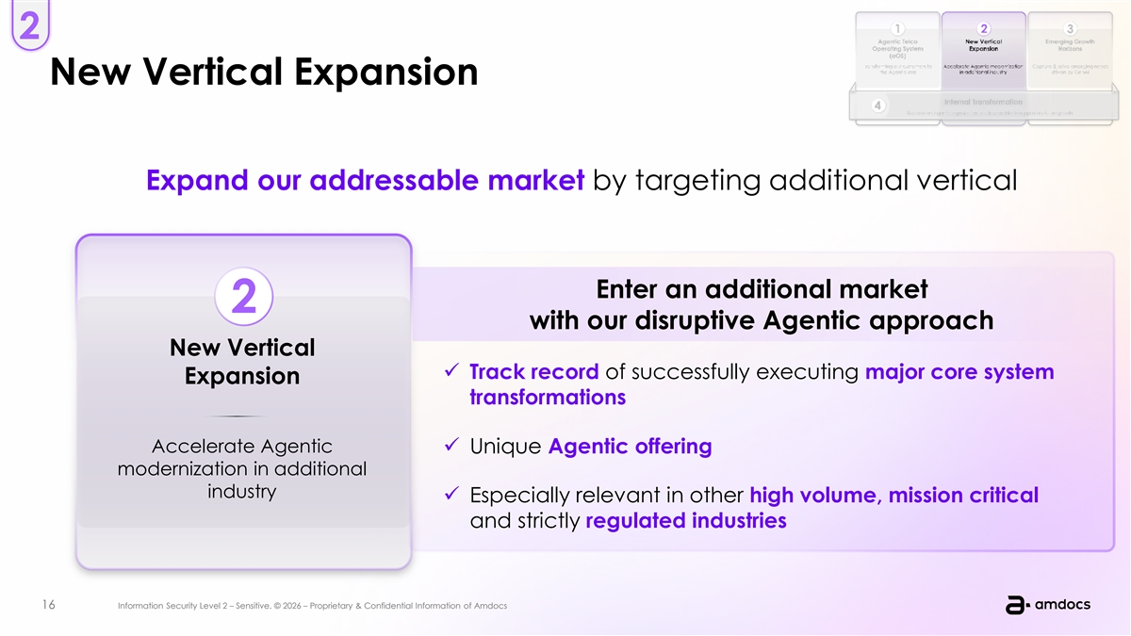
2 New Vertical Expansion Expand our addressable market by targeting additional vertical Enter an additional market 2 with our disruptive Agentic approach New Vertical ü Track record of successfully executing major core system Expansion transformations Accelerate Agentic ü Unique Agentic offering modernization in additional industry ü Especially relevant in other high volume, mission critical and strictly regulated industries 16 16 IIn nf fo or rm ma at tiio on n S Sec ecu ur riit ty y L Lev evel el 2 2 – – S Se en ns siit tiive ve.. © © 2026 2026 – – P Prrop oprriie et ta arry y & & C Con onffiid de en nt tiia all I In nffor orm ma at tiion on of of A Am md doc ocs s

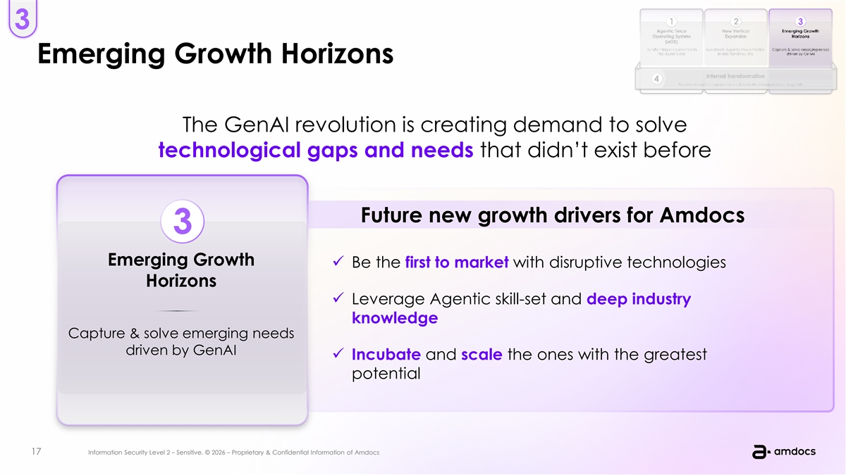
3 Emerging Growth Horizons The GenAI revolution is creating demand to solve technological gaps and needs that didn’t exist before Future new growth drivers for Amdocs 3 Emerging Growth ü Be the first to market with disruptive technologies Horizons ü Leverage Agentic skill-set and deep industry knowledge Capture & solve emerging needs driven by GenAI ü Incubate and scale the ones with the greatest potential 17 17 IIn nf fo or rm ma at tiio on n S Sec ecu ur riit ty y L Lev evel el 2 2 – – S Se en ns siit tiive ve.. © © 2026 2026 – – P Prrop oprriie et ta arry y & & C Con onffiid de en nt tiia all I In nffor orm ma at tiion on of of A Am md doc ocs s

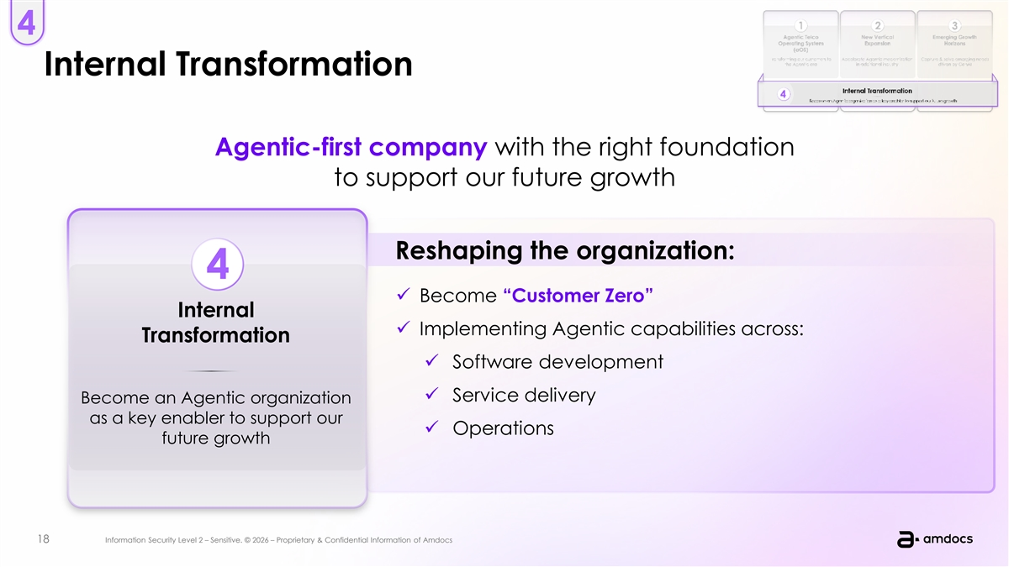
4 Internal Transformation Agentic-first company with the right foundation to support our future growth Reshaping the organization: 4 ü Become “Customer Zero” Internal ü Implementing Agentic capabilities across: Transformation ü Software development ü Service delivery Become an Agentic organization as a key enabler to support our ü Operations future growth 18 18 IIn nf fo or rm ma at tiio on n S Sec ecu ur riit ty y L Lev evel el 2 2 – – S Se en ns siit tiive ve.. © © 2026 2026 – – P Prrop oprriie et ta arry y & & C Con onffiid de en nt tiia all I In nffor orm ma at tiion on of of A Am md doc ocs s


Bringing it all together 1 2 We have the right strategy to seize this Our recent commercial momentum exciting opportunity for Amdocs is an important proof point and our telco customers 4 3 We see opportunities to expand We’ve got the right talent, skills and beyond telco to an additional leadership necessary to quickly vertical and new emerging horizons adapt and drive us forward 19 19 IIn nf fo or rm ma at tiio on n S Sec ecu ur riit ty y L Lev evel el 2 2 – – S Se en ns siit tiive ve.. © © 2026 2026 – – P Prrop oprriie et ta arry y & & C Con onffiid de en nt tiia all I In nffor orm ma at tiion on of of A Am md doc ocs s


Chief Financial Officer Financial Review & Outlook 20 Information Security Level 2 – Sensitive. © 2026 – Proprietary & Confidential Information of Amdocs

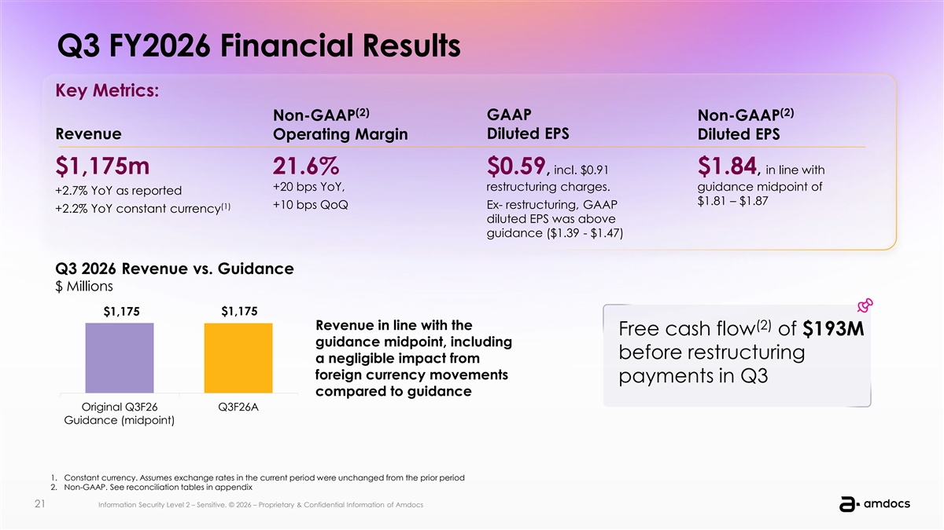
Q3 FY2026 Financial Results Key Metrics: (2) (2) Non-GAAP GAAP Non-GAAP Revenue Operating Margin Diluted EPS Diluted EPS $1,175m 21.6% $0.59, incl. $0.91 $1.84, in line with +20 bps YoY, restructuring charges. guidance midpoint of +2.7% YoY as reported $1.81 – $1.87 (1) +10 bps QoQ Ex- restructuring, GAAP +2.2% YoY constant currency diluted EPS was above guidance ($1.39 - $1.47) Q3 2026 Revenue vs. Guidance $ Millions $1,175 $1,175 Revenue in line with the (2) Free cash flow of $193M guidance midpoint, including before restructuring a negligible impact from foreign currency movements payments in Q3 compared to guidance Original Q3F26 Q3F26A Guidance (midpoint) 1. Constant currency. Assumes exchange rates in the current period were unchanged from the prior period 2. Non-GAAP. See reconciliation tables in appendix 21 21 IIn nf fo or rm ma at tiio on n S Sec ecu ur riit ty y L Lev evel el 2 2 – – S Se en ns siit tiive ve.. © © 2026 2026 – – P Prrop oprriie et ta arry y & & C Con onffiid de en nt tiia all I In nffor orm ma at tiion on of of A Am md doc ocs s

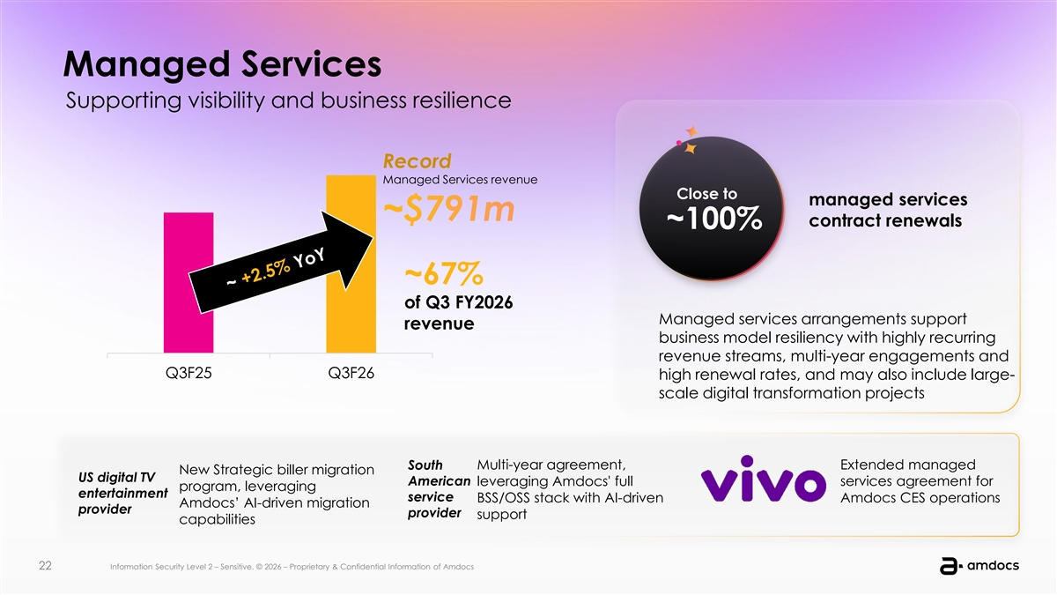
Managed Services Supporting visibility and business resilience Record Managed Services revenue Close to managed services contract renewals ~100% ~67% of Q3 FY2026 Managed services arrangements support revenue business model resiliency with highly recurring revenue streams, multi-year engagements and Q3F25 Q3F26 high renewal rates, and may also include large- scale digital transformation projects South Multi-year agreement, Extended managed New Strategic biller migration US digital TV American leveraging Amdocs' full services agreement for program, leveraging entertainment service BSS/OSS stack with AI-driven Amdocs CES operations Amdocs’ AI-driven migration provider provider support capabilities 22 22 IIn nf fo or rm ma at tiio on n S Sec ecu ur riit ty y L Lev evel el 2 2 – – S Se en ns siit tiive ve.. © © 2026 2026 – – P Prrop oprriie et ta arry y & & C Con onffiid de en nt tiia all I In nffor orm ma at tiion on of of A Am md doc ocs s

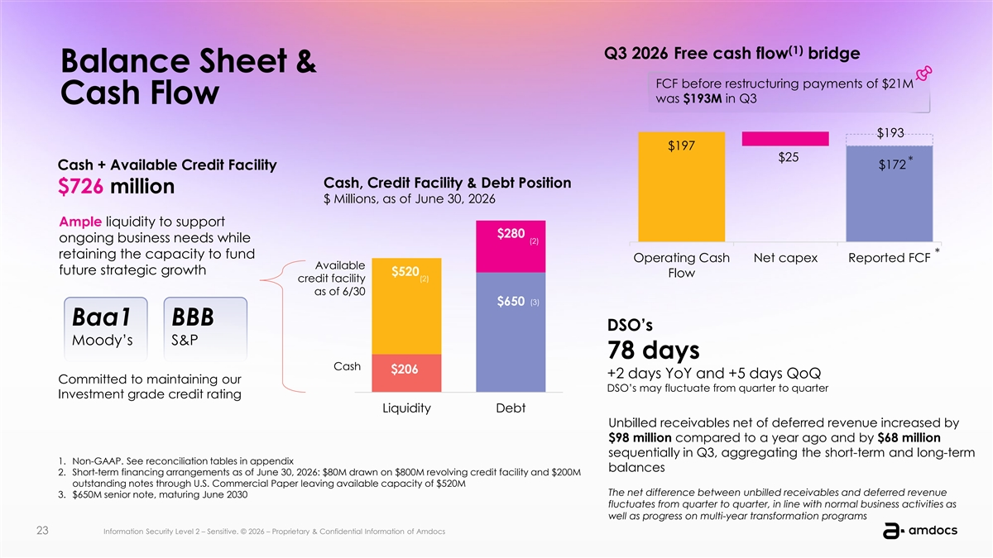
(1) Q3 2026 Free cash flow bridge Balance Sheet & FCF before restructuring payments of $21M was $193M in Q3 Cash Flow $193 $197 $25 * $172 Cash + Available Credit Facility Cash, Credit Facility & Debt Position $726 million $ Millions, as of June 30, 2026 Ample liquidity to support $280 ongoing business needs while (2) * retaining the capacity to fund Operating Cash Net capex Reported FCF Available future strategic growth $520 Flow (2) credit facility as of 6/30 (3) $650 Baa1 BBB DSO’s Moody’s S&P 78 days Cash $206 +2 days YoY and +5 days QoQ Committed to maintaining our DSO’s may fluctuate from quarter to quarter Investment grade credit rating Liquidity Debt Unbilled receivables net of deferred revenue increased by $98 million compared to a year ago and by $68 million sequentially in Q3, aggregating the short-term and long-term 1. Non-GAAP. See reconciliation tables in appendix balances 2. Short-term financing arrangements as of June 30, 2026: $80M drawn on $800M revolving credit facility and $200M outstanding notes through U.S. Commercial Paper leaving available capacity of $520M The net difference between unbilled receivables and deferred revenue 3. $650M senior note, maturing June 2030 fluctuates from quarter to quarter, in line with normal business activities as well as progress on multi-year transformation programs 23 23 IIn nf fo or rm ma at tiio on n S Sec ecu ur riit ty y L Lev evel el 2 2 – – S Se en ns siit tiive ve.. © © 2026 2026 – – P Prrop oprriie et ta arry y & & C Con onffiid de en nt tiia all I In nffor orm ma at tiion on of of A Am md doc ocs s

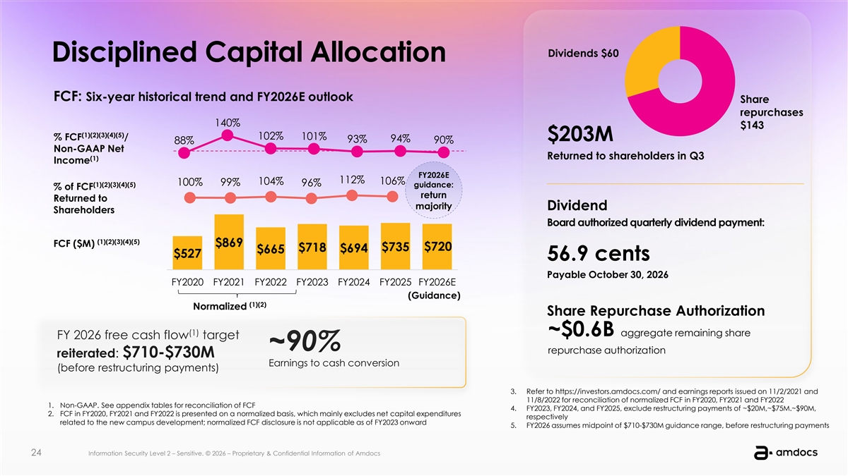
Dividends $60 Disciplined Capital Allocation FCF: Six-year historical trend and FY2026E outlook Share repurchases 140% $143 (1)(2)(3)(4)(5) 102% % FCF / 101% $203M 94% 93% 90% 88% Non-GAAP Net Returned to shareholders in Q3 (1) Income FY2026E 112% 106% 104% 100% 99% (1)(2)(3)(4)(5) 96% guidance: % of FCF return Returned to majority Dividend Shareholders Board authorized quarterly dividend payment: (1)(2)(3)(4)(5) FCF ($M) $869 $735 $720 $718 $694 $665 $527 56.9 cents Payable October 30, 2026 FY2020 FY2021 FY2022 FY2023 FY2024 FY2025 FY2026E (Guidance) (1)(2) Normalized Share Repurchase Authorization (1) ~$0.6B aggregate remaining share FY 2026 free cash flow target ~90% repurchase authorization reiterated: $710-$730M Earnings to cash conversion (before restructuring payments) 3. Refer to https://investors.amdocs.com/ and earnings reports issued on 11/2/2021 and 11/8/2022 for reconciliation of normalized FCF in FY2020, FY2021 and FY2022 1. Non-GAAP. See appendix tables for reconciliation of FCF 4. FY2023, FY2024, and FY2025, exclude restructuring payments of ~$20M,~$75M.~$90M, 2. FCF in FY2020, FY2021 and FY2022 is presented on a normalized basis, which mainly excludes net capital expenditures respectively related to the new campus development; normalized FCF disclosure is not applicable as of FY2023 onward 5. FY2026 assumes midpoint of $710-$730M guidance range, before restructuring payments 24 24 IIn nf fo or rm ma at tiio on n S Sec ecu ur riit ty y L Lev evel el 2 2 – – S Se en ns siit tiive ve.. © © 2026 2026 – – P Prrop oprriie et ta arry y & & C Con onffiid de en nt tiia all I In nffor orm ma at tiion on of of A Am md doc ocs s

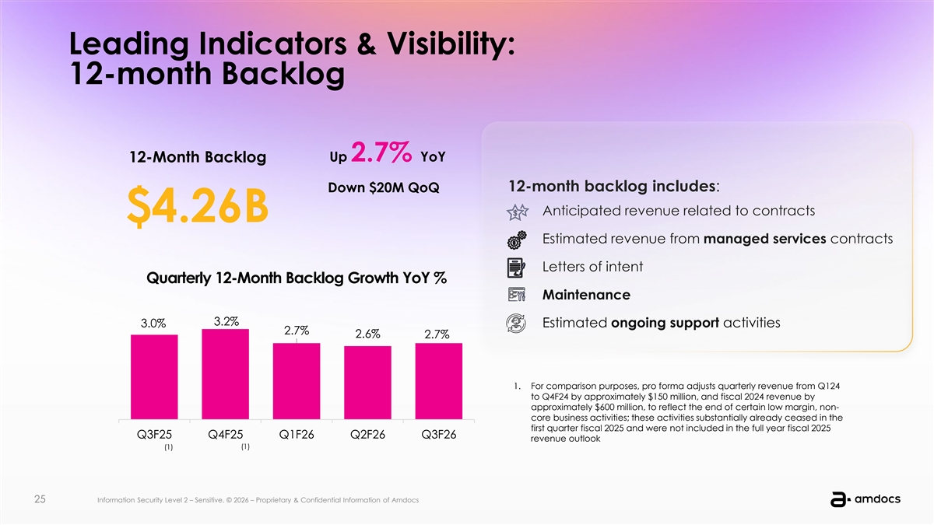
Leading Indicators & Visibility: 12-month Backlog Up 2.7% YoY 12-Month Backlog 12-month backlog includes: Down $20M QoQ Anticipated revenue related to contracts $4.26B Estimated revenue from managed services contracts Letters of intent Quarterly 12-Month Backlog Growth YoY % Maintenance 3.2% 3.0% Estimated ongoing support activities 2.7% 2.6% 2.7% 1. For comparison purposes, pro forma adjusts quarterly revenue from Q124 to Q4F24 by approximately $150 million, and fiscal 2024 revenue by approximately $600 million, to reflect the end of certain low margin, non- core business activities; these activities substantially already ceased in the first quarter fiscal 2025 and were not included in the full year fiscal 2025 Q3F25 Q4F25 Q1F26 Q2F26 Q3F26 revenue outlook (1) (1) 25 25 IIn nf fo or rm ma at tiio on n S Sec ecu ur riit ty y L Lev evel el 2 2 – – S Se en ns siiti tiv ve e.. © © 2026 2026 – – P Prrop oprriie et ta arry y & & C Con onffiid de en nt tiia all I In nffor orm ma at tiion on of of A Am md doc ocs s

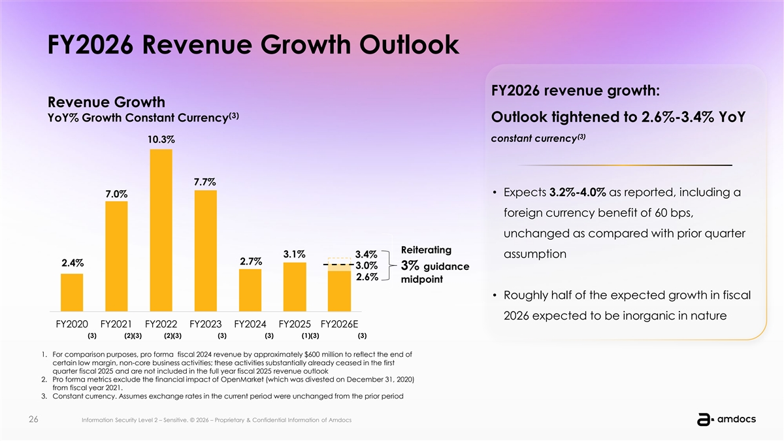
FY2026 Revenue Growth Outlook FY2026 revenue growth: Revenue Growth (3) YoY% Growth Constant Currency Outlook tightened to 2.6%-3.4% YoY (3) constant currency 10.3% 7.7% • Expects 3.2%-4.0% as reported, including a 7.0% foreign currency benefit of 60 bps, unchanged as compared with prior quarter Reiterating 3.1% 3.4% assumption 2.7% 2.4% 3.0% 3% guidance 2.6% midpoint • Roughly half of the expected growth in fiscal 2026 expected to be inorganic in nature FY2020 FY2021 FY2022 FY2023 FY2024 FY2025 FY2026E (3) (2)(3) (2)(3) (3) (3) (1)(3) (3) 1. For comparison purposes, pro forma fiscal 2024 revenue by approximately $600 million to reflect the end of certain low margin, non-core business activities; these activities substantially already ceased in the first quarter fiscal 2025 and are not included in the full year fiscal 2025 revenue outlook 2. Pro forma metrics exclude the financial impact of OpenMarket (which was divested on December 31, 2020) from fiscal year 2021. 3. Constant currency. Assumes exchange rates in the current period were unchanged from the prior period 26 26 IIn nf fo or rm ma at tiio on n S Sec ecu ur riit ty y L Lev evel el 2 2 – – S Se en ns siit tiive ve.. © © 2026 2026 – – P Prrop oprriie et ta arry y & & C Con onffiid de en nt tiia all I In nffor orm ma at tiion on of of A Am md doc ocs s

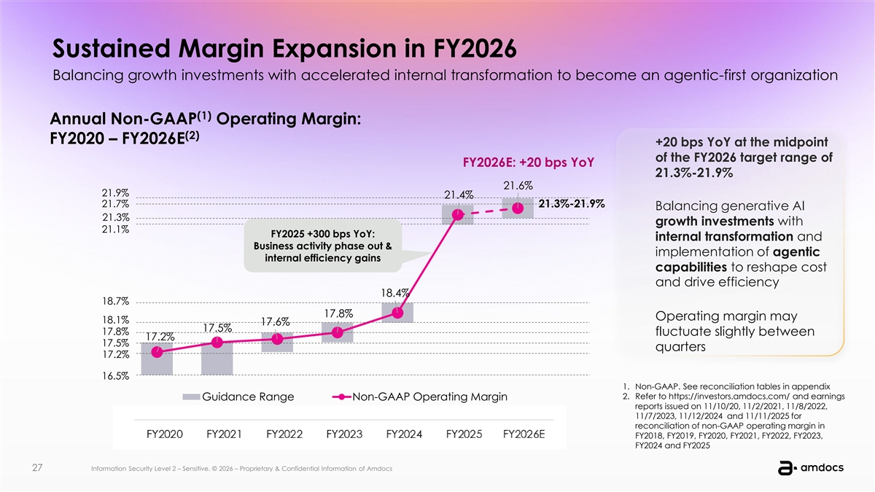
Sustained Margin Expansion in FY2026 Balancing growth investments with accelerated internal transformation to become an agentic-first organization (1) Annual Non-GAAP Operating Margin: (2) FY2020 – FY2026E +20 bps YoY at the midpoint of the FY2026 target range of FY2026E: +20 bps YoY 21.3%-21.9% 21.6% 21.9% 21.4% 21.7% 21.3%-21.9% Balancing generative AI 21.3% growth investments with 21.1% FY2025 +300 bps YoY: internal transformation and Business activity phase out & implementation of agentic internal efficiency gains capabilities to reshape cost and drive efficiency 18.4% 18.7% 17.8% Operating margin may 18.1% 17.6% 17.5% 17.8% fluctuate slightly between 17.2% 17.5% quarters 17.2% 16.5% 1. Non-GAAP. See reconciliation tables in appendix 2. Refer to https://investors.amdocs.com/ and earnings Guidance Range Non-GAAP Operating Margin reports issued on 11/10/20, 11/2/2021, 11/8/2022, 11/7/2023, 11/12/2024 and 11/11/2025 for reconciliation of non-GAAP operating margin in FY2018, FY2019, FY2020, FY2021, FY2022, FY2023, FY2024 and FY2025 27 27 IIn nf fo or rm ma at tiio on n S Sec ecu ur riit ty y L Lev evel el 2 2 – – S Se en ns siiti tiv ve e.. © © 2026 2026 – – P Prrop oprriie et ta arry y & & C Con onffiid de en nt tiia all I In nffor orm ma at tiion on of of A Am md doc ocs s

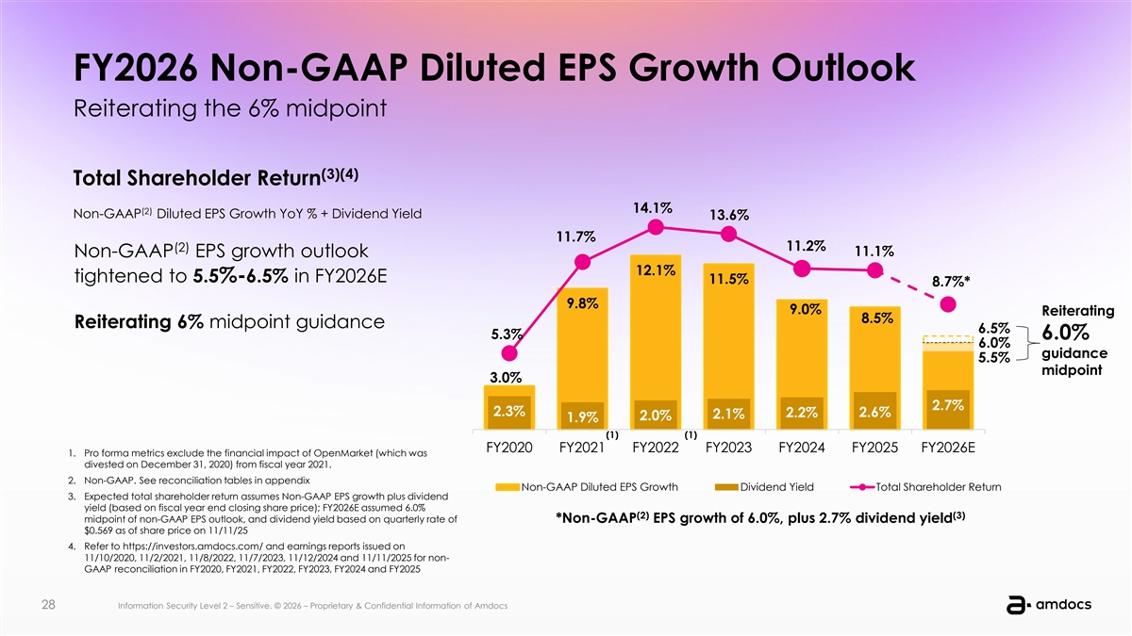
FY2026 Non-GAAP Diluted EPS Growth Outlook Reiterating the 6% midpoint (3)(4) Total Shareholder Return 14.1% (2) Non-GAAP Diluted EPS Growth YoY % + Dividend Yield 13.6% 11.7% 11.2% (2) 11.1% Non-GAAP EPS growth outlook 12.1% tightened to 5.5%-6.5% in FY2026E 11.5% 8.7%* 9.8% 9.0% Reiterating 8.5% Reiterating 6% midpoint guidance 6.5% 5.3% 6.0% 6.0% guidance 5.5% midpoint 3.0% 2.7% 2.3% 2.2% 2.6% 2.1% 2.0% 1.9% (1) (1) FY2020 FY2021 FY2022 FY2023 FY2024 FY2025 FY2026E 1. Pro forma metrics exclude the financial impact of OpenMarket (which was divested on December 31, 2020) from fiscal year 2021. 2. Non-GAAP. See reconciliation tables in appendix Non-GAAP Diluted EPS Growth Dividend Yield Total Shareholder Return 3. Expected total shareholder return assumes Non-GAAP EPS growth plus dividend yield (based on fiscal year end closing share price); FY2026E assumed 6.0% (2) (3) midpoint of non-GAAP EPS outlook, and dividend yield based on quarterly rate of *Non-GAAP EPS growth of 6.0%, plus 2.7% dividend yield $0.569 as of share price on 11/11/25 4. Refer to https://investors.amdocs.com/ and earnings reports issued on 11/10/2020, 11/2/2021, 11/8/2022, 11/7/2023, 11/12/2024 and 11/11/2025 for non- GAAP reconciliation in FY2020, FY2021, FY2022, FY2023, FY2024 and FY2025 28 28 IIn nf fo or rm ma at tiio on n S Sec ecu ur riit ty y L Lev evel el 2 2 – – S Se en ns siiti tiv ve e.. © © 2026 2026 – – P Prrop oprriie et ta arry y & & C Con onffiid de en nt tiia all I In nffor orm ma at tiion on of of A Am md doc ocs s


Q&A 29 29 IIn nf fo or rm ma at tiio on n S Sec ecu ur riit ty y L Lev evel el 2 2 – – S Se en ns siiti tiv ve e.. © © 2026 2026 – – P Prrop oprriie et ta arry y & & C Con onffiid de en nt tiia all I In nffor orm ma at tiion on of of A Am md doc ocs s

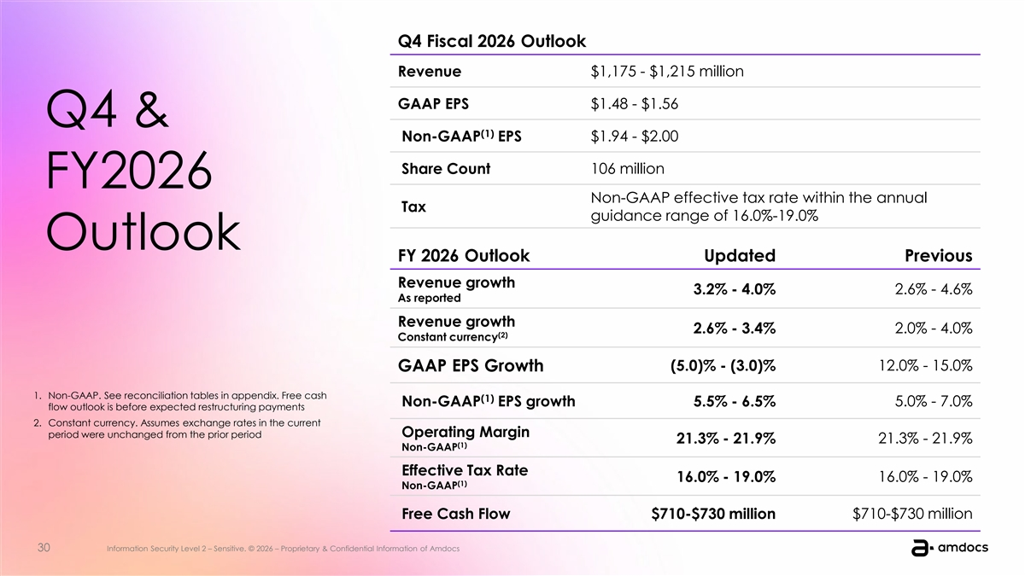
Q4 Fiscal 2026 Outlook Revenue $1,175 - $1,215 million GAAP EPS $1.48 - $1.56 Q4 & (1) Non-GAAP EPS $1.94 - $2.00 Share Count 106 million FY2026 Non-GAAP effective tax rate within the annual Tax guidance range of 16.0%-19.0% Outlook FY 2026 Outlook Updated Previous Revenue growth 3.2% - 4.0% 2.6% - 4.6% As reported Revenue growth 2.6% - 3.4% 2.0% - 4.0% (2) Constant currency GAAP EPS Growth (5.0)% - (3.0)% 12.0% - 15.0% 1. Non-GAAP. See reconciliation tables in appendix. Free cash (1) Non-GAAP EPS growth 5.5% - 6.5% 5.0% - 7.0% flow outlook is before expected restructuring payments 2. Constant currency. Assumes exchange rates in the current Operating Margin period were unchanged from the prior period 21.3% - 21.9% 21.3% - 21.9% (1) Non-GAAP Effective Tax Rate 16.0% - 19.0% 16.0% - 19.0% (1) Non-GAAP Free Cash Flow $710-$730 million $710-$730 million 30 30 IIn nf fo or rm ma at tiio on n S Sec ecu ur riit ty y L Lev evel el 2 2 – – S Se en ns siit tiive ve.. © © 2026 2026 – – P Prrop oprriie et ta arry y & & C Con onffiid de en nt tiia all I In nffor orm ma at tiion on of of A Am md doc ocs s


Appendix Outlook & Reconciliation Tables 31 31 IIn nf fo or rm ma at tiio on n S Sec ecu ur riit ty y L Lev evel el 2 2 – – S Se en ns siit tiive ve.. © © 2026 2026 – – P Prrop oprriie et ta arry y & & C Con onffiid de en nt tiia all I In nffor orm ma at tiion on of of A Am md doc ocs s

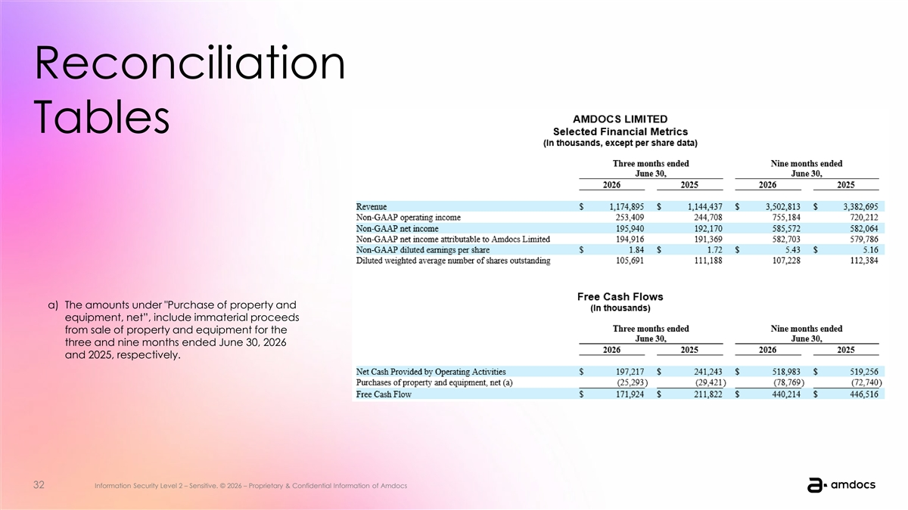
Reconciliation Tables a) The amounts under Purchase of property and equipment, net”, include immaterial proceeds from sale of property and equipment for the three and nine months ended June 30, 2026 and 2025, respectively. 32 32 IIn nf fo or rm ma at tiio on n S Sec ecu ur riit ty y L Lev evel el 2 2 – – S Se en ns siit tiive ve.. © © 2026 2026 – – P Prrop oprriie et ta arry y & & C Con onffiid de en nt tiia all I In nffor orm ma at tiion on of of A Am md doc ocs s

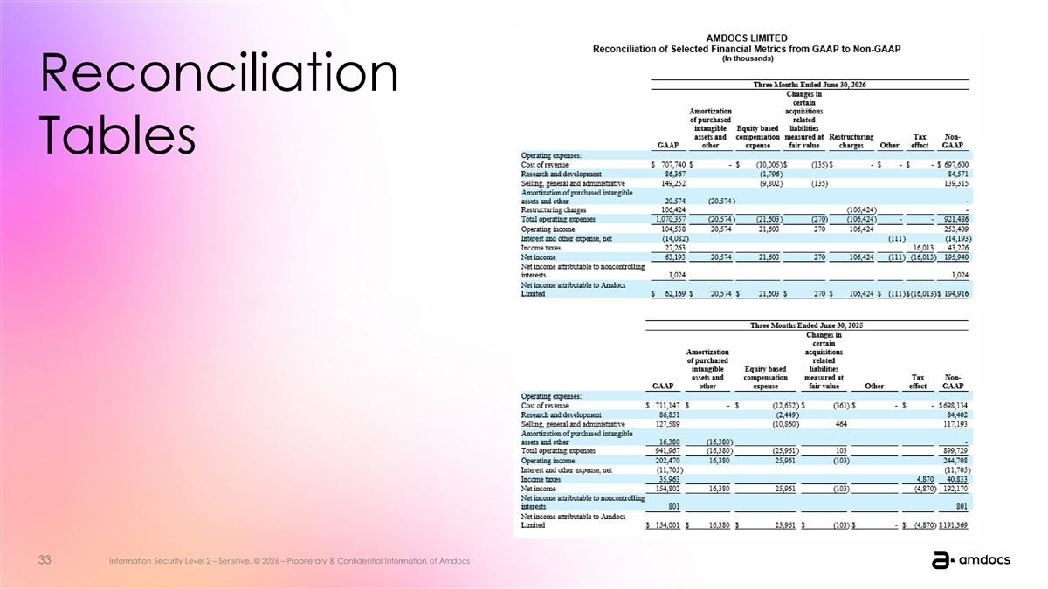
Reconciliation Tables 33 33 IIn nf fo or rm ma at tiio on n S Sec ecu ur riit ty y L Lev evel el 2 2 – – S Se en ns siit tiive ve.. © © 2026 2026 – – P Prrop oprriie et ta arry y & & C Con onffiid de en nt tiia all I In nffor orm ma at tiion on of of A Am md doc ocs s

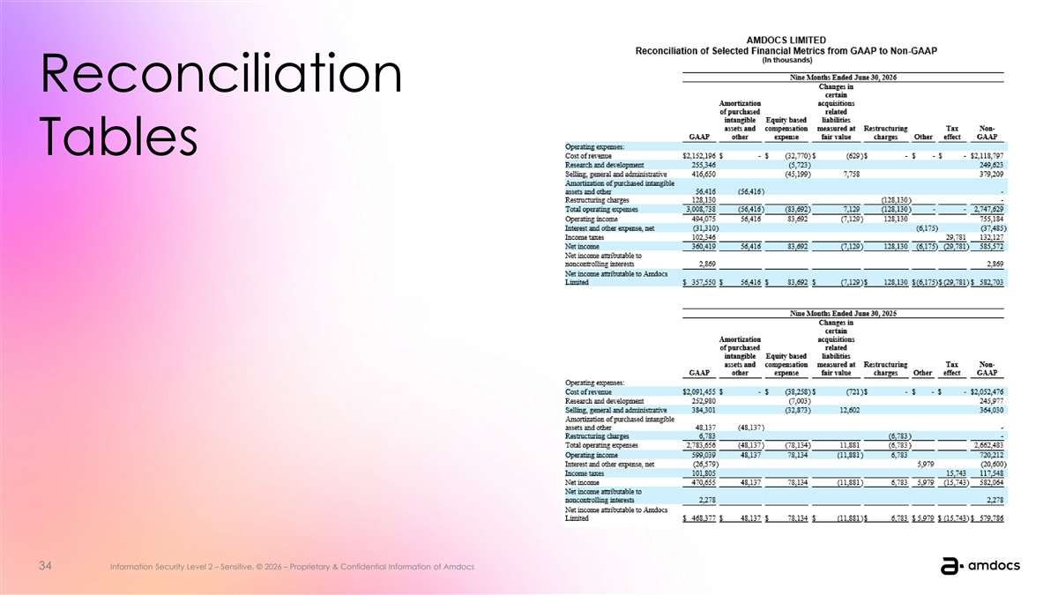
Reconciliation Tables 34 34 IIn nf fo or rm ma at tiio on n S Sec ecu ur riit ty y L Lev evel el 2 2 – – S Se en ns siit tiive ve.. © © 2026 2026 – – P Prrop oprriie et ta arry y & & C Con onffiid de en nt tiia all I In nffor orm ma at tiion on of of A Am md doc ocs s


35 Information Security Level 2 – Sensitive. © 2026 – Proprietary & Confidential Information of Amdocs

