UNITED STATES SECURITIES AND EXCHANGE COMMISSION

WASHINGTON, D.C. 20549

FORM 6-K

REPORT OF FOREIGN PRIVATE ISSUER

PURSUANT TO RULE 13a-16 OR 15d-16 UNDER
THE SECURITIES EXCHANGE ACT OF 1934

For the month of December 2010

Commission File Number 1-14840

AMDOCS LIMITED

Suite 5, Tower Hill House Le Bordage

St. Peter Port, Island of Guernsey, GY1 3QT

Amdocs, Inc.

1390 Timberlake Manor Parkway, Chesterfield, Missouri 63017

(Address of principal executive offices)

Indicate by check mark whether the registrant files or will file annual reports under cover of Form 20-F or Form 40-F:

FORM 20-F ☑ FORM 40-F o

Indicate by check mark if the registrant is submitting the Form 6-K in paper as permitted by Regulation S-T Rule 101(b)(1): o

Indicate by check mark if the registrant is submitting the Form 6-K in paper as permitted by Regulation S-T Rule 101(b)(7): o

Indicate by check mark whether the registrant by furnishing the information contained in this Form is also thereby furnishing the information to the

Commission pursuant to Rule 12g3-2(b) under the Securities Exchange Act of 1934:

YES o NO ☑

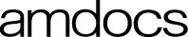
NOTICE OF ANNUAL GENERAL MEETING OF SHAREHOLDERS

TO BE HELD ON WEDNESDAY, JANUARY 26, 2011

To the Shareholders:

The annual general meeting of shareholders of Amdocs Limited will be held at 10:00 a.m., local time, on Wednesday, January 26, 2011, at the offices of WilmerHale, 399 Park Avenue, New York, New York, 31st floor, for the following purposes:
- To approve the election of each of the following 13 individuals to serve as directors of Amdocs Limited until the next annual general meeting of shareholders or until his earlier resignation or removal or until his respective successor is elected and qualified (Proposal I);

Bruce K. Anderson

Adrian Gardner

Charles E. Foster

James S. Kahan

Zohar Zisapel

Julian A. Brodsky

Eli Gelman

Nehemia Lemelbaum

John T. McLennan

Robert A. Minicucci

Simon Olswang

Richard Sarnoff

Giora Yaron

- To approve our Consolidated Financial Statements for the fiscal year ended September 30, 2010 (Proposal II); and

- To ratify and approve the appointment of Ernst & Young LLP as our independent registered public accounting firm for the fiscal year ending September 30, 2011, and until the next annual general meeting, and authorize the Audit Committee of the Board of Directors to fix the remuneration of such independent registered public accounting firm in accordance with the nature and extent of its services (Proposal III). Our shareholders will also act on such other business as may properly come before the annual general meeting.

The Board of Directors has fixed the close of business on November 22, 2010 as the record date for the determination of our shareholders entitled to notice of, and to vote on the matters proposed at, the annual general meeting and any adjournments thereof.

By Order of the Board of Directors
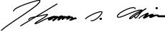

THOMAS G. O’BRIEN

Secretary and Treasurer

December 20, 2010


YOUR VOTE IS IMPORTANT

ALL SHAREHOLDERS OF AMDOCS LIMITED (WHETHER THEY EXPECT TO ATTEND THE ANNUAL GENERAL MEETING OR NOT) ARE REQUESTED TO COMPLETE, SIGN, DATE AND RETURN PROMPTLY THE PROXY CARD ENCLOSED WITH THIS NOTICE. IF YOU ARE THE RECORD HOLDER OF YOUR ORDINARY SHARES, YOU CAN ALSO AUTHORIZE THE VOTING OF YOUR SHARES OVER THE INTERNET OR BY TELEPHONE AS PROVIDED IN THE INSTRUCTIONS SET FORTH ON THE ENCLOSED PROXY CARD. YOU CAN CHANGE YOUR VOTE AND REVOKE YOUR PROXY AT ANY TIME BEFORE THE POLLS CLOSE AT THE ANNUAL GENERAL MEETING BY FOLLOWING THE PROCEDURES DESCRIBED IN THE ACCOMPANYING PROXY STATEMENT.

A proxy card for the annual general meeting for the fiscal year ended September 30, 2010 is enclosed and our Annual Report on Form 20-F is available on our website at www.amdocs.com/proxy or by request. Shareholders are entitled to appoint another person as proxy to exercise all or any rights to attend and to speak and vote at a meeting of the Company. A Shareholder may appoint more than one proxy in relation to a meeting provided that each proxy is appointed to exercise the rights in respect of different shares. If, within 30 minutes from the appointed time for the meeting, a quorum is not present, the meeting if convened by or upon a requisition shall be dissolved. If otherwise convened, it shall stand adjourned for seven days at the same time and place or to such other day and at such other time and place as the Board of Directors may determine and no notice of adjournment need be given. At that meeting, those shareholders present in person or by proxy will form a quorum whatever their number and the number of shares held by them.

AMDOCS LIMITED

PROXY STATEMENT

ANNUAL GENERAL MEETING OF SHAREHOLDERS

TO BE HELD ON WEDNESDAY, JANUARY 26, 201l

References in this Proxy Statement to “Amdocs”, “we”, “our” and “us” refer to Amdocs Limited and its consolidated subsidiaries and their respective predecessors.

This Proxy Statement and the accompanying proxy are being furnished to shareholders of Amdocs Limited, a company organized under the laws of Guernsey, in connection with the solicitation by its Board of Directors of proxies from holders of its outstanding ordinary shares, par value £0.01 per share, for use at the annual general meeting of shareholders to be held at 10:00 a.m., local time, on Wednesday, January 26, 2011, at the offices of WilmerHale, 399 Park Avenue, New York, New York, 31st floor, or at any adjournments thereof (the “General Meeting”).

This Proxy Statement and the accompanying proxy are first being mailed or delivered to our shareholders on or about December 20, 2010.

At the General Meeting, the holders of our ordinary shares as of the close of business on November 22, 2010 (the “Record Date”)

will be asked to take the following actions:

- Elect 13 directors to serve until the next annual general meeting of shareholders or until their earlier resignation or removal or successors are elected and qualified (Proposal I);

- Approve our Consolidated Financial Statements for the fiscal year ended September 30, 2010 (Proposal II); and

- Ratify and approve the appointment of Ernst & Young LLP as our independent registered public accounting firm for the fiscal year ending September 30, 2011, and until the next annual general meeting, and authorize the Audit Committee of the Board of Directors to fix the remuneration of such independent registered public accounting firm in accordance with the nature and extent of its services (Proposal III).

The proxy confers discretionary authority with respect to any amendments or modifications of proposals that properly may be brought before the General Meeting. As of the date hereof, we are not aware of any such amendments or modifications or other matters to be presented for action at the General Meeting. However, if any other matters properly come before the General Meeting, the proxies solicited hereby will be exercised on such matters in accordance with the reasonable judgment of the proxyholders.

As of the Record Date, Amdocs had outstanding 191,772,268 ordinary shares. Each ordinary share is entitled to one vote on all matters presented at the General Meeting. Only holders of record of ordinary shares at the close of business on the Record Date are entitled to notice of, and to vote at, the General Meeting. Votes cast in person or by proxy at the General Meeting will be tabulated by the inspector of elections appointed for the General Meeting who will also determine whether a quorum is present for the transaction of business. Two or more shareholders of record, together holding a majority of our outstanding ordinary shares present in person or represented by proxy, shall constitute a quorum for purposes of the General Meeting.

Approval of Proposals I, II and III requires the affirmative vote of a majority of our ordinary shares voted in person or by proxy at the General Meeting.

The enclosed proxy provides that each shareholder may specify that his, her or its ordinary shares be voted “for”, “against” or “abstain” from voting with respect to each of Proposals II and III. Each shareholder may specify that his, her or its ordinary shares may be voted “for” any of the director nominees named in Proposal I, or they may be “withheld” from any such nominees. If proxies in the accompanying form are properly executed and returned, the ordinary shares represented thereby will be voted in the manner specified therein. If not otherwise specified, in the reasonable discretion of the proxyholders, the ordinary shares represented by a proxy will be voted FOR each of the proposals.

Proxies will not be counted as voting in respect of any matter as to which abstention is indicated, but abstentions will be counted as ordinary shares that are present for purposes of determining whether a quorum is present at the General Meeting. Nominees who are members of the New York Stock Exchange, or the NYSE, and who, as brokers, hold ordinary shares in “street name” for customers have, by NYSE rules, the authority to vote on certain items in the absence of instructions from their customers, the beneficial owners of the ordinary shares. If such nominees or brokers indicate that they do not have authority to vote shares as to a particular matter (the “Broker Non-Votes”), we will not count those votes in favor of such matter. Broker Non-Votes will be counted as ordinary shares that are present for purposes of determining whether a quorum is present.

Shareholders of record are entitled to appoint one or more proxies to attend and vote at the General Meeting in their stead. If a shareholder of record elects to appoint a proxy other than by using the enclosed proxy card (or by Internet or telephone as provided in the instructions set forth in the enclosed proxy card), the shareholder must deliver such proxy, together with a power of attorney or other authority, at or before the General Meeting on January 26, 2011. We strongly encourage our shareholders to use the enclosed proxy card or to authorize the voting of their shares over the Internet or by telephone as provided in the instructions set forth in the enclosed proxy card.

Any shareholder giving a proxy may revoke it at any time before it is exercised at the General Meeting by:

- Filing with our Secretary, in care of our principal U.S. subsidiary, Amdocs, Inc. (at the address that appears on the last page of this Proxy Statement), written notice of such revocation bearing a later date than the proxy or a subsequent proxy relating to the same ordinary shares, provided that such proxy or subsequent proxy shall be deposited at such address at least 48 hours before the scheduled General Meeting or adjournment thereof, as the case may be; or

- Attending the General Meeting and voting in person (although attendance at the General Meeting will not in and of itself constitute revocation of a proxy).

IMPORTANT NOTICE REGARDING THE AVAILABILITY OF PROXY MATERIALS FOR THE ANNUAL GENERAL MEETING OF SHAREHOLDERS TO BE HELD ON JANUARY 26, 2011

This proxy statement and the 2010 Annual Report to Shareholders are available for viewing, printing and downloading at www.amdocs.com/proxy.

You may also request a copy of the materials relating to our annual general meeting, including this proxy statement and form of proxy for our annual general meeting and our Annual Report on Form 20-F for the fiscal year ended September 30, 2010 by contacting our investor relations department by telephone at (314) 212-8328 or by e-mail at dox_info@amdocs.com.

IMPORTANT

Whether or not you attend the General Meeting, your vote is important. Accordingly, you are asked to sign and return the accompanying proxy regardless of the number of ordinary shares you own. If you are the record holder of your ordinary shares, you can also authorize the voting of your shares over the Internet or by telephone as provided in the instructions set forth on the enclosed proxy card. Ordinary shares can be voted at the General Meeting only if the holder is present or represented by proxy.

2

PROPOSAL I

ELECTION OF DIRECTORS

Our Board of Directors is comprised of 13 directors, and, currently 13 individuals are serving as directors. As set forth below, the Board of Directors has nominated 13 individuals as nominees for election as directors at the General Meeting, all of whom are incumbent directors and one of whom was appointed by our Board effective March 1, 2010. Each director elected at the General Meeting will serve until the next annual general meeting of shareholders or until his earlier resignation or removal or a successor is elected and qualified.

Ordinary shares represented by proxies returned duly executed will be voted, unless otherwise specified, in favor of the 13 nominees for the Board of Directors named below. If any or all of such persons should be unable to serve, the persons named in the enclosed proxy will vote the shares covered thereby for such substitute nominee or nominees as the Board of Directors may select. The Board of Directors has no reason to believe that any such nominee will be unable or unwilling to serve.

Set forth below are the names and ages of the nominees for director, the principal occupations of each nominee currently and for at least the past five years, and the year in which he became a director of Amdocs.

Name | Age
Bruce K. Anderson | 70 | Mr. Anderson has been Chairman of the Board of Directors of Amdocs since
 |  | September 1997. Since August 1978, Mr. Anderson has been a general partner of
 |  | Welsh, Carson, Anderson & Stowe (“WCAS”), an investment firm that specializes in
 |  | the acquisition of companies in the information and business services and health care
 |  | industries. Until September 2003, investment partnerships affiliated with WCAS had
 |  | been among our largest shareholders. Mr. Anderson served for nine years with
 |  | Automated Data Processing, Inc. (“ADP”) until his resignation as Executive Vice
 |  | President and a director of ADP, and President of ADP International, effective August
 |  | 1978. Mr. Anderson serves on the board of Alliance Data Systems, Inc., a publicly-
 |  | held company that provides transaction, credit and marketing services to large
 |  | consumer based businesses. Mr. Anderson’s career in information technology investing
 |  | and service, and his experience as a director of many public and private companies,
 |  | have given him sharp business acumen, financial expertise and extensive experience
 |  | providing strategic and financial advisory services to complex organizations.
Adrian Gardner | 48 | Mr. Gardner has been a director of Amdocs since April 1998 and is Chairman of the
 |  | Audit Committee. Since November 2007, Mr. Gardner has been Chief Financial
 |  | Officer of PA Consulting Group, a London- based business consulting firm. From April
 |  | until November 2007, Mr. Gardner was a private investor. Mr. Gardner was Chief
 |  | Financial Officer of ProStrakan Group plc, a pharmaceuticals company based in the
 |  | United Kingdom and listed on the London Stock Exchange, from 2002 until April 2007
 |  | and a director from April 2002 until June 2007. Prior to joining ProStrakan, he was a
 |  | Managing Director of Lazard LLC, based in London, where he worked with
 |  | technology- and telecommunications-related companies. Prior to joining Lazard in
 |  | 1989, Mr. Gardner qualified as a chartered accountant with Price Waterhouse (now
 |  | PricewaterhouseCoopers). Mr. Gardner is a member of the Institute of Chartered
 |  | Accountants in England & Wales. Mr. Gardner’s extensive experience as an
 |  | accountant, technology investment banker and chief financial officer enables him to
 |  | make valuable contributions to our strategic and financial affairs.
Charles E. Foster | 74 | Mr. Foster has been a director of Amdocs since December 2001 and is Chairman of the
 |  | Nominating and Corporate Governance Committee. Since January 2010, Mr. Foster has
 |  | served as the Chair of the Board of Trustees of CPS Energy, a municipally owned
 |  | energy utility. He was Chairman of the Board of Prodigy Communications Corporation
 |  | from June until November
 |  | 3

Name | Age
 |  | 2001. From April 1997 until June 2001, Mr. Foster served as Group President of SBC,
 |  | where he was responsible, at various times, for engineering, network, centralized
 |  | services, marketing and operations, information systems, procurement, treasury,
 |  | international operations, wireless services, merger integration, real estate, Yellow Pages
 |  | and cable TV operations. In 2005, SBC acquired AT&T Corp. and became AT&T Inc.
 |  | AT&T is our most significant customer. Mr. Foster serves as trustee of the Southwest
 |  | Foundation for Bio-Medical Research, a non-profit research institute. Mr. Foster is a
 |  | former member of the Texas Society of Professional Engineers and a director of
 |  | Morningside Ministries Foundation, a non-profit operator of nursing homes in the
 |  | San Antonio area. Mr. Foster’s decades of operations and management experience and
 |  | responsibility at SBC lends him deep telecommunications industry expertise.
James S. Kahan | 63 | Mr. Kahan has been a director of Amdocs since April 1998 and is Chairman of the
 |  | Compensation Committee, and a member of the Executive and Nominating and
 |  | Corporate Governance Committees. From 1983 until his June 2007 retirement, he
 |  | worked at SBC, which is now AT&T, and served as a Senior Executive Vice President
 |  | from 1992 until June 2007. AT&T is our most significant customer. Prior to joining
 |  | AT&T, Mr. Kahan held various positions at several telecommunications companies,
 |  | including Western Electric, Bell Laboratories, South Central Bell and AT&T Corp.
 |  | Mr. Kahan also serves on the Board of Directors of Live Nation Entertainment, Inc.,
 |  | the world’s largest live music and ticketing entity. Mr. Kahan’s long service at SBC and
 |  | AT&T, as well as his management and financial experience at several public and
 |  | private companies, have provided him with extensive knowledge of the
 |  | telecommunications industry, particularly with respect to corporate development,
 |  | mergers and acquisitions and business integration.
Zohar Zisapel | 61 | Mr. Zisapel has been a director of Amdocs since July 2008 and is the Chairman of the
 |  | Technology and Innovation Committee. Mr. Zisapel co-founded RAD Data
 |  | Communications Ltd. and has been its chairman since 1982, a privately-held voice and
 |  | data communications company and part of the RAD Group, a family of independent
 |  | networking and telecommunications companies. Mr. Zisapel also serves as chairman of
 |  | Ceragon Networks Ltd., RADVision Ltd. and RADCOM Ltd., each of which is a
 |  | publicly- traded member of the RAD Group, as well as on the boards of directors of
 |  | several privately-held companies. Mr. Zisapel previously served as chairman of the
 |  | Israel Association of Electronic Industries from 1998 until 2001. Mr. Zisapel’s
 |  | experience as founder, chairman and director of several public and private high
 |  | technology companies, and his leadership in several government organizations,
 |  | demonstrate his leadership capability and provide him with valuable insights into the
 |  | voice and data communications industries.
Julian A. Brodsky | 77 | Mr. Brodsky has been a director of Amdocs since July 2003. Mr. Brodsky has served as
 |  | a director and as Vice Chairman of Comcast Corporation since 1989. From 1989 to
 |  | May 2004, Mr. Brodsky was Chairman of Comcast Interactive Capital, LP, a venture
 |  | fund affiliated with Comcast. He is a director of RBB Fund, Inc. Mr. Brodsky brings to
 |  | our board of directors deep and extensive knowledge of the cable industry gained
 |  | through his longstanding executive leadership roles at Comcast, as well as financial
 |  | expertise in capital markets, accounting and tax matters gained through his experience
 |  | as Chief Financial Officer of Comcast and as a practicing CPA.
Eli Gelman | 52 | Mr. Gelman has been a director of Amdocs since 2002. On November 15, 2010,
 |  | Mr. Gelman became the President and Chief Executive Officer of
 |  | 4

Name | Age
 |  | Amdocs Management Limited, our wholly- owned subsidiary. Since January 2010,
 |  | Mr. Gelman has served as a director of Retalix, a publicly-held global software
 |  | company, and from January 2010 to December 2010, he also served as the Chairman of
 |  | Retalix. From April 2008 to December 2010, Mr. Gelman devoted his time to
 |  | charitable matters focused on youth education. He served as Executive Vice President
 |  | of Amdocs Management Limited from October 2002 until April 2008 and as our Chief
 |  | Operating Officer from October 2006 until April 2008. Prior to October 2002, he was a
 |  | Senior Vice President, where he headed our U.S. sales and marketing operations and
 |  | helped spearhead our entry into the customer care and billing systems market. Before
 |  | that, Mr. Gelman was an account manager for our major European and North American
 |  | installations, and has led several major software development projects. Before joining
 |  | Amdocs, Mr. Gelman was involved in the development of real-time software systems
 |  | for communications networks. Mr. Gelman’s qualifications to serve on our board of
 |  | directors include his more than two decades of service to Amdocs and its customers,
 |  | including as our Chief Operating Officer. With more than 28 years of experience in the
 |  | software industry, he possesses a vast institutional knowledge and strategic
 |  | understanding of our organization and industry.
Nehemia Lemelbaum | 68 | Mr. Lemelbaum has been a director of Amdocs since December 2001 and was a Senior
 |  | Vice President of Amdocs Management Limited from 1985 until January 2005. Since
 |  | 2005, Mr. Lemelbaum has been a private investor and since November 2009, he has
 |  | been a director of Retalix, a publicly-held global software company. Since December
 |  | 2006, Mr. Lemelbaum has also been a director and the Chief Executive Officer of
 |  | EHYN, a privately-held investment company. He joined Amdocs in 1985, with initial
 |  | responsibility for U.S. operations. Mr. Lemelbaum led our development of graphic
 |  | products for the Yellow Pages industry and later led our development of customer care
 |  | and billing systems, as well as our penetration into that market. Prior to joining
 |  | Amdocs, he served for nine years with Contahal Ltd., a leading Israeli software
 |  | company, first as a senior consultant, and later as Managing Director. From 1967 to
 |  | 1976, Mr. Lemelbaum was employed by the Ministry of Communications of Israel (the
 |  | organization that predated Bezeq, the Israel Telecommunication Corp. Ltd.), with
 |  | responsibility for computer technology in the area of business data processing. With
 |  | more than two decades in our leadership ranks, including representing us with analysts
 |  | and investors for five years during and after our initial public offering, Mr. Lemelbaum
 |  | has extensive communication software industry experience, and deep institutional
 |  | knowledge and understanding of our business and strategy.
John T. McLennan | 65 | Mr. McLennan has been a director of Amdocs since November 1999. From May 2000
 |  | until June 2004, he served as Vice-Chair and Chief Executive Officer of Allstream
 |  | (formerly AT&T Canada). Mr. McLennan founded and was the President of Jenmark
 |  | Consulting Inc. from 1997 until May 2000. From 1993 to 1997, Mr. McLennan served
as the President and Chief Executive Officer of Bell Canada. Prior to that, he held various positions at several telecommunications companies, including BCE Mobile Communications and Cantel Inc. Mr. McLennan is also a director of Air Canada Jazz, a publicly-held regional airline company, Chairman of Emera Inc., a Canadian publicly-held energy services company, and director of Nova Scotia Power Inc., a wholly-owned subsidiary of Emera Inc. From 2005 to 2008, Mr. McLennan also served as a director of Medisys Inc., a healthcare management company. We believe Mr. McLennan’s qualifications to sit on our board of directors include his years of experience in the telecommunications industry, including as chief

5

Name | Age
 |  | executive officer of a leading Canadian telecommunications provider, and his
 |  | experience providing strategic advice to complex organizations across a variety of
 |  | industries, including as a public company director.
Robert A. Minicucci | 58 | Mr. Minicucci has been a director of Amdocs since September 1997. He has been a
 |  | general partner of WCAS since 1993. From 1992 to 1993, Mr. Minicucci served as
 |  | Senior Vice President and Chief Financial Officer of First Data Corporation, a provider
 |  | of information processing and related services for credit card and other payment
 |  | transactions. From 1991 to 1992, he served as Senior Vice President and Treasurer of
 |  | the American Express Company. He served for 12 years with Lehman Brothers (and its
 |  | predecessors) until his resignation as a Managing Director in 1991. Mr. Minicucci is
 |  | also a director of two other publicly-held companies: Alliance Data Systems, Inc. and
 |  | Retalix Ltd., and several private companies. Mr. Minicucci’s career in information
 |  | technology investing, including as a director of more than twenty different public and
 |  | private companies, and his experience as chief financial officer to a public company
 |  | and treasurer of another public company, have provided him with strong business
 |  | acumen and strategic and financial expertise.
Simon Olswang | 66 | Mr. Olswang has been a director of Amdocs since November 2004. In 2002,
 |  | Mr. Olswang retired as Chairman of Olswang, a media and communications law firm
 |  | in the United Kingdom that he founded in 1981. He is a member of the Advisory Board
 |  | of Palamon Capital Partners LLP and of the Board of Directors of Amiad Filtration
 |  | Systems Limited, an Israeli company listed on the London AIM market, which is active
 |  | in the clean water industry. Mr. Olswang was a member of the Board of Directors of
 |  | The British Library until March 2008 and has served as a non- executive director of a
 |  | number of companies and organizations, including Aegis Group plc, The Press
 |  | Association and the British Film Institute. Mr. Olswang previously served as Trustee of
 |  | Langdon College of Further (Special) Education in Salford, of which he is a co-
 |  | founder. We believe Mr. Olswang’s qualifications to sit on our board of directors
 |  | include his extensive experience providing strategic and legal advisory services to
 |  | complex organizations, as well as startups, in the media and communications industry.
Richard Sarnoff | 51 | Mr. Sarnoff has been a director of Amdocs since March 1, 2010, and is employed by
 |  | Bertelsmann AG, a diversified media and services company, where he serves as Co-
 |  | Chairman of Bertelsmann, Inc. and President of Bertelsmann Digital Media
 |  | Investments. Previously, Mr. Sarnoff served as Executive Vice President and Chief
 |  | Financial Officer of Random House, Inc., a general trade book publisher and subsidiary
 |  | of Bertelsmann AG. Since 2005, he has served on the Board of Directors of Activision
 |  | Blizzard, Inc., a worldwide online and console game and entertainment software
 |  | publisher. Mr. Sarnoff also served as a member of the Supervisory Board of
 |  | Bertelsmann AG from 2002 to 2008, as a member of the Board of Directors of the
 |  | Princeton Review, an educational preparation company, from 2000 to 2009 and as a
 |  | member of the Board of Directors of Audible, Inc., a provider of spoken audio
 |  | entertainment, information, and educational programming, from 2001 to 2008. He was
 |  | also formerly Chairman of the Board of the American Association of Publishers. We
 |  | believe that Mr. Sarnoff brings to our board his experience and business expertise
 |  | gained while serving in executive roles and board positions for companies in the media,
 |  | entertainment and digital technology industries.
Giora Yaron | 61 | Dr. Yaron has been a director of Amdocs since July 2009. Dr. Yaron co-founded Itamar
 |  | Medical Ltd., a publicly-traded medical technology company, and has been its co-
 |  | chairman since 1997. Dr. Yaron provides consulting services to Itamar Medical and to
 |  | various other technology
 |  | 6

Name Age

companies. He co-founded Exanet, Inc., a privately-held company focused on building single entity scalable storage networks, and has been its chairman since 2000. In 2009, Dr. Yaron also co-founded Qwilt, Inc., a privately-held video technology company and serves as one of its directors. Since 2004, Dr. Yaron has been the chairman of Yissum Research Development Company, the technology transfer company of the Hebrew University of Jerusalem. Dr. Yaron also has served on the advisory board of Rafael Advanced Defense Systems, Ltd., a developer of high-tech defense systems, since 2008. In addition, Dr. Yaron previously co-founded and served as chairman of Qumranet Inc. from 2006 to 2008, a privately-held enterprise software company acquired by Red Hat, Mercury Interactive from 1996 to 2006, a publicly-traded IT optimization software company acquired by Hewlett-Packard, P- cube Inc., a privately-held company focused on content-based switching for smart networks acquired by Cisco, Comsys Communication and Signal Processing Ltd., a semiconductor company. We believe that Dr. Yaron’s qualifications to sit on our board of directors include his experience as an entrepreneur and the various leadership positions he has held on the boards of directors of software and technology companies.

Board Committees

Our Board of Directors has formed five committees as described below. Members of each committee are appointed by the Board of Directors.

Audit Committee. The Audit Committee reviews, acts on and reports to the Board of Directors with respect to various auditing and accounting matters, including the selection of our independent registered public accounting firm, the scope of the annual audits, fees to be paid to our independent registered public accounting firm, the performance of our independent registered public accounting firm, and assists with the Board of Directors’ oversight of our accounting practices, financial statement integrity and compliance with legal and regulatory requirements, including establishing and maintaining adequate internal control over financial reporting. The current members of our Audit Committee are Messrs. Gardner (Chair), Foster, McLennan, Olswang and Sarnoff, all of whom are independent directors, as required by the rules of the NYSE, and pursuant to the categorical director independence standards adopted by our Board of Directors. The Board of Directors has determined that Mr. Gardner is an “audit committee financial expert” as defined by rules promulgated by the U.S. Securities and Exchange Commission, or the SEC, and that each member of the Audit Committee is financially literate as required by the rules of the NYSE. The Audit Committee written charter is attached to this Proxy Statement as Appendix A, and it is available on our website at www.amdocs.com.

Nominating and Corporate Governance Committee. The Nominating and Corporate Governance Committee identifies individuals qualified to become members of our Board of Directors, recommends to the Board of Directors the persons to be nominated for election as directors at the annual general meeting of shareholders, develops and makes recommendations to the Board of Directors regarding our corporate governance principles and oversees the evaluations of our Board of Directors and our management. The current members of the Nominating and Corporate Governance Committee are Messrs. Foster (Chair), Kahan, Brodsky and Gardner. All of the members of the Nominating and Corporate Governance Committee are independent directors, as required by the rules of the NYSE, and pursuant to the categorical director independence standards adopted by our Board of Directors. The Nominating and Corporate Governance Committee written charter is available on our website at www.amdocs.com. The Nominating and Corporate Governance Committee has approved corporate governance guidelines that are also available on our website at www.amdocs.com. You may request a copy of the corporate governance guidelines, at no cost, by writing to us at the address listed below under the heading “Annual Report on Form 20-F.”

Compensation Committee. The Compensation Committee discharges the responsibilities of our Board of Directors relating to the compensation of the Chief Executive Officer of Amdocs Management Limited and makes recommendations to our Board of Directors with respect to the compensation of our other executive officers. The current members of our Compensation Committee are Messrs. Kahan (Chair), Anderson and Minicucci, all of

7

whom are independent directors, as required by the rules of the NYSE, and pursuant to the categorical director independence standards adopted by our Board of Directors. The Compensation Committee written charter is available on our website at www.amdocs.com.

Executive Committee. The Executive Committee has such responsibilities as may be delegated to it from time to time by the Board of Directors. The current members of our Executive Committee are Messrs. Anderson (Chair), Gelman, Kahan, Lemelbaum and Minicucci.

Technology and Innovation Committee. The Technology and Innovation Committee was established to assist the Board of Directors in reviewing our technological development, opportunities and innovation, in connection with our current and future business and markets. The current members of our Technology and Innovation Committee are Messrs. Zisapel (Chair), Anderson, Gelman and Lemelbaum and Dr. Yaron.

Our independent directors receive no compensation from us, except in connection with their membership on the Board of Directors and its committees as described below regarding Non-Employee Directors under “— Compensation of Directors”.

Board and Committee Meetings

During the past fiscal year, the Board of Directors held seven meetings. In addition, the Audit Committee held eight meetings, the Compensation Committee held five meetings, the Nominating and Corporate Governance Committee held five meetings, the Executive Committee held seven meetings and the Technology and Innovation Committee held four meetings in the 2010 fiscal year. During fiscal 2010, each of our directors attended at least 75% of the aggregate of the number of Board of Directors meetings held during the time he was serving as a director and meetings held by all committees on which he then served, except for one director who attended 71% of such meetings. During fiscal 2010, our directors who are not our employees, which we refer to as Non-Employee Directors, held one meeting without management present. Executive sessions of the Non-Employee Directors are generally held in conjunction with regularly scheduled meetings of the Board of Directors. At other times, such meetings may be held at the request of any Non-Employee Director. The presiding director of each such executive session is elected by the Non-Employee Directors who attend such executive session. Shareholders and other interested parties may communicate directly with the presiding directors or with the independent directors as a group as described below under the heading “Communicating with the Independent Directors.”

Communicating with the Independent Directors

The Board of Directors will give appropriate attention to written communications that are submitted by shareholders and other interested parties, and will respond if and as appropriate. The Chairman of the Board, with the assistance of our corporate secretary, is primarily responsible for monitoring communications from shareholders and other interested parties and for providing copies or summaries to the directors as he considers appropriate.

Communications are forwarded to all directors if they relate to important substantive matters and include suggestions or comments that our Chairman and corporate secretary consider to be important for the directors to know. In general, communications relating to corporate governance and long-term corporate strategy are more likely to be forwarded than communications relating to ordinary business affairs, personal grievances and matters as to which we tend to receive repetitive or duplicative communications.

Shareholders who wish to send communications on any topic to the Board of Directors or to our independent or presiding directors should address such communications c/o Corporate Secretary, Amdocs Inc., 1390 Timberlake Manor Parkway, Chesterfield, Missouri 63017.

Significant Corporate Governance Differences

We believe there are no significant ways that our corporate governance practices differ from those followed by U.S. domestic issuers under the NYSE listing standards.

8

Director Qualification Standards

Our Board of Directors has adopted a formal set of categorical independence standards with respect to the determination of director independence.

In accordance with these standards and the rules of the NYSE, our Board of Directors has determined that each of the following 12 of our current 13 directors has no material relationship with us and is therefore independent: Messrs. Anderson, Gardner, Brodsky, Foster, Kahan, Lemelbaum, McLennan, Minicucci, Olswang, Zisapel and Sarnoff and Dr. Yaron.

The full text of our categorical standards is attached to this Proxy Statement as Appendix B.

Code of Ethics and Business Conduct

Our Board of Directors has adopted a Code of Ethics and Business Conduct that sets forth legal and ethical standards of conduct for our directors and employees, including executive officers, our subsidiaries and other business entities controlled by us worldwide. The code is available on our website at www.amdocs.com and you may request a copy, at no cost, by writing to us at the address listed below under the heading “Annual Report on Form 20-F.” We intend to post on our website all disclosures that are required by law or NYSE rules concerning any amendments to, or waivers from, any provision of the code.

Risk Management Oversight

Our management is responsible for assessing and managing risk, and periodically reviews areas of material risk within our organization in order to evaluate and enhance risk identification and mitigation strategies. Our Board of Directors oversees and reviews these risk management efforts as they relate to strategic and business risks. Our audit committee oversees and reviews these efforts as they relate to operational and financial risks, and it periodically reports and makes recommendations to our Board of Directors.

Compensation Policies and Practices

We structure our compensation to consist of both fixed and variable elements, including salary, equity, cash bonuses and insurance benefits. The fixed portions of compensation, such as salary, are designed to be market based and provide steady income regardless of our stock price performance. The variable portions of compensation, such as equity incentives and performance bonuses, are designed to reward the accomplishment of both short- and long-term corporate objectives. By basing a portion of our compensation on our long-term performance, we believe we reduce the risk that employees will focus on short-term goals to the detriment of our long-term stability. Further, our short-term incentive compensation is designed to reward short-term goals that we believe will enhance our long-term corporate success. Additionally, although we vary the elements of compensation that we use at different employee positions and rank, our compensation philosophy is applicable to all employees, including our executives. We believe this encourages consistent behavior across our organization, rather than establishing different approaches depending on an employee’s position or rank. We do not believe our compensation policies and practices encourage excessive or inappropriate risk taking.

Compensation of Directors

Each Non-Employee Director receives compensation for his services as a director in the form of cash and restricted shares. Each Non-Employee Director receives an annual cash payment of $80,000. Each member of our Audit and Executive Committees who is a Non-Employee Director and who is not the chairman of such committees receives an annual cash payment of $5,000. Each member of our Compensation, Nominating and Corporate Governance and Technology and Innovation Committees, who is a Non-Employee Director and who is not the chairman of such committees, receives an annual cash payment of $1,000. The Chairmen of our Audit and Executive Committees each receives an annual cash payment of $10,000 and the Chairmen of our Compensation, Nominating and Corporate Governance and Technology and Innovation Committees each receives an annual cash payment of $5,000. Each Non-Employee Director receives an annual grant of restricted shares at a total value of $150,000. The Chairman of the Board of Directors receives an additional annual amount equal to $200,000, of

9

which $75,000 is paid in cash and $125,000 is awarded in the form of restricted shares. All restricted share awards to our Non-Employee Directors are immediately vested with respect to 25%, with the remainder vesting annually in three equal installments. The price per share for the purpose of determining the value of the grants to our Non-Employee Directors is the NYSE closing price of our shares on the last trading day preceding the grant date. We also reimburse all of our Non-Employee Directors for their reasonable travel expenses incurred in connection with attending Board or committee meetings.

During the 2010 fiscal year, we granted to 13 Non-Employee Directors an aggregate of 75,402 restricted shares at a weighted average price of $26.69 per share, with vesting over three year terms.

It is proposed that each of the following 13 individuals be elected to serve as a director of Amdocs Limited until the next annual general meeting of shareholders or until his earlier resignation or removal or until his respective successor is elected and qualified:

Bruce K. Anderson

Adrian Gardner

Charles E. Foster

James S. Kahan

Julian A. Brodsky

Eli Gelman

Nehemia Lemelbaum

John T. McLennan

Robert A. Minicucci

Simon Olswang

Richard Sarnoff

Giora Yaron

Zohar Zisapel

Required Affirmative Vote

The affirmative vote of holders of a majority of our ordinary shares represented in person or by proxy at the General Meeting is necessary for the election of each director nominee named above.

THE BOARD OF DIRECTORS RECOMMENDS THAT THE SHAREHOLDERS VOTE “FOR” EACH OF THE DIRECTOR NOMINEES NAMED ABOVE.

10

SECURITY OWNERSHIP OF CERTAIN

BENEFICIAL OWNERS AND MANAGEMENT

The following table sets forth specified information with respect to the beneficial ownership of our ordinary shares as of November 22, 2010 of (i) any person known by us to be the beneficial owner of more than 5% of our ordinary shares, and (ii) all of our directors and executive officers as a group. Beneficial ownership is determined in accordance with the rules of the SEC and, unless otherwise indicated, includes voting and investment power with respect to all ordinary shares, subject to community property laws, where applicable. The number of ordinary shares used in calculating the percentage beneficial ownership included in the table below is based on 191,772,268 ordinary shares outstanding as of November 22, 2010. Information concerning shareholders other than our directors and executive officers is based on periodic public filings made by such shareholders and may not necessarily be accurate as of November 22, 2010.

 |  |  | Shares |  | Percentage
Name |  |  | Beneficially |  | Percentage
 |  |  | Owned |  | Ownership
 | Thornburg Investment Management Inc.(1) |  | 20,682,441 | 10.78%
 | Manning & Napier Advisors, Inc..(2) |  | 12,111,330 | 6.32%
 | Ameriprise Financial, Inc.(3) |  | 11,586,312 | 6.04%
 | All directors and executive officers as a group (19 persons)(4) |  | 4,742,358 | 2.45%

- The address of Thornburg Investment Management Inc., or Thornburg, is 2300 North Ridgetop Road, Santa Fe, New Mexico 87506. Based on a Schedule 13G filed by Thornburg with the SEC on January 7, 2010, Thornburg had sole voting and dispositive power over all of these ordinary shares.

- Based in a Schedule 13G filed by Manning & Napier Advisors, Inc., or Manning & Napier, with the SEC on June 18, 2010, Manning & Napier had sole voting power over 11,326,615 of our ordinary shares and sole dispositive power over 12,111,300 of our ordinary shares. The address of Manning & Napier is 290 Woodcliff Drive, Fairport, NY 14450.

- Based on a Schedule 13G filed by Ameriprise Financial, Inc., or Ameriprise, and RiverSource Investments, LLC, or RiverSource, with the SEC on February 10, 2010, Ameriprise and RiverSource had shared dispositive power over 11,586,312 of our ordinary shares. Ameriprise is the parent company of RiverSource. Ameriprise and RiverSource disclaim beneficial ownership of these shares. The address of Ameriprise and RiverSource is 145 Ameriprise Financial Center, Minneapolis, Minnesota 55474.

- Includes options held by such directors and executive officers that are exercisable within 60 days after November 22, 2010.

11

AUDIT COMMITTEE MATTERS

Our management is responsible for the preparation of our financial statements and for maintaining an adequate system of disclosure controls and procedures and internal control over financial reporting for that purpose. Our independent registered public accounting firm is responsible for conducting an independent audit of our annual financial statements in accordance with generally accepted accounting principles, as well as an independent audit of management’s assessment of our internal control over financial reporting, and issuing reports on the results of their audits. The Audit Committee is responsible for providing independent, objective oversight of these processes.

The Audit Committee has reviewed our audited financial statements for the fiscal year ended September 30, 2010 and has discussed these financial statements with our management and independent registered public accounting firm.

The Audit Committee has also discussed with our independent registered public accounting firm the matters required to be discussed by Statement on Auditing Standards 61 (Communication with Audit Committees). SAS 61 (as codified in AU Section 380 of the Codification of Statements on Auditing Standards) requires our independent registered public accounting firm to discuss with our Audit Committee, among other things, the following:

- methods to account for significant unusual transactions;

- the effect of significant accounting policies in controversial or emerging areas for which there is a lack of authoritative guidance or consensus;

- the process used by management in formulating particularly sensitive accounting estimates and the basis for the auditors’ conclusions regarding the reasonableness of those estimates; and

- disagreements with management over the application of accounting principles, the basis for management’s accounting estimates and the disclosures in the financial statements.

Our independent registered public accounting firm also provided the Audit Committee with the written disclosures and the letter required by the Public Company Accounting Oversight Board (PCAOB) Ethics and Independence Rule 3526 (Rule 3526), Communication with Audit Committees Concerning Independence. PCAOB Rule 3562 requires auditors annually to disclose in writing all relationships that in the auditor’s professional opinion may reasonably be thought to bear on independence, confirm their perceived independence and engage in a discussion of independence. The Audit Committee has discussed with the independent registered public accounting firm its independence from us.

Based on its discussions with management and the independent registered public accounting firm, and its review of the representations and information provided by management and the independent registered public accounting firm, the Audit Committee recommended to our Board of Directors that the audited financial statements be included in our Annual Report on Form 20-F for the fiscal year ended September 30, 2010.

Pre-Approval Policies and Procedures

The Audit Committee has adopted policies and procedures relating to the pre-approval of all audit services to be provided to us, whether provided by our principal auditor or other firms, and all other services to be provided to us by our independent registered public accounting firm. These policies generally provide that we will not engage our independent registered public accounting firm to render audit or non-audit services unless the service is specifically approved in advance by the Audit Committee or the engagement is entered into pursuant to the pre-approval procedure described below.

From time to time, the Audit Committee may pre-approve specified types of services that are expected to be provided to us by our independent registered public accounting firm during the next 12 months. Any such pre-approval is detailed as to the particular service or type of services to be provided and is also generally subject to a maximum dollar amount.

12

PROPOSAL II

APPROVAL OF OUR CONSOLIDATED FINANCIAL STATEMENTS

FOR THE FISCAL YEAR ENDED SEPTEMBER 30, 2010

Our Annual Report for the fiscal year ended September 30, 2010 is available on our website at http://dox.client.shareholder.com. Our Consolidated Financial Statements for the fiscal year ended September 30, 2010 are included in our Annual Report. At the General Meeting, we will review the Operating and Financial Review and Prospects section of our Annual Report and will answer appropriate questions related thereto.

It is proposed that the following ordinary resolution be adopted at the General Meeting:

“RESOLVED, that the Consolidated Financial Statements of Amdocs Limited for the fiscal year ended September 30, 2010 be, and the same hereby are, approved.”

Required Affirmative Vote

The affirmative vote of holders of a majority of the ordinary shares represented in person or by proxy at the General Meeting is necessary for the approval of the ordinary resolution to approve the Consolidated Financial Statements.

THE BOARD OF DIRECTORS RECOMMENDS THAT THE SHAREHOLDERS VOTE “FOR” THE APPROVAL OF OUR CONSOLIDATED FINANCIAL STATEMENTS.

13

PROPOSAL III

RATIFICATION AND APPROVAL OF

INDEPENDENT REGISTERED PUBLIC ACCOUNTING FIRM

The Audit Committee of the Board of Directors has selected the firm of Ernst & Young LLP to continue to serve as our independent registered public accounting firm for the fiscal year ending September 30, 2011 and until the next annual general meeting, and the Audit Committee recommends to the shareholders that they (i) ratify and approve such selection, and (ii) authorize the Audit Committee of the Board of Directors to fix the remuneration of such registered public accounting firm. Ernst & Young LLP audited Amdocs’ books and accounts for the fiscal year ended September 30, 2011 and has served as our independent public accounting firm since 1996. One or more representatives of Ernst & Young LLP are expected to be present at the General Meeting, will have an opportunity to make a statement if he or she so desires and will be available to respond to appropriate questions.

Independent Accountant Fees and Other Matters

The following table summarizes the fees of Ernst & Young LLP, our independent registered public accounting firm, billed to us for each of the last two fiscal years for audit services and billed to us in each of the last two fiscal years for other services:

Fee Category |  |  |  |  |  | 2010 | 2009
 | Audit Fees(1) |  |  | $ |  | 3,200,000 | $ 3,300,000
 | Audit-Related Fees(2) |  |  | $ |  | 1,700,000 | $ 1,300,000
 | Tax Fees(3) |  |  | $ |  | 1,400,000 | $ 1,100,000

- Audit fees consist of fees associated with the annual audit and reviews of our quarterly financial results submitted on Form 6-K, consultations on various accounting issues and performance of local statutory audits.

- Audit-related services principally include SAS 70 report issuances and due diligence examinations.

- Tax fees consist of fees associated with tax compliance, tax advice and tax planning services.

It is proposed that the following ordinary resolution be adopted at the General Meeting:

“RESOLVED, that (i) the appointment of Ernst & Young LLP as Amdocs Limited’s independent registered public accounting firm for the fiscal year ending September 30, 2011 and until Amdocs Limited’s next annual general meeting be, and it hereby is, ratified and approved, and (ii) the Audit Committee of the Board of Directors be, and it hereby is, authorized to fix the remuneration of such independent registered public accounting firm in accordance with the nature and extent of its services.”

Required Affirmative Vote

The affirmative vote of holders of a majority of the ordinary shares represented in person or by proxy at the General Meeting is necessary for the approval of the ordinary resolution to ratify and approve the appointment of Ernst & Young LLP and the authorization of the Audit Committee of the Board of Directors to fix its remuneration.

THE AUDIT COMMITTEE OF THE BOARD OF DIRECTORS AND THE BOARD OF DIRECTORS RECOMMEND THAT THE SHAREHOLDERS VOTE “FOR” THE RATIFICATION AND APPROVAL OF THE APPOINTMENT OF ERNST & YOUNG LLP AS THE COMPANY’S INDEPENDENT REGISTERED PUBLIC ACCOUNTING FIRM AND THE AUTHORIZATION OF THE AUDIT COMMITTEE TO FIX THE REMUNERATION OF ERNST & YOUNG LLP.

14

MISCELLANEOUS

Other Matters

Our management knows of no other business to be transacted at the General Meeting; but, if any other matters are properly presented to the General Meeting, the persons named in the enclosed form of proxy will vote upon such matters in accordance with their reasonable discretion.

Annual Report on Form 20-F

Once filed with the SEC, we will promptly provide without charge, at the written request of any shareholder, a copy of our Annual Report on Form 20-F, including our audited financial statements, financial statement schedules and exhibits, as filed with the SEC. Our Annual Report on Form 20-F will also be accessible to the general public via the Internet at the SEC’s web site located at http://www.sec.gov as well as on our website at www.amdocs.com. Requests for copies of our Annual Report on Form 20-F should be mailed to our principal U.S. subsidiary at:

Amdocs, Inc.

1390 Timberlake Manor Parkway

Chesterfield, Missouri 63017

Fax: (314) 212-8358

E-mail: dox_info@amdocs.com

Attention:

Mr. Thomas G. O’Brien

Secretary and Treasurer of Amdocs Limited

Expenses of Solicitation

The cost of solicitation of proxies will be borne by Amdocs, including expenses in connection with preparing and mailing this Proxy Statement. In addition to solicitation of proxies by mail, our directors, officers and employees (who will receive no additional compensation therefor) have solicited the return of proxies by Internet and telephone and may solicit the return of proxies by facsimile or personal interview. In addition, we have retained American Stock Transfer & Trust Company and Phoenix Advisory Partners to assist in the solicitation of proxies. We will also reimburse brokerage houses and other custodians, nominees and fiduciaries for their expenses in accordance with the regulations of the NYSE concerning the sending of proxies and proxy materials to the beneficial owners of our ordinary shares.

BY ORDER OF THE BOARD OF DIRECTORS

THOMAS G. O’BRIEN

Secretary and Treasurer

December 20, 2010

15

APPENDIX A

AMDOCS LIMITED

AUDIT COMMITTEE CHARTER

A. Purpose

The Audit Committee of Amdocs Limited (the “Company”) is a standing committee of the Board of Directors. The primary objective of the Audit Committee is to assist the Board of Directors’ oversight of: the Company’s accounting practices; the integrity of the Company’s financial statements; the Company’s compliance with legal and regulatory requirements; the qualifications, independence, and performance of the Company’s registered public accounting firm (the “independent auditor”); and the internal audit function.

- Membership, Structure, and Administration

  - Size and Member Qualifications — The Audit Committee shall consist of at least three members of the Board of Directors, all of whom shall be independent of management and the Company and shall satisfy the independence requirements as defined, by the applicable rules of the New York Stock Exchange (NYSE) and Rule 10A-3(b)(1) of the Securities Exchange Act of 1934. Each member of the Audit Committee shall be financially literate, as such qualification is interpreted by the Board of Directors in its business judgment, or must become financially literate within a reasonable period of time after his or her appointment to the Audit Committee. At least one member of the Audit Committee shall be an “audit committee financial expert” (as defined by applicable SEC rules) as determined by the business judgment of the Board of Directors.

  - Board of Directors Authority — Members of the Audit Committee shall be appointed by the Board of Directors. The Audit Committee shall report regularly to the Board of Directors. Unless otherwise determined by the Board of Directors, no member of the Audit Committee may serve on the audit committee of more than two other public companies. The Board of Directors may remove members of the Audit Committee from such committee with or without cause.

  - Chair — Unless the Board of Directors elects a Chair of the Audit Committee, the Audit Committee shall elect one by majority

vote.

  - Compensation — The compensation of the Audit Committee members shall be as determined by the Board of Directors. No member of the Audit Committee may receive, directly or indirectly, any compensation from the Company other than director’s fees (in cash and/or company shares or options or in-kind consideration).

  - Meetings — The Audit Committee shall meet on a schedule and in a manner the Audit Committee shall establish. The Audit Committee may also act by unanimous written consent in lieu of a meeting. Periodically, the Audit Committee shall meet separately with: the independent auditor, members of the Company’s management, and the Company’s internal auditor. A special meeting may be called on not less than 24 hours notice, at any time by the Chairman. The Audit Committee shall keep such records of its meetings, as it shall deem appropriate.

  - Subcommittees — The Audit Committee may form and delegate authority to one or more subcommittees as it deems appropriate from time to time under the circumstances.

  - Authority — The Audit Committee shall maintain unrestricted communication with the independent auditors, the Company’s internal audit function personnel, counsel and financial management to assure that each understands and accepts its responsibilities for direct communication with the Audit Committee as appropriate. The Audit Committee shall have full access to the books and records of the Company, as well as, full access to interview employees, if necessary. The Chairman of the Audit Committee shall have the authority to direct the Company’s internal audit function to carry out such special audit projects as, in the Chairman’s judgment, are warranted.

  - Performance and Charter Evaluations — The Audit Committee shall maintain this Audit Committee Charter and obtain the approval of the Board of Directors for all revisions or changes to the Charter. The Audit Committee shall review and reassess the Charter as conditions dictate or at least annually.

A-1

- Responsibilities and Duties

  - General — The Audit Committee shall discharge its responsibilities and shall assess the information provided by the Company’s management, the internal auditor and the independent auditors, in accordance with its business judgment. Management is responsible for the preparation, presentation, and integrity of the Company’s financial statements, for the appropriateness of the accounting principles and the reporting policies that are used by the Company and for establishing and maintaining adequate internal control over financial reporting. The independent auditors are responsible for auditing the Company’s financial statements and the Company’s internal control over financial reporting and for reviewing the Company’s unaudited interim financial statements. The authority and responsibilities set forth in this Charter do not reflect or create any duty or obligation of the Audit Committee to plan or conduct any audit, to determine or certify that the Company’s financial statements are complete, accurate, fairly presented, or in accordance with generally accepted accounting principles or applicable law, or to guarantee the independent auditor’s report.

  - Oversight of Independent Auditors

a. Selection and Reporting — The Audit Committee shall be directly responsible for appointing, evaluating and, when necessary, terminating the independent auditors. The Audit Committee is also directly responsible for oversight of the independent auditor’s work, including the resolution of disagreements between Company management and the independent auditors regarding financial reporting. The independent auditors shall report directly to the Audit Committee.

b. Compensation — The Audit Committee shall take direct responsibility for setting compensation of the independent auditors. The Audit Committee is empowered, without further action by the Board of Directors, to cause the Company to pay the compensation of the independent auditor established by the Audit Committee.

c. Independence — On a periodic but no less frequently than annual basis, the Audit Committee shall obtain from the independent auditors a formal written statement delineating all their relationships with the Company or professional services that may impact their objectivity and independence, including those required to be disclosed by the PCAOB Ethics and Independence Rule 3526 (Rule 3526), Communication with Audit Committees Concerning Independence. In addition, the Audit Committee shall review with the independent auditors the nature and scope of any disclosed relationships or professional services and any appropriate actions necessary to ensure the continuing independence of the auditors.

d. Quality-Control Report — At least annually, the Audit Committee shall obtain and review a report by the independent auditors describing:

- the internal quality-control procedures at the independent auditor’s firm; and

- any material issues raised by the most recent internal quality-control review, or peer review, of the independent auditor’s firm, or by any inquiry or investigation by any governmental or professional authorities, within the preceding five years, relating to one or more independent audits carried out by the independent auditor’s firm, and any steps taken to deal with any such issues.

e. Pre-approval of Services — The Audit Committee shall pre-approve all audit services to be provided to the Company, whether provided by the principal auditor or other firms, and all other services (review, attest and non-audit) to be provided to the Company by the independent auditor; provided, however, that de minimis non-audit services may instead be approved in accordance with applicable NYSE and SEC rules. The Audit Committee shall cause the Company to disclose compliance with any applicable disclosure requirements regarding approval by the Audit Committee of any non-audit services to be performed by the independent auditor. Any decision of a subcommittee to pre-approve audit or non- audit services shall be presented to the full Audit Committee at its next scheduled meeting.

f. Review Scope of Services — The Audit Committee shall meet with the independent auditors and financial management of the Company to review the scope of the proposed audit and quarterly reviews for the current year and the procedures to be utilized. This review should include an evaluation of the adequacy of the auditor’s staffing and compensation.

A-2

g. Discussion of Independent Auditors’ Comments and Recommendations — The Audit Committee shall meet with the independent auditors to review their comments and recommendations with respect to:

- internal accounting controls;

- audit difficulties, including restrictions on the scope of the independent auditors’ activities or access to requested information or significant disagreements with management;

- analyses prepared by management and/or the independent auditor setting forth significant financial reporting issues and judgments made in connection with the preparation of the financial statements, including analyses of the effects of alternative GAAP methods;

- the effect of regulatory and accounting initiatives, as well as off balance sheet structures; and

- other matters relating to the accounting procedures and records of the Company.

The Audit Committee shall also review with the independent auditors the consideration given by management to such and any corrective action taken by management with respect thereto.

h. Interim Financial Information — The Audit Committee shall direct the independent auditor to use its best efforts to perform all reviews of interim financial information prior to disclosure by the Company of such information and to discuss promptly with the Audit Committee and the CFO any matters identified in connection with the auditor’s review of interim financial information which are required to be discussed by applicable auditing standards.

- Review of Financial Data and Disclosures

a. Review of Quarterly Reviewed and Annual Audited Financial Data — The Audit Committee shall meet to review and discuss the financial data in the quarterly financial statements and annual report, including the Company’s specific disclosures under “Operating and Financial Review and Prospects”; any accompanying opinions of the independent auditors; and matters required to be discussed by applicable auditing standards with financial management and the independent auditors and report thereon to the Board of Directors prior to the release, by public filing or other public disclosure, of earnings.

b. Review of Auditor Reports — The Audit Committee shall review and evaluate reports required to be made by the independent auditor pursuant to critical accounting policies and practices; alternative treatments of financial information within generally accepted accounting principles that have been discussed with Company management, ramifications of the use of such alternative disclosures and treatments, and the treatment preferred by the independent auditor; and other material written correspondence between Company management and the independent auditor, such as a management letter or schedule of unadjusted differences.

c. Review of Earnings Release and Other Financial Information — The Audit Committee shall discuss generally the type and presentation of information to be disclosed in the Company’s earnings press releases, as well as in financial information and earnings guidance provided to analysts, rating agencies and others.

- Review of Internal Reports and Processes

a. Review of Internal Audit Function — The Audit Committee shall review and evaluate the activities and recommendations of the Company’s internal audit function and the responses of the Company to such recommendations, including the independence and authority of the function. The Audit Committee is responsible to review the scope of the internal audit function, as well as, its staffing and compensation.

b. Oversight of Company’s Internal Control Processes — The Audit Committee shall coordinate the Board of Director’s oversight of the Company’s significant internal control processes, including the process of preparing the interim and annual financial results; disclosure controls and procedures; internal audit function; and code of business conduct and ethics. The Audit Committee shall receive and review the reports of the CEO and CFO required by Rule 13a-14 of the Securities Exchange Act of 1934.

c. Succession Planning Process — The Audit Committee shall review and evaluate the performance and the succession planning process for the Company’s finance and accounting personnel.

A-3

d. Procedure for Complaints — The Audit Committee shall establish procedures to provide for (i) receiving, tracking, retaining and treating complaints received by the Company regarding employee reports of conflicts in interest; unethical or illegal activities; or accounting, accounting controls, auditing matters and (ii) the confidential, anonymous submission by employees of the Company of concerns regarding such matters. The Audit Committee shall establish procedures for the reporting of such matters, when significant, to the Board of Directors.

e. Discussion with Company Counsel — The Audit Committee shall review periodically legal, environmental, code of ethics, and related matters with the Company’s counsel.

f. Hiring Policies — The Audit Committee shall establish policies regarding the hiring of employees or former employees of the Company’s independent auditors.

g. Risk Management — The Audit Committee shall discuss the Company’s policies with respect to risk assessment and risk management, including guidelines and policies to govern the process by which the Company’s exposure to risk is handled. The Audit Committee should also discuss the Company’s major financial risk exposures and steps taken by management to monitor and control such exposures.

h. Related Party Transactions — The Audit Committee shall review and approve the Company’s policies and procedures for reviewing and approving related party transactions (i.e., transactions within the scope of Item 7.B. of Form 20-F), and, to the extent no other policy or procedure applies to a particular proposed related party transaction, the Audit Committee shall have the authority to review and approve such transaction.

- Administration

a. Audit Committee Independence — The Audit Committee shall make inquiry of each member of the Audit Committee to confirm compliance with independence requirements as defined by Section 301 of the Sarbanes-Oxley Act of 2002 to the extent applicable to the Company.

b. Outside Consultants — The Audit Committee shall retain independent counsel or consultants if necessary to carry out responsibilities. The Audit Committee is empowered, without further action by the Board of Directors, to cause the Company to pay the compensation of such advisors.

c. Administrative Expenses — The Audit Committee is empowered, without further action by the Board of Directors, to cause the Company to pay the ordinary administrative expenses of the Audit Committee that are necessary or appropriate to carry out its duties.

d. Report to Board of Directors — The Audit Committee shall report, no less frequently than annually or more frequently as circumstances require, to the Board of Directors concerning the Audit Committee’s actions since the previous report and the Audit Committee’s agenda for the ensuing year, which report shall contain recommendations as appropriate.

e. Audit Committee Report — The Audit Committee shall prepare an annual committee report as necessary or appropriate under the rules and regulations of the SEC.

f. Written Affirmation to the NYSE — On an annual basis, no later than one month after the Annual Meeting of Stockholders, and after each change in the composition of the Audit Committee, the Audit Committee shall direct the Company to prepare and provide to the NYSE such written confirmations regarding the membership and operation of the Audit Committee as the NYSE rules require.

g. Annual Self-Evaluation — At least annually, the Audit Committee shall evaluate its own performance.

- Other Responsibilities

a. Review of Other Outside Reports — The Audit Committee shall review reports received from regulators and other legal and regulatory matters that have been brought to the attention of the Audit Committee and that may have a material effect on the financial statements or related company compliance policies.

A-4

b. Other investigations — The Audit Committee shall conduct or authorize investigations into any matter brought to the Audit Committee’s attention within the scope of its duties, including anything as may be referred to the Audit Committee by the Board of Directors.

c. Other Matters — The Audit Committee shall consider such other matters in relation to the financial affairs of the Company as the Audit Committee may, in its discretion, determine to be advisable.

d. Additional Powers — The Audit Committee shall have such other duties as may be delegated from time to time by the Board of Directors.

A-5

APPENDIX B

CATEGORICAL STANDARDS

In addition to applying the requirements under the NYSE rules, the Board has adopted guidelines to assist it in determining whether a director has a “material relationship” with the Company. Under these guidelines, a director will be considered to have a material relationship with the Company if during the last three years prior to the independency determination date:

- Charitable Contributions. The director, or an immediate family member of the director, has served as an executive officer of a charitable organization that receives payments from the Company in an amount which, in any single fiscal year since the determination date, exceeds the greater of $1,000,000, or 2% of such charitable organization consolidated gross revenues as reported in its last completed fiscal year.

- Indebtedness. The director or an immediate family member of the director has served, as an executive officer of another company which was indebted to the Company, or to which the Company was indebted, at the time the director was serving as an executive officer, where the total amount of either company’s indebtedness to the other in any single fiscal year since the determination date exceeds five percent (5%) of such company’s consolidated gross revenues as reported in its last completed fiscal year.

For purposes of the above standards: (i) “Company” includes Amdocs Limited and any parent or subsidiary that would be required under U.S. generally accepted accounting principles to prepare financial statements on a consolidated basis; and (ii) “Immediate Family Member” includes a person’s spouse, parents, children, siblings, mothers and fathers-in-law, sons and daughters-in-law, brothers and sisters-in-law, and anyone (other than domestic employees) who shares such person’s home, other than individuals who are no longer immediate family members as a result of legal separation or divorce, or those who have died or become incapacitated.

B-1

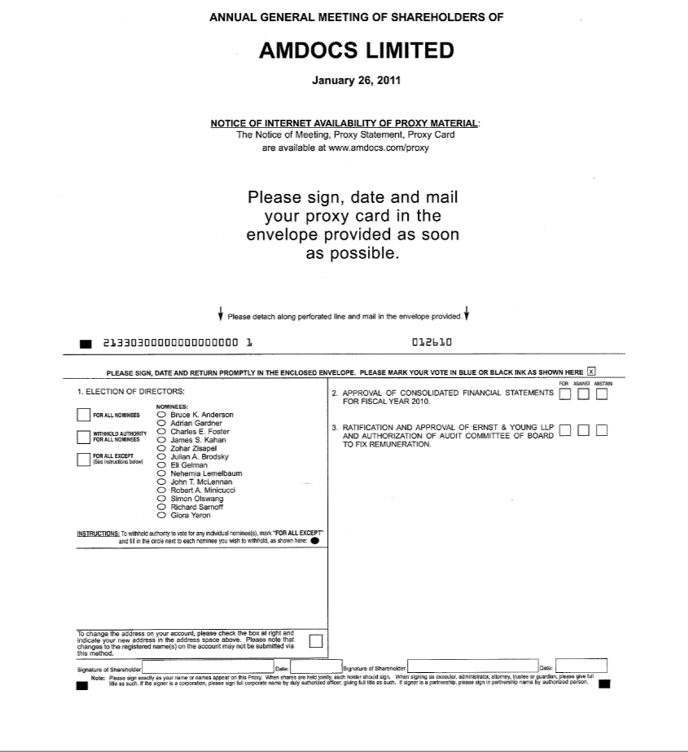

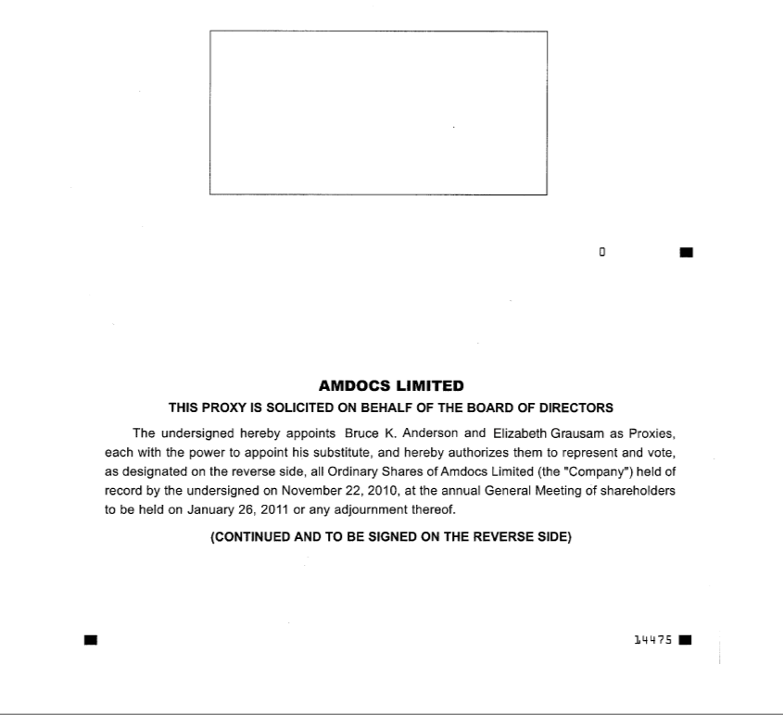

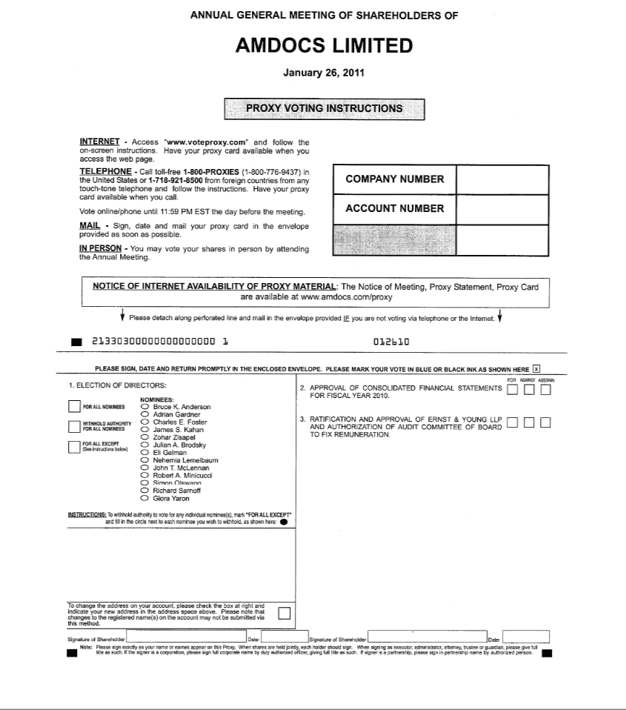

SIGNATURES

Pursuant to the requirements of the Securities Exchange Act of 1934, the registrant has duly caused this report to be signed on its behalf by the undersigned, thereunto duly authorized.

AMDOCS LIMITED

/s/ Thomas G. O’Brien

Thomas G. O’Brien

Treasurer and Secretary

Authorized U.S. Representative

Date: December 20, 2010

