UNITED STATES

SECURITIES AND EXCHANGE COMMISSION
WASHINGTON, D.C. 20549

Form 6-K

REPORT OF FOREIGN PRIVATE ISSUER

PURSUANT TO RULE 13a-16 OR 15d-16
OF THE SECURITIES EXCHANGE ACT OF 1934

For the month of May 2023

Commission File Number 1-14840

AMDOCS LIMITED

Hirzel House, Smith Street,

St. Peter Port, Island of Guernsey, GY1 2NG

Amdocs, Inc.

625 Maryville Centre Drive, Suite 200, Saint Louis, Missouri 63141
(Address of principal executive offices)

Indicate by check mark whether the registrant files or will file annual reports under cover of Form 20-F or Form 40-F:

FORM 20-F ☒ FORM 40-F ☐

Indicate by check mark if the registrant is submitting the Form 6-K in paper as permitted by Regulation S-T Rule 101(b)(1): ☐

Indicate by check mark if the registrant is submitting the Form 6-K in paper as permitted by Regulation S-T Rule 101(b)(7): ☐

Indicate by check mark whether the registrant by furnishing the information contained in this form is also thereby furnishing the information to the

Commission pursuant to Rule 12g3-2(b) under the Securities Exchange Act of 1934:

YES ☐ NO ☒

If “Yes” is marked, indicate below the file number assigned to the registrant in connection with Rule 12g3-2(b): 82- _______

On May 10, 2023 Amdocs Limited (“Amdocs”) issued a press release announcing financial results for the quarter ended March 31, 2023. A copy of the press release and the accompanying presentation are furnished as Exhibits 99.1 and 99.2 to this Report of Foreign Private Issuer on Form 6-K.

In addition, on May 10, 2023, Amdocs also announced that it has entered into a definitive agreement to acquire the service assurance business of TEOCO for consideration of approximately $90 million in cash, subject to the satisfaction of the conditions to closing. A copy of the press release is furnished as Exhibit 99.3 to this Report of Foreign Private Issuer on Form 6-K.

The information in this Form 6-K (including Exhibits 99.1, 99.2 and 99.3) shall not be deemed “filed” for purposes of Section 18 of the Securities Exchange Act of 1934 (the “Exchange Act”) or otherwise subject to the liabilities of that section, nor shall it be deemed incorporated by reference in any filing under the Securities Act of 1933 or the Exchange Act.

SIGNATURES

Pursuant to the requirements of the Securities Exchange Act of 1934, the registrant has duly caused this report to be signed on its behalf by the undersigned, thereunto duly authorized.

AMDOCS LIMITED

By: /s/ Matthew E. Smith

Matthew E. Smith

Secretary and Authorized Signatory

Date: May 10, 2023

 |  |  | EXHIBIT INDEX
EXHIBIT |  | DESCRIPTION
NO.
99.1 |  | Amdocs Limited Press Release Announcing Q2 Earnings, dated May 10, 2023.
99.2 |  | Fiscal Q2 2023 Earnings Presentation
99.3 |  | Amdocs Limited Press Release Announcing TEOCO Acquisition, dated May 10, 2023.
Exhibit 99.1


Amdocs Limited Reports Second Quarter Fiscal 2023 Results

Record Quarterly Revenue of $1.22 Billion, Above Midpoint of Guidance and up 6.8% YoY

as Reported and 8.2% YoY in Constant Currency⁽²⁾

Reiterates Fiscal 2023 Revenue Growth Outlook while Tightening Expected Range to 6%-8% as Reported and 7%-9% Constant Currency⁽²⁾
Reiterates Fiscal 2023 Earnings per Share Growth Targets

Reiterates Fiscal 2023 Free Cash Flow⁽¹⁾ Outlook of $700 Million

Second Quarter Fiscal 2023 Highlights

(All comparisons are against the prior year)

  - Record revenue of $1,223 million, up 6.8% as reported and up 8.2% in constant currency⁽²⁾; revenue was above the midpoint of $1,200-$1,240 million guidance range

  - Record revenue of $829 million in North America, up 7.4%, and record revenue of $172 million in Europe, up 16.6%

  - Record managed services revenue of $719 million, equivalent to approximately 59% of total revenue

  - GAAP diluted EPS of $1.23, above the midpoint of $1.18-$1.26 guidance range

  - Non-GAAP diluted EPS of $1.47, at the midpoint guidance range of $1.44-$1.50

  - GAAP operating income of $182 million; GAAP operating margin of 14.9%, up 220 basis points sequentially, primarily due to restructuring charges, and up 60 basis points as compared to last year’s second fiscal quarter

  - Non-GAAP operating income of $218 million; non-GAAP operating margin of 17.8%, up 10 basis points sequentially and up 20 basis points as compared to last year’s second fiscal quarter

- Please refer to the Selected Financial Metrics tables below (figures may not sum because of rounding).

- Revenue on a constant currency basis assumes exchange rates in the current period were unchanged from the prior period

- Free cash flow of $259 million, comprised of cash flow from operations of $294 million, less $35 million in net capital expenditures and other⁽¹⁾; reiterates full year fiscal 2023 free cash outlook of $700 million
- Repurchased $106 million of ordinary shares during the second fiscal quarter

- Record twelve-month backlog of $4.11 billion, up 5.7% as compared to last year’s second fiscal quarter

- The Board of Directors of Amdocs approved a definitive agreement on May 10, 2023, to acquire the service assurance business of TEOCO for a consideration of approximately $90 million in cash, subject to closing conditions

JERSEY CITY, NJ – May 10, 2023 – Amdocs Limited (NASDAQ: DOX), a leading provider of software and services to communications and media companies, today reported operating results for the three months ended March 31, 2023.

“I am pleased with our second fiscal quarter performance as we progressed our strategy to deliver the next-generation cloud-based products and software services that global communications service providers need to unlock the potential of 5G and broadband networks, data-driven intelligence, and improved consumer and B2B experience. Record revenue of $1.22 billion was up 8.2% from a year ago in constant currency⁽²⁾, driven by our best-ever quarters in North America and Europe, and we saw continued sales momentum with many cloud-related wins in the quarter. New deals included key awards with T-Mobile in the US, two new logos in Eastern Europe, and a significant cloud-migration engagement with PLDT in the Philippines. On the strategic front, we expanded our Microsoft partnership to bring a new AI-powered Customer Engagement Platform, and we sharpened our focus on the growth potential of B2B with the launch of CES23, our most advanced Customer Experience Suite yet. Additionally, we signed a definitive agreement to acquire the service assurance business of TEOCO to enhance the execution of our network automation strategy,” said Shuky Sheffer, president and chief executive officer of Amdocs Management Limited.

“Demonstrating strong execution, we maintained a high rate of project deployments in Q2, which included major milestone achievements with many of the world’s largest service providers. Driven by ongoing efficiency gains, profitability improved on a sequential and year ago basis and free cash flow generation was very strong on the back of healthy cash collections from customers. In managed services, we renewed several customer agreements which included an extended multiyear partnership with Globe in the Philippines and an expanded cloud-related engagement with a major Western European operator,” said Tamar Rapaport-Dagim, chief financial officer & chief operating officer of Amdocs Management Limited.

Sheffer concluded, “As said previously, Amdocs and our global customers are not immune to economic and industry cycles, and we continue to closely monitor the operating environment. As a key technology enabler, we believe Amdocs is positioned at the heart of a multi-year, technology-driven investment cycle centered around the major long-term trends of 5G, network automation, digital modernization, and cloud. Moreover, we believe Amdocs’ role as a trusted partner is even more relevant during this period of rapidly shifting market dynamics as we work to help service providers improve consumer and B2B experience, accelerate cost reduction, and increase efficiency. Overall, considering our strong first half performance and the visibility provided by our unique business model, we expect to deliver constant currency⁽²⁾ revenue growth within a tighter range of 7% to 9% in fiscal 2023, while maintaining improved profitability and robust earnings to cash conversion for the full year.”

Revenue

(All comparisons are against the prior year period)

 |  |  | In millions
 | Three months ended
 |  | March 31, 2023
 | Actual |  |  | Guidance
Revenue | $ 1,223 |  | $1,200 - $1,240
Revenue Growth, as reported | 6.8%
Revenue Growth, constant currency ⁽²⁾ | 8.2%

- Revenue for the second fiscal quarter of 2023 was at the midpoint of Amdocs’ guidance, even after adjusting for a positive impact from foreign currency movements of approximately $3 million compared to our guidance assumptions

- Revenue for the second fiscal quarter includes a positive impact from foreign currency movements of approximately $7 million relative to the first quarter of fiscal 2023

Net Income and Earnings Per Share

 |  |  | In thousands, expect per
` |  |  | share data
 |  |  | Three months ended
 |  |  | March 31,
 |  |  | 2023 |  |  | 2022
GAAP Measures
Net Income | $ |  | 150,309 | $ |  | 158,497
Net Income attributable to Amdocs Limited | $ |  | 149,603 | $ |  | 158,497
Diluted earnings per share | $ |  | 1.23 | $ |  | 1.28
Non-GAAP Measures
Non-GAAP Net Income | $ |  | 179,298 | $ |  | 190,944
Non-GAAP Net Income attributable to Amdocs Limited | $ |  | 178,592 | $ |  | 190,944
Non-GAAP Diluted earnings per share | $ |  | 1.47 | $ |  | 1.54

- Non-GAAP net income excludes amortization of purchased intangible assets and other acquisition-related costs, changes in certain acquisition related liabilities measured at fair value, equity-based compensation expenses and other, net of related tax effects, in all the periods presented.

For further details of the reconciliation of selected financial metrics from GAAP to Non-GAAP, please refer to the tables below.

Capital Allocation: Returning Cash to Shareholders

- Quarterly Cash Dividend Program: On May 10, 2023, the Board approved the Company’s next quarterly cash dividend payment of

$0.435 per share and set June 30, 2023 as the record date for determining the shareholders entitled to receive the dividend, which will be payable on July 28, 2023

- Share Repurchase Activity: Repurchased $106 million of ordinary shares during the second quarter of fiscal 2023

Twelve-month Backlog

Twelve-month backlog was a record $4.11 billion at the end of the second quarter of fiscal 2023, up approximately 5.7% as compared to last year’s second fiscal quarter. Twelve-month backlog includes anticipated revenue related to contracts, estimated revenue from managed services contracts, letters of intent, maintenance and estimated on-going support activities.

Third Quarter Fiscal 2023 Outlook

 | In millions, except per share data
 | Q3 2023
Revenue | $1,215-$1,255
GAAP diluted EPS | $1.16-$1.26
Non-GAAP diluted EPS | $1.45-$1.51

- Third quarter revenue guidance assumes immaterial sequential impact from foreign currency fluctuations as compared to the second quarter of fiscal 2023

- Third quarter non-GAAP diluted EPS guidance excludes equity-based compensation expense of approximately $0.15-$0.17 per share, amortization of purchased intangible assets and other acquisition-related costs of approximately $0.08 per share, changes in certain acquisitions related liabilities measured at fair value, and other, net of related tax effects

Full Year Fiscal 2023 Outlook

 |  | FY 2023, year-over-year growth
 |  | Current Guidance |  | Previous Guidance
Revenue growth, as reported | 6.0%-8.0% |  |  | 5.0%-9.0%
Revenue growth, constant currency⁽²⁾ | 7.0%-9.0% |  |  | 6.0%-10.0%
GAAP diluted EPS growth | 3.0%-10.0% |  |  | 3.0%-10.0%
Non-GAAP diluted EPS growth | 9.0%-13.0% |  |  | 9.0%-13.0%

 | FY 2023, in millions
 | Current Guidance | Previous Guidance
Free cash flow⁽¹⁾ | ~$700 | ~$700

- Full year fiscal 2023 revenue guidance incorporates an expected unfavorable impact from foreign currency fluctuations of approximately 1% year-over-year, consistent with previous expectation

- Non-GAAP diluted earnings per share growth excludes equity-based compensation expense of approximately $0.58-$0.63 per share, amortization of purchased intangible assets and other acquisition-related costs of approximately $0.35 per share, restructuring charges of approximately $0.15 per share, changes in certain acquisitions related liabilities measured at fair value, and other, net of related tax effects

- Non-GAAP effective tax rate is anticipated to be within a range of 13.0% to 17.0% for the full year fiscal 2023

- Free cash flow⁽¹⁾ is comprised of cash flow from operations, less net capital expenditures and other

The forward looking statements regarding our third fiscal quarter 2023 and full year fiscal 2023 guidance take into consideration the Company’s current expectations regarding macro and industry specific risks and various uncertainties and certain assumptions that we will discuss on our earnings conference call. However, we note that market dynamics continue to shift rapidly and we cannot predict all possible outcomes, including those resulting from certain geopolitical events, the current inflationary environment, global or regional events, such as the COVID-19 pandemic and the prevailing level of macro-economic, business and operational uncertainty, which have created, and continues to create, a significant amount of uncertainty, or from current and potential customer consolidation or their other strategic corporate activities.

Conference Call and Earnings Webcast Presentation Details

Amdocs will host a conference call and earnings webcast presentation on May 10, 2023 at 5:00 p.m. Eastern Time to discuss the Company’s second quarter of fiscal 2023 results.

To participate in the call, please register here to receive the dial-in numbers and unique access PIN. The conference call and webcast will also be carried live on the Internet and may be accessed via the Amdocs website at https://investors.amdocs.com. Presentation slides will be available shortly before the webcast.

Non-GAAP Financial Measures

This release includes non-GAAP diluted earnings per share and other non-GAAP financial measures, including free cash flow and normalized free cash flow, revenue on a constant currency⁽²⁾ basis, non-GAAP cost of revenue, non-GAAP research and development, non-GAAP selling, general and administrative, non-GAAP operating income, non-GAAP operating margin, non-GAAP interest and other expenses, net, non-GAAP income taxes, non-GAAP effective tax rate, non-GAAP net income, non-GAAP net income attributable to Amdocs Limited and non-GAAP diluted earnings per share growth. These other non-GAAP measures exclude the following items:

- amortization of purchased intangible assets and other acquisition-related costs;

- changes in certain acquisition-related liabilities measured at fair value;

- restructuring and unusual charges or benefits (such as a gain from divestiture of OpenMarket);

- equity-based compensation expense;

- other; and

- tax effects related to the above.

Free cash flow equals cash generated by operating activities less net capital expenditures and other. Normalized free cash flow, a measure of our operating performance, is further adjusted to exclude net capital expenditures related to the new campus development, payments for non-recurring and unusual charges (such as capital gains tax in relation to the divestiture of OpenMarket), and payments of acquisition related liabilities. These non-GAAP financial measures are not in accordance with, or an alternative for, generally accepted accounting principles and may be different from non-GAAP financial measures used by other companies. In addition, these non-GAAP financial measures are not based on any comprehensive set of accounting rules or principles. Amdocs believes that non-GAAP financial measures have limitations in that they do not reflect all of the amounts associated with Amdocs’ results of operations as determined in accordance with GAAP and that these measures should only be used to evaluate Amdocs’ results of operations in conjunction with the corresponding GAAP measures.

Amdocs believes that the presentation of non-GAAP diluted earnings per share and other financial measures, including free cash flow and normalized free cash flow, revenue on a constant currency⁽²⁾ basis, non-GAAP cost of revenue, non-GAAP research and development, non-GAAP selling, general and administrative, non-GAAP operating income, non-GAAP operating margin, non-GAAP interest and other expenses, net, non-GAAP income taxes, non-GAAP effective tax rate, non-GAAP net income, non-GAAP net income attributable to Amdocs Limited and non-GAAP diluted earnings per share growth when shown in conjunction with the corresponding GAAP measures, provides useful information to investors and management regarding financial and business trends relating to its financial condition and results of operations, as well as the net amount of cash generated by its business operations after taking into account capital spending required to maintain or expand the business.

For its internal budgeting process and in monitoring the results of the business, Amdocs’ management uses financial statements that do not include amortization of purchased intangible assets and other acquisition-related costs, changes in certain acquisition-related liabilities measured at fair value, restructuring and unusual charges or benefits, equity-based compensation expense, other and related tax effects. Amdocs’ management also uses the foregoing non-GAAP financial measures, in addition to the corresponding GAAP measures, in reviewing the financial results of Amdocs. In addition, Amdocs believes that significant groups of investors exclude these items in reviewing its results and those of its competitors, because the amounts of the items between companies can vary greatly depending on the assumptions used by an individual company in determining the amounts of the items.

Amdocs further believes that, where the adjustments used in calculating non-GAAP diluted earnings per share are based on specific, identified amounts that impact different line items in the Consolidated Statements of Income (including cost of revenue, research and development, selling, general and administrative, operating income, interest and other expenses, net, income taxes and net income), it is useful to investors to understand how these specific line items in the Consolidated Statements of Income are affected by these adjustments. Please refer to the Reconciliation of Selected Financial Metrics from GAAP to Non-GAAP tables below.

Supporting Resources

- Keep up with Amdocs news by visiting the Company’s website

- Subscribe to Amdocs’ RSS Feed and follow us on Twitter, Facebook, LinkedIn and YouTube

About Amdocs

Amdocs helps those who build the future to make it amazing. With our market-leading portfolio of software products and services, we unlock our customers’ innovative potential, empowering them to provide next-generation communication and media experiences for both the individual end user and large enterprise customers. Our 31,000 employees around the globe are here to accelerate service providers’ migration to the cloud, enable them to differentiate in the 5G era, and digitalize and automate their operations. Listed on the NASDAQ Global Select Market, Amdocs had revenue of $4.58 billion in fiscal 2022.

For more information, visit Amdocs at www.amdocs.com.

This press release includes information that constitutes forward-looking statements made pursuant to the safe harbor provision of the Private Securities Litigation Reform Act of 1995, including statements about Amdocs’ growth and business results in future quarters and years. Although we believe the expectations reflected in such forward-looking statements are based upon reasonable assumptions, we can give no assurance that our expectations will be obtained or that any deviations will not be material. Such statements involve risks and uncertainties that may cause future results to differ from those anticipated. These risks include, but are not limited to, the effects of general macro-economic conditions, prevailing level of macroeconomic, business and operational uncertainty, including as a result of geopolitical events or other global or regional events such as the COVID-19 pandemic, as well as the current inflationary environment, and the effects of these conditions on the company’s clients’ businesses and levels of business activity, Amdocs’ ability to grow in the business markets that it serves, Amdocs’ ability to successfully integrate acquired businesses, adverse effects of market competition, rapid technological shifts that may render the Company’s products and services obsolete, potential loss of a major customer, our ability to develop long-term relationships with our customers, and risks associated with operating businesses in the international market. Amdocs may elect to update these forward-looking statements at some point in the future; however, Amdocs specifically disclaims any obligation to do so. These and other risks are discussed at greater length in Amdocs’ filings with the Securities and Exchange Commission, including in our Annual Report on Form 20-F for the fiscal year ended September 30, 2022 filed on December 13, 2022 and our Form 6-K furnished for the first quarter of fiscal 2023 on February 13, 2023.

Contact:

Matthew Smith

Head of Investor Relations

Amdocs

314-212-8328

E-mail: dox_info@amdocs.com

AMDOCS LIMITED

Consolidated Statements of Income

(In thousands, except per share data)

 |  | Three months ended |  |  |  |  |  |  |  | Six months ended
 |  | March 31, |  |  |  |  |  |  |  | March 31,
 |  | 2023 |  |  |  | 2022 |  |  |  | 2023 |  |  |  | 2022
Revenue | $1,223,304 |  |  |  | $1,145,271 |  |  | $2,409,024 |  |  |  | $2,249,903
Operating expenses:
Cost of revenue |  | 795,485 |  |  |  | 741,257 |  |  |  | 1,552,334 |  |  |  | 1,457,975
Research and development |  | 89,274 |  |  |  | 87,064 |  |  |  | 185,000 |  |  |  | 169,009
Selling, general and administrative |  | 143,328 |  |  |  | 134,982 |  |  |  | 286,550 |  |  |  | 263,058
Amortization of purchased intangible assets and other |  | 12,940 |  |  |  | 18,317 |  |  |  | 28,253 |  |  |  | 36,064
Restructuring charges |  | — |  |  |  | — |  |  |  | 24,536 |  |  |  | —
 |  | 1,041,027 |  |  |  | 981,620 |  |  |  | 2,076,673 |  |  |  | 1,926,106
Operating income |  | 182,277 |  |  |  | 163,651 |  |  |  | 332,351 |  |  |  | 323,797
Interest and other expense, net |  | (2,938) |  |  |  | (8,619) |  |  |  | (7,901) |  |  |  | (11,181)
Gain from sale of a business |  | — |  |  |  | — |  |  |  | — |  |  |  | 10,000
Income before income taxes |  | 179,339 |  |  |  | 155,032 |  |  |  | 324,450 |  |  |  | 322,616
Income tax expense (benefit) |  | 29,030 |  |  |  | (3,465) |  |  |  | 44,269 |  |  |  | 30,517
Net income | $ | 150,309 |  |  | $ | 158,497 |  |  | $ | 280,181 |  |  | $ | 292,099
Net income attributable to noncontrolling interests |  | 706 |  |  |  | — |  |  |  | 911 |  |  |  | —
Net income attributable to Amdocs Limited | $ | 149,603 |  |  | $ | 158,497 |  |  | $ | 279,270 |  |  | $ | 292,099
Basic earnings per share attributable to Amdocs Limited | $ | 1.24 |  |  | $ | 1.29 |  |  | $ | 2.32 |  |  | $ | 2.36
Diluted earnings per share attributable to Amdocs Limited | $ | 1.23 |  |  | $ | 1.28 |  |  | $ | 2.30 |  |  | $ | 2.34
Cash dividends declared per ordinary share | $ | 0.435 |  |  | $ | 0.395 |  |  | $ | 0.830 |  |  | $ | 0.755
Basic weighted average number of shares outstanding |  | 120,516 |  |  |  | 122,977 |  |  |  | 120,585 |  |  |  | 123,748
Diluted weighted average number of shares outstanding |  | 121,359 |  |  |  | 123,821 |  |  |  | 121,430 |  |  |  | 124,571

AMDOCS LIMITED

Selected Financial Metrics

(In thousands, except per share data)

 |  |  | Three months ended |  |  |  |  |  |  |  |  |  |  | Six months ended
 |  |  |  | March 31, |  |  |  |  |  |  |  |  |  | March 31,
 |  |  | 2023 |  |  |  |  |  |  | 2022 |  |  |  | 2023 |  |  |  |  | 2022
Revenue | $1,223,304 |  |  |  |  | $1,145,271 |  |  |  |  |  |  | $2,409,024 |  |  |  | $2,249,903
Non-GAAP operating income |  |  | 217,737 |  |  |  |  |  |  | 201,625 |  |  |  | 427,275 |  |  |  |  | 395,232
Non-GAAP net income |  |  | 179,298 |  |  |  |  |  |  | 190,944 |  |  |  | 355,840 |  |  |  |  | 341,079
Non-GAAP net income attributable to Amdocs Limited |  |  | 178,592 |  |  |  |  |  |  | 190,944 |  |  |  | 354,929 |  |  |  |  | 341,079
Non-GAAP diluted earnings per share | $ |  | 1.47 |  |  | $ |  |  |  | 1.54 |  |  | $ | 2.92 |  |  | $ |  | 2.74
Diluted weighted average number of shares outstanding |  |  | 121,359 |  |  |  |  |  |  | 123,821 |  |  |  | 121,430 |  |  |  |  | 124,571
 | Free Cash Flows
 | (In thousands)
 |  |  |  | Three months ended |  |  |  |  |  |  |  |  |  | Six months ended
 |  |  |  |  |  | March 31, |  |  |  |  |  |  |  | March 31,
 |  |  |  | 2023 |  |  |  |  |  |  | 2022 |  |  | 2023 |  |  |  |  | 2022
Net Cash Provided by Operating Activities |  |  | $294,476 |  |  |  |  |  |  | $168,856 |  |  |  | $377,702 |  |  | $ |  | 372,974
Purchases of property and equipment, net (a) |  |  | (35,119) |  |  |  |  |  |  | (47,271) |  |  |  | (68,822) |  |  |  |  | (104,496)
Free Cash Flow |  |  |  | $259,357 |  |  |  |  |  |  | $121,585 |  |  | $308,880 |  |  |  | $ | 268,478

Normalized Free Cash Flow ^{(b)} for the three and six months ended March 31, 2022: $159,758 and $345,437, respectively, excluding net capital expenditures related to the new campus development of $30,109 and $59,416, respectively, payment for acquisition related liability of $4,871 and $14,350, respectively, and tax payment on sale of business of $3,193.

- The amounts under “Purchase of property and equipment, net” include proceeds from sale of property and equipment of $255 and $555 for the six months ended March 31, 2023 and 2022, respectively.
- Since Q12023, the Normalized Free Cash Flow is no longer applicable.

AMDOCS LIMITED

Reconciliation of Selected Financial Metrics from GAAP to Non-GAAP

(In thousands)

 |  |  |  |  |  |  |  |  |  |  | Three Months Ended March 31, 2023
 |  |  |  |  |  |  |  |  |  |  |  |  |  |  |  |  |  |  |  | Changes in
 |  |  |  |  |  |  |  |  |  |  |  |  |  |  |  |  |  |  |  |  | certain
 |  |  |  |  |  |  |  | Amortization |  |  |  |  |  |  |  |  |  |  |  | acquisitions
 |  |  |  |  |  |  |  | of purchased |  |  |  |  |  |  |  |  |  |  |  |  | related
 |  |  |  |  |  |  |  | intangible |  |  |  |  |  | Equity based |  |  |  |  |  | liabilities
 |  |  |  |  |  |  |  | assets and |  |  |  |  |  | compensation |  |  |  |  |  | measured at |  |  |  |  |  |  |  | Tax
 |  |  | GAAP |  |  |  |  | other |  |  |  |  |  | expense |  |  |  |  |  | fair value |  |  |  |  |  |  |  | effect |  |  |  | Non-GAAP
Operating expenses:
Cost of revenue | $ |  | 795,485 |  |  |  | $ |  |  |  | — |  | $ |  |  | (10,061) |  |  |  | $ |  | (1,159) |  |  |  | $ |  |  | — |  |  | $ | 784,265
Research and development |  |  |  | 89,274 |  |  |  |  |  |  |  |  |  |  |  |  | (1,703) |  |  |  |  |  |  |  |  |  |  |  |  |  |  |  | 87,571
Selling, general and administrative |  |  | 143,328 |  |  |  |  |  |  |  |  |  |  |  |  |  | (9,597) |  |  |  |  |  |  |  |  |  |  |  |  |  |  |  | 133,731
Amortization of purchased intangible assets and other |  |  |  | 12,940 |  |  | (12,940) |  |  |  |  |  |  |  |  |  |  |  |  |  |  |  |  |  |  |  |  |  |  |  |  |  | —
Total operating expenses
Total operating expenses |  |  | 1,041,027 |  |  |  |  | (12,940) |  |  |  |  |  |  |  | (21,361) |  |  |  |  |  | (1,159) |  |  |  |  |  |  | — |  |  |  | 1,005,567
Operating income |  |  | 182,277 |  |  |  |  |  |  | 12,940 |  |  |  |  |  |  | 21,361 |  |  |  |  | 1,159 |  |  |  |  |  |  | — |  |  |  | 217,737
Interest and other expense, net |  |  |  | (2,938) |  |  |  |  |  |  |  |  |  |  |  |  |  |  |  |  |  |  |  |  |  |  |  |  |  |  |  |  | (2,938)
Income taxes |  |  |  | 29,030 |  |  |  |  |  |  |  |  |  |  |  |  |  |  |  |  |  |  |  |  |  | 6,471 |  |  |  |  |  |  | 35,501
Net income |  |  | 150,309 |  |  |  |  |  |  | 12,940 |  |  |  |  |  |  | 21,361 |  |  |  |  | 1,159 |  |  |  | (6,471) |  |  |  |  |  |  | 179,298
Net income attributable to noncontrolling interests |  |  |  | 706 |  |  |  |  |  |  |  |  |  |  |  |  |  |  |  |  |  |  |  |  |  |  |  |  |  |  |  |  | 706
Net income attributable to Amdocs Limited
Net income attributable to Amdocs Limited |  | $ | 149,603 |  |  |  | $ |  |  | 12,940 |  |  | $ |  |  |  | 21,361 |  |  | $ |  | 1,159 |  |  |  | $(6,471) |  |  |  |  |  | $ | 178,592
 |  |  |  |  |  |  |  |  |  |  | Three Months Ended March 31, 2022
 |  |  |  |  |  |  |  |  |  |  |  |  |  |  |  |  |  | Changes in
 |  |  |  |  |  |  |  |  |  |  |  |  |  |  |  |  |  | certain
 |  |  |  | Amortization |  |  |  |  |  |  |  |  |  |  |  |  |  | acquisitions
 |  |  |  |  | of purchased |  |  |  |  |  |  |  |  |  |  |  |  | related
 |  |  |  |  | intangible |  |  |  |  |  | Equity based |  |  |  |  |  |  | liabilities
 |  |  |  |  | assets and |  |  |  |  |  | compensation |  |  |  |  |  | measured at |  |  |  |  |  |  |  |  |  |  |  | Tax
 | GAAP |  |  |  | other |  |  |  |  |  | expense |  |  |  |  |  |  | fair value |  |  |  |  | Other |  |  |  |  |  | effect |  |  |  | Non-GAAP
Operating expenses:
Cost of revenue | $741,257 |  |  | $ |  |  | — |  |  | $ |  |  | (8,070) |  |  |  | $ | (1,820) |  |  |  | $ | — |  |  | $ |  |  | — |  |  |  | $ 731,367
Research and development | 87,064 |  |  |  |  |  |  |  |  |  |  |  | (1,375) |  |  |  |  |  |  |  |  |  |  |  |  |  |  |  |  |  |  |  | 85,689
Selling, general and administrative | 134,982 |  |  |  |  |  |  |  |  |  |  |  | (8,392) |  |  |  |  |  |  |  |  |  |  |  |  |  |  |  |  |  |  |  | 126,590
Amortization of purchased intangible assets and other | 18,317 |  |  |  |  |  | (18,317) |  |  |  |  |  |  |  |  |  |  |  |  |  |  |  |  |  |  |  |  |  |  |  |  |  | —
Total operating expenses
Total operating expenses | 981,620 |  |  |  |  |  | (18,317) |  |  | (17,837) |  |  |  |  |  |  |  | (1,820) |  |  |  |  | — |  |  |  |  |  | — |  |  |  | 943,646
Operating income | 163,651 |  |  |  |  |  | 18,317 |  |  |  |  |  | 17,837 |  |  |  |  | 1,820 |  |  |  |  | — |  |  |  |  |  | — |  |  |  | 201,625
Interest and other expense, net | (8,619) |  |  |  |  |  |  |  |  |  |  |  |  |  |  |  |  |  |  |  |  |  | 1,100 |  |  |  |  |  |  |  |  |  | (7,519)
Income tax (benefit) expense | (3,465) |  |  |  |  |  |  |  |  |  |  |  |  |  |  |  |  |  |  |  |  |  |  |  |  |  |  |  | 6,627 |  |  |  | 3,162
Net income
Net income | $158,497 |  |  |  | $ |  | 18,317 |  |  |  | $ |  | 17,837 |  |  |  | $ | 1,820 |  |  |  | $ | 1,100 |  |  | $(6,627) |  |  |  |  |  |  | $ 190,944

AMDOCS LIMITED

Reconciliation of Selected Financial Metrics from GAAP to Non-GAAP

(In thousands)

 |  |  |  |  |  |  |  |  |  |  |  |  |  |  | Six Months Ended March 31, 2023
 |  |  |  |  |  |  |  |  |  |  |  |  |  |  |  |  |  |  | Changes in
 |  |  |  |  |  |  |  |  |  |  |  |  |  |  |  |  |  |  | certain
 |  |  |  |  |  |  | Amortization |  |  |  |  |  |  |  |  |  |  |  | acquisitions
 |  |  |  |  |  |  | of purchased |  |  |  |  |  |  |  |  |  |  |  | related
 |  |  |  |  |  |  | intangible |  |  |  |  | Equity based |  |  |  |  |  |  | liabilities
 |  |  |  |  |  |  | assets and |  |  |  |  | compensation |  |  |  |  |  | measured at |  |  |  |  | Restructuring |  |  |  |  |  |  |  | Tax
 |  |  | GAAP |  |  |  | other |  |  |  |  |  | expense |  |  |  |  |  | fair value |  |  |  |  |  | charges |  |  |  |  | effect |  |  | Non-GAAP
Operating expenses:
Cost of revenue | $1,552,334 |  |  |  |  | $ |  | — |  |  | $ |  | (18,716) |  |  |  |  | $ |  | (1,284) |  |  | $ |  |  |  | — |  | $ |  | — |  | $1,532,334
Research and development | 185,000 |  |  |  |  |  |  |  |  |  |  |  |  |  | (3,187) |  |  |  |  |  |  |  |  |  |  |  |  |  |  |  |  |  | 181,813
Selling, general and administrative | 286,550 |  |  |  |  |  |  |  |  |  |  |  | (18,948) |  |  |  |  |  |  |  |  |  |  |  |  |  |  |  |  |  |  |  | 267,602
Amortization of purchased intangible assets and
other | 28,253 |  |  |  |  | (28,253) |  |  |  |  |  |  |  |  |  |  |  |  |  |  |  |  |  |  |  |  |  |  |  |  |  |  | —
Restructuring charges | 24,536 |  |  |  |  |  |  |  |  |  |  |  |  |  |  |  |  |  |  |  |  |  |  |  | (24,536) |  |  |  |  |  |  |  | —
Total operating expenses |  |  | 2,076,673 |  |  |  | (28,253) |  |  |  |  |  | (40,851) |  |  |  |  |  |  | (1,284) |  |  |  |  | (24,536) |  |  |  |  |  | — |  | 1,981,749
Operating income
Operating income |  |  | 332,351 |  |  |  |  | 28,253 |  |  |  |  |  |  | 40,851 |  |  |  |  | 1,284 |  |  |  |  | 24,536 |  |  |  |  |  | — |  | 427,275
Interest and other expense, net |  |  |  | (7,901) |  |  |  |  |  |  |  |  |  |  |  |  |  |  |  |  |  |  |  |  |  |  |  |  |  |  |  |  | (7,901)
Income taxes | 44,269 |  |  |  |  |  |  |  |  |  |  |  |  |  |  |  |  |  |  |  |  |  |  |  |  |  |  |  | 19,265 |  |  |  | 63,534
Net income | 280,181 |  |  |  |  |  |  | 28,253 |  |  |  |  |  |  | 40,851 |  |  |  |  | 1,284 |  |  |  |  | 24,536 |  |  |  | (19,265) |  |  |  | 355,840
Net income attributable to noncontrolling
interests |  |  |  | 911 |  |  |  |  |  |  |  |  |  |  |  |  |  |  |  |  |  |  |  |  |  |  |  |  |  |  |  |  | 911
Net income attributable to Amdocs Limited |  |  | $ 279,270 |  |  |  | $ | 28,253 |  |  | $ |  |  |  | 40,851 |  |  | $ |  | 1,284 |  |  | $ |  | 24,536 |  |  |  | $(19,265) |  |  |  | $ 354,929
 |  |  |  |  |  |  |  |  |  |  |  |  | Six Months Ended March 31, 2022
 |  |  |  |  |  |  |  |  |  |  |  |  |  |  |  | Changes in
 |  |  |  |  |  |  |  |  |  |  |  |  |  |  |  | certain
 |  |  |  | Amortization |  |  |  |  |  |  |  |  |  |  |  | acquisitions
 |  |  |  |  | of purchased |  |  |  |  |  |  |  |  |  |  | related
 |  |  |  |  | intangible |  |  |  | Equity based |  |  |  |  |  |  | liabilities |  |  |  |  | Gain from
 |  |  |  |  | assets and |  |  | compensation |  |  |  |  |  |  |  | measured at |  |  |  |  | sale of a |  |  |  |  |  |  |  |  |  | Tax
 |  | GAAP |  |  |  | other |  |  | expense |  |  |  |  |  |  | fair value |  |  |  |  | business |  |  |  |  |  | Other |  |  |  | effect |  | Non-GAAP
Operating expenses:
Cost of revenue | $1,457,975 |  |  | $ |  |  | — | $ |  |  | (15,217) |  |  |  |  | $ |  | (793) |  | $ |  |  | — |  | $ |  | — |  | $ |  | — |  | $1,441,965
Research and development | 169,009 |  |  |  |  |  |  |  |  |  | (2,598) |  |  |  |  |  |  |  |  |  |  |  |  |  |  |  |  |  |  |  |  |  | 166,411
Selling, general and administrative | 263,058 |  |  |  |  |  |  |  |  |  | (16,763) |  |  |  |  |  |  |  |  |  |  |  |  |  |  |  |  |  |  |  |  |  | 246,295
Amortization of purchased intangible
assets and other |  | 36,064 |  |  |  | (36,064) |  |  |  |  |  |  |  |  |  |  |  |  |  |  |  |  |  |  |  |  |  |  |  |  |  |  | —
Total operating expenses
Total operating expenses |  | 1,926,106 |  |  |  | (36,064) |  |  |  |  | (34,578) |  |  |  |  |  |  | (793) |  |  |  |  | — |  |  |  | — |  |  |  | — |  | 1,854,671
Operating income | 323,797 |  |  |  |  | 36,064 |  |  |  |  | 34,578 |  |  |  |  |  |  | 793 |  |  |  |  | — |  |  |  | — |  |  |  | — |  | 395,232
Interest and other expense, net | (11,181) |  |  |  |  |  |  |  |  |  |  |  |  |  |  |  |  |  |  |  |  |  |  |  |  |  | (2,505) |  |  |  |  |  | (13,686)
Gain from sale of a business | 10,000 |  |  |  |  |  |  |  |  |  |  |  |  |  |  |  |  |  |  | $(10,000) |  |  |  |  |  |  |  |  |  |  |  |  | —
Income tax (benefit) expense | 30,517 |  |  |  |  |  |  |  |  |  |  |  |  |  |  |  |  |  |  |  |  |  |  |  |  |  |  |  |  |  | 9,950 |  | 40,467
Net income | $ 292,099 |  |  | $ |  | 36,064 |  | $ |  |  | 34,578 |  |  |  |  | $ |  | 793 |  | $(10,000) |  |  |  |  | $ |  | (2,505) |  | $(9,950) |  |  |  | 341,079

AMDOCS LIMITED

Condensed Consolidated Balance Sheets

(In thousands)

 |  |  |  | As of
 |  |  | March 31, | September 30,
 |  |  | 2023 |  |  | 2022
 | ASSETS
 | Current assets:
 | Cash and cash equivalents | $ | 623,404 | $ |  | 573,377
 | Short-term interest-bearing investments |  | 238,163 |  |  | 244,603
 | Accounts receivable, net, including unbilled of $166,866 and $157,165, respectively |  | 991,486 |  |  | 946,777
 | Prepaid expenses and other current assets |  | 251,883 |  |  | 238,390
 | Total current assets |  | 2,104,936 |  |  | 2,003,147
 | Property and equipment, net |  | 797,023 |  |  | 794,287
 | Lease assets |  | 157,587 |  |  | 176,884
 | Goodwill and other intangible assets, net |  | 2,798,295 |  |  | 2,841,137
 | Other noncurrent assets |  | 606,329 |  |  | 574,938
Total assets |  | $ | 6,464,170 | $ |  | 6,390,393
 | LIABILITIES AND SHAREHOLDERS’ EQUITY
 | Current liabilities
 | Accounts payable, accruals and other | $ | 934,907 | $ |  | 955,658
 | Lease liabilities |  | 38,319 |  |  | 43,336
 | Deferred revenue |  | 351,671 |  |  | 253,686
 | Total current liabilities |  | 1,324,897 |  |  | 1,252,680
 | Lease liabilities |  | 120,170 |  |  | 138,378
 | Long-term debt, net of unamortized debt issuance costs |  | 645,404 |  |  | 645,117
 | Other noncurrent liabilities |  | 744,138 |  |  | 793,940
 | Total Amdocs Limited Shareholders’ equity |  | 3,586,141 |  |  | 3,517,769
 | Noncontrolling interests |  | 43,420 |  |  | 42,509
Total equity |  |  | 3,629,561 |  |  | 3,560,278
 | Total liabilities and equity | $ | 6,464,170 |  | $ | 6,390,393

AMDOCS LIMITED

Consolidated Statements of Cash Flows

(In thousands)

Six months ended
March 31,
 | 2023 |  |  | 2022
Cash Flow from Operating Activities:
Net income | $ 280,181 |  |  | $ 292,099
Reconciliation of net income to net cash provided by operating activities:
Depreciation, amortization and impairment | 103,086 |  |  | 101,071
Amortization of debt issuance cost | 287 |  |  | 279
Equity-based compensation expense | 40,851 |  |  | 34,578
Gain from sale of a business | — |  |  | (10,000)
Deferred income taxes | (27,357) |  |  | (35,879)
Loss from short-term interest-bearing investments | 1,625 |  |  | 1,333
Net changes in operating assets and liabilities, net of amounts acquired:
Accounts receivable, net | (53,485) |  |  | (140,863)
Prepaid expenses and other current assets | (20,416) |  |  | 3,848
Other noncurrent assets | (245) |  |  | 3,042
Lease assets and liabilities, net | (3,928) |  |  | (67)
Accounts payable, accrued expenses and accrued personnel | (38,602) |  |  | (22,006)
Deferred revenue | 81,959 |  |  | 102,997
Income taxes payable, net | (11,245) |  |  | 27,378
Other noncurrent liabilities | 24,991 |  |  | 15,164
Net cash provided by operating activities | 377,702 |  |  |  | 372,974
Cash Flow from Investing Activities:
Purchase of property and equipment, net (a) | (68,822) |  |  | (104,496)
Proceeds from sale of short-term interest-bearing investments | 10,360 |  |  | 13,142
Purchase of short-term interest-bearing investments | — |  |  | (34,275)
Net cash paid for business acquisitions | — |  |  | (24,497)
Net cash received from sale of a business | — |  |  | 10,000
Other | (2,593) |  |  | (2,958)
Net cash used in investing activities | (61,055) |  |  |  | (143,084 | )
Cash Flow from Financing Activities:
Repurchase of shares | (205,637) |  |  | (300,929)
Proceeds from employee stock option exercises | 34,840 |  |  | 50,550
Payments of dividends | (95,370) |  |  | (89,366)
Payment of contingent consideration from a business acquisition | (453) |  |  | (6,153)
Net cash used in financing activities | (266,620 |  | ) |  | (345,898 | )
Net increase (decrease) in cash and cash equivalents | 50,027 |  |  |  | (116,008)
Cash and cash equivalents at beginning of period | 573,377 |  |  | 709,064
Cash and cash equivalents at end of period | $ 623,404 |  |  |  | $ 593,056

AMDOCS LIMITED

Supplementary Information

(In millions)

 |  |  |  |  |  | Three months ended
 |  | March 31, |  |  | December 31, |  |  | September 30, |  |  | June 30, |  |  | March 31,
 |  |  | 2023 |  |  | 2022 |  |  | 2022 |  |  | 2022 |  |  | 2022
North America | $ |  | 829.0 | $ |  | 812.7 | $ |  | 794.4 |  | $ | 788.0 |  | $ | 772.2
Europe |  |  | 171.7 |  |  | 168.7 |  |  | 146.4 |  |  | 146.1 |  |  | 147.2
Rest of the World |  |  | 222.6 |  |  | 204.3 |  |  | 225.7 |  |  | 226.2 |  |  | 225.9
Total Revenue | $1,223.3 |  |  | $ |  | 1,185.7 | $ |  | 1,166.5 |  | $1,160.3 |  |  | $1,145.3
 |  |  |  |  |  | Three months ended
 |  | March 31, |  |  | December 31, |  |  | September 30, |  |  | June 30, |  |  | March 31,
 |  |  | 2023 |  |  | 2022 |  |  | 2022 |  |  | 2022 |  |  | 2022
Managed Services Revenue | $ |  | 718.9 | $ |  | 699.8 | $ |  | 714.6 |  | $ | 717.9 |  | $ | 663.4
 |  |  |  |  |  |  |  |  | as of
 |  | March 31, |  |  | December 31, |  |  | September 30, |  |  | June 30, |  |  | March 31,
 |  |  | 2023 |  |  | 2022 |  |  | 2022 |  |  | 2022 |  |  | 2022
12-Month Backlog | $ |  | 4,110 | $ |  | 4,090 | $ |  | 3,970 |  | $ | 3,950 |  | $ | 3,890

# # #



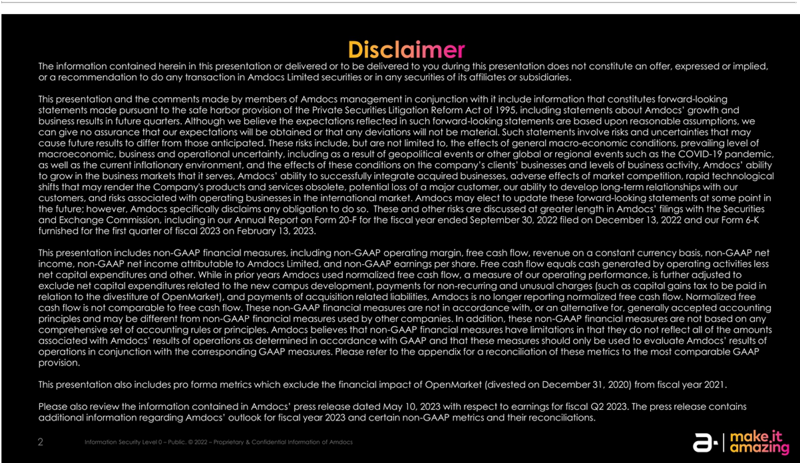







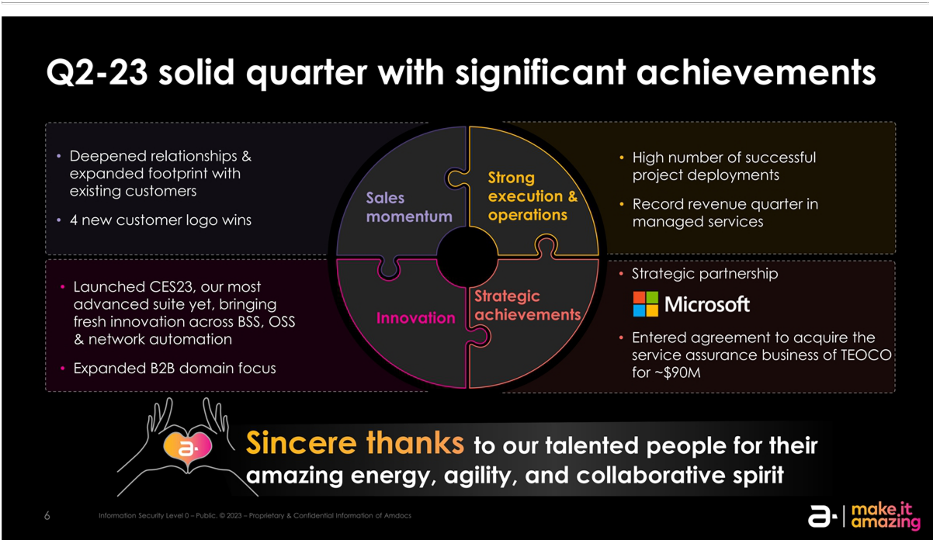

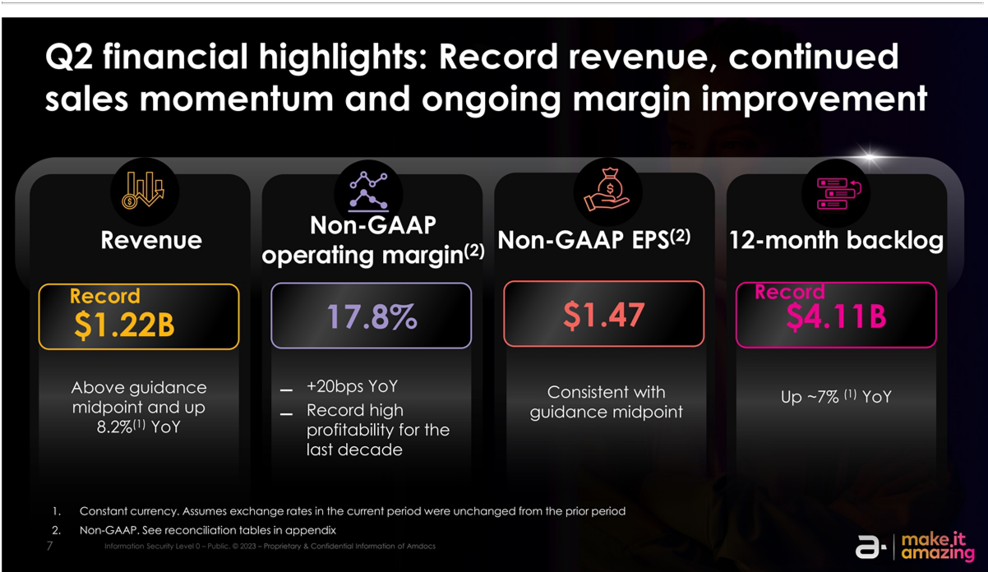

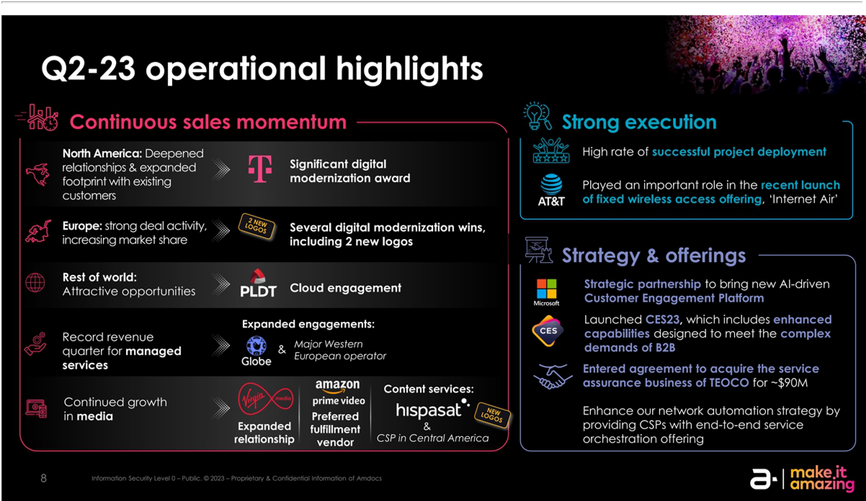

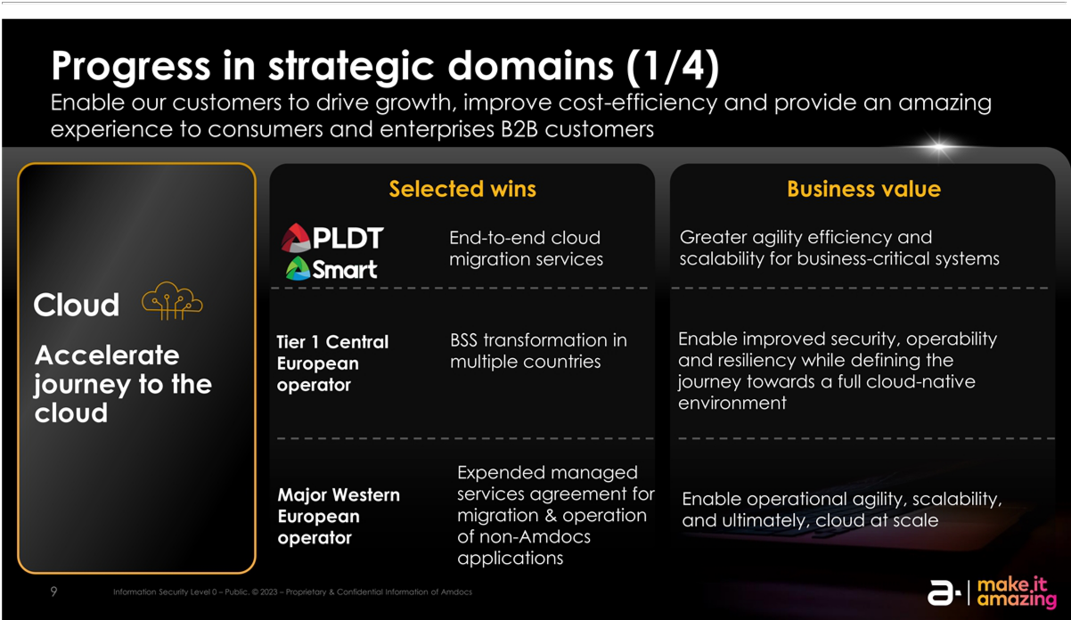

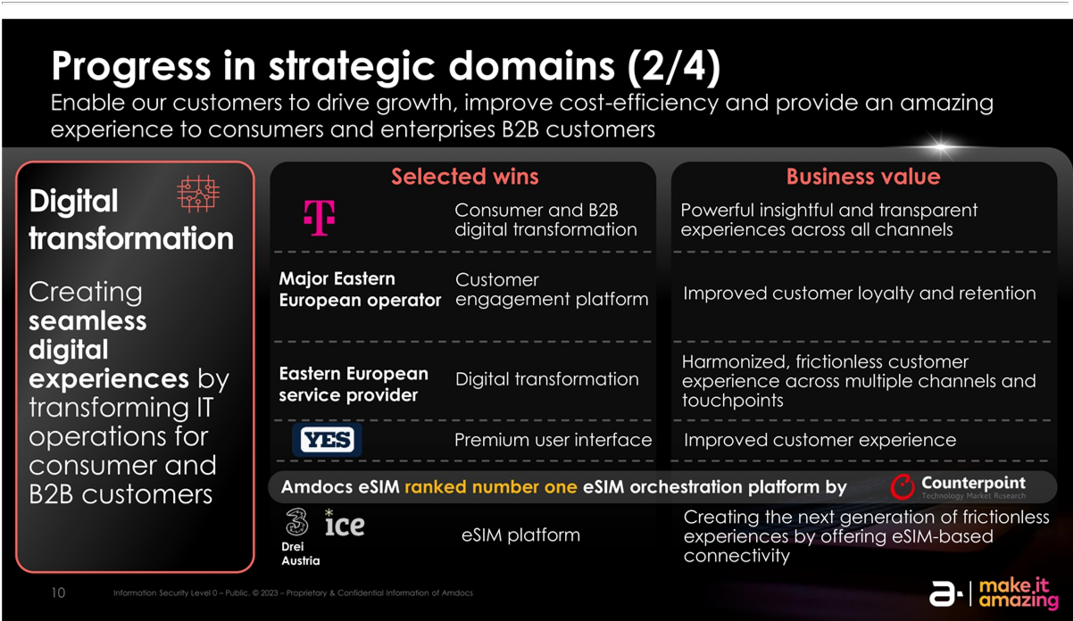

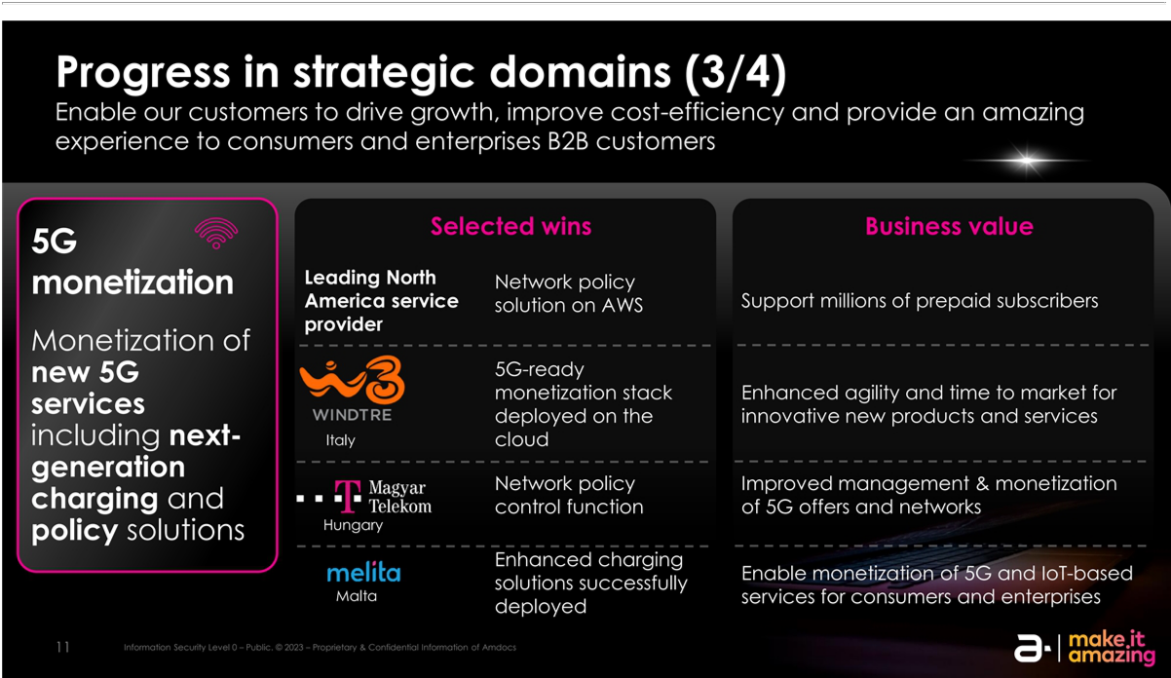

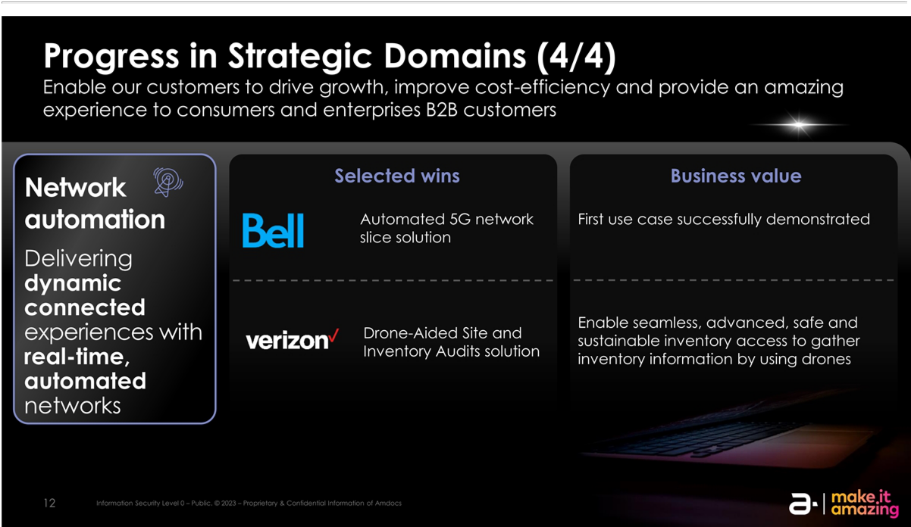

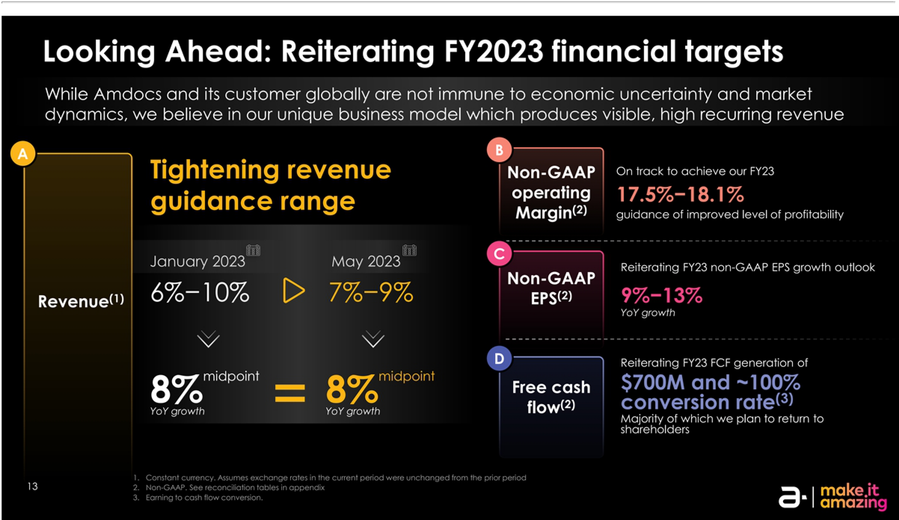



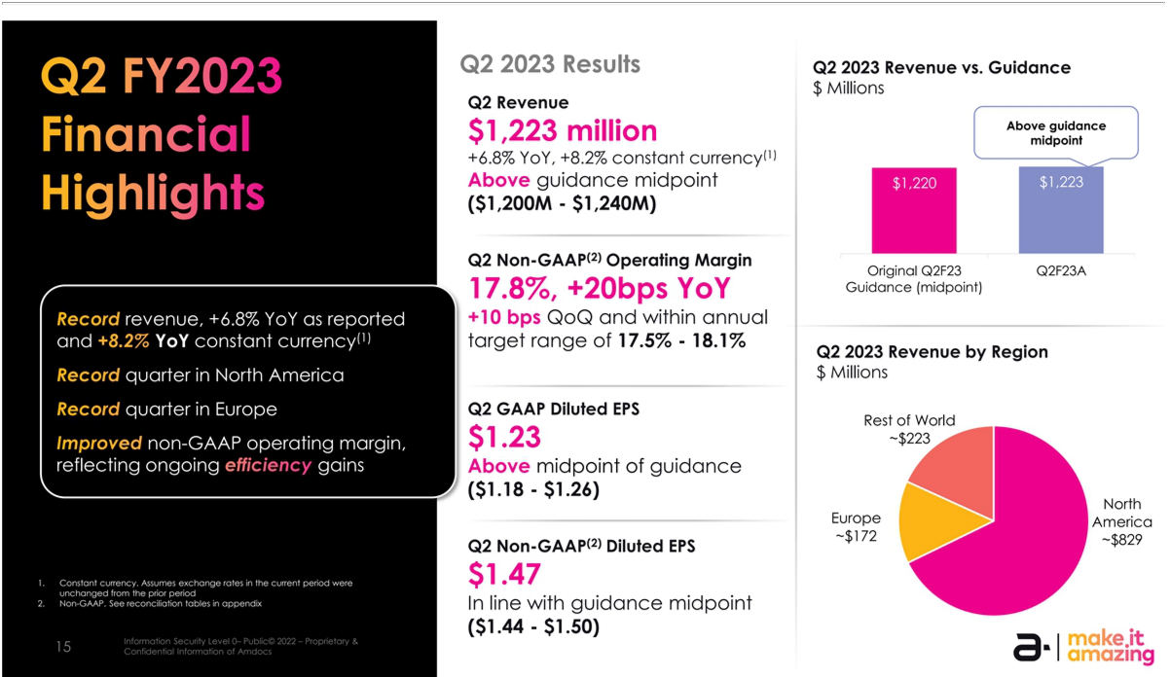

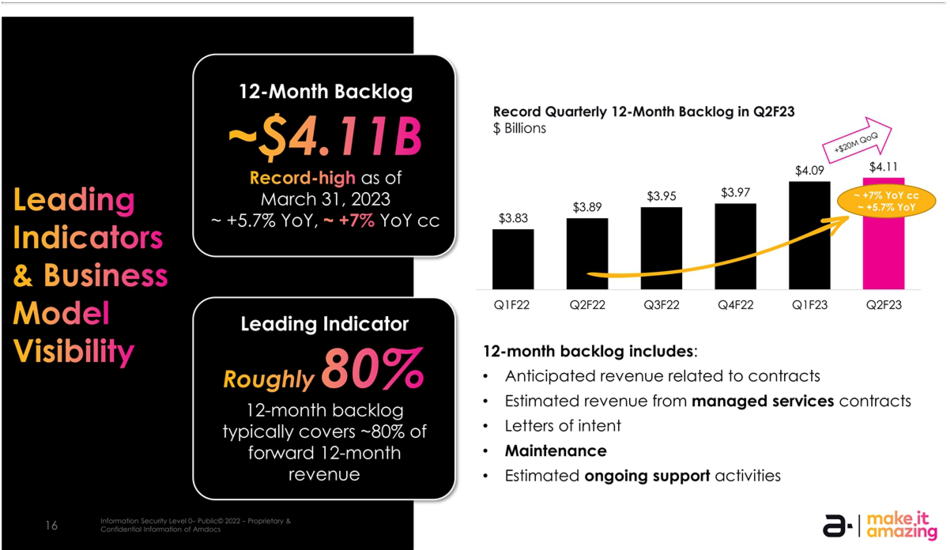

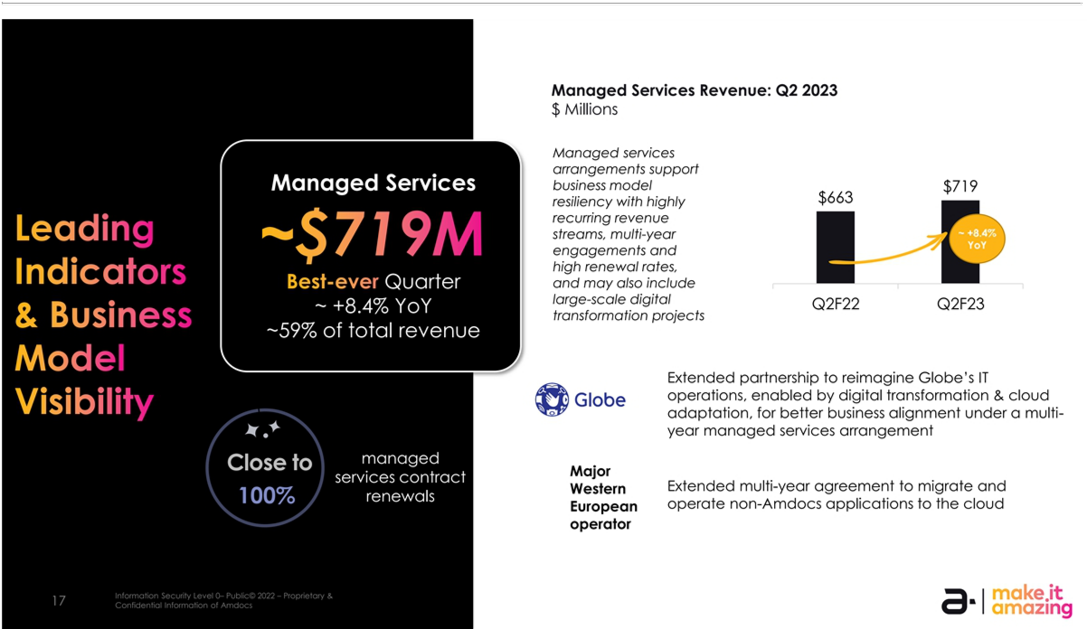

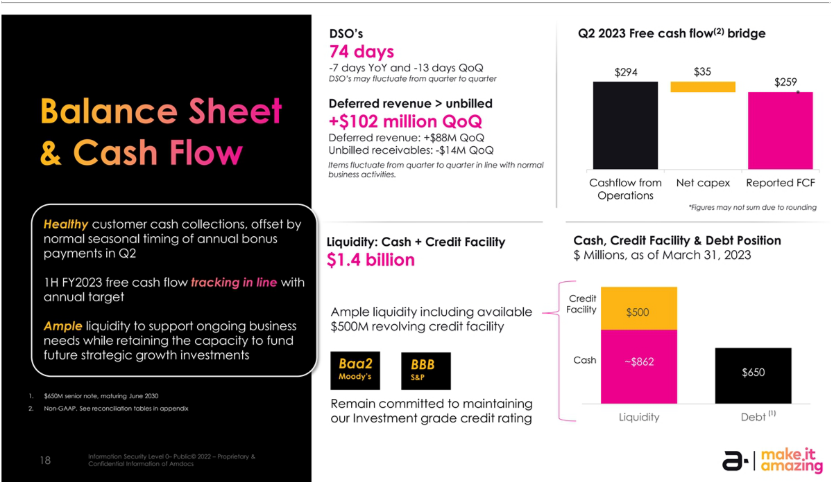

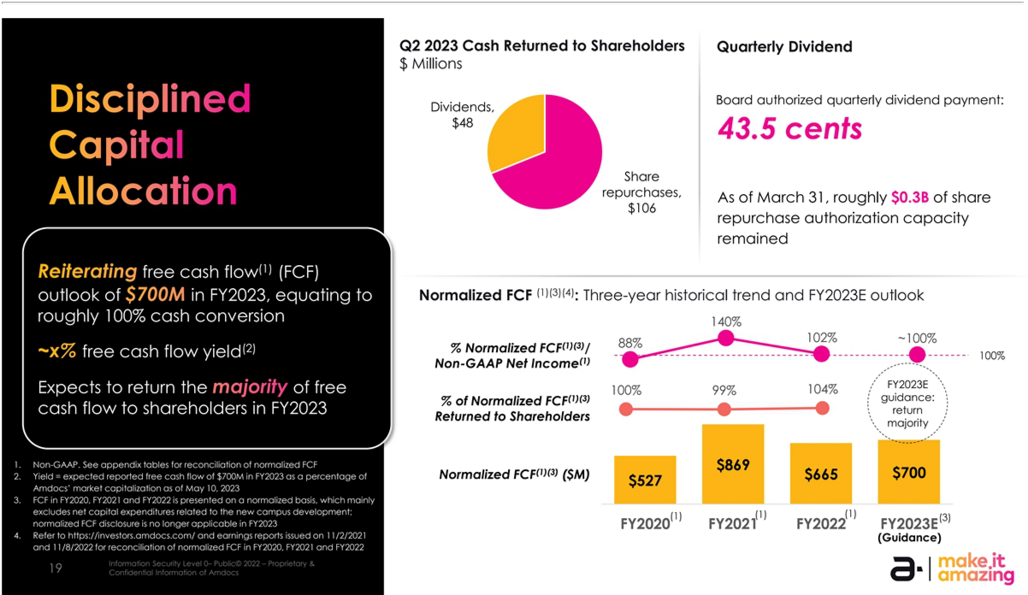

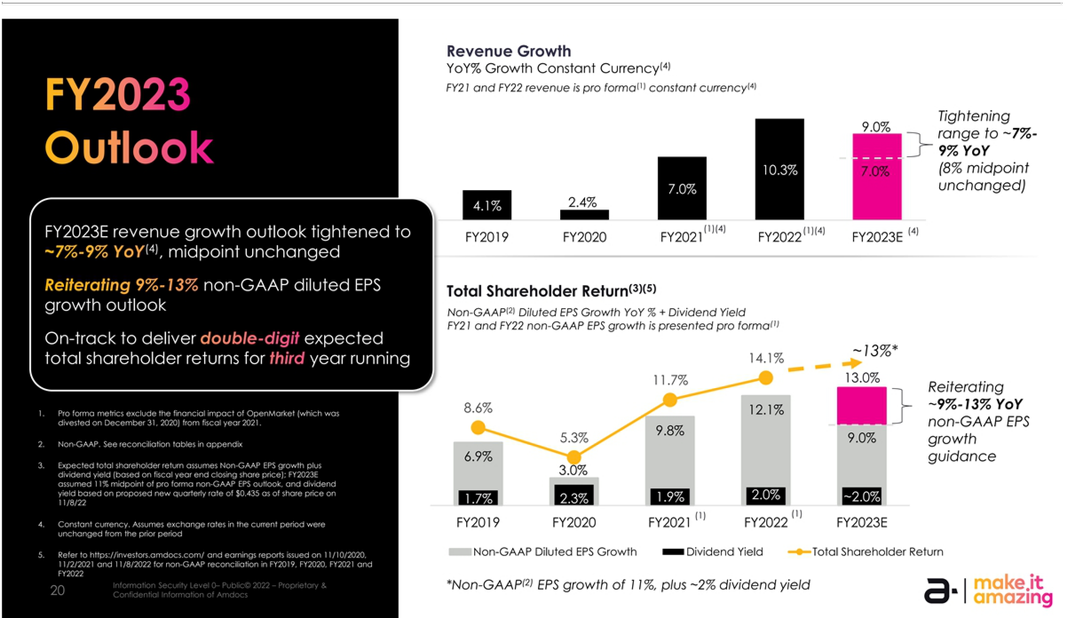

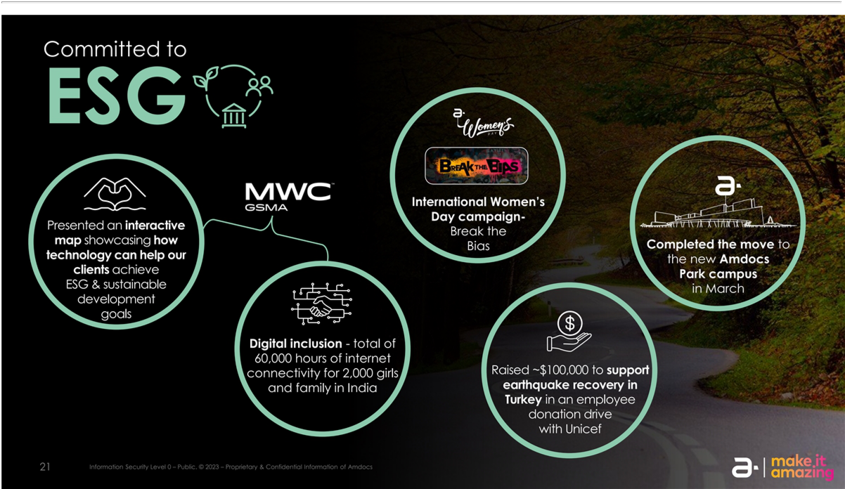





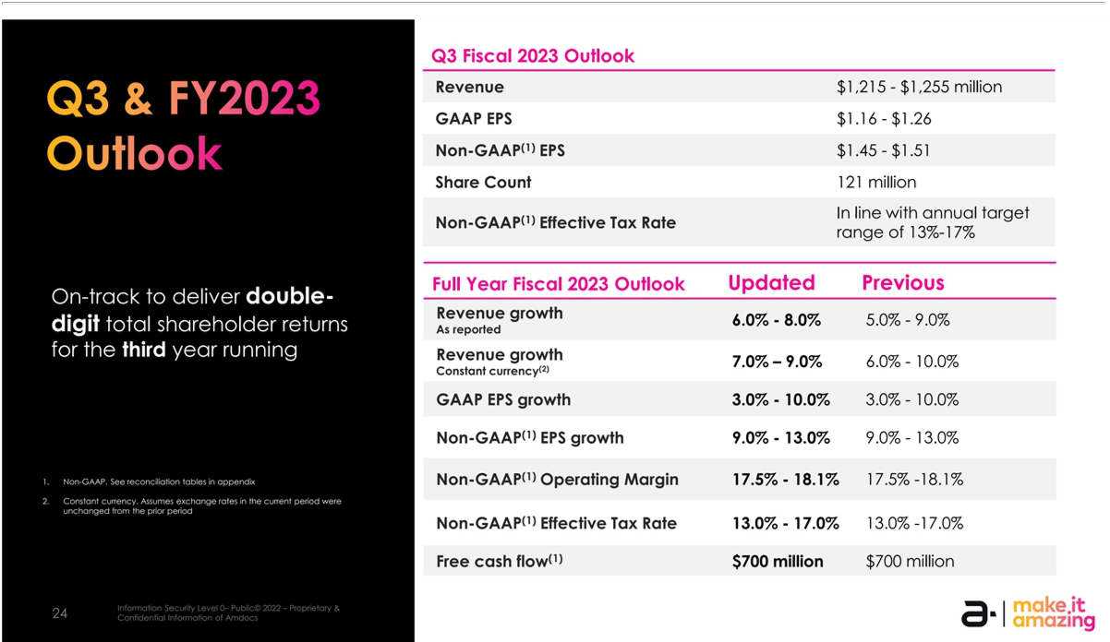



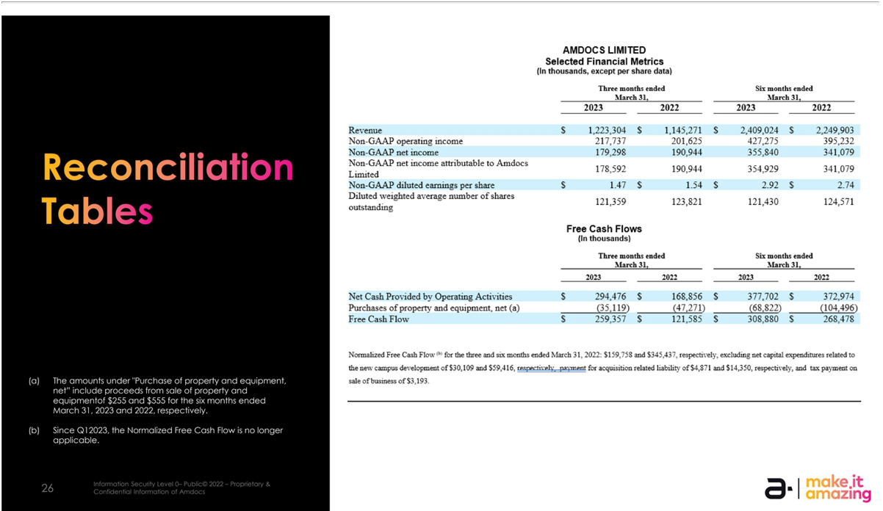

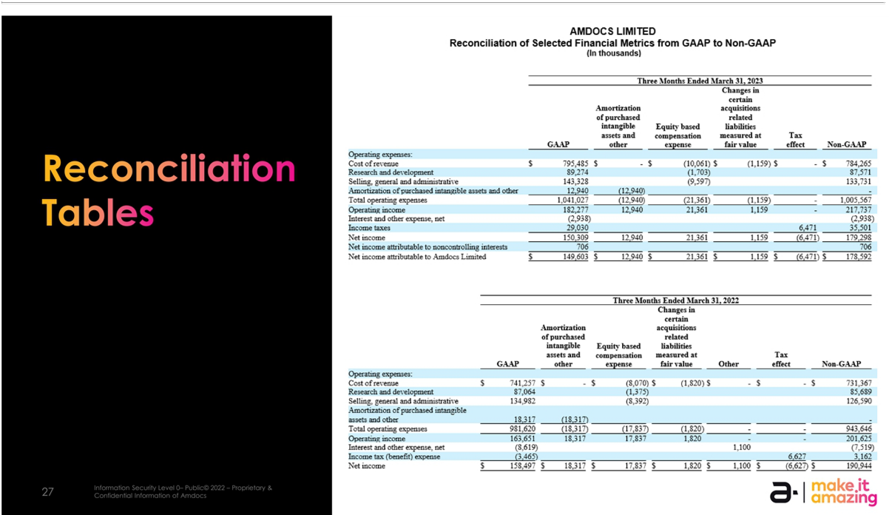

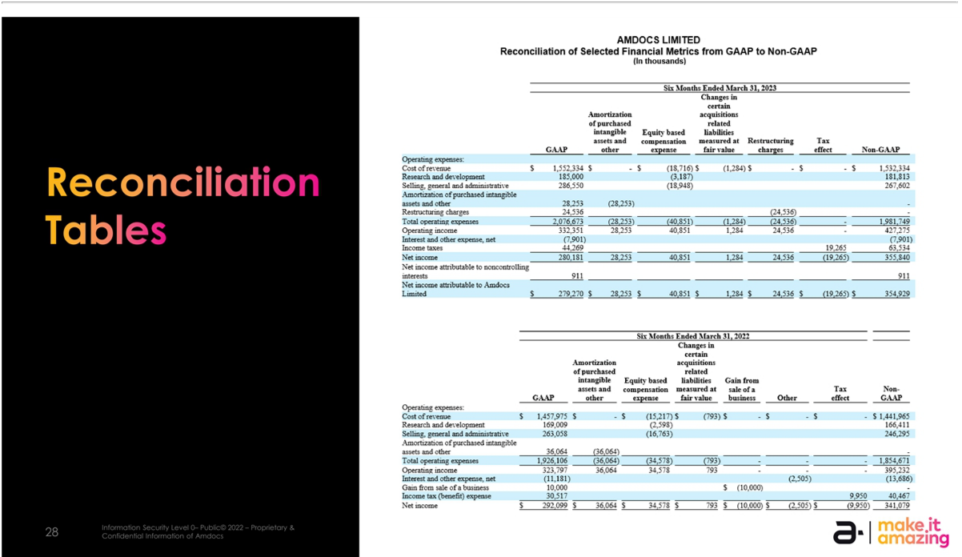



Exhibit 99.3


Amdocs to Acquire Service Assurance Business of TEOCO to Assure and Enable

Monetization of Next Generation Dynamic Customer Experiences

JERSEY CITY, NJ – May 10, 2023 –Amdocs (NASDAQ: DOX), a leading provider of software and services to communications and media companies, today announced that it has entered into a definitive agreement to acquire the service assurance business of TEOCO. The acquisition will enable Amdocs to provide service providers with a unique end-to-end service orchestration offering, assuring the quality of service and enabling the monetization of next generation dynamic customer experiences.

“The move will enhance Amdocs’ offering by bringing key assurance expertise and capabilities in-house, enabling us to offer truly end-to-end service orchestration. In today’s dynamic and complex 5G era, such a holistic, end-to-end approach is key to delivering on the promise of amazing experiences our customers’ end users expect.” said Shuky Sheffer, President and CEO of Amdocs Management Limited. “Amdocs and TEOCO already partner in some opportunities within the service assurance domain, and this acquisition and the new seamlessly integrated offering will enable us to better serve existing and new customers.”

Amdocs is acquiring the service assurance business of TEOCO for a consideration of approximately $90 million in cash, subject to the satisfaction of the conditions to closing. Additional consideration may be paid later based on the achievement of certain performance metrics. Revenue from TEOCO is expected to be immaterial in fiscal 2023 and expected to add approximately 0.5% to total revenue in fiscal year 2024.

The impact on GAAP diluted EPS will not be known until after Amdocs completes the purchase price allocation.

The impact of the acquisition on Amdocs’ non-GAAP diluted earnings per share is expected to be neutral in the full fiscal years 2023 and 2024. Non-GAAP diluted earnings per share excludes amortization of purchased intangible assets and other acquisition-related costs, changes in certain acquisitions related liabilities measured at fair value, restructuring charges, equity-based compensation expenses and other, net of related tax effects.

Supporting Resources

- Keep up with Amdocs news by visiting the company’s website

- Follow us on Twitter, Facebook, LinkedIn and YouTube

About Amdocs

Amdocs helps those who build the future to make it amazing. With our market-leading portfolio of software products and services, we unlock our customers’ innovative potential, empowering them to provide next-generation communication and media experiences for both the individual end user and enterprise customers. Our 31,000 employees around the globe are here to accelerate service providers’ migration to the cloud, enable them to differentiate in the 5G era, and digitalize and automate their operations. Listed on the NASDAQ Global Select Market, Amdocs had revenue of $4.58 billion in fiscal 2022. For more information, visit www.amdocs.com

Amdocs’ Forward-Looking Statement

This press release includes information that constitutes forward-looking statements made pursuant to the safe harbor provision of the Private Securities Litigation Reform Act of 1995, including statements about Amdocs’ growth and business results in future quarters and years. Although we believe the expectations reflected in such forward-looking statements are based upon reasonable assumptions, we can give no assurance that our expectations will be obtained or that any deviations will not be material. Such statements involve risks and uncertainties that may cause future results to differ from those anticipated. These risks include, but are not limited to, the effects of general macro-economic conditions, prevailing level of macroeconomic, business and operational uncertainty, including as a result of geopolitical events or other global or regional events such as the COVID-19 pandemic, as well as the current inflationary environment, and the effects of these conditions on the company’s clients’ businesses and levels of business activity, Amdocs’ ability to grow in the business markets that it serves, Amdocs’ ability to successfully integrate acquired businesses, adverse effects of market competition, rapid technological shifts that may render the Company’s products and services obsolete, potential loss of a major customer, our ability to develop long-term relationships with our customers, and risks associated with operating businesses in the international market. Amdocs may elect to update these forward-looking statements at some point in the future; however, Amdocs specifically disclaims any obligation to do so. These and other risks are discussed at greater length in Amdocs’ filings with the Securities and Exchange Commission, including in our Annual Report on Form 20-F for the fiscal year ended September 30, 2022 filed on December 13, 2022 and our Form 6-K furnished for the first quarter of fiscal 2023 on February 13, 2023.

Media Contacts

Jeff Barak

Amdocs Public Relations

Tel: +972 645 3637

Email: Jeff.Barak@amdocs.com

Holly Abbott

Babel PR for Amdocs

Tel: +44 (0)7527 521057

Email: amdocs@babelpr.com / holly.abbott@babelpr.com

